Week 03 – Report – Julien Esposito

Question 03 – Creating a new user
sudo useradd chris_butler

Question 04 – Creating Password for New User (done in previous step)
sudo passwd chris_butler

Question 05 – Visual Check
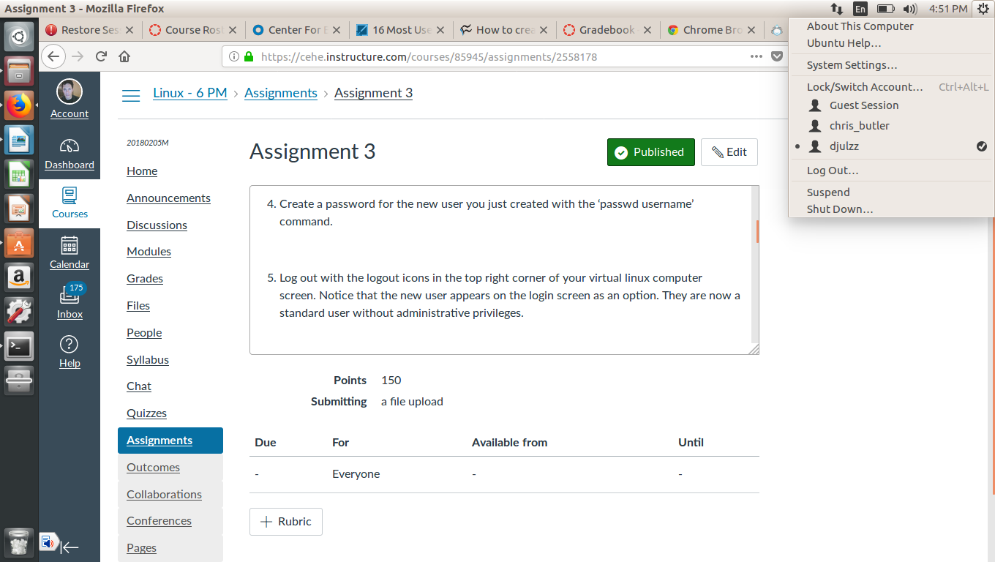

Question 6

usermod -a -G adm chris_butler

Question 8
sudo usermod -l chris chris_butler

Question 9
Take a screenshot from the top right menu instead.

Question 10
sudo usermod -l chris_butler chris

Question 11
sudo useradd lockme && sudo passwd lockme

Question 12
sudo passwd -l lockme

Question 13
sudo passwd -u lockme

Question 14
sudo useradd deleteme && sudo passwd deleteme

Question 15
sudo groupadd groupalpha

Question 16

- Add the deleteme user to the group ‘groupbravo’ with the commands from step 7.

- Remove the deleteme user from the group ‘groupbravo’ with the command ‘gpasswd -d username groupname’. NOTE: The -d switch means to remove/delete user from the group. This does not delete the user from anything else.

- Delete the deleteme user with the command ‘userdel username’.

- Delete the groupbravo group with the command ‘groupdel groupname’.

