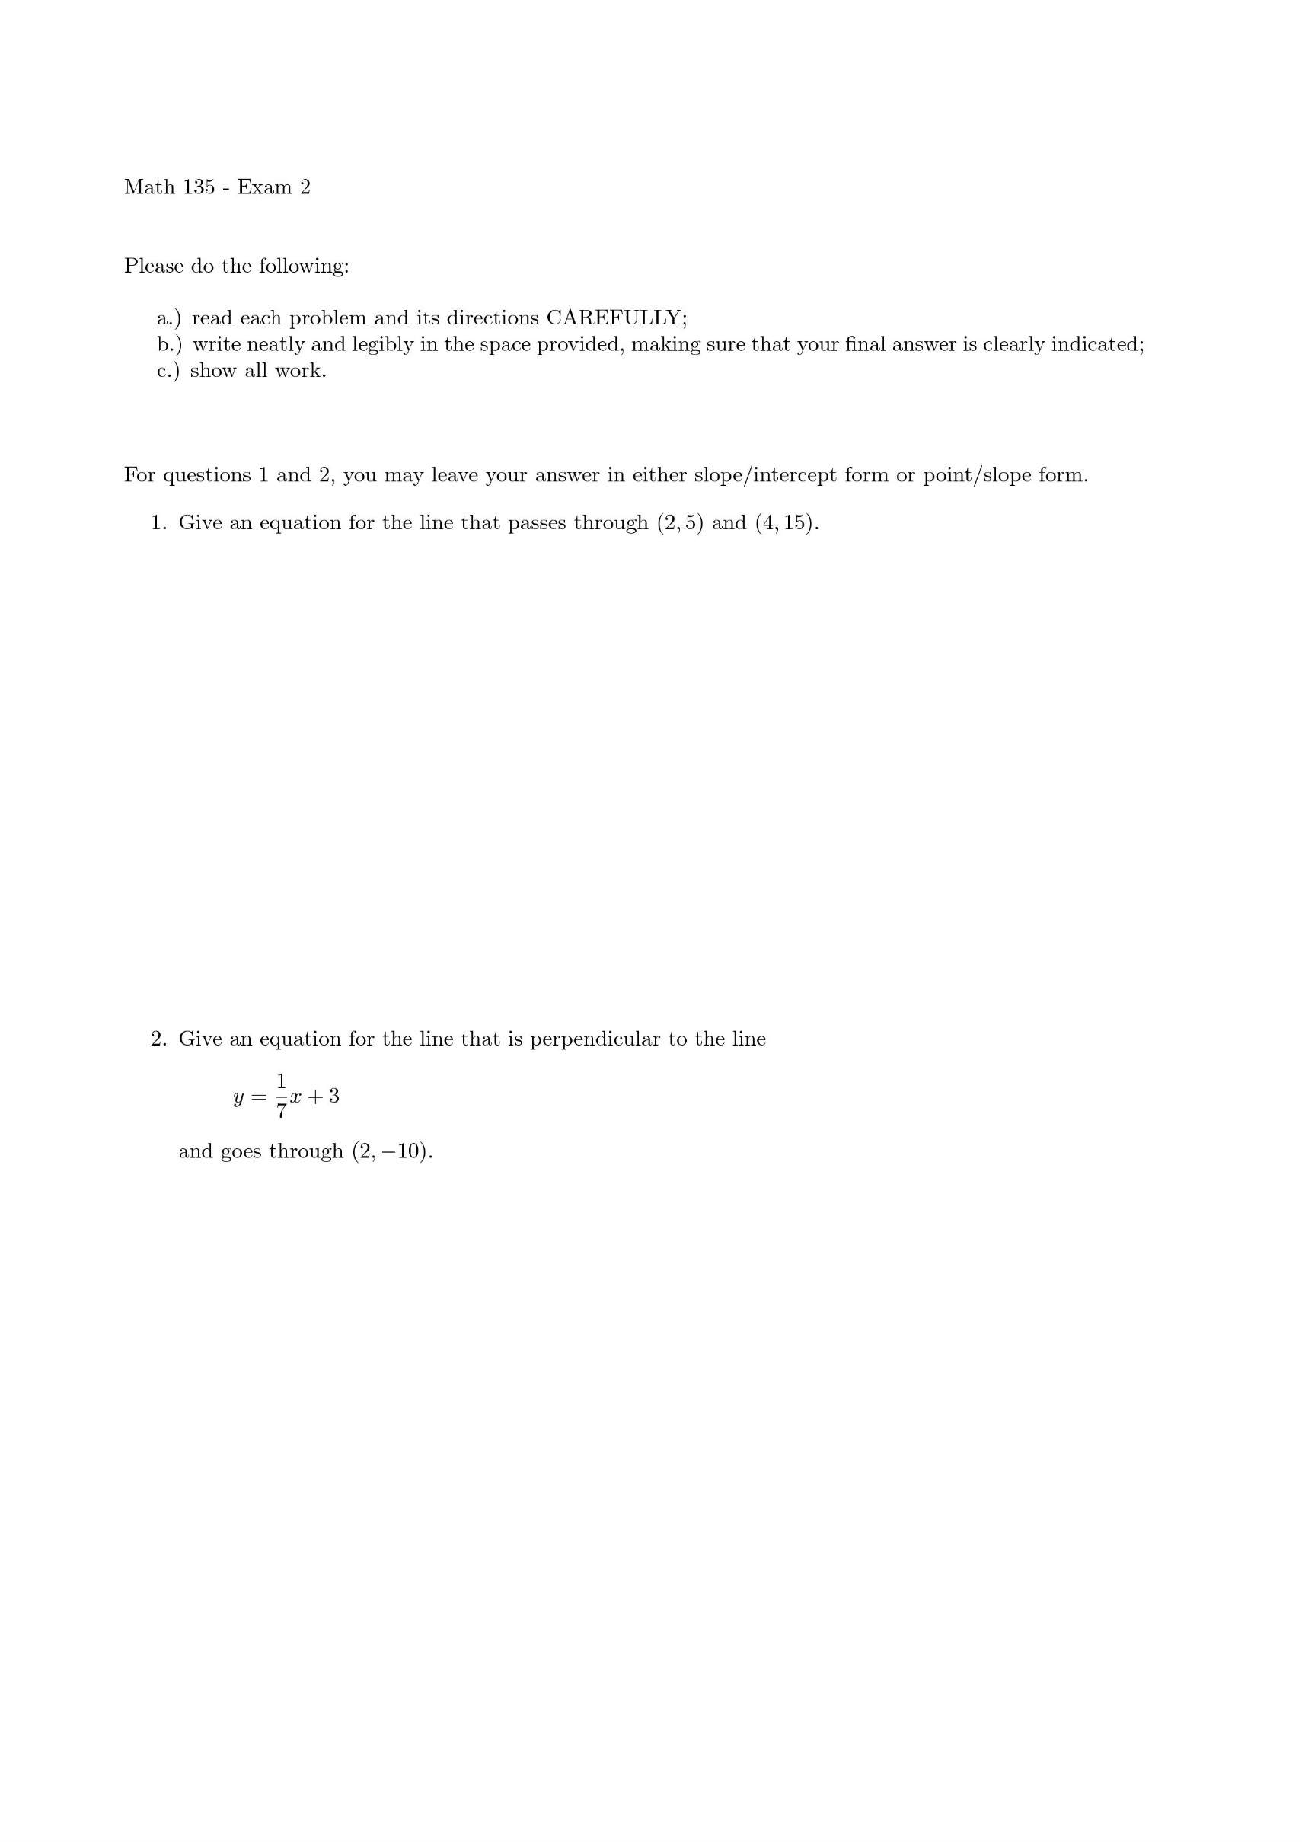

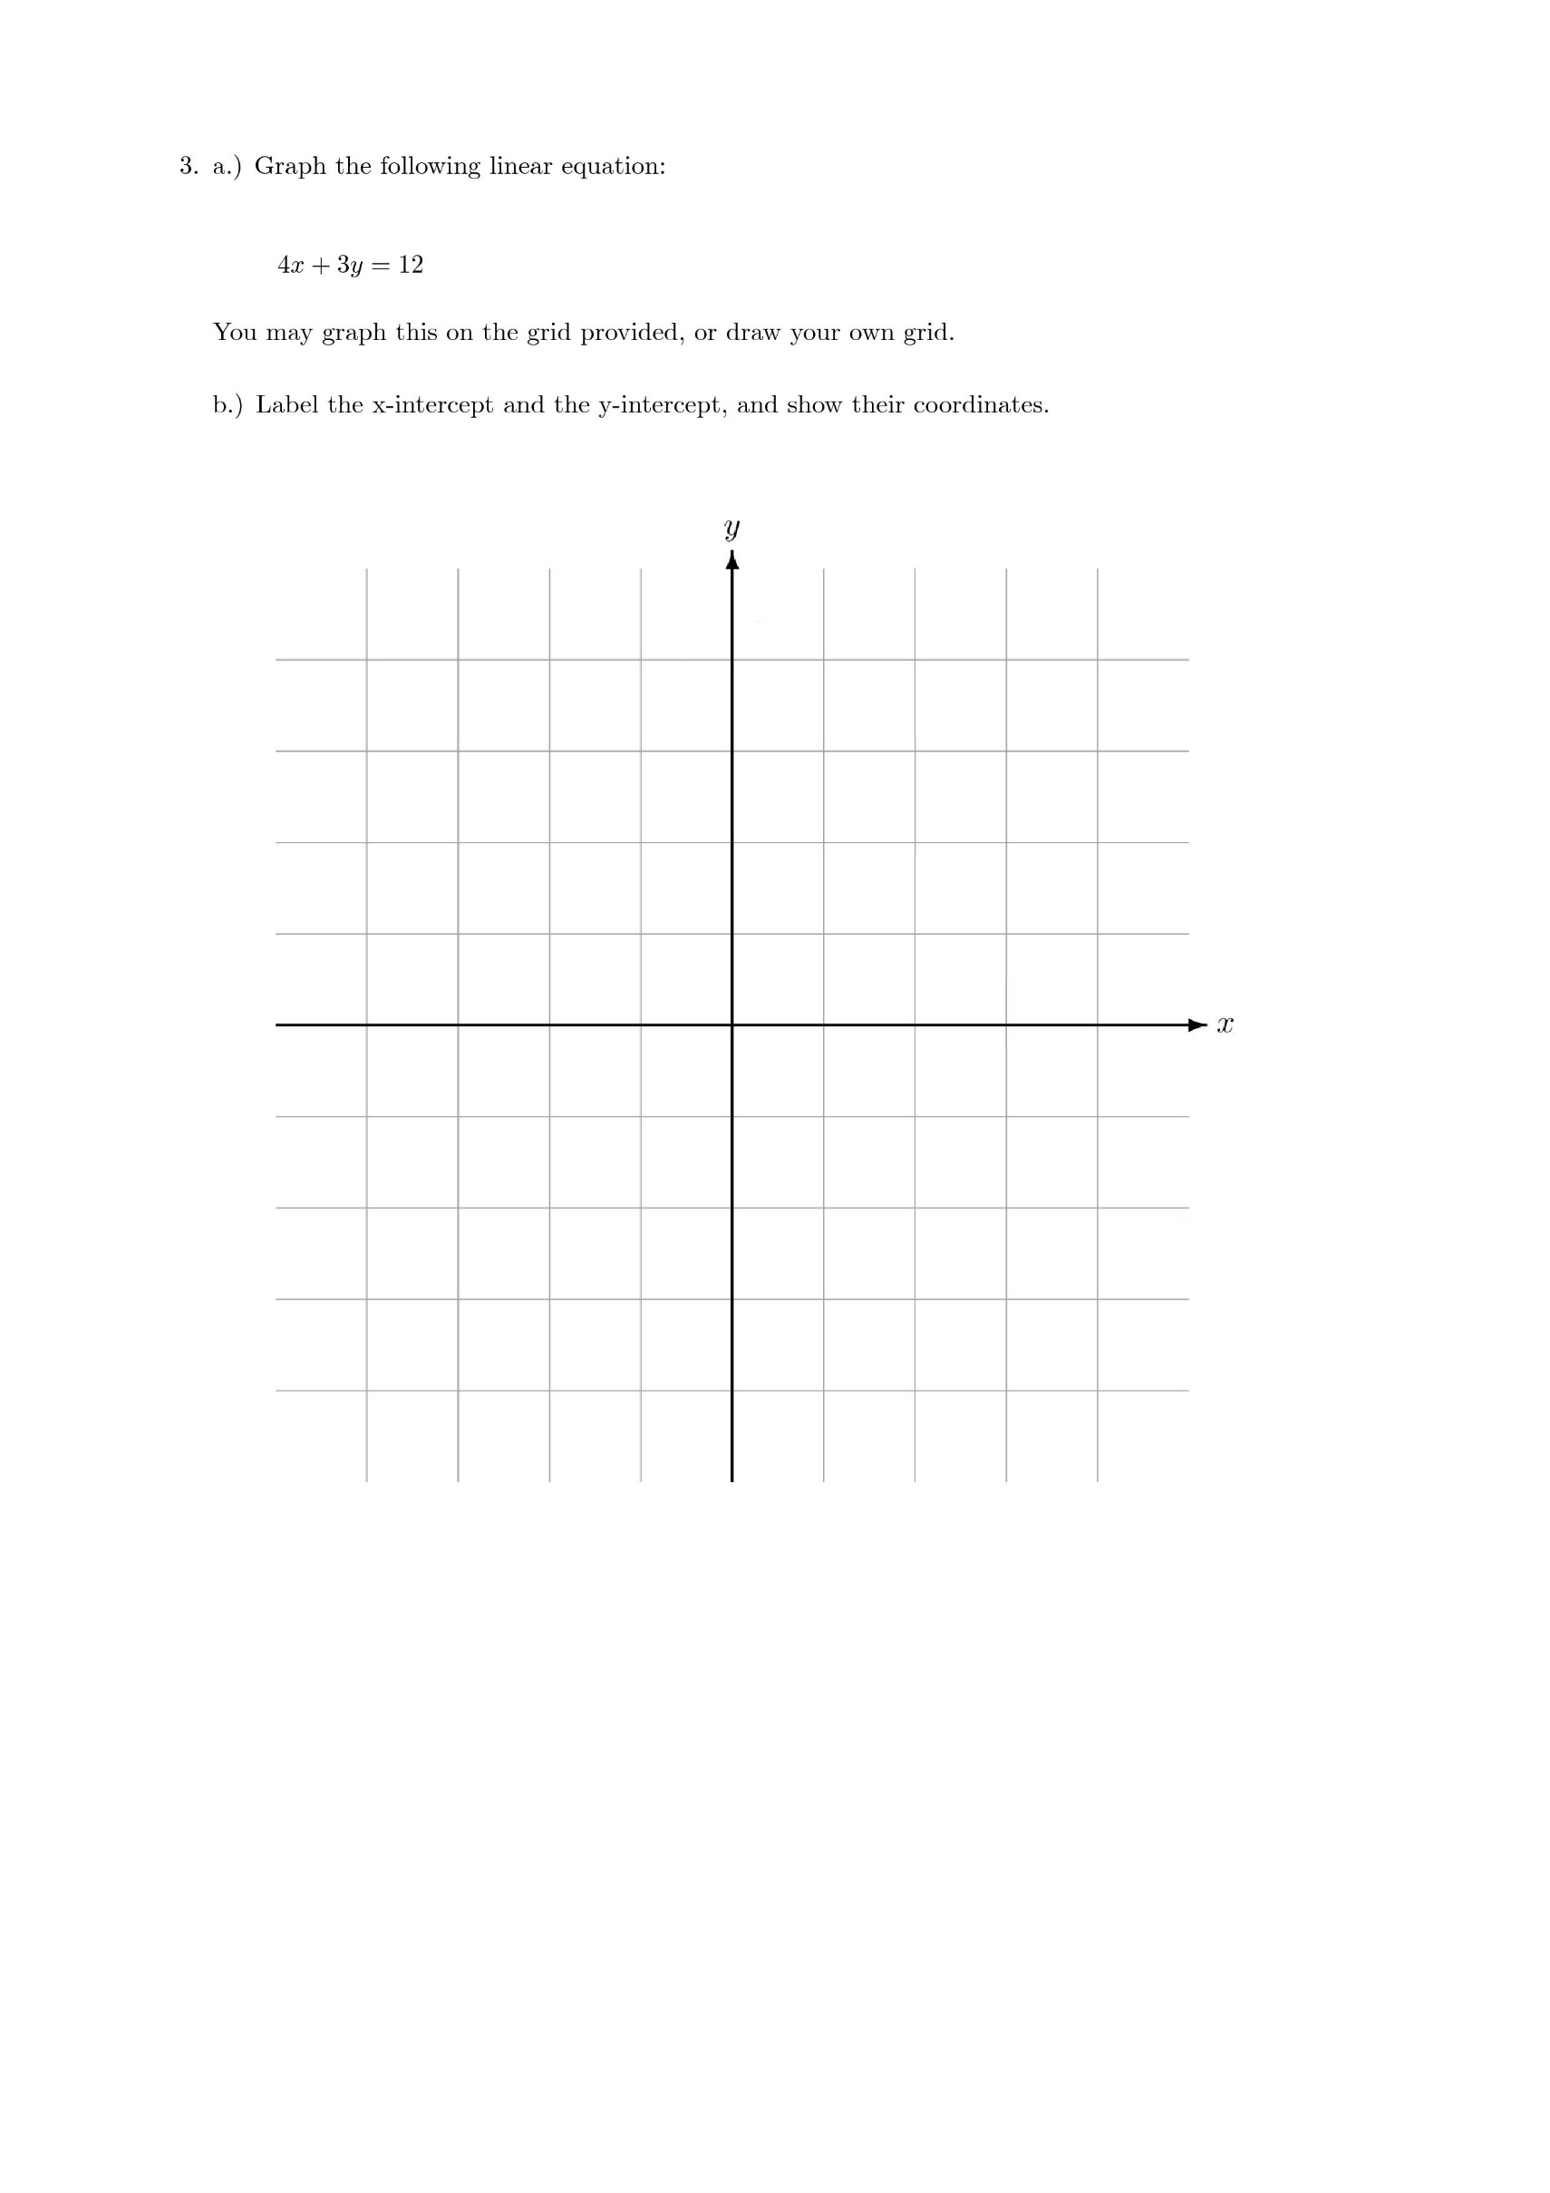

A close up of a flower

Description generated with high confidence

A close up of a flower

Description generated with high confidence

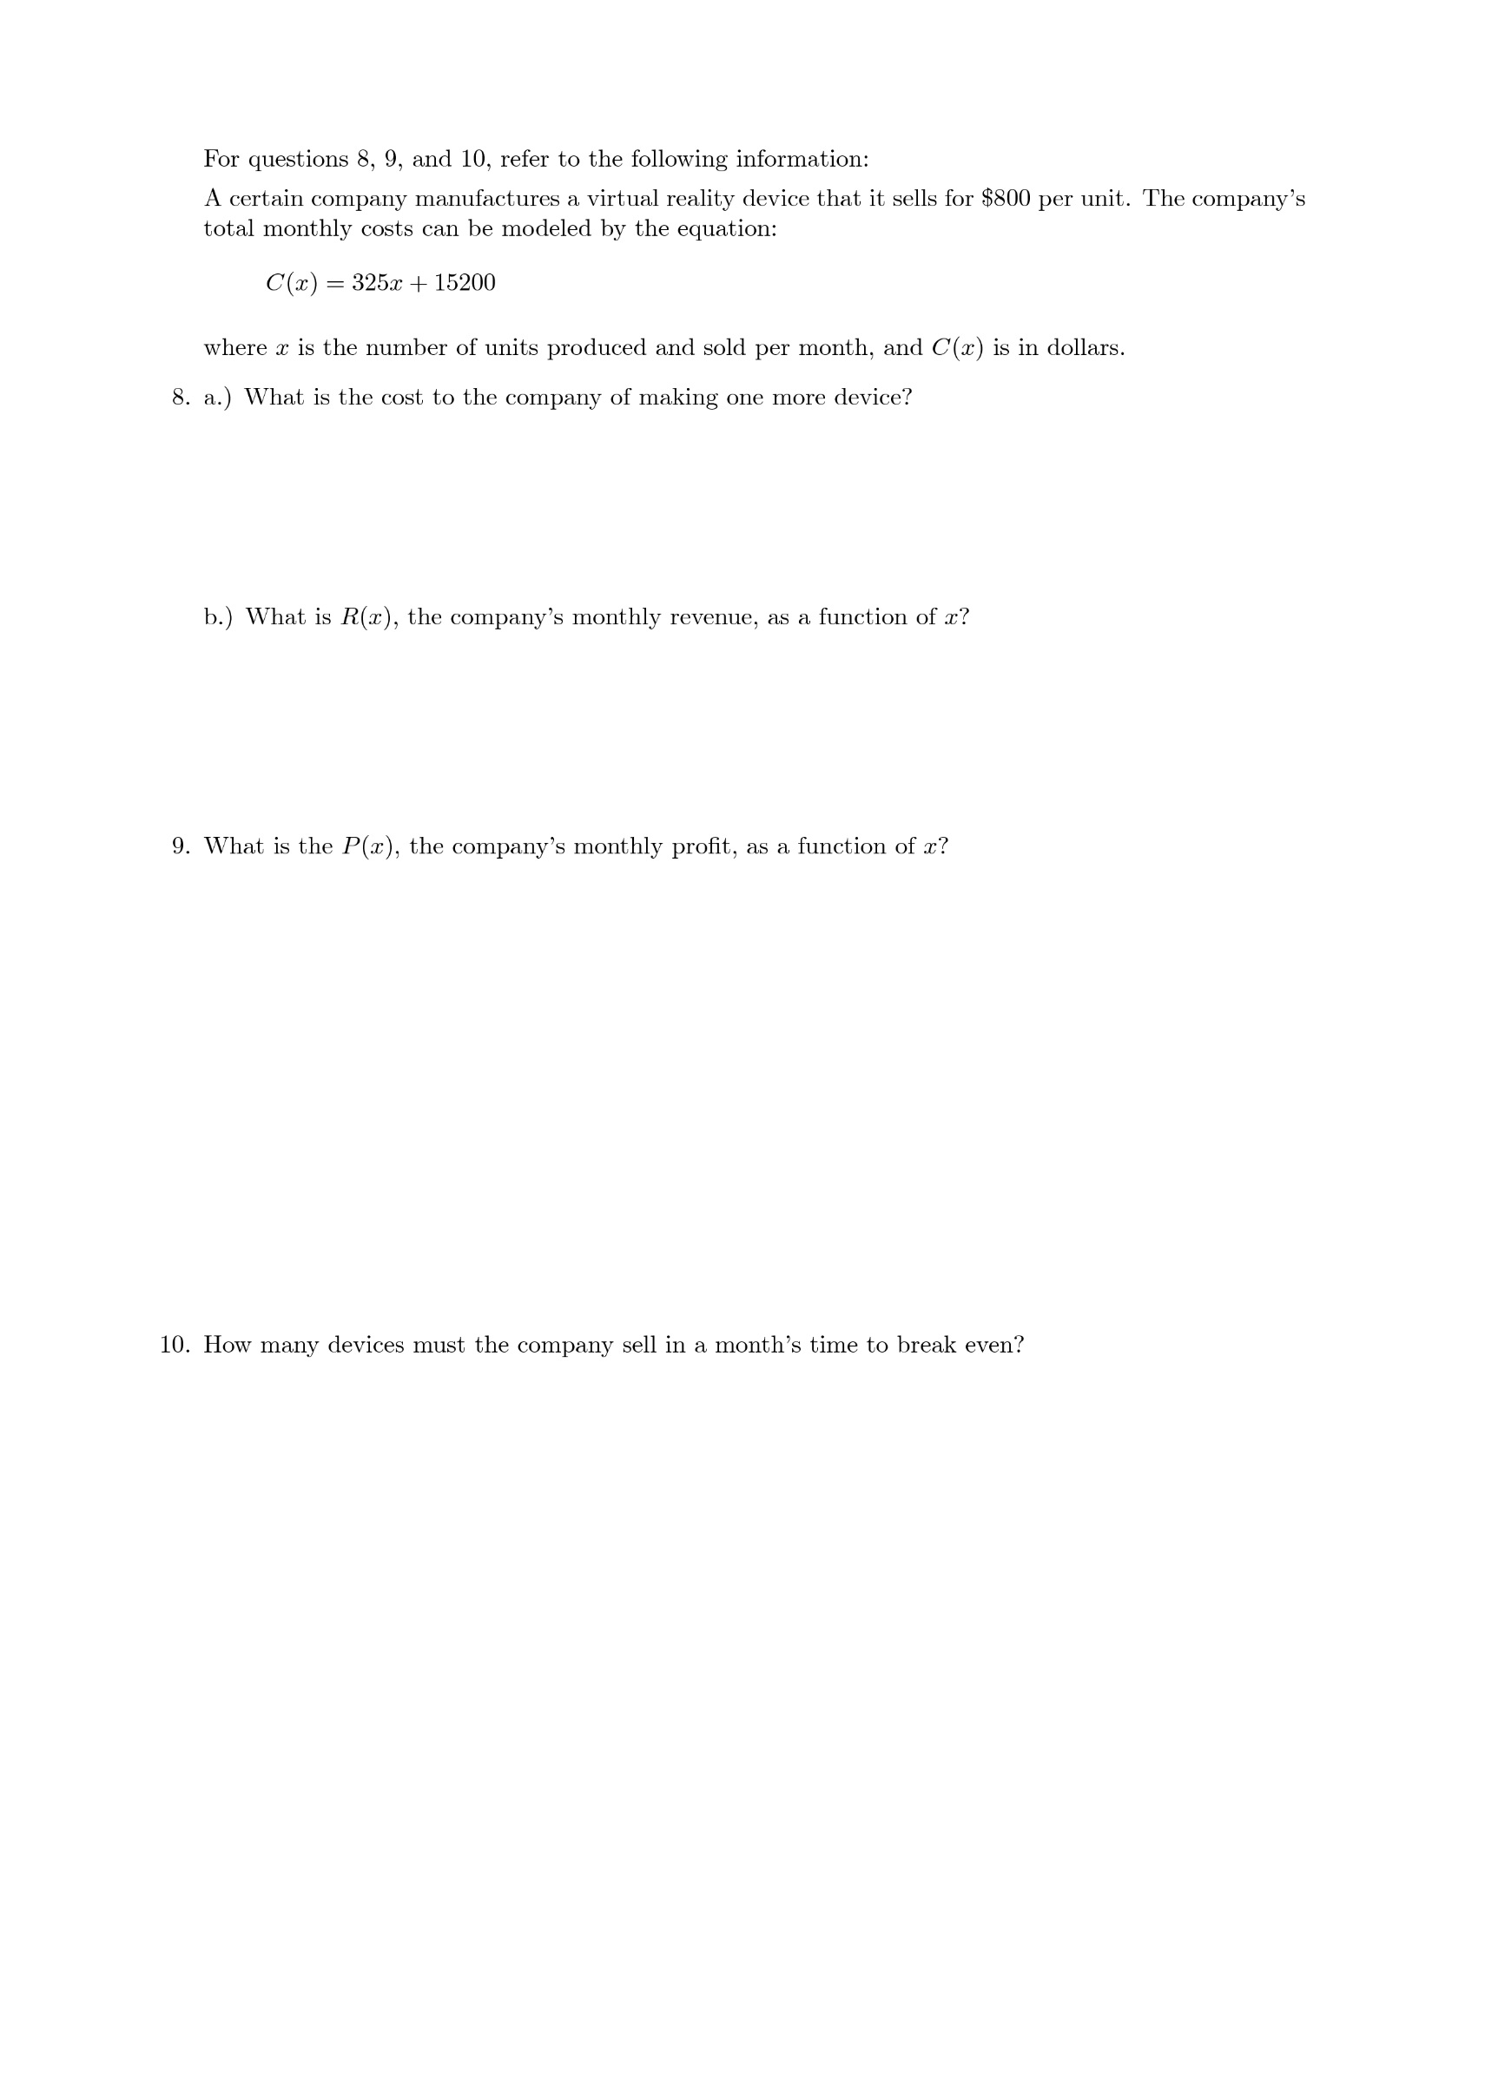

A screenshot of a cell phone

Description generated with very high confidence