A screenshot of a tree

Description generated with high confidence

A picture containing animal

Description generated with high confidence

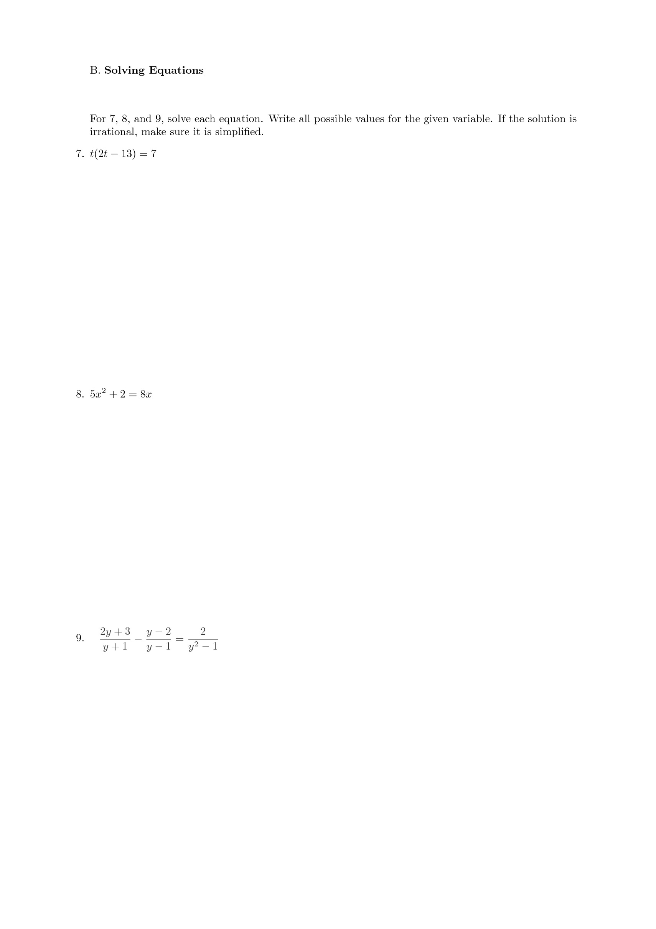



A screenshot of a cell phone

Description generated with very high confidence

A close up of a flower

Description generated with high confidence

A screenshot of a cell phone

Description generated with high confidence

A screenshot of a cell phone

Description generated with very high confidence

A screenshot of a cell phone

Description generated with very high confidence



A close up of a flower

Description generated with high confidence

A screenshot of a cell phone

Description generated with very high confidence