**Steps-**

1. First we made a matrix (in this example it is of size 10x11) and populated it with random numbers using rand() function.
2. Then take 5 points from the user.
3. then check for each point if it lies inside Convex Hull by using ConvexHull function.
4. If point lies inside Convex Hull then add the value on that point from matrix into our answer.

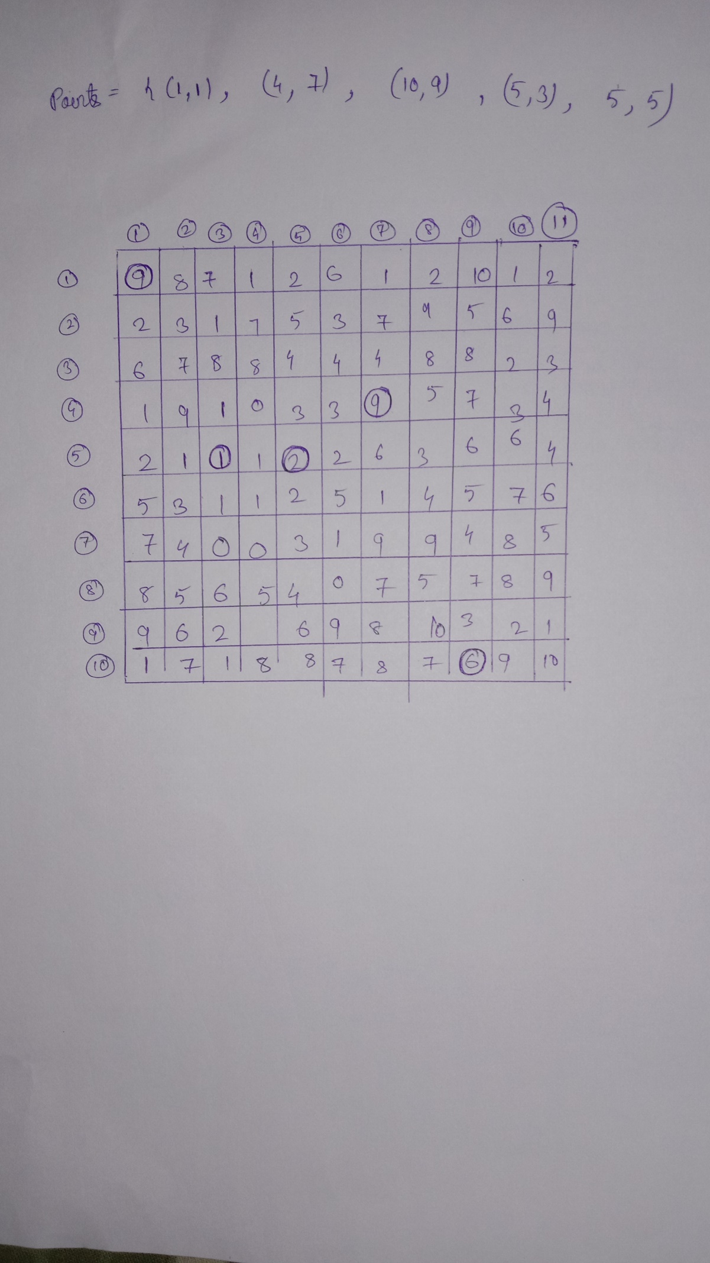

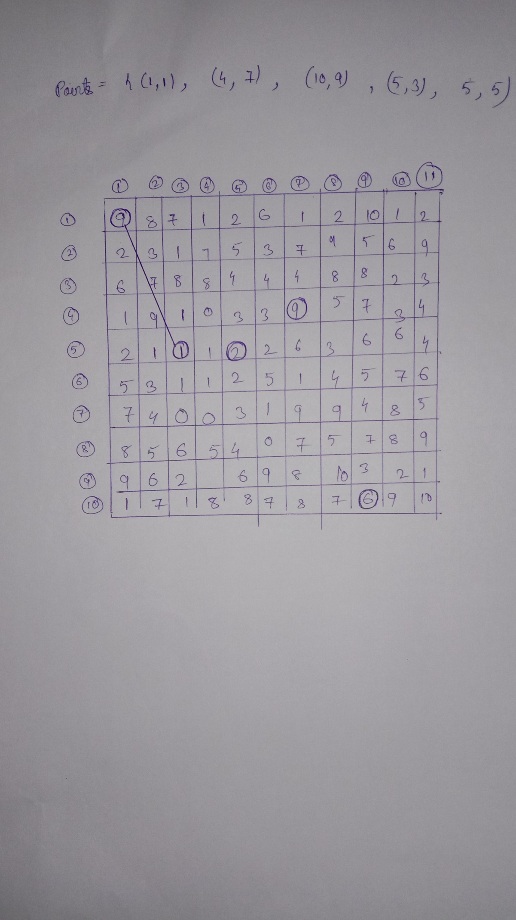

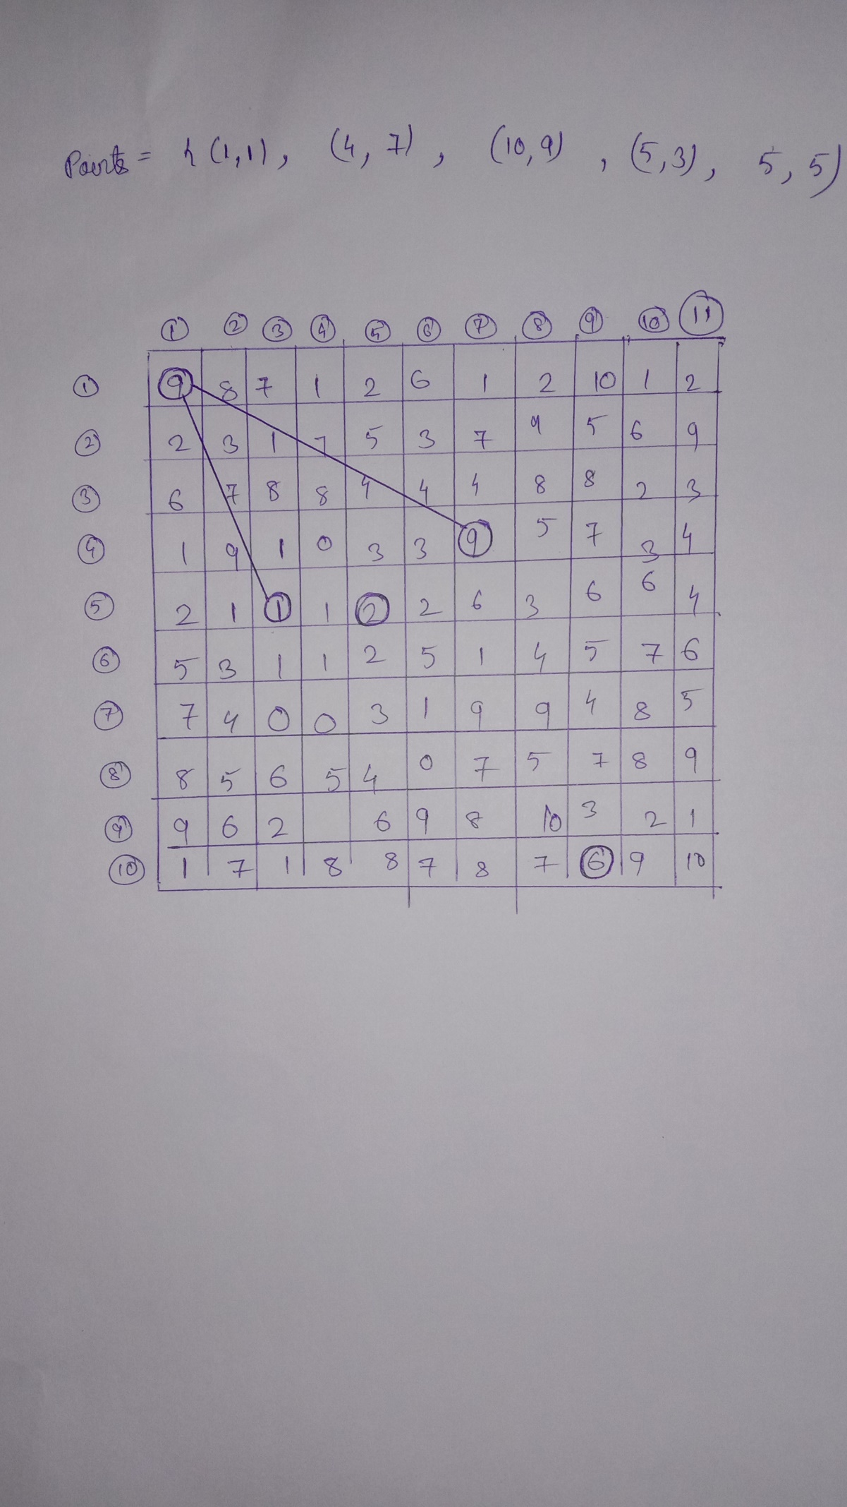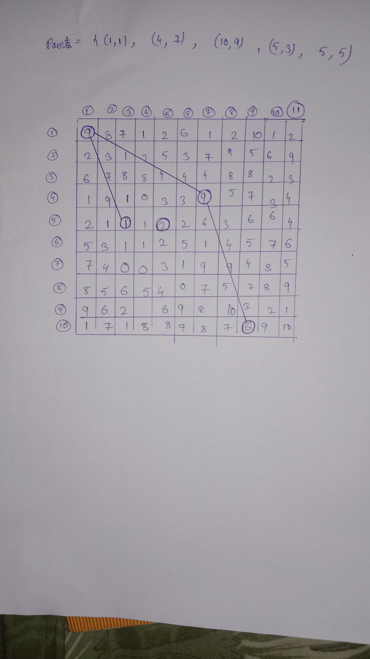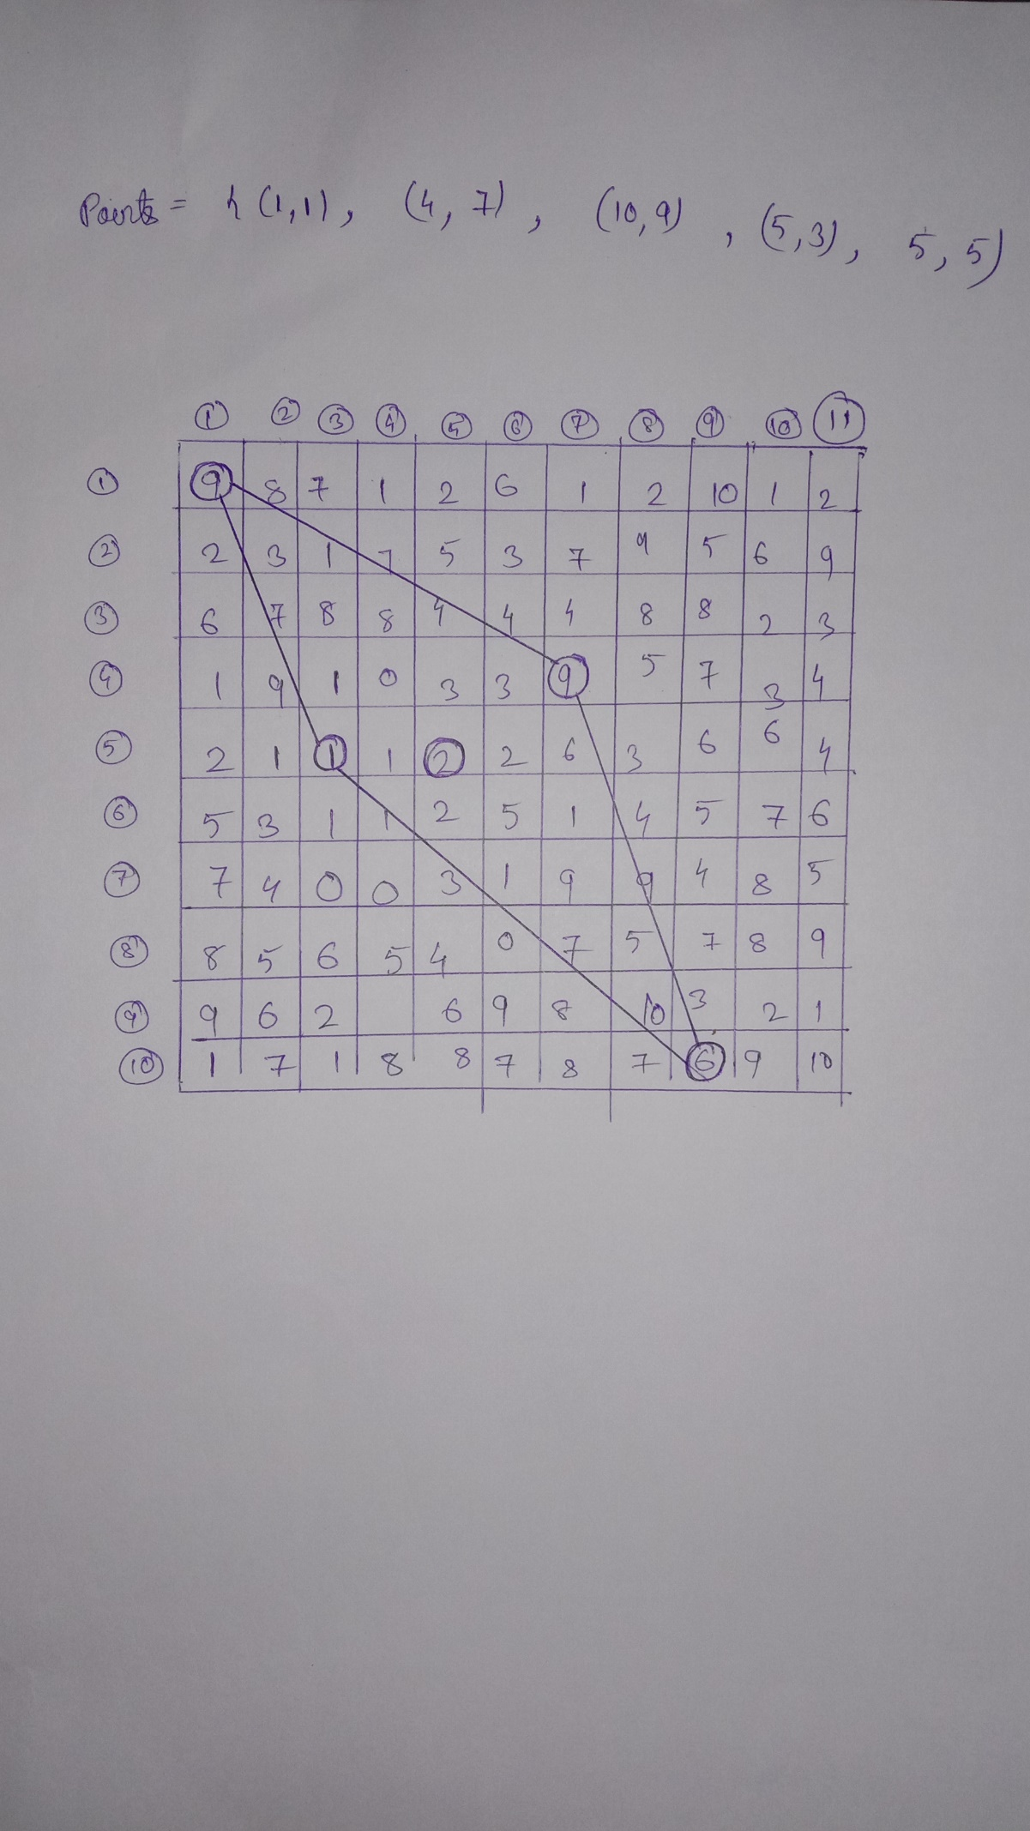

Here we have not considered the point (5,5) while constructing the convex hull because it was not lying on the boundary.

This is very important property of convex hull that it keeps most of the points inside the hull, if it doesn’t participate in the formation of Convex Hull.