RoboLogger Service

Installation and User guide
Version 1.0

RoboLogger Overview
This Jabber-based service will allow users to converse with one another about a specific Polaris experiment-ID and have their observations automatically recorded in the Observations section of the Polaris dashboard for that experiment. This should facilitate better archival persistence of experimental observations and reduce the amount of 'pencil and paper' recording of experimental data.

Typically, an experimenter will register with the RoboLogger Service once and later, when a logged conference with another experimenter (or software provider, etc.) is desired, a valid ACME Jabber user will instruct the service to set a conference room. When instructed to do so, the RoboLogger Service will create a new RoboLogger which will in turn create a conference room and invite specific users to the conference.

Later, on demand, any participant may use a command ('RoboLogger[Record]') to instruct the service to record the conversation to Polaris.

Installation
The RoboLogger Service and library is installed via the customary setup.py installer. IN addition, you may have to install the conference.dll file in the jabber_run_directory/libs directory.

Configuration
The RoboLogger Service requires some minor changes to ACME's Jabber.xml file. One turns on conferencing (a.k.a. groupchat), the other.
In order to make the service browseable via a GUI client, one must add the following stanza to the "<browse></browse>" segment of jabber.xml:

<service id="robologger" name=" robologger ">
<ns>jabber:iq:gateway</ns>
<ns>jabber:iq:register</ns>
</service>

Conferencing should also be turned on via assuring that this stanza appears in the "<browse></browse>" segment:

<conference type="public" jid="conference.localhost" name="Public Chatrooms"/>

The RoboLogger Service requires an entry like this in the services segment of the jabber.xml:

<service id=" robologger " >
<accept>
<ip/>
<secret>secret</secret>
<port>7002</port>
</accept>
</service>

Finally, the Jabber Server needs to understand how to load RoboLogger . For both Windows and Linux, this should be installed in the JabberD's library directory. The following stanza should be added the Jabber.xml. Note that the actual specification for the library on whether the operating system is Windows (in which case the load library will be a .DLL file) or Linux (in which case the load library will be a .SO file). The remainder of the stanza should closely resemble the following:

<service id='conference.localhost'>
<load><conference>./libs/conference.dll</conference></load>
<conference xmlns="jabberd:config:conference">
<public/>
<vCard>
<FN>Public Chatrooms</FN>
<DESC>This service is for public chatrooms.</DESC>
<URL>http://foo.bar/</URL>
</vCard>
<history>20</history>
<notice>
<join> has become available</join>
<leave> has left</leave>
<rename> is now known as </rename>
</notice>
<room jid="help@conference.localhost">
<name>Assistance Zone</name>
<privacy/>
</room>
<room jid="admin@conference.localhost">
<name>Adminz only</name>
<secret>ACME</secret>
<notice>
<join> just rocks!</join>
<leave> gets lost</leave>
<rename> feels it is more important to be known as </rename>
</notice>
</room>
</conference>
</service>

Starting the Service
The way that RoboLogger works is that a service must init and connect and authenticate to a Jabber Server, in the case of Ultralog, this is the ACME Jabber Server. The RoboLogger Service is an ordinary Python programme. It can be started after a reboot and after the ACME Jabber Server starts and is ready for service. The RoboLogger Service must be stared in order to use its capabilities to spawn and create a RoboLogger that will be capable of logging the conversations of human users to Polaris.

Using the Service
In this section, we describe the use of the Observation Recorder by multiple users. A user should login using one of the GUI chat clients:

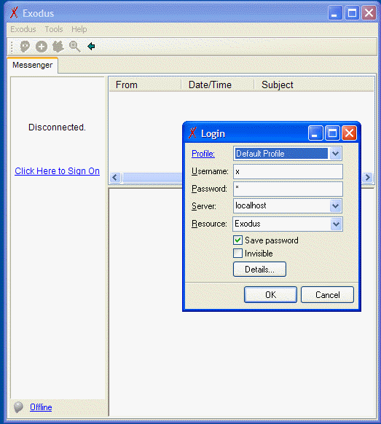
Figure 1 - Login to a GUI client

After logging in, a user can register with the RoboLogger service, as shown in the next series of screen shots:

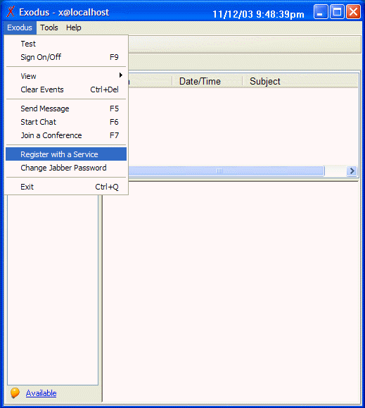
Figure 2 - Registering (1)
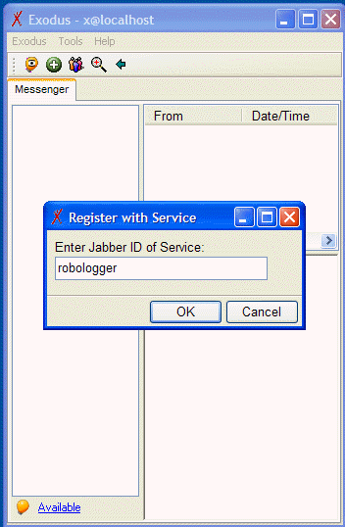
Figure 3 - Registering (2)
A set of 'wizard screens' will pop up and describe the service:
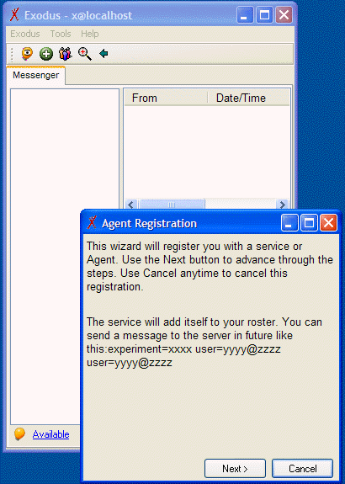
Figure 4 - Registering (3)
The user simply clicks through until the 'Finish' screen shows. The user is acknowledged and added to the service's roster:
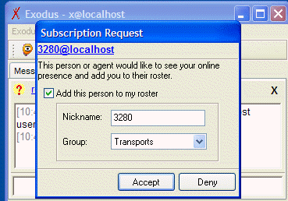
Figure 5 – Acknowledgement

Now the user should chat with the Service whenever a recorded conference is needed:

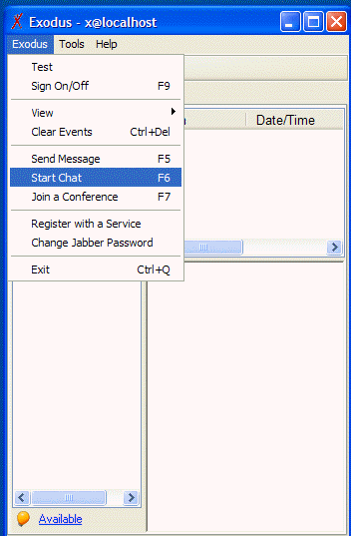
Figure 6 - Starting a chat with the service

The syntax of the instruction to the service is in this strict format:
experiment=<polaris-experiment-id> user=<JID> user=<JID>

as shown in the next exhibit. Order is not important. There should be no spaces between the label, the "=" separator, and the value. The following figure shows this:
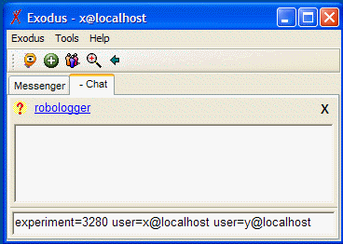
Figure 7 - Commanding a conference setup

As a result of this command being issued to the RoboLogger, a conference (groupchat) room is set up for the specified users and they are invited to the conference, which is virtually hosted by the experiment:

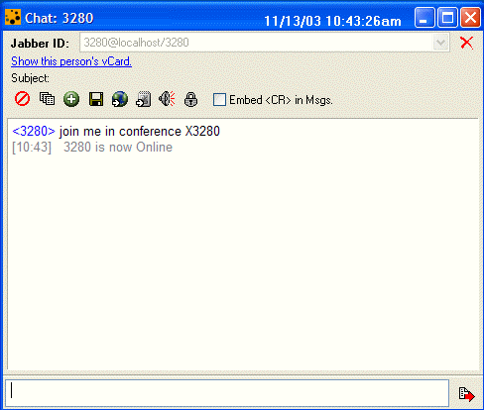
Figure 8 - Registration Result
Finally, the user joins a conference with the other invited experimenters and the experiment:

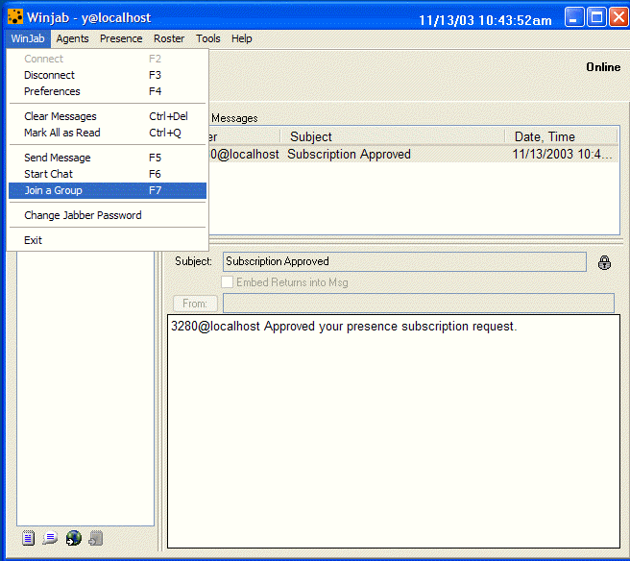
Figure 9 - Joining the conference
Discussion ensues. At any time the experimenters want to record the conversation to the Polaris Observations, they should command 'RECORD', exactly as shown:

