A case study examining the changes in behaviour and spatial selection in Eastern Grey Kangaroos following the introduction of two wallaby species.

### Dajun Wang

**Contents**

Introduction 9

Material and methods 11

Study subjects 11

Data Collection 11

Data analysis 13

Results 17

Enclosure use 17

Behavioural shifts 20

Discussion 23

Conclusion 25

References 27

**List of Figures**

1. The separate zonation of the exhibit; description of zones are described in-text.

Will be requesting section for a cleaner version. 13

1. The Modified Spread of Participation Index (SPI) of Grey Kangaroos (*n* = 6; GKs), Bennett’s wallabies (*n* = 4; BWs) and Swamp wallabies (*n* = 2; SWs) describing spatial use of a mixed-species exhibit in the Singapore Zoo.

Treatment levels are indicated on the x-axis. 18

1. The Electivity Index values (EI; -1 to 1) of resident Ks and introduced BWs and SWs across six separate zones within a mixed-species exhibit. Different shapes are used to represent the different treatments: circles, triangles and squares are used to represent Treatments 1, 2 and 3 respectively. Here, degree of utilisation corresponds to blue and red color; EI values above 0 describes extent of utilisation (i.e., coloured blue) while EI values below 0 describes

extent of under-utilisation (i.e., coloured red). 19

1. The activity budgets of Grey kangaroos (GK), Bennett’s wallabies (BWs) and Swamp wallabies (SWs) as computed across the different treatments (i.e., T1–T3). Treatment 1, 2 and 3 are colored red, green and blue, respectively.

Simultaneous behaviours that occur < 1% across all three treatments were removed (i.e., Dr, N, P, Nso, Pso, O). 20

1. The daily Shannon Index (SI) adapted to examine behavioural diversity in Grey Kangaroos (*n* = 6; GKs), Bennett’s wallabies (*n* = 4; BWs) and Swamp wallabies (*n* = 2; SWs). Here, greater SI values describes a greater diversity in

exhibited behaviour and is usually indicative of better animal welfare. 21

**List of Tables**

1 The ethogram and behavioural key used for examining behaviours in kangaroos

and wallabies 12

# Introduction

Intro goes here

# Material and methods

## Study subjects

The study group consisted of 4.2 Eastern Grey kangaroos (GK), 3.0, Bennett’s wallaby (BW), and 2.0 Swamp Wallaby (SW) living in an environmentally-enriched exhibit at the Singapore Zoo. Like most macropod-themed exhibits, visitors are permitted to walk through the exhibit via a guided trail while feeding and contact with the animals is largely prohibited. Visitorship was not counted in this study, and all individuals were adults with no prior co-habitation exposure. The layout of the exhibit is interspersed with natural foliage and logs (plant types) to provide natural shade and cover while feeding and drinking troughs are fixed in specific areas (see Figure 1).

## Data Collection

As residents of the exhibit, baseline activity and spatial use data were first collected from the GKs for 10 days (2018-12-07 – 2018-12-16) prior to the separate introduction of the BWs and SWs (2018-12-17 and 2019-02-27, respectively); activity and spatial use data were then collected for a period of 10 days after the introduction of each wallaby species. However, due to an unrelated health issue, one SW (‘Mickey’) was removed from the exhibit 7 days post-introduction thus tallying in 25, 15 and 7 days of observational data for the GKs, BWs, and SWs, respectively. As a result, the collected observational data can be grouped into three

Table 1: The ethogram and behavioural key used for examining behaviours in kangaroos and wallabies

|  |  |  |
| --- | --- | --- |
| **Behaviour** | **Key** | **Description** |
| Rest | Re | Sitting or lying with body motionless for at least 30 sec, not moving |
| Vigilance | Vi | Head up, ears pointing upwards. |
| Locomotion | Lo | Moving from point A to point B using any method (pentapedal/bipedal) |
| Drinking | Dr | Water consumption |
| Feeding | Fe | Food consumption; grazing and/or browsing |
| Grooming | Gr | Licking own fur/wiping face with paws |
| Intra-antagonism | N | Negative interaction between same species (Fights, Kicks, Etc) |
| Intra-mutualism | P | Positive interaction between same species |

Negative interaction

Positive interactions

(Grooming, courtship, Etc)

Nso Negative interaction between wallaby and kangaroo (Fights, Kicks, Etc)

Pso Positive interaction between wallaby and kangaroo (elaborate?)

Others O Other behaviours not specified in the ethogram.

Out-of-Sight OOS Observer is unable to see animal

treatments designed to characterise inter-species interaction (if applicable): T1 (i.e., solely GKs), T2 (i.e., GKs and BWs) and T3 (i.e., GKs, BWs, and SWs).

Behavioural observations were done using instantaneous scan sampling method where a single observation consisting of the behaviour and approximate zonal location (see Figure 1 for detail) of each individual was recorded. Here, observations were conducted at an hourly interval over a 10 h period that coincides with the operational hours of the exhibit (0900 – 1800 h). Observations were jotted on paper before being transferred onto an excel file. The descriptions of the recorded behaviours during the observation period are described in Table 1.

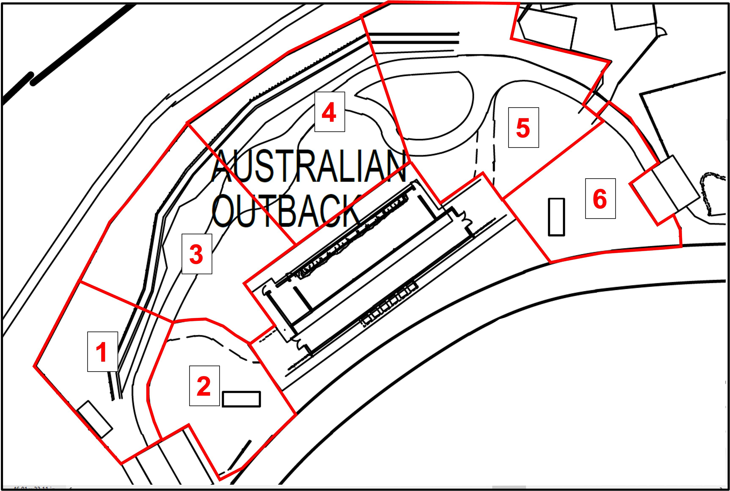

Figure 1: The separate zonation of the exhibit; description of zones are described in-text.

## Data analysis

Due to the presence of unequal zone sizes, the modified spread of participation (SPI) index (first described by Plowman 2003) was used to examine exhibit use across each zone for each species. As per Original SPI, the values for Modified SPI also vary between 0 and 1 where 0 describes near-perfect space-use of the enclosure while 1 describes the inverse (i.e., uneven space-use).

The formula for deriving the SPI index is simply as follows:

*SPI* = *|f*0 *− fe|*

2(

*N − femin*)

Here, *fo* refers to the number of times an animal was observed in a zone, *fe* is the expected frequency for the zone (based on the respective size of each zone), *femin* is the expected frequency in the exhibit’s smallest zone and N refers to the number of observations for the observation period.

As the Modified SPI only provides a single index that characterizes overall exhibit use, an Electivity Index (EI) was also included to describe exhibit use across each identified zone (see Figure 1). Originally conceived for use in ecology (Vanderploeg and Scavia 1979), the EI have been adapted to examine the spatial preference / selection of a broad range of captive animals in exhibits or enclosures under varying degrees of environmental enrichment (see review by Brereton and Fernandez 2021). As such, the inclusion of the EI further elucidates variation or differences in exhibit use following intrinsic (e.g., age) and/or extrinsic (e.g., inclusion of furniture) changes. In its computation, the EI for each identified zone is represented by a value ranging between 1 (indicating sole of the zone) and -1 (indicate no use of the zone) while a value of 0 indicates perfect proportional use of the indicated zone in relation to its size. Much like the modified SPI formula described above, the EI is also designed to overcome the challenges associated with unequal zone sizes (Brereton and Fernandez 2021).

The formula for deriving the EI is simply:

*EI* =

*N*

*N*

*Wi −* 1

*Wi* + 1

*ri*

*Wi* = *pi*

I: *ri*

*pi*

Here, *ri* refers to the observed use of a resource or zone, and *pi* refers to the expected use of a given resource. The letter *N* denotes the total number of zones (*n* = 6; see Figure 1

or resources available to the study species.

To examine the variations and/or shifts in behaviour of each species post-introduction, species- and treatment-specific activity budgets and the Shannon’s Index of Diversity, or Shannon Index, were calculated. Here, the SI is used to examine the diversity of grouped behaviours exhibited by each species and has been applied various other animal-related studies (Menchetti et al. 2019).

The formula for computing the SI is simply:

*B*

*— × ×*

*SI* = *pi ln pi*

*i*=1

where *B* is the number of behaviour types (*n* = *≤* 12; see Table 1) and *pi* is the proportion of behaviour *i*. Greater index values demonstrates a greater diversity in exhibited behaviour and index values increases linearly with number of behaviour types and abundances. As an index, the SD index is relatively accurate and useful indicator of positive welfare (see Miller et al. 2020) and can be used to simply compare between treatments. All analysis were performed with the *dplyr* package (Wickham et al. 2015) within the R environment (version 4.1.2).

# Results

## Enclosure use

Although the space use patterns of kangaroos remained relatively un-affected by the introduction of both wallaby species, the BWs exhibited a significant shift towards uneven space use after the introduction of the SWs (Figure 2). Seemingly, the change in space use patterns exhibited by the BWs resulted in SPI values that were comparable to the newly-introduced SWs.

In general, there is very little change observed in the GKs’ EI values across the different zones of the exhibit except for the significant increase of utilisation in Zone 5 following the introduction of the SWs (Figure 3). On the other hand, the introduction of the SWs incurred remarkable changes in the BWs zonal use of the exhibit. For instance, the use of Zones 1, 5 and 6 exhibited substantial shifts as the utilisation of the aforementioned zones decreased significantly while the use of Zones 2 and 4 increased significantly (Figure 3). Lastly, the SWs exhibited a clear preference for Zone 1 while the EI value for the remaining zones demonstrated a relatively greater degree of under-utilisation.

GK BW SW

0.8

0.6

Daily Modified SPI

0.4

1 2 3 1 2 3 1 2 3

Treatment

Figure 2: The Modified Spread of Participation Index (SPI) of Grey Kangaroos (*n* = 6; GKs), Bennett’s wallabies (*n* = 4; BWs) and Swamp wallabies (*n* = 2; SWs) describing spatial use of a mixed-species exhibit in the Singapore Zoo. Treatment levels are indicated on the x-axis.

BW

0.5

0.0

−0.5

−1.0

SW

0.5

0.0

EI index

−0.5

−1.0

NA

0.5

0.0

−0.5

−1.0

Z1 Z2 Z3 Z4 Z5 Z6

Zone

Figure 3: The Electivity Index values (EI; -1 to 1) of resident Ks and introduced BWs and SWs across six separate zones within a mixed-species exhibit. Different shapes are used to represent the different treatments: circles, triangles and squares are used to represent Treatments 1, 2 and 3 respectively. Here, degree of utilisation corresponds to blue and red color; EI values above 0 describes extent of utilisation (i.e., coloured blue) while EI values below 0 describes extent of under-utilisation (i.e., coloured red).

## Behavioural shifts

In general, all three macropod species were mostly engaged in resting behaviour with feeding following closely (Figure 4). Here, the introduction of the BWs did not incur any significant changes in the behaviour repertoire of the GKs. On the other hand, the introduction of the SWs resulted in a general decrease in locomotive and grooming behaviour in both GKs and BWs; BWs were also observed to rest less and engage in greater feeding and vigilant behaviours (Figure 4).

GK

60

40

20

0

BW

60

40

Proportion [%]

20

0

SW

60

40

20

0

Re Vi

Lo Fe Gr

Behaviours

Figure 4: The activity budgets of Grey kangaroos (GK), Bennett’s wallabies (BWs) and Swamp wallabies (SWs) as computed across the different treatments (i.e., T1–T3). Treatment 1, 2 and 3 are colored red, green and blue, respectively. Simultaneous behaviours that occur

< 1% across all three treatments were removed (i.e., Dr, N, P, Nso, Pso, O).

Although the change in behavioural diversity has been largely insignificant across treatments, there is some evidence to suggest that the introduction of the SWs effected a notable decrease in the behavioural diversity of GKs and BWs (Figure 5). On the other

hand, the transition from T1 to T2 (i.e., introduction of the BWs) observed a small, albeit insignificant, increase in behavioural diversity in the GKs.

GK BW SW

1.00

0.75

SI

0.50

1 2 3 1 2 3 1 2 3

Treatments

Figure 5: The daily Shannon Index (SI) adapted to examine behavioural diversity in Grey Kangaroos (*n* = 6; GKs), Bennett’s wallabies (*n* = 4; BWs) and Swamp wallabies (*n* = 2; SWs). Here, greater SI values describes a greater diversity in exhibited behaviour and is usually indicative of better animal welfare.

# Discussion

Discussion goes here Some food for thought:

* Are there reports of aggression between species?
* Any change in BCS or increase in stress-related health issues?

**Weight loss in Bennett’s Wallabies**

Nelas (BW) reported with weight loss 13.1kg (10/11)-> 12.145kg (28/12), but gained weight again 13.3 (10/2)

Shawn (BW) also lost weight 22kg (10/11) to 21.2kg (10/2) but gained it back eventually.

-Could be attributed to unfamiliarity in new environment and avoidance of feeding zone

-Increase in weight over time could be attributed to habituation or spending more time in feeding area

-not down to open exhibit concept as the BW face more human interaction at Wallaby trail (smaller exhibit, closer to guests)

**Decreased vigilance and increased resting of Bennet’s Wallabies following introduction of Swamp Wallabies**

-Could be independent of introduction of Swamp Wallabies and merely down to habituation to new environment and Kangaroos over time

-Initial vigilance also due to presence of Kangaroos (with few individuals showing aggression initially) and presence of unfamiliar keepers

**Incidences of aggression between species**

-Aggression seen by certain Kangaroos (Hana, Roddy) towards Wallabies following the introduction of the Bennet’s Wallabies; chased by Kangaroos around, but no physical contact

-castration of older male Kangaroos may be a reason for low incidences of aggression shown (the male Roddy which was seen chasing Wallabies was still young and had yet to be castrated yet)

-No interspecific activities noted for Swamp Wallabies as they spent most of their time in the corner zones away from the other species

Space use:

Kangaroos space use patterns unaffected mostly, only change was increased utilization of Zone 5

-> Commonly in 3,4 because it’s nearest to the feeding and watering areas.

BW uneven space use when SW were introduced. After introduction, BW used 1,5,6 less, more in 2,4.

--> initially 1,5,6 because the kangaroos are in 3,4? Are they usually friendly in the wild? Whats the natural behaviour?

--> why the change in enclosure use after introduction of SW? Do wallaby species usually interact in the wild? Doesn’t seem to be able to be in the same zone? Maybe look into group size?

SW only in Z1.

--> possibly due to more shade, further from the crowds, visual barrier from the kangaroos?

Behaviour:

# Conclusion

Conclusion goes here

# References

Brereton, J.E., and Fernandez, E.J. 2021. Which Index Should I Use? A Comparison of Indices for Enclosure Use Studies. : 2021.07.04.451046. Cold Spring Harbor Laboratory. [doi:10.1101/2021.07.04.451046.](https://doi.org/10.1101/2021.07.04.451046)

Menchetti, L., Righi, C., Guelfi, G., Enas, C., Moscati, L., Mancini, S., and Diverio, S. 2019. Multi-Operator Qualitative Behavioural Assessment for dogs entering the shelter. Applied Animal Behaviour Science **213**: 107–116. [doi:10.1016/j.applanim.2019.02.008.](https://doi.org/10.1016/j.applanim.2019.02.008)

Miller, L.J., Vicino, G.A., Sheftel, J., and Lauderdale, L.K. 2020. Behavioral Diver- sity as a Potential Indicator of Positive Animal Welfare. Animals **10**(7): 1211. [doi:10.3390/ani10071211.](https://doi.org/10.3390/ani10071211)

Plowman, A.B. 2003. A note on a modification of the spread of participation index allowing for unequal zones. Applied Animal Behaviour Science **83**(4): 331–336. [doi:10.1016/S0168-](https://doi.org/10.1016/S0168-1591(03)00142-4) [1591(03)00142-4.](https://doi.org/10.1016/S0168-1591(03)00142-4)

Vanderploeg, H.A., and Scavia, D. 1979. Two Electivity Indices for Feeding with Special Reference to Zooplankton Grazing. Journal of the Fisheries Board of Canada. NRC Research Press Ottawa, Canada. [doi:10.1139/f79-055.](https://doi.org/10.1139/f79-055)

Wickham, H., Francois, R., Henry, L., Müller, K., and others. 2015. Dplyr: A grammar of data manipulation. R package version 0.4 **3**: p156.