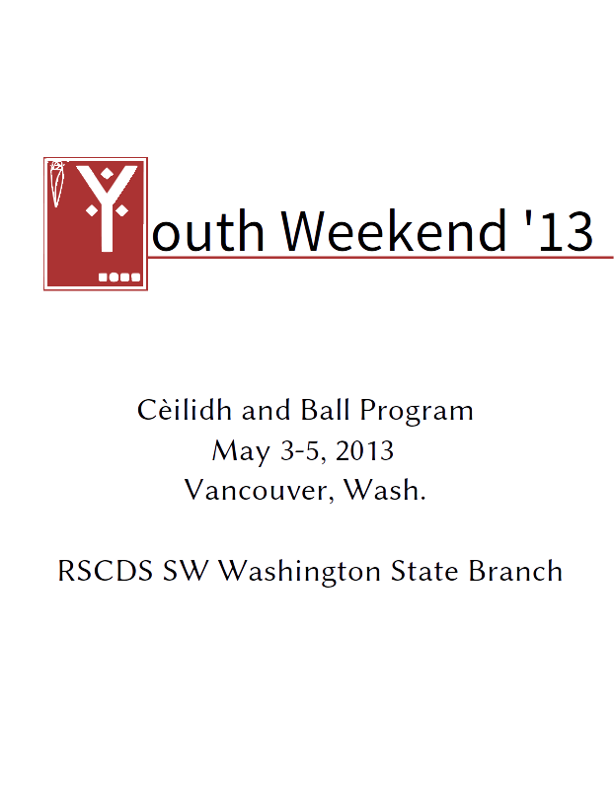
Youth Weekend 2013

Teachers:
Linda Mae Dennis, Lea Maiolo, Kathlleen Mintz

Musicians:
Cynthia Soohoo and Maggie Hannahs

Organizers:
Kathlleen Mintz, Rebecca Mintz, and
Darrick J. Wong
Dance Among the Stars

Musicians:
Lisa Scott, Leslie Hirsch, and
Linda Danielson

Many thanks to the Southwest Washington State RSCDS branch and all of our volunteers for helping us put on Youth Weekend!

See you next year!

Built with LibreOffice, Inkscape, psutils, bash, and make, with Linux.
Fonts: Linux Libertine, Linux Biolinum, and Source Sans Pro.
Copyright © 2012-2013 RSCDS Southwest Washington State Branch.
Source code available at https://github.com/djwong/yww2013

