EE5393HW4

LI DAOQI 5101728 [daoqi001@umn.edu](mailto:daoqi001@umn.edu)

Problem 1

I do question b. See uploaded code. This is a program that generate the truth table corresponding to the conditional permutation written in CKT.txt.

In uploaded code CKT is the circuit corresponding to function

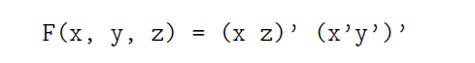

varList =

xzy

TT =

0 1 0 1 0 1 0 1

0 0 1 1 0 0 1 1

0 0 0 0 1 1 1 1

ans =

0 1 0 0 1 1 1 0

TTr =

0 1 0 0 1 1 1 0

TTr is the truth table compute from my program, ans is the truth table compute directly from the function, they are the same, this verify my program works correctly.

Note that the order of x, y, z in TT is not conventional order x, y, z but rather x, z, y, showing in varList. This is the order that variables appear in the circuit.

