ECE6333 Kalman Filter Project

This project is worth 100 points

# Introduction

The goal of this project is to familiarize students with the implementation and evaluation of a discrete-time Kalman filter.

# Discrete Time Model

Suppose we have a particle constrained to the *xy*-plane and define the state of the particle as

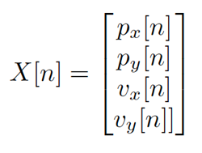

where *px*[*n*] and *py*[*n*] correspond to the *x* and *y* coordinates of the particle on the plane, respectively, and *vx*[*n*] and *vy*[*n*] correspond to the *x* and *y* velocities of the particle on the plane, respectively. The particle’s dynamics are specified by the linear time-invariant state update equation

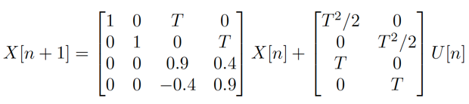

where *U* [*n*] ∼ N (0*, Q*) is the process noise.

Further suppose we can observe the *x, y* position of the particle affected by the measurement noise

*V* [*n*] ∼ N (0*, R*) as

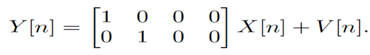

For all parts of this assignment, we will assume *T* = 0*.*1 seconds, *Q* = *I*2, and *R* = 0*.*01 · *I*2 where *I*2 is the

2 × 2 identity matrix.

# Assignment

* 1. Download process noise and measurement noise from the other files. Given a deterministic initial- ization *X*[0] = [1*,* 2*,* 0*,* −1]⊤, generate 51 states and observations (*N* = 50). Compare your results to the .mat file with states and observations from the other files. Your states and observations should match those from the other files exactly (within Matlab precision). This confirms that you are able to correctly generate states and observations, which is a pre-requisite for being able to simulate the Kalman filter.
  2. Now generate your own states and observations with your own process and measurement noises. As- sume an prior on the initial state of *X*[0] ∼ N (*m*[0]*,* Σ[0]) with

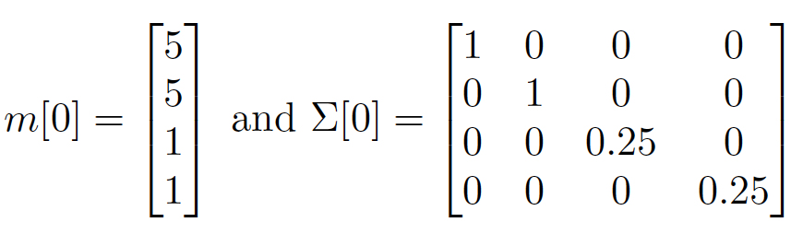

Run a Kalman filter on these observations given the dynamical model parameters and compare the Kalman filter’s *estimates* to the batch MMSE estimator (you will need to write this as well) for *n* = 0*, . . . ,* 10. They should agree. This confirms that you are able to correctly generate MMSE estimates with the Kalman filter, at least for small values of *n*.

* 1. Now set up a loop in which you generate new realizations of the states (including the initial state) and observations and run the Kalman filter. Run this loop 5000 times for *N* = 50. Save the following variables (with dimensions)
     + Process noise realizations U(5000,2,50).
     + Measurement noise realizations V(5000,2,51).
     + States X(5000,4,51).
     + Observations Y(5000,2,51).
     + State estimates Xhat_k_k(5000,4,51).
     + State predictions Xhat_kplus1_k(5000,4,51).

to a .mat file. You should compute the mean squared errors for all four state predictions and all four state estimates from the 5000 iterations. Plot these MSEs as a function of the sample index and compare your results to the error covariance matrices and the steady state predictions. They should closely agree.

* 1. Submit the following to the instructor via email prior to the due date:
     + Your final Matlab code. It should be well commented and should have your name in the header. If you wrote any custom functions, they should also be included. The instructor should be able to run your code directly without errors.
     + Your .mat file from step 3. The variables must be named correctly and have the correct dimensions.
     + A one-page (single-sided) report in pdf format explaining your code and the main results. Your font size must not be smaller than 10 point. Please just focus on any special aspects of your code and provide at least one plot of the MSE performance of your Kalman filter.