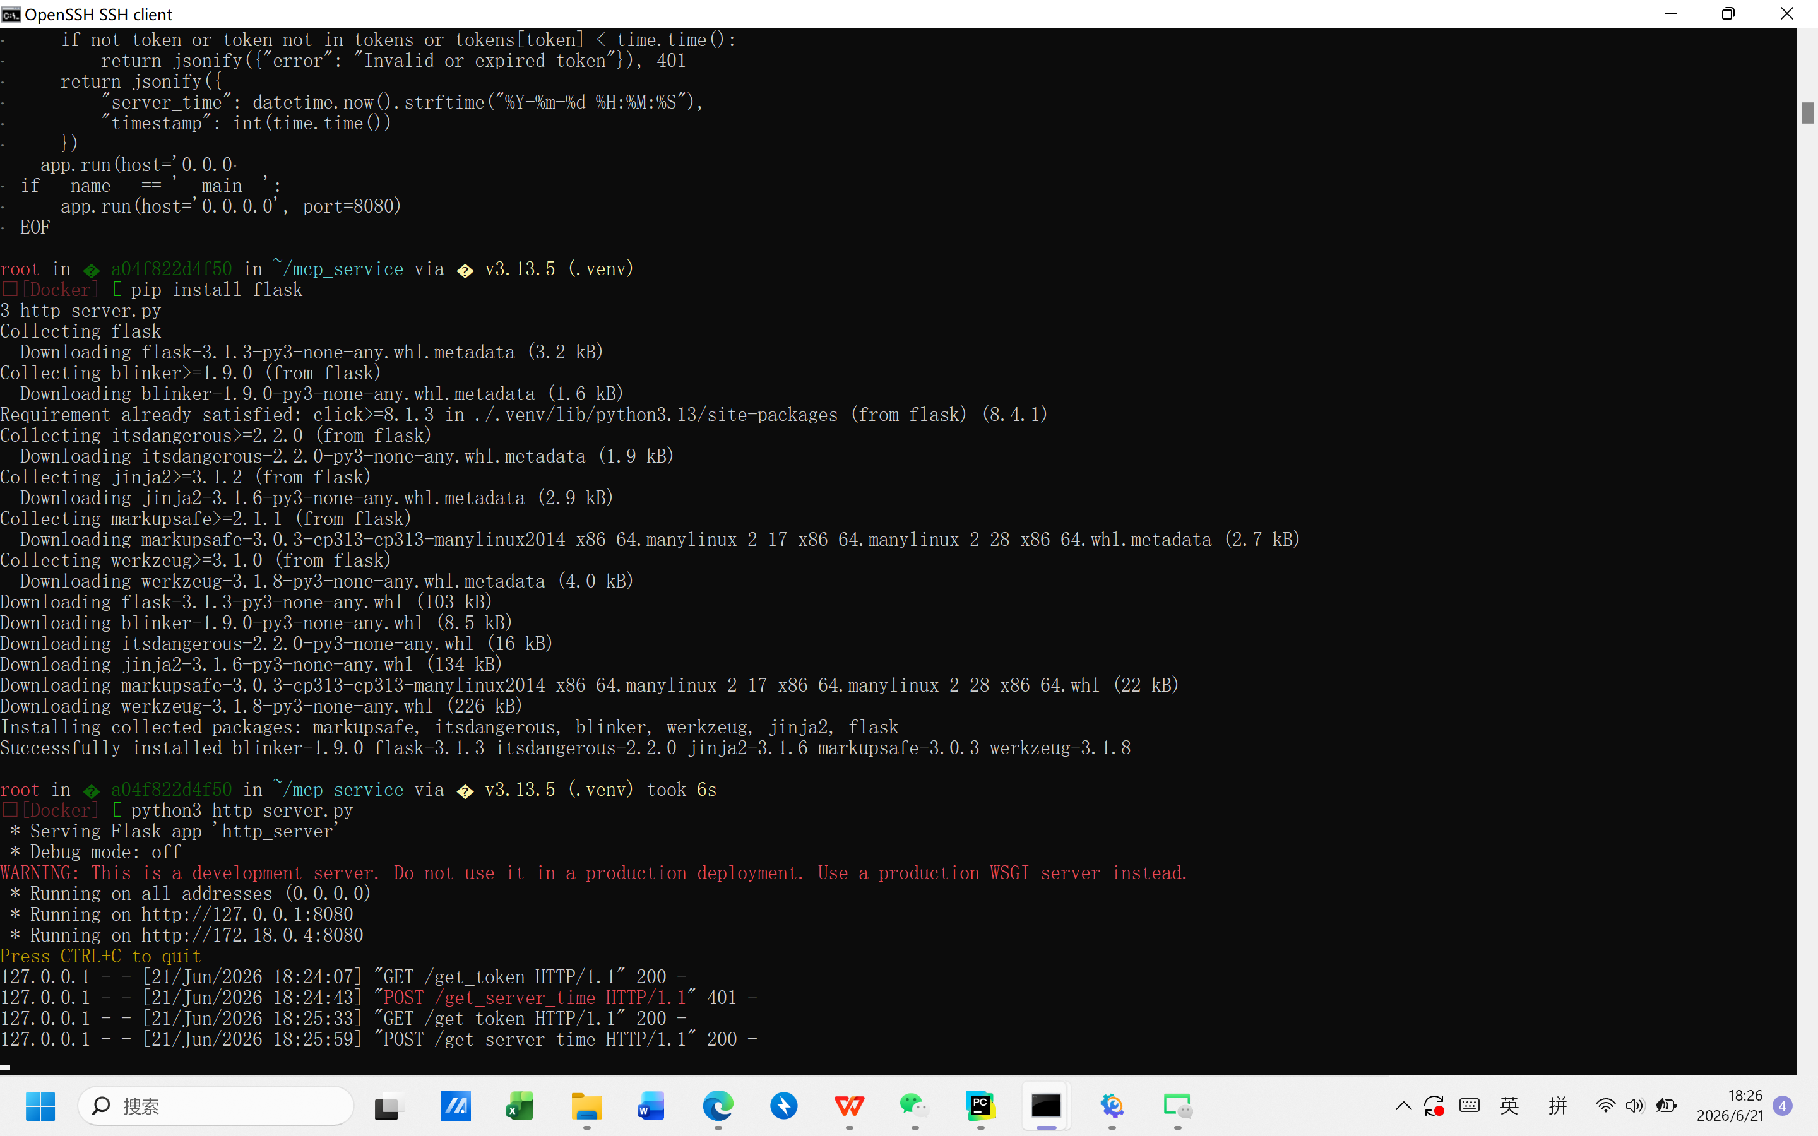
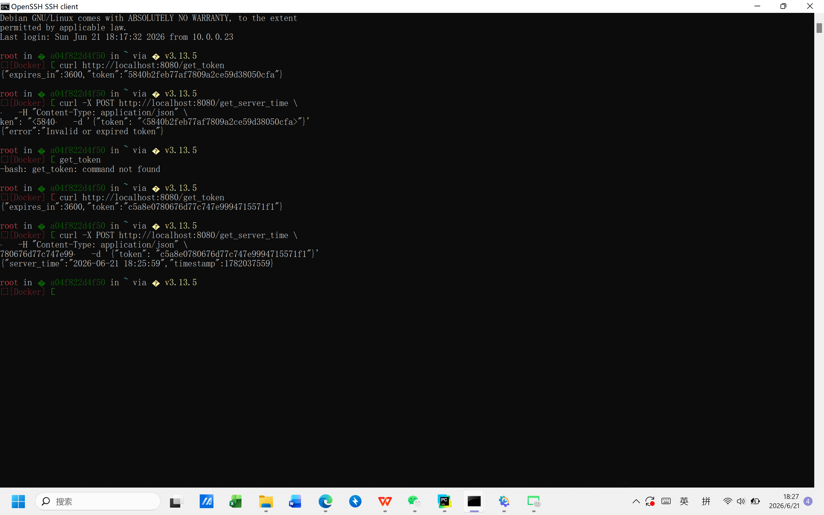
代码：
from flask import Flask, request, jsonify
import time
import secrets
from datetime import datetime

app = Flask(__name__)
tokens = {}

@app.route('/get_token', methods=['GET'])
def get_token():
token = secrets.token_hex(16)
tokens[token] = time.time() + 3600
return jsonify({"token": token, "expires_in": 3600})

@app.route('/get_server_time', methods=['POST'])
def get_server_time():
data = request.get_json()
token = data.get('token') if data else None
if not token or token not in tokens or tokens[token] < time.time():
return jsonify({"error": "Invalid or expired token"}), 401
return jsonify({
"server_time": datetime.now().strftime("%Y-%m-%d %H:%M:%S"),
"timestamp": int(time.time())
})

if __name__ == '__main__':
app.run(host='0.0.0.0', port=8080)

