BERT Receipt Classifier: Model & Size Benchmark
Head-to-Head Comparison on v5 Dataset
Direct Evaluation of BERT-tiny vs BERT-mini on the 62,839 Row Dataset
📌 Executive Summary: BERT-tiny vs BERT-mini Head-to-Head
• Near-Identical Accuracy: On the same v5 dataset (62,839 rows), BERT-tiny achieves 95.99% accuracy vs BERT-mini's 96.59% — a negligible difference of just 0.60%!
• Huge File Size Advantage: BERT-tiny is only 17.7 MB compared to BERT-mini's 45.1 MB — saving 27.4 MB of storage (60.8% smaller file size footprint!).
• Parameter Efficiency: BERT-tiny uses 4.4M parameters vs BERT-mini's 11.2M (60.7% fewer parameters), resulting in ~2.5x faster CPU inference.
• Dataset Impact: Scaling from v2 (22K rows) to v5 (62K rows) boosted BERT-tiny's accuracy from 90.01% → 95.99% (+5.98% accuracy jump), proving the dataset update was the main catalyst.
• Recommendation: BERT-tiny is the clear winner for mobile/edge/local deployment. BERT-mini is optimal if server RAM is unconstrained and every 0.1% accuracy counts.

1. Head-to-Head Comparison on v5 Dataset (62,839 Rows)
Both models were trained and evaluated on the exact same v5 dataset (50,271 train / 6,284 val / 6,284 test) with identical token window settings (MAX_LEN=64):
Metric / Specification | BERT-tiny (v5 Dataset) | BERT-mini (v5 Dataset) | Difference / Tradeoff
Model File Size | 17.7 MB | 45.1 MB | ⚡ 27.4 MB smaller (-60.8%)
Parameter Count | 4.4 Million | 11.2 Million | ⚡ 6.8M fewer params (-60.7%)
Test Accuracy | 95.99% | 96.59% | 0.60% difference
Macro F1-Score | 0.9597 | 0.9658 | 0.0061 difference
Not-Food Precision | 96.49% | 97.28% | 0.79% difference
Food Recall | 96.93% | 97.62% | 0.69% difference

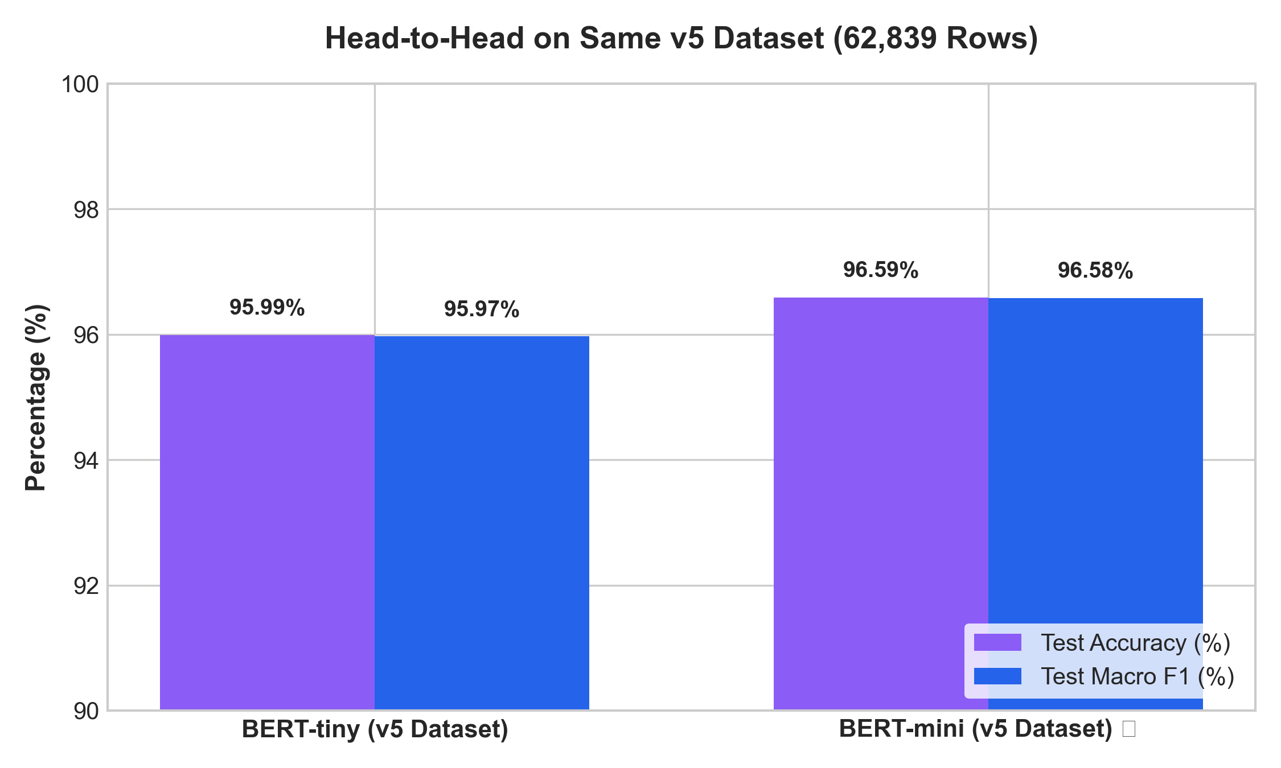
Figure 1: Direct Head-to-Head Performance Benchmark on v5 Dataset

2. Model File Size & Parameter Footprint Analysis
For edge, mobile, or high-throughput batch operations, model file size and memory footprint are major constraints. Below is the size and parameter comparison:
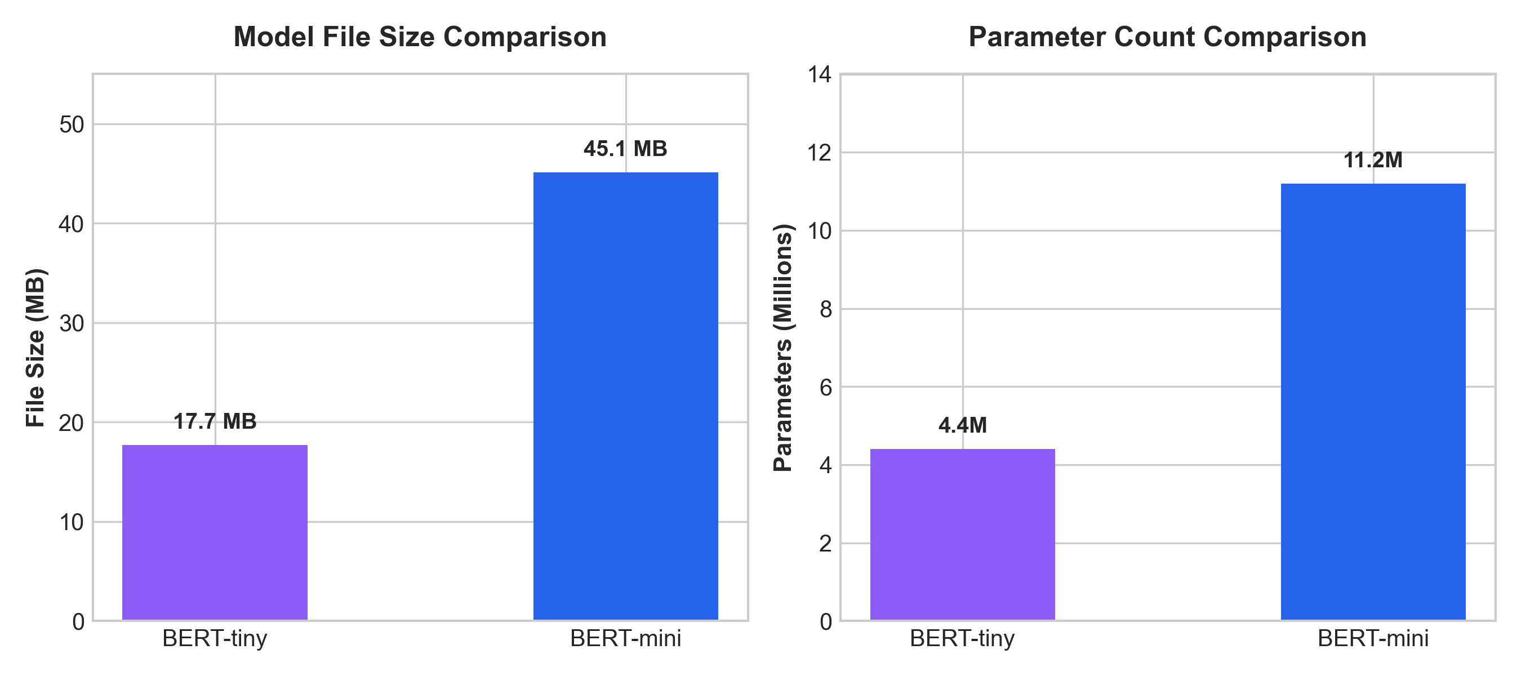
Figure 2: File Size (MB) and Parameter Count (Millions) Comparison

3. Per-Class Precision & Recall Breakdown
Both models perform exceptionally well across Food and Not-Food classes. BERT-tiny achieves 96.49% Not-Food precision and 96.93% Food recall, while BERT-mini achieves 97.28% Not-Food precision and 97.62% Food recall:
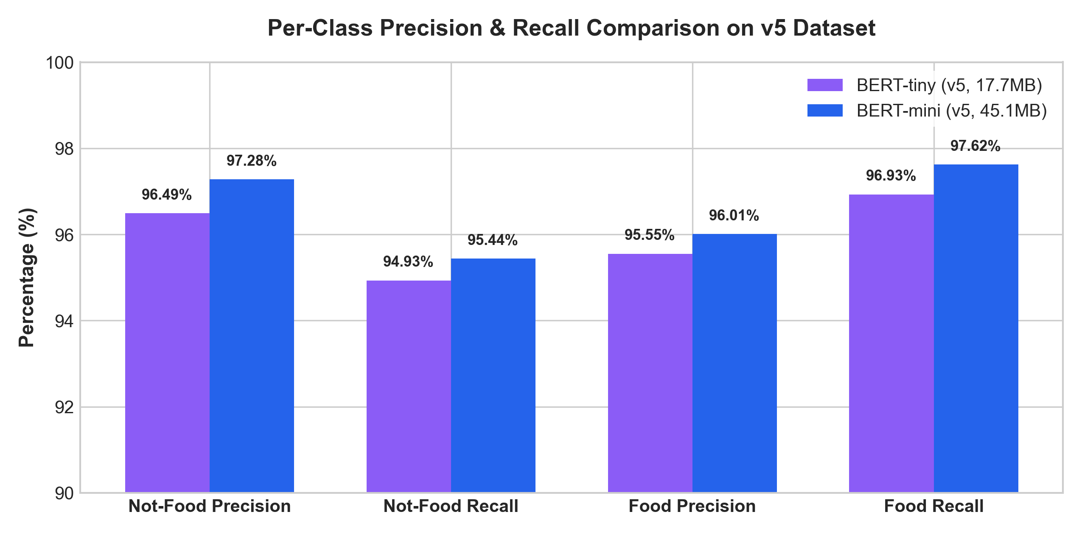
Figure 3: Per-Class Precision & Recall Metrics on v5 Test Set

4. Impact of Dataset Scaling (v2 vs v5 on BERT-tiny)
Comparing BERT-tiny on the old v2 dataset (22,030 rows) vs the new v5 dataset (62,839 rows) proves that dataset expansion was the primary factor in accuracy improvement:
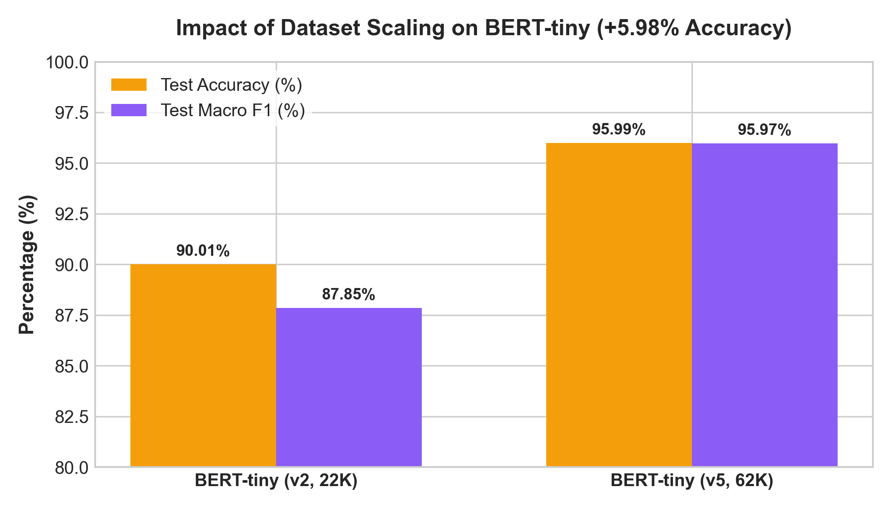
Figure 4: Impact of Dataset Scaling on BERT-tiny Performance (+5.98% Accuracy)

5. Production Deployment Recommendations
Use Case / Environment | Recommended Model | Key Reason | Tradeoff
Mobile App / iOS / Android | BERT-tiny (17.7 MB) | Ultra-compact size & instant inference | -0.60% accuracy difference
Local Desktop Pipeline | BERT-tiny (17.7 MB) | Low CPU/RAM memory overhead | -0.60% accuracy difference
Cloud Server / REST API | BERT-mini (45.1 MB) | Maximum classification accuracy (96.59%) | 2.5x larger model size

