**Pools and Water parks for sale!**

*You know how it is.. You need a professional looking VRML aqua park parts that wouldn’t just represent your intention well, but you also want it to be sense-fully structured. Not to mention pretty animations too. Well, look no further, because we have a solution for you.*

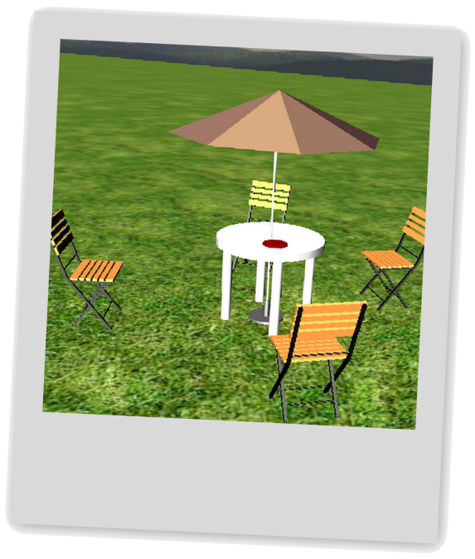

Are you used to the comfort of the real world? Then there’s no need to compromise in virtual reality. Our models will provide sufficient number of seats and a table to place objects on. Last but not least there’s a folding parasol which will shield you from harmful sunrays.

As in case of all our models, this set is equipped with custom light source activated by avatar’s proximity. And the best thing is: Tidying up is just as easy as use. Chairs can be folded and leaned against the table. It like one click away!

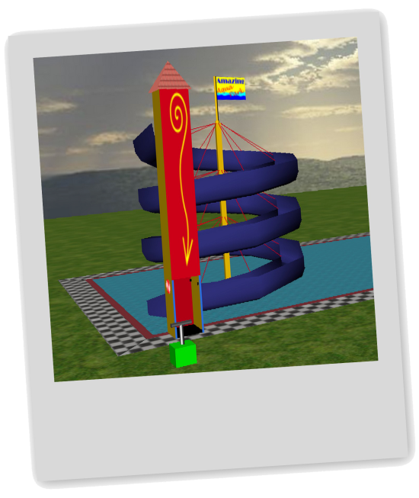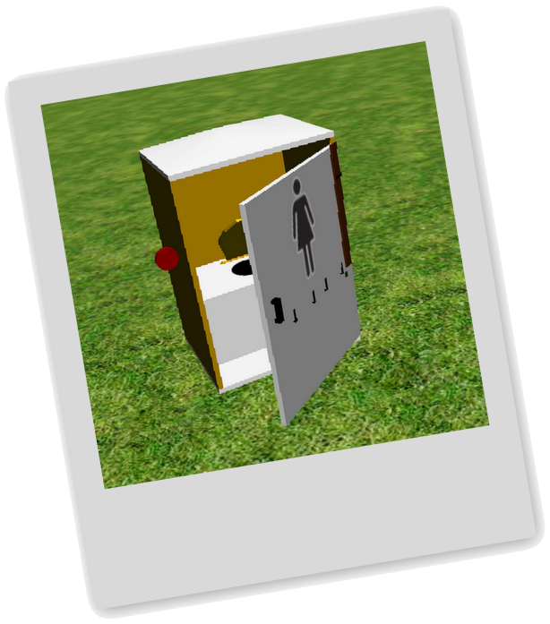

What kind of a water park would it be without a proper attraction? Of course we’ve got one - twenty-eight-feet-tall monumental water slide that everybody loves. A color-changing elevator, a free shaped roof and a flag fluttering in the wind (or along our visitor’s wishes) – it’s simply perfect

You can easily tell if the toboggan is running – there’s a stylish candy-caned circle decoration for that. No matter whether you’re going to stop or resume it, the detonation box does the job. As a cherry on top comes the possibility of customizing the front texture of the tower.

Let’s not beat around the bush. Even in a virtual reality there has to be place to “rest”. That’s why we offer our first-class state-of-the-art ToiToi Restrooms. Thanks to interchangeable door textures, avatars can use the right restroom just for her or him.

Safety is guaranteed: Every Restroom has a latch built-in. Don’t worry that it squeaks and looks kind of rustic, it locks properly. And if you happen to feel alone and isolated from the outside world, there’s no need to panic. Turn your look upwards and you will see either an azure sky with silver clouding or shinning stars of a summer night.