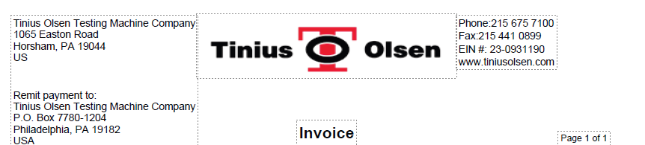
Header section need to be fixed if region or territory is crm.territory.name as territory_name= R1,R2,R3,R5)
When region is crm.territory.name as territory_name=R4 then
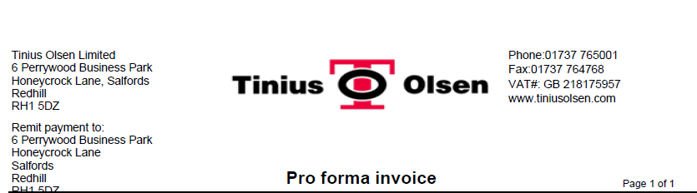
Change Invoice with Proforma Invoice
Page number should be printed as present in header in same format based on number of pages.

Date should be the date on which proforma invoice is send or createdon
Add TO Ref as label it should conca two fields as crm.msdyn_workorder. msdyn_name/ crm.msdyn_workorder. cf_axserviceorderid
PO should be crm.msdyn_workorder .cf_ponumber,
Invoice number – need to decide
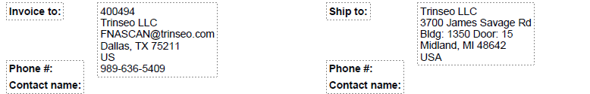
Invoice to- concat (if Region is crm.territory.name as territory_name= R1,R2,R3 or R5- then crm.account.cf_accountnumberus as account_cf_accountnumberus and if R4 - crm.territory.name as territory_name=R4 then crm.account.cf_accountnumberuk as account_cf_accountnumberuk, and name & address as crm.account.name as account_name,
crm.account.address1_line1 as account_address1_line1,
crm.account.address1_line2 as account_address1_line2,
crm.account.address1_line3 as account_address1_line3,
crm.account.emailaddress1 as account_emailaddress1,
crm.account.address1_city as account_address1_city,
crm.account.address1_stateorprovince as account_address1_stateorprovince,
crm.account.address1_postalcode as account_address1_postalcode,
crm.account.address1_country as account_address1_country,
Phone- crm.contact.telephone1 as contact_telephone1,
Contact name- crm.contact.fullname as contact_fullname
Delivery address as
msdyn_addressname as delivery_addressname,
msdyn_address1 as delivery_address1,
msdyn_address2 as delivery_address2,
msdyn_address3 as delivery_address3,
msdyn_city as delivery_city,
msdyn_stateorprovince as delivery_stateorprovince,
msdyn_postalcode as delivery_postalcode,
msdyn_country as delivery_country,
msdyn_phonenumber as delivery_phonenumber,

Line details
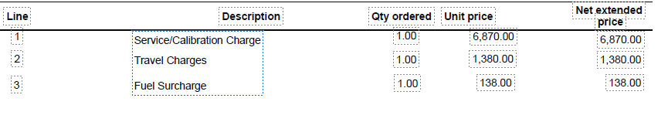
Line details will be pulled from crm.fees and crm.msdyn_workorderproduct
From crm.fees qty orderd should be always 1, description will be crm.fees. cf_projectcategoryname, unit price and net extended will be crm.fees. msdyn_unitcost

For crm.msdyn_workorderproduct
Description- crm.msdyn_workorderproduct. msdyn_productname
Qty ordered- crm.msdyn_workorderproduct. msdyn_quantity
Unit price- crm.msdyn_workorderproduct. msdyn_unitamount
Net extended price- crm.msdyn_workorderproduct. msdyn_totalamount
if crm.territory.name as territory_name= R1,R2,R3,R5, then
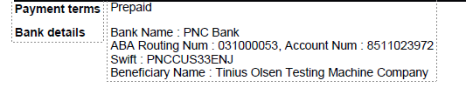
Also keep below section as footer
When Region is crm.territory.name as territory_name= R4
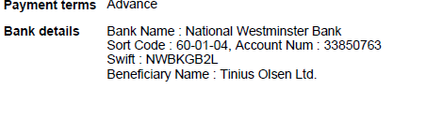
Total Section
if crm.territory.name as territory_name= R1,R2,R3,R5, then
keep amount with $ and if if crm.territory.name as territory_name= R4, then £

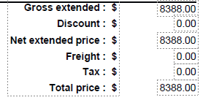
Calculation-
Gross extended : total of unit price*qty ordered
Discount : - always zero
Net extended price : - sum of net extended price
Freight : - if any added on order
Tax : - if line is taxable(When Region is crm.territory.name as territory_name= R4
and crm.account.address1_country as account_address1_country=GB then tax will be 23 % of net extended price)
Total price : $- sum of Net Extended+Freight+Tax

Queries for different tables
Workorder
-------------------------
SELECT msdyn_workorderid,
msdyn_name,

msdyn_serviceaccount,
msdyn_billingaccount,

cf_axsalesorder,
cf_axserviceorderid,

cf_companystructure,
cf_contactperson,
cf_ponumber,

cf_servicelocation,
msdyn_addressname,
msdyn_address1,
msdyn_address2,
msdyn_address3,
msdyn_city,
msdyn_stateorprovince,
msdyn_postalcode,
msdyn_country,
msdyn_phonenumber,

msdyn_serviceterritory,

ownerid,
transactioncurrencyid,
createdon,
modifiedon,

FROM crm.workorder
where cf_axserviceorderid='SV378702';
--------------------------------------------------------------------
Parts
--------------------
SELECT

msdyn_workorder,
msdyn_workordername,
msdyn_workorderproductid,

msdyn_lineorder,
msdyn_product,
msdyn_productname,

msdyn_pricelistname,
msdyn_unitname,
msdyn_unitamount,

msdyn_quantity,

msdyn_totalamount,

ownerid,

owneridname,
msdyn_taxable,
owningbusinessunit,
owningbusinessunitname,

transactioncurrencyid,
transactioncurrencyidname

FROM crm.msdyn_workorderproduct
where msdyn_workorder='8bec21c3-11a2-f111-b8db-00224806d136';
---------------------------------------
Product
---------------------

SELECT productid,
cf_itemnumber,
name,
cf_companystructure

FROM crm.product
where productid='6ee98eb1-4201-e611-80e0-c4346bac29f8';

-------------------------------------------------------------------------
Fee line
-----------------SELECT
msdyn_workorder,
cf_projectcategorylistname,
cf_projectcategoryname,

createdon,
msdyn_unitname,
msdyn_unitcost,

msdyn_additionalcost,
msdyn_additionalcost_base,

msdyn_commissioncosts,
msdyn_commissioncosts_base,

msdyn_duration,
msdyn_durationtobill,

msdyn_lineorder,

msdyn_pricelistname,

msdyn_taxable,

ownerid,

owneridname

FROM crm.fees
where msdyn_workorder='8bec21c3-11a2-f111-b8db-00224806d136';
--------------------------------------------------------
join crm.account ON account.accountid = workorder.msdyn_billingaccount
account
-----------------------------

SELECT accountid,
name,
cf_accountnumberuk,
cf_accountnumberus,
telephone1,
address1_line1,
address1_line2,
address1_line3,
emailaddress1,
address1_city,
address1_stateorprovince,
address1_postalcode,
address1_country,

cf_accountnumbercn,
cf_accountnumberin,

cf_administrationstoppedcn,
cf_administrationstoppedin,

ownerid,
transactioncurrencyid,
primarycontactid,
statecode,
statuscode

FROM crm.account
where accountid='d99729a6-a483-de11-90d1-001a64c8b160';

-------------------------

SELECT

msdyn_workorder,
msdyn_workordername,
msdyn_workorderproductid,

msdyn_lineorder,
msdyn_product,
msdyn_productname,

msdyn_pricelistname,
msdyn_unitname,
msdyn_unitamount,

msdyn_quantity,

msdyn_totalamount,

ownerid,

owneridname,
crm.msdyn_workorderproduct.msdyn_taxable as line_taxable,
owningbusinessunit,
owningbusinessunitname,

crm.msdyn_workorderproduct.transactioncurrencyid as line_transactioncurrencyid,
crm.msdyn_workorderproduct.transactioncurrencyidname as line_transactioncurrencyidname,
crm.product.name as product_name,
crm.product.cf_itemnumber as product_itemnumber

FROM crm.msdyn_workorderproduct
join crm.product on crm.msdyn_workorderproduct.msdyn_product=crm.product.productid

where msdyn_workorder='8bec21c3-11a2-f111-b8db-00224806d136';

---------------------------------------------------------------------------
Proposal Invoice header
SELECT msdyn_workorderid,
msdyn_name,

msdyn_serviceaccount,
msdyn_billingaccount,

cf_axsalesorder,
cf_axserviceorderid,

cf_companystructure,
cf_contactperson,
cf_ponumber,

cf_servicelocation,
msdyn_addressname as delivery_addressname,
msdyn_address1 as delivery_address1,
msdyn_address2 as delivery_address2,
msdyn_address3 as delivery_address3,
msdyn_city as delivery_city,
msdyn_stateorprovince as delivery_stateorprovince,
msdyn_postalcode as delivery_postalcode,
msdyn_country as delivery_country,
msdyn_phonenumber as delivery_phonenumber,

msdyn_serviceterritory,

crm.workorder.ownerid as workorder_ownerid,
crm.workorder.transactioncurrencyid as workorder_transactioncurrencyid,
crm.workorder.createdon as workorder_createdon,
crm.workorder.modifiedon as workorder_modifiedon,
crm.account.name as account_name,
crm.account.cf_accountnumberuk as account_cf_accountnumberuk,
crm.account.cf_accountnumberus as account_cf_accountnumberus,
crm.account.telephone1 as account_telephone1,
crm.account.address1_line1 as account_address1_line1,
crm.account.address1_line2 as account_address1_line2,
crm.account.address1_line3 as account_address1_line3,
crm.account.emailaddress1 as account_emailaddress1,
crm.account.address1_city as account_address1_city,
crm.account.address1_stateorprovince as account_address1_stateorprovince,
crm.account.address1_postalcode as account_address1_postalcode,
crm.account.address1_country as account_address1_country,
crm.contact.fullname as contact_fullname,
crm.contact.emailaddress1 as contact_emailaddress1,
crm.contact.telephone1 as contact_telephone1,
cf_servicelocation.cf_name as cf_servicelocation_cf_name,
crm.territory.name as territory_name,
crm.cf_company.cf_name as cf_company_cf_name
FROM crm.workorder
join crm.account ON account.accountid = workorder.msdyn_billingaccount
join crm.cf_servicelocation ON crm.cf_servicelocation.cf_servicelocationid = workorder.cf_servicelocation
join crm.contact ON contact.contactid = workorder.cf_contactperson
join crm.territory ON territory.territoryid = workorder.msdyn_serviceterritory
join crm.cf_company ON crm.cf_company.cf_companyid = workorder.cf_companystructure
where cf_axserviceorderid='SV378702';

or can use

proposal header
SELECT workorderid,
workordernumber,
serviceaccount,
billingaccount,
salesordernumber,
serviceordernumber,
companystructure,
contactperson,
ponumber,
servicelocation,
delivery_addressname,
delivery_address1,
delivery_address2,
delivery_address3,
delivery_city,
delivery_stateorprovince,
delivery_postalcode,
delivery_country,
delivery_phonenumber,
serviceterritory,
workorder_ownerid,
workorder_transactioncurrencyid,
workorder_createdon,
workorder_modifiedon,
account_name,
account_cf_accountnumberuk,
account_cf_accountnumberus,
customeraccount,
currency,
account_telephone1,
account_address1_line1,
account_address1_line2,
account_address1_line3,
account_emailaddress1,
account_address1_city,
account_address1_stateorprovince,
account_address1_postalcode,
account_address1_country,
contact_fullname,
contact_emailaddress1,
contact_telephone1,
servicelocation_name,
territory_name,
company_name,
company_address,
remit_to,
company_phone,
company_fax,
company_vat_ein,
company_url
FROM crm.proposalheader

proposal line

SELECT workorderid,
workordernumber,
serviceordernumber,
linenumber,
linetype,
sourcelinenumber,
sourcerecordid,
description,
uom,
qty_orderd,
unitamount,
netamount
FROM crm.proposalline

