NAANMUDHALVANPROJECT

**CookBook-YourVirtualKitchenAssistant**

1Introduction

Project Title: Cook Book Teamid:NM2025TMID48441

TeamleaderName:M. DINESH

Team Members:

1. SHAHIDH.S-Demovideomaking

2.HAISH.V-CodeDeveloper

3.DHARSHAN.K-Document

4.THARUNKUMAR.M-UPLOD

2.ProjectOverview

Purpose:

SmartCookisaReact.js-basedonlinecookbookapplicationthatallowsuserstobrowse, save, and share recipes. It aims to make cooking easier by providing detailed recipes, step-by-step instructions, and personalized recommendations.

Features:

* Browserecipesbycategory,cuisine,oringredients
* Savefavoriterecipestopersonalprofile
* Addandedituser-submittedrecipes
* ResponsiveUIformobileanddesktop

# Architecture

ComponentStructure:

* + Header(navigationbar)
  + RecipeList(listofrecipes)
  + RecipeDetail(individualrecipepage)
  + Favorites(user’ssavedrecipes)
  + AddRecipeForm(formtoaddnewrecipes)
  + Footer

StateManagement:

UsingReactContextAPItomanageglobalstateforrecipesanduserfavorites.

Routing:

ReactRouterv6handlesnavigationbetweenHome,RecipeDetail,Favorites,andAddRecipe pages.

# SetupInstructions

Prerequisites:

* Node.js
* MongoDB
* Git
* React.js
* Express.js–Mongoose–VisualStudioCode Installation Steps

1.ClonetheRepository

# FolderStructure

Client:

/src

/components Header.js RecipeList.js RecipeDetail.js AddRecipeForm.js

/pages Home.js Favorites.js

/context RecipesContext.js

/assets images/

Utilities:

* api.jsforfetchingrecipesfromAPI
* helpers.jsforcommonformattingfunctions

# RunningtheApplication

Frontend:cdclient npm start

Backend:cd server npm start Access:[http://localhost:3000](http://localhost:3000/)

# ComponentDocumentation

KeyComponents:

* + RecipeList:DisplaysrecipecardsfetchedfromAPI.Props:recipes[].
  + RecipeDetail:Showsfullrecipedetails.Props:recipeId.

ReusableComponents:

* + RecipeCard–usedinRecipeListandFavorites.
  + Button–styledbuttoncomponentusedthroughouttheapp.

# StateManagement

GlobalState:

ManagedbyRecipesContextforrecipes,favorites,anduserloginstatus.

LocalState:

ForminputstatesmanagedinsideAddRecipeForm.

# UserInterface

IncludescreenshotsorGIFsof:

* + Homepageshowingrecipes
  + Recipedetailpage
  + Addingarecipe

# Styling

CSSFrameworks/Libraries:

TailwindCSSforstyling;StyledComponentsforscopedstyles.

Theming:

Darkandlightmodetoggleimplementedviacontext.

# Testing

TestingStrategy:

Jest+ReactTestingLibraryforunitandintegrationtests.

CodeCoverage:

Usingjest--coveragetoensure80%+coverage.

# ScreenshotsorDemo

Addactualscreenshotsorademolink:

* + DemoLink:https://smartcook-demo.netlify.app

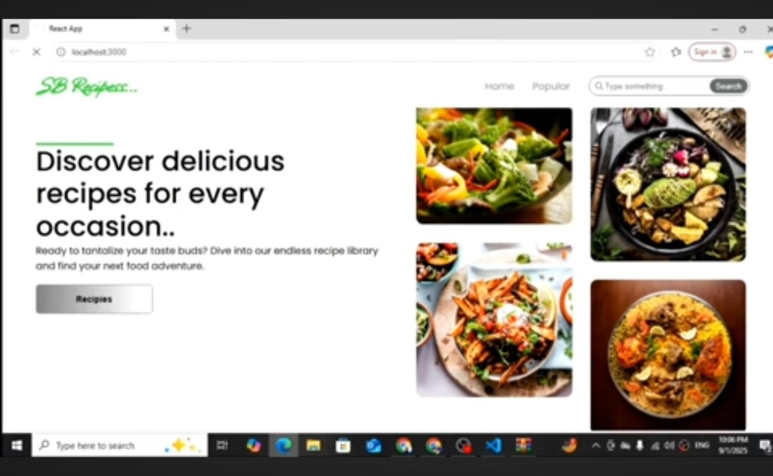

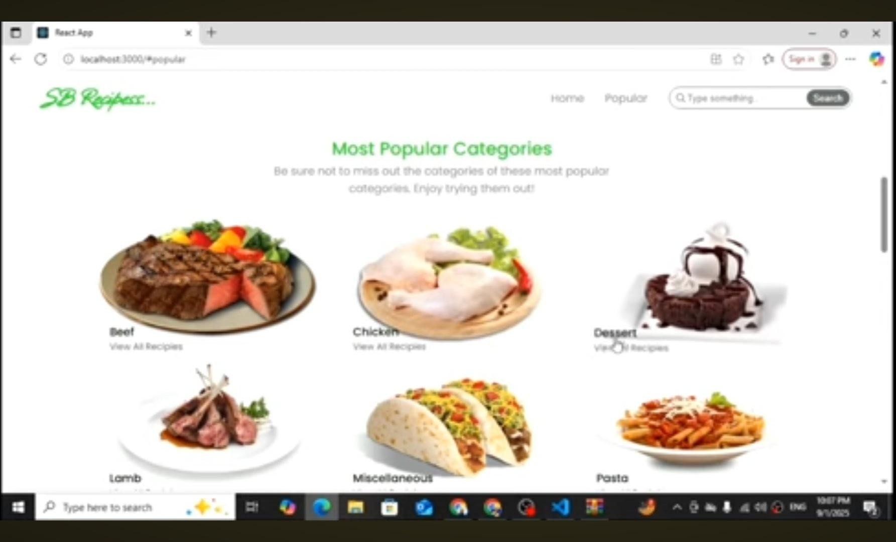

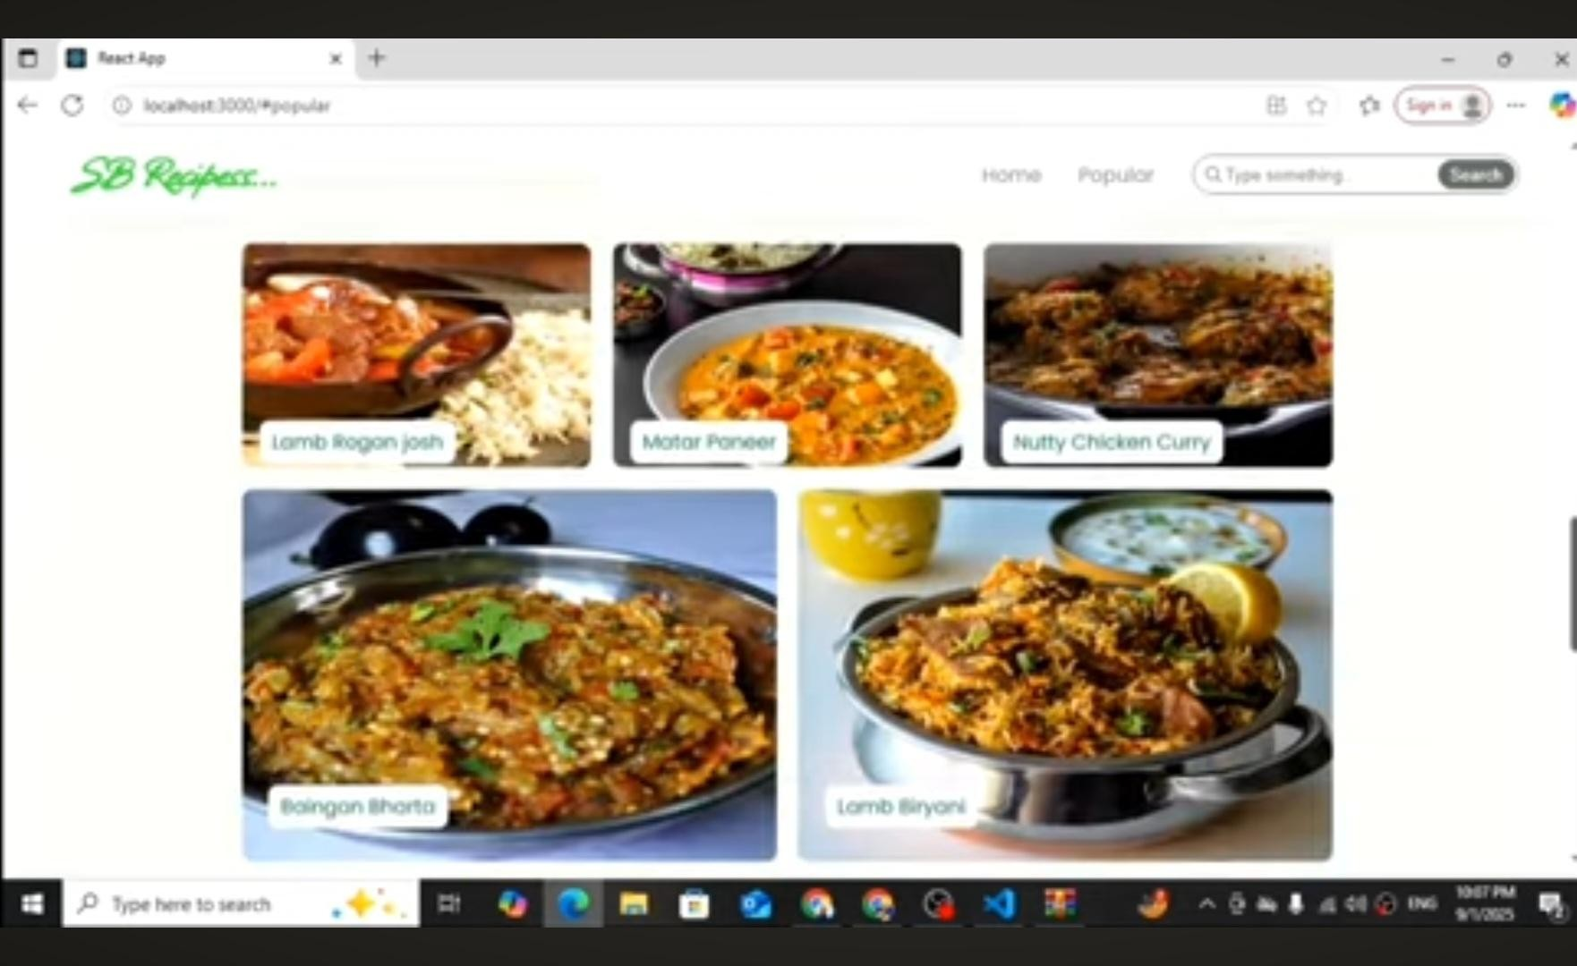

# KnownIssues

Searchfilteringmaybeslowwithverylargerecipelists. Image upload sometimes fails on slow networks.

# FutureEnhancements

Addshoppinglistgenerationfromrecipeingredients Introduce push notifications for new recipes

Offlinemodeforsavedrecipes