tcmpdump_step

**1. Capture Packets from Specific Interface**

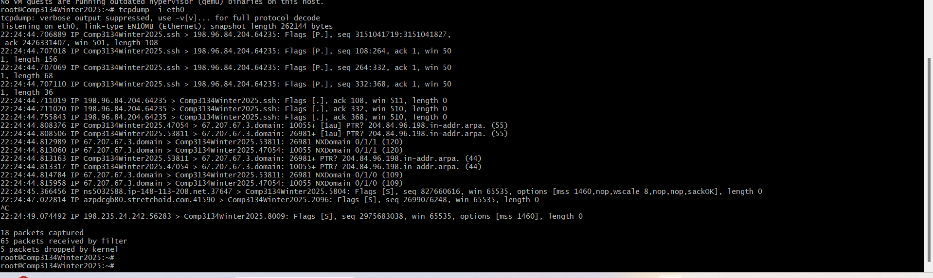

2. Capture Only N Number of Packets

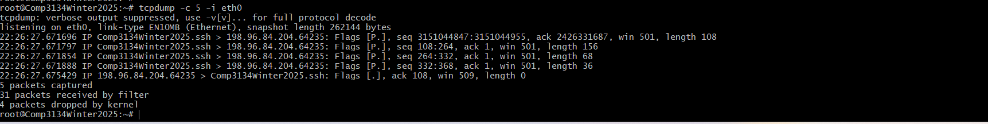

**3. Print Captured Packets in ASCII**

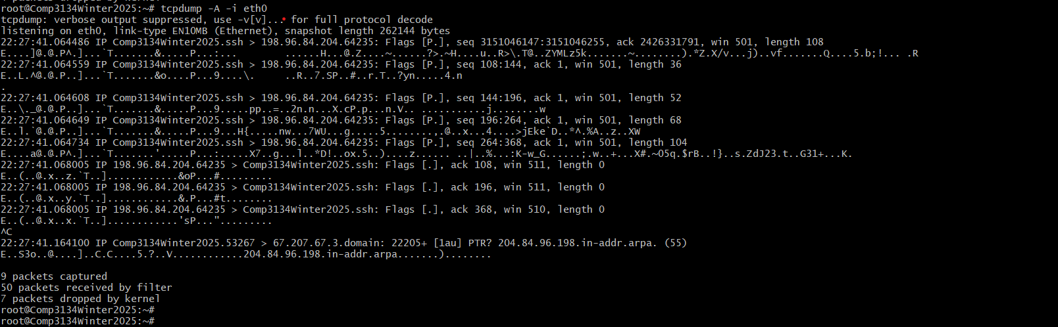

**4. Display Available Interfaces**

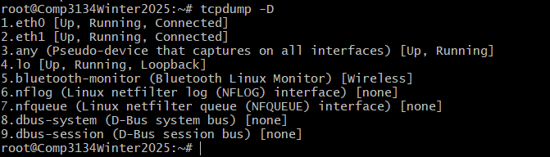

**5. Display Captured Packets in HEX and ASCII**

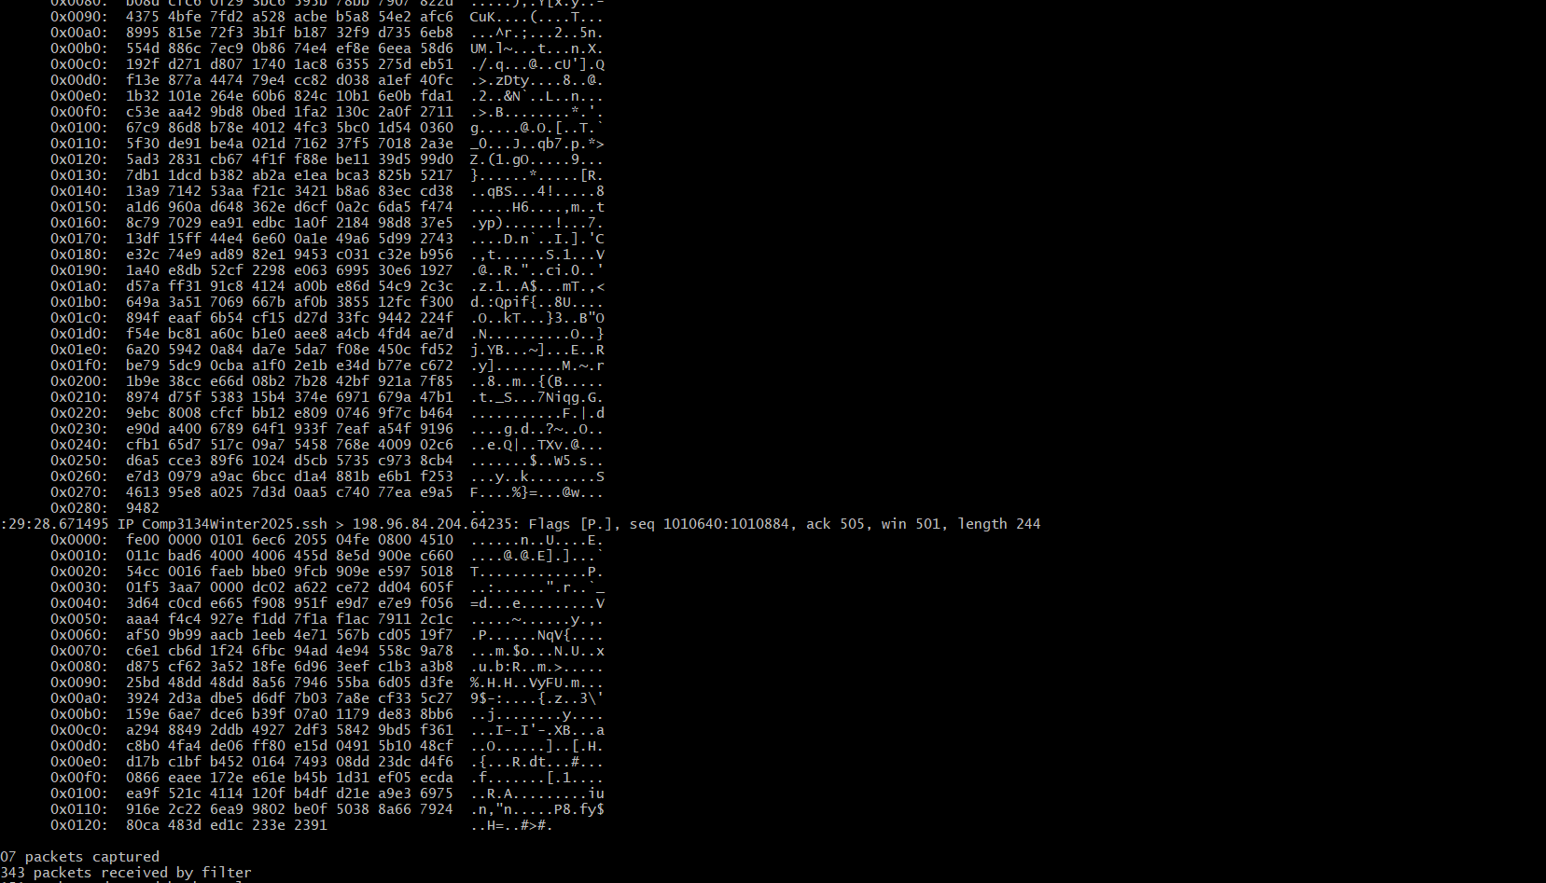

**6. Capture and Save Packets in a File**

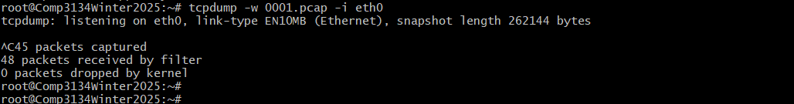

**7. Read Captured Packets File**

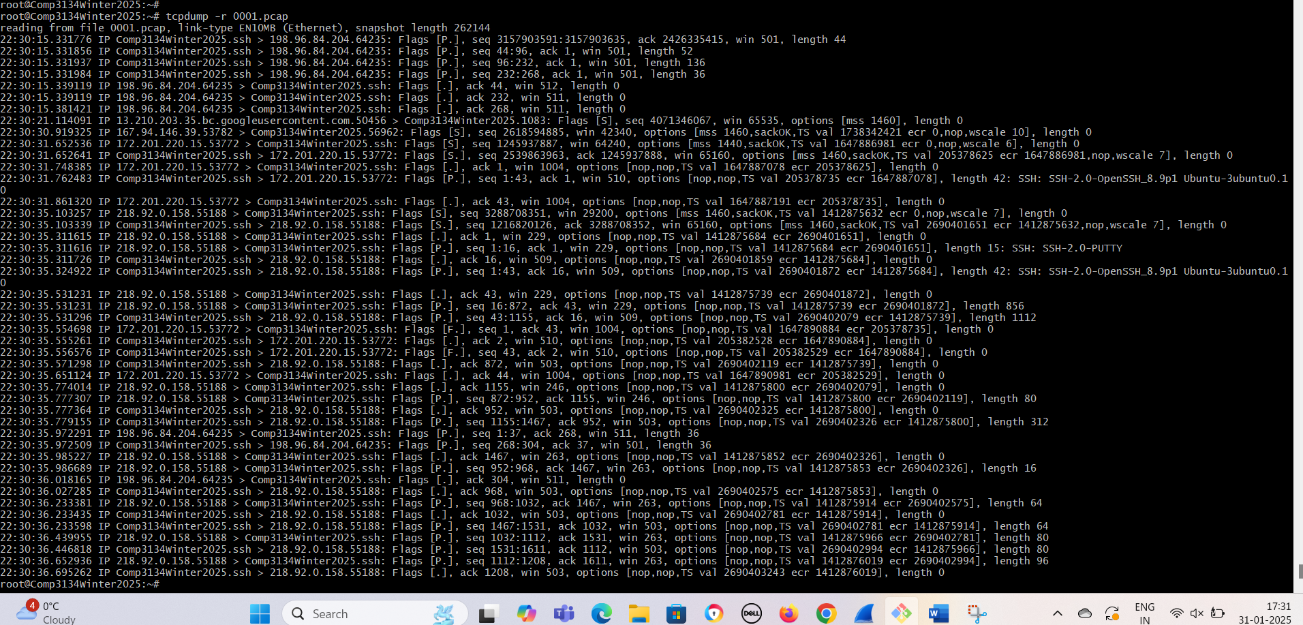

**8. Capture IP Address Packets**

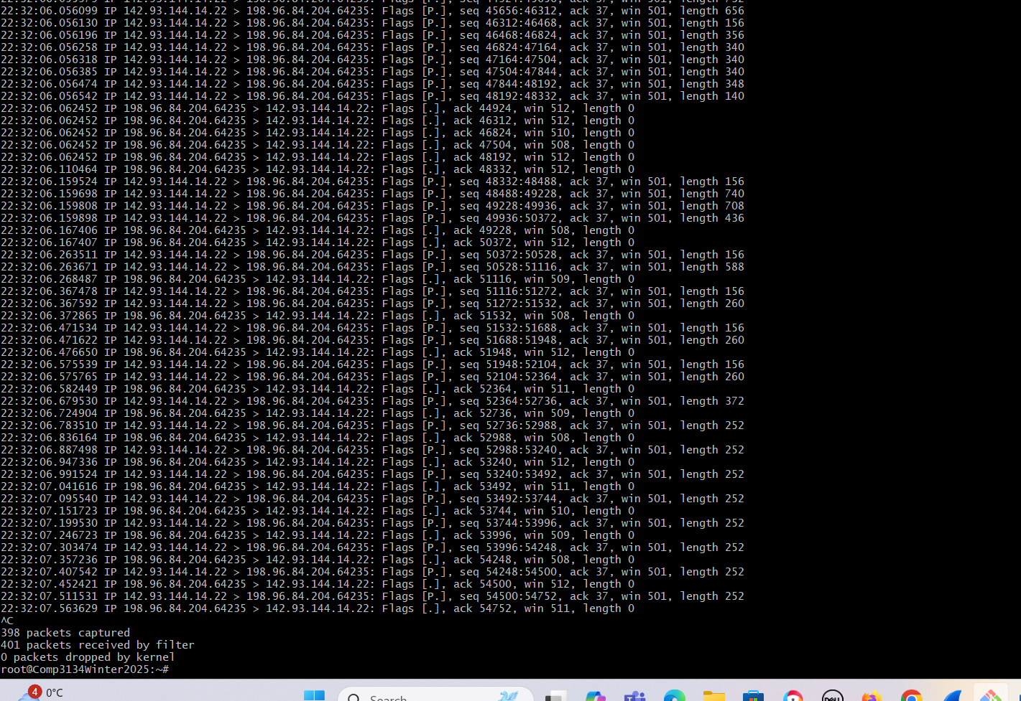

**9. Capture only TCP Packets.**

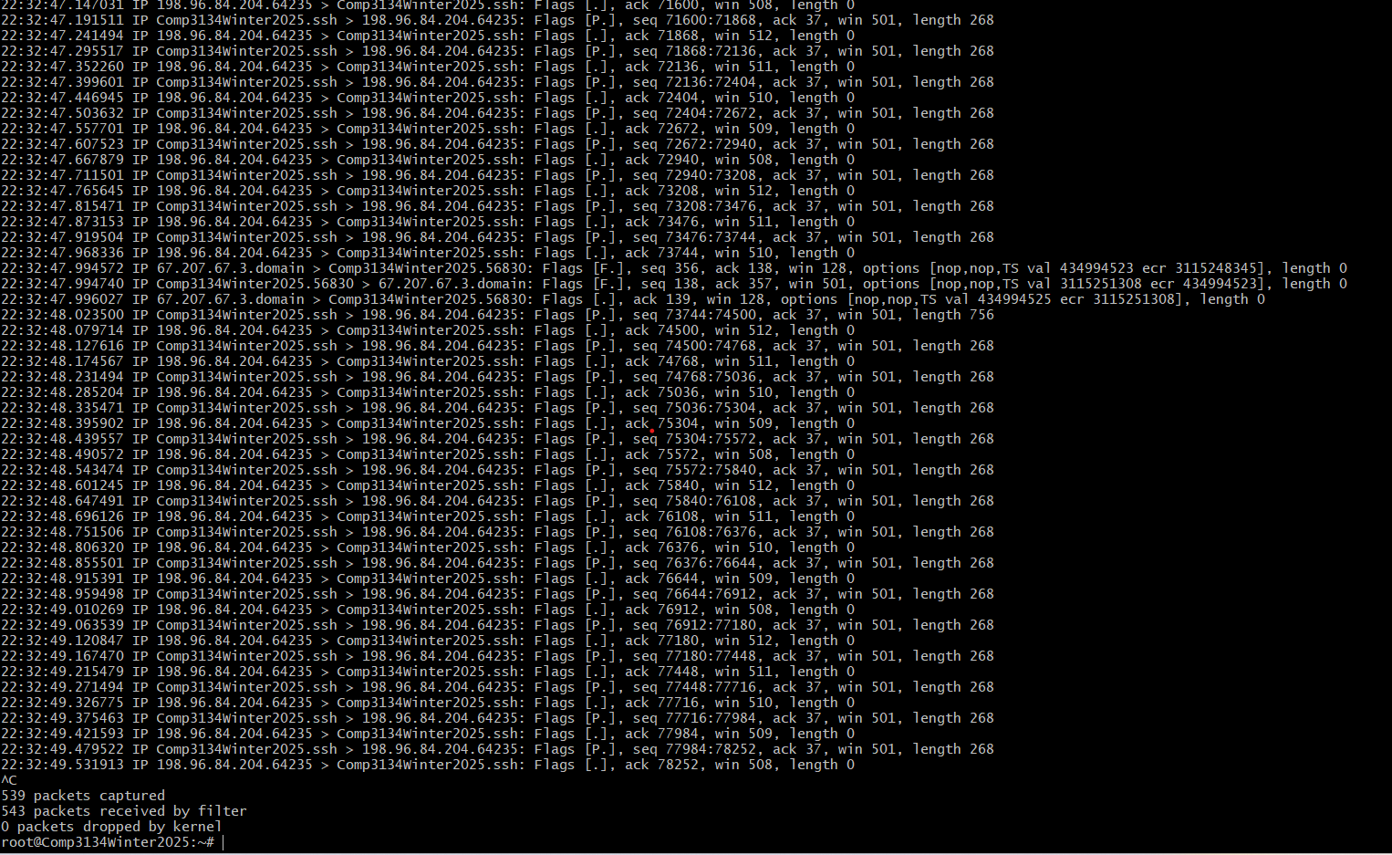

**10. Capture Packet from Specific Port**

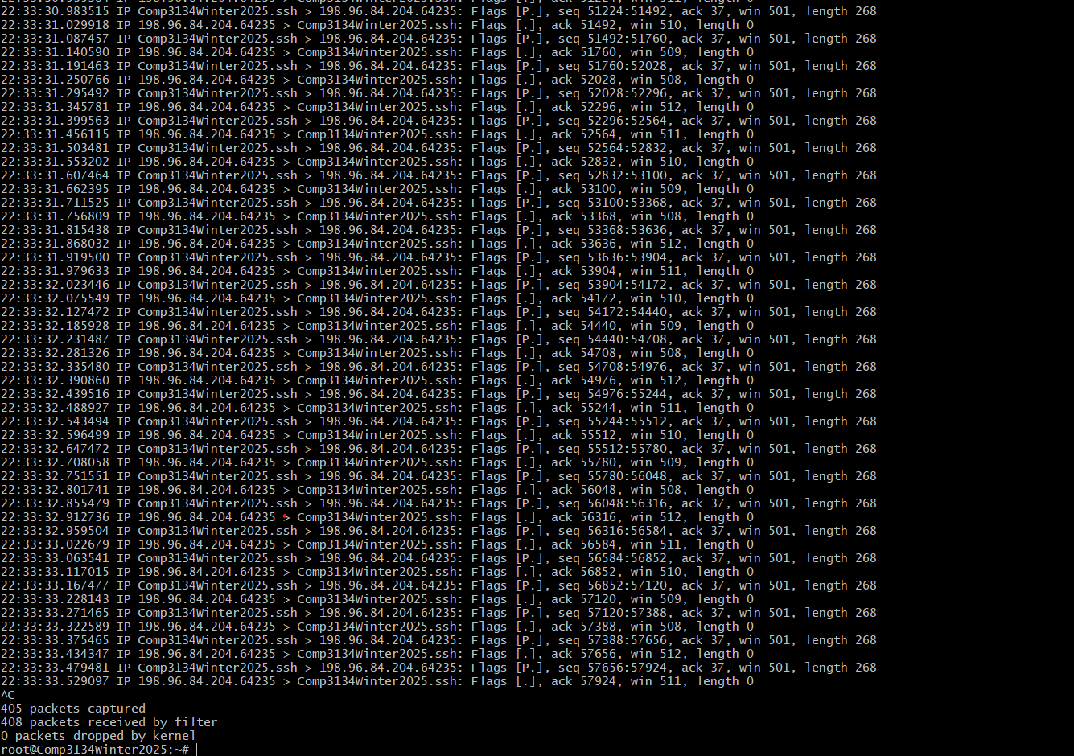

**11. Capture Packets from source IP**

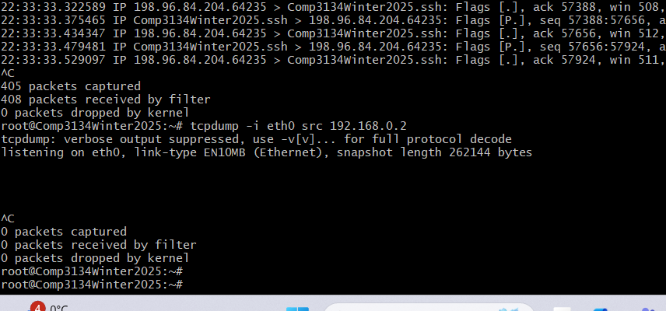

**12. Capture Packets from destination IP**

