Machine Learning: Lab 4

As you can see from the graphs and learning rates below, increasing lambda does not actually help us better fit the data. With a lambda of 0, we have the highest learning rate of 86.4%. The lambda of 1 you could argue has the best fit, and might work better on future data, because it has a closed decision boundary, but there is no doubt that as you get higher and higher in lambda values, our learning rate takes a big hit and the decision boundary we are drawing overlaps less and less of our values.

# Lambda 0: learning rate – 86.4

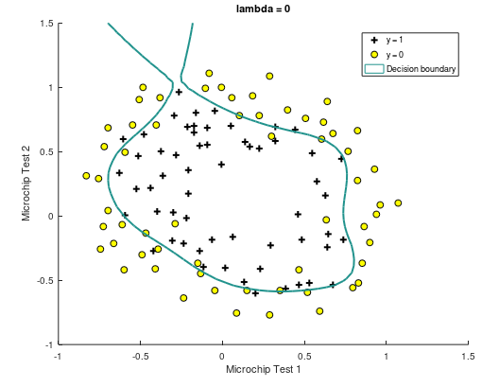

# Lambda 1: learning rate – 83.05

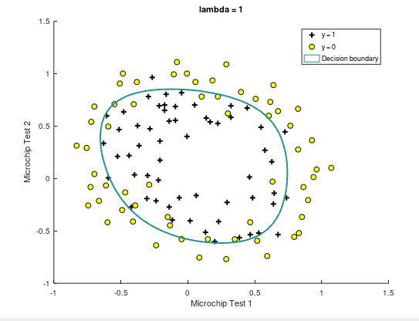

# Lambda 10: learning rate – 74.6

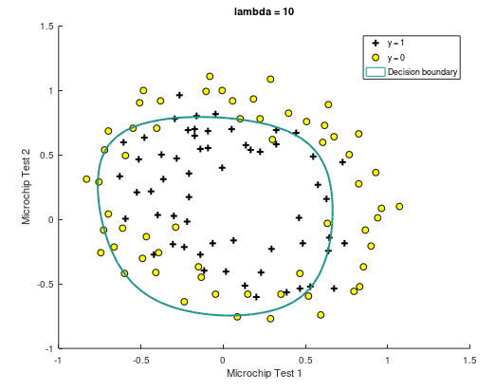

# Lambda 100: learning rate – 61.02

