Syllabison

Use Case Analysis

Koi Stephanos

Software Systems Engineering

# **Problem Identification and Definition**



### **Team Members:**

Madeline Manna

Shayne Parker

Koi Stephanos

Chiamaka Chukwuemeka

### **1.** **Project Name:**

Syllabison Syllabus Manager

### **2.** **Contact information of Project Sponsor(s):**

Dr. Evelyn Roach: 439-6821, roache@etsu.edu

Technical Manager, Degree Works & Curriculog

Office of the Registrar, Room 102A

Casey Gardner: 439-4366, gardnerca@etsu.edu

Curriculum & Catalog Coordinator

Office of the Registrar, Room 102

### **3.** **Business Objectives**

*Ø Facilitate a better understanding of students' needs or desires for taking a class.*

### **4.** **Vision Statement**

***For*** *instructors, students, and alumni* ***who*** *need to access their course syllabi,* ***the*** *Syllabison Syllabus Manager* ***is*** *an online platform* ***that*** *will provide access to syllabi for courses taught at East Tennessee State University. The system will be searchable by course number and rubric, and would allow for viewing and printing of course syllabi with the click of a button.*

*This system will save the client the time and effort needed to manually respond to individual requests or inquiries from instructors, students, or alumni concerning requests for copies of course syllabi. In addition, this platform would help the client provide better service to instructors, students, and alumni by reducing the waiting time required to provide course syllabi, as this information would be available on the platform in real time.* ***Unlike*** *the current process of directing students to departments to obtain course syllabi,* ***our*** *system will house syllabi from many different courses taught at ETSU (past or present), and will be accessible on ETSU’s network to browsing users (i.e. instructors, students, and alumni).*

### **5.** **Scope**

*Syllabison will primarily be used by instructors, administrators, the curriculog system, former and current students. Administrators will upload and maintain historical and current syllabi, while all new syllabi will be imported through the Curriculog system. Browsing users will search the system and view/download syllabi at their discretion.*

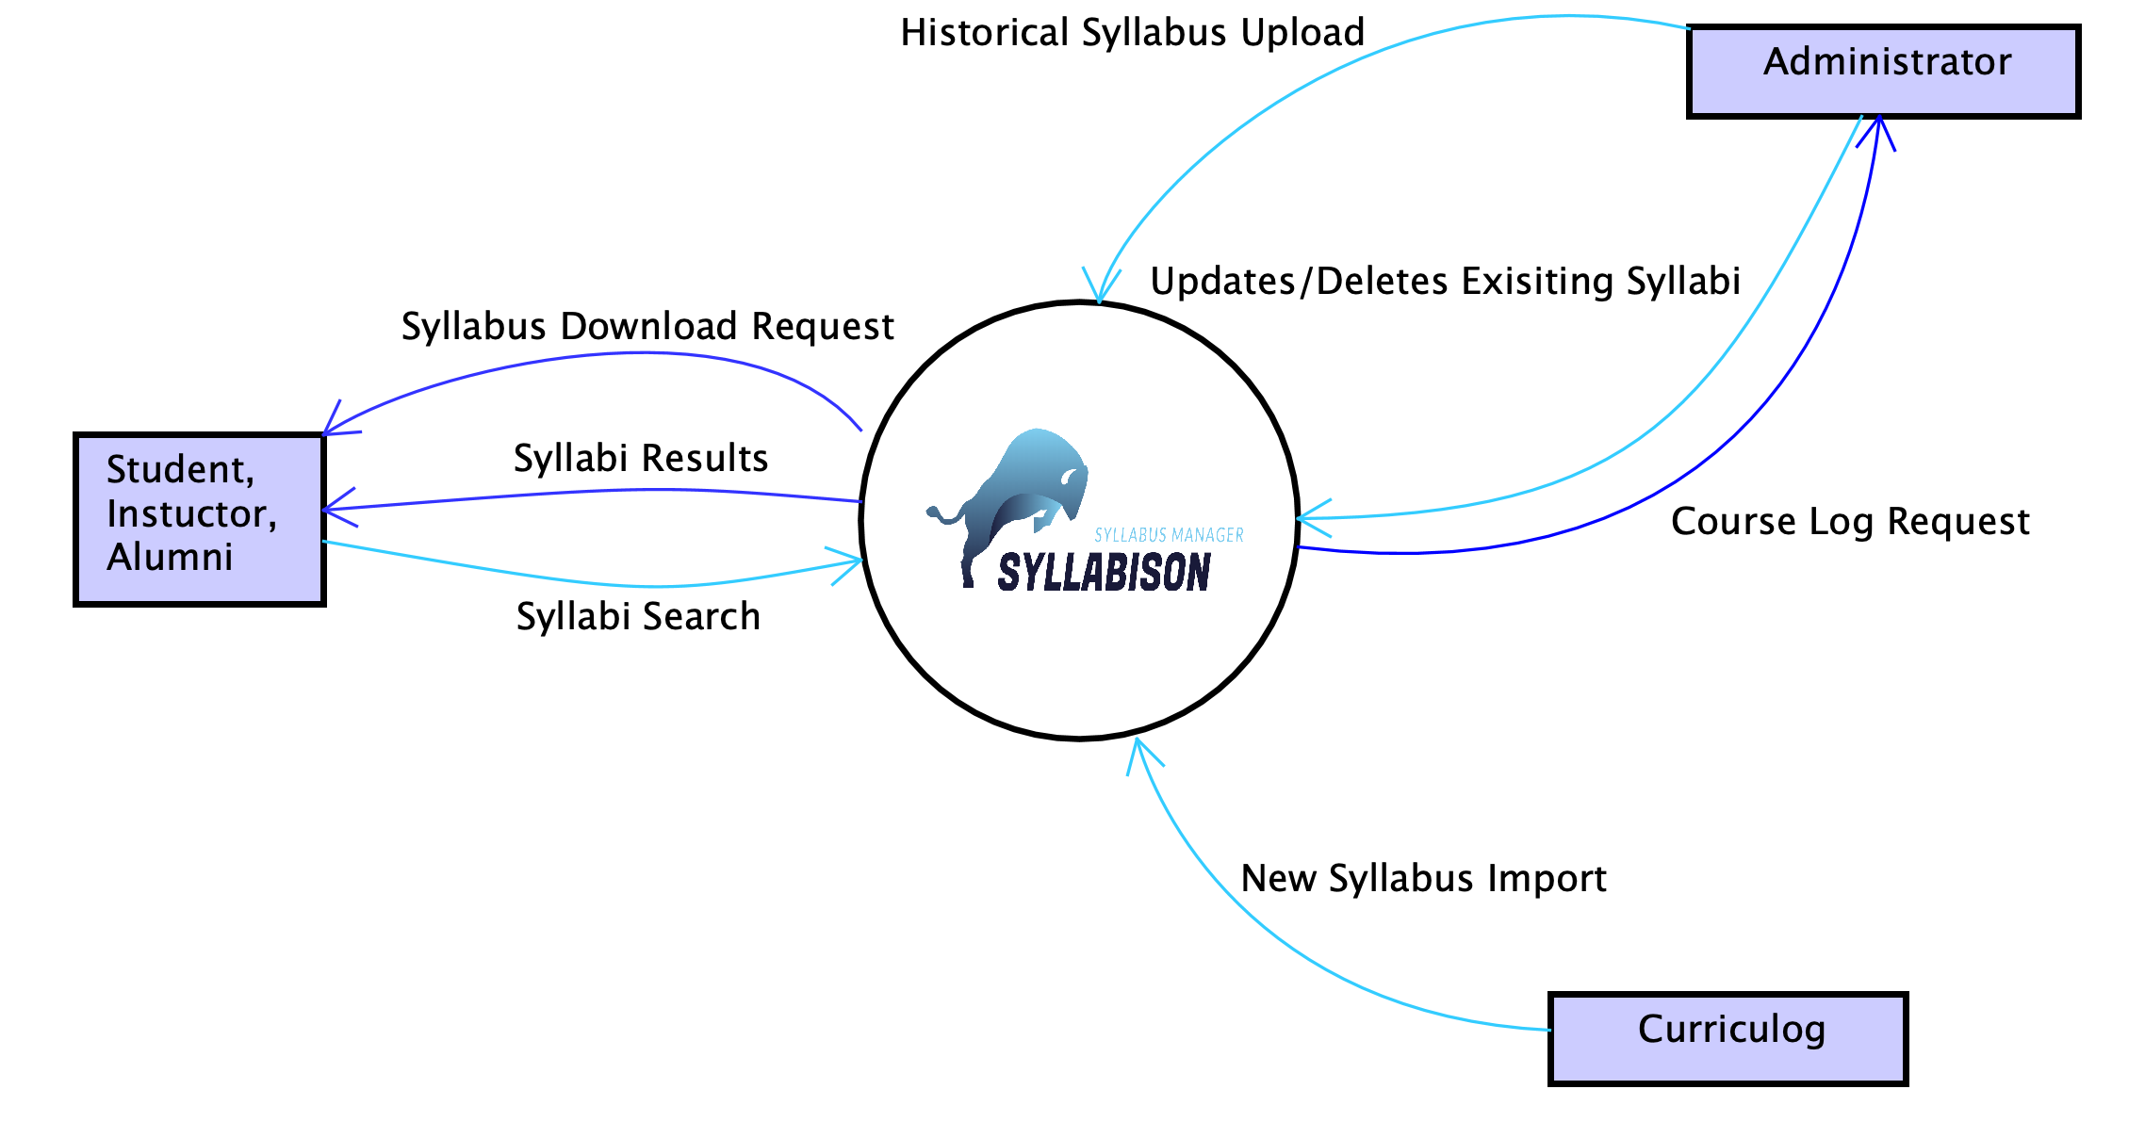

### **6.** **User Roles**

* Administrator
* Browsing User

### **7.** **User Functionalities**

#### An Administrator shall be able to upload an existing syllabus.

#### An Administrator shall be able to create a new syllabus.

#### An Administrator shall be able to edit existing syllabi.

#### An Administrator shall be able to delete existing syllabi.

#### A Browsing User shall be able to search for existing syllabi.

#### A Browsing User shall be able to sort existing syllabi.

#### A Browsing User shall be able to download existing syllabi.

#### A User shall be able to view course details.

#### An Administrator shall be able to toggle an existing syllabus between active and inactive.

#### An Administrator shall be able to log onto the platform.

#### An Administrator shall be able to log off the platform.

#### A Browsing User shall be able to click the Home link to go to the home view.

### **8. Any special issues or considerations. Any limitations and exclusions (not tracking PCs).**

* Priority is to be given to courses that are currently being offered by ETSU. Archived courses would be given secondary priority.
* Current and outdated rubrics would be tied together in searches, as header information should contain both rubrics. Eg COMM 101 formerly known as SPCH 101

### **9.** **Glossary of Terms**

* Rubric:
  + Subject of a course or approved four letter code eg CSCI.
* Curriculog system:
  + A curriculum approval process system used for facilitating changes to course curriculum and policies made by the university faculty.

### **10.** **Priority List of the functionalities**

5. SearchExisting

8. ViewSyllabusDetails

7. DownloadSyllabus

2. ImportSyllabus

10. LogOn

11. LogOff

3. EditSyllabus

9. ToggleActive

6. SortExisting

1. UploadSyllabus

4. DeleteSyllabus

12. ClickHomeLink

# **Use Case Analysis Documents**

|  |  |
| --- | --- |
|  | |
| Primary Actors: | BrowsingUser |
| Importance Level: | Low |
| Stakeholders: | BrowsingUser – wants to download a copy of the selected syllabus |
| Requirement Id: | UC-7-DownloadSyllabus |
| Requirement: | A BrowsingUser shall be able to download an existing Syllabus for their records. |
| Quality Requirements: | Download option is at top of UI |
| Story: | As a BrowsingUser, I want to download a selected syllabus so that I can keep a copy for my records. |
| Pre-Conditions: | I’m viewing the details of the syllabus I intend to download. |
| Post-Conditions: | **Success**  The syllabus is downloaded.  **Alternative**  The syllabus is not downloaded  **Exception**  The complete syllabus is not downloaded |
| Trigger: | I click on the Download button on the Syllabus details page. |
| Normal Flow of Events: | 1. Syllabison responds by opening folder select dialog.    1. Uses current browser’s native UI 2. I select a location for the download. (See Alternative)    1. Location must have write access for current BrowsingUser 3. Syllabison responds by downloading the syllabus.    1. Saved as PDF    2. Placed in specified download location |
| Alternatives | **Alternative**   1. I select Cancel 2. Syllabison responds with the previously viewed syllabus details page. |
| Exception | **Exception**  1. I lose connection to the server.  2. The download fails |
| Storage Requirements | **Data Element Storage Constraint**  - Syllabus - PDF file, < 2mb |
| PDF Format | **<PDF>** ::= <CourseRubric><CourseCode><space>-<space><CourseName>  <Credits>  <CourseDescription>  <Prereqs>  <Coreqs>    <CoursePurpose>  <LearningOutcomes>  <MajorCourseTopics>  <RevisionDate> <IsInactive>  **<CourseRubric>** ::= 4{<letter>}4  **<CourseCode>** ::= 4{<digit>}4  **<CourseName>** ::= 4{<alphanumeric>}30  **<Credits>** ::= 1{<digit>}1  **<Prereqs>** ::= 0{<alphanumeric>}30  **<Coreqs>** ::= 0{<alphanumeric>}30  **<CoursePurpose>** ::= 50{<alphanumeric>}300  **<LearningOutcomes>** ::= 50{<alphanumeric>}300  **<MajorCourseTopics>** ::= 30{<alphanumeric>}100  **<RevisionDate>** ::= 1{<system date>}1  **<IsInactive>** ::= 1{“Current” ∨ “Historical”}1  **<system date>** ::= <MMM><space><DD><space><YYYY>  **<MMM>** ::= JAN | FEB | MAR | APR | MAY | JUN | JUL | AUG |  SEP | OCT | NOV | DEC  **<DD>** ::= <digit><digit>  **<YYYY>**  ::= <digit><digit><digit><digit>  **<digit>**  ::= 0 | 1 | 2 | 3 | 4 | 5 | 6 | 7 | 8 | 9 |

# Behavioral Model

|  |
| --- |
|  |

# Functional Model

|  |
| --- |
|  |

# 

# Prototype

|  |
| --- |
|  |

# Scenarios

**I successfully view a syllabus’s details**

1. I’m viewing the details of a syllabus
2. I select the Download option from the top of the screen
3. I choose where to save the syllabus on my computer
4. The syllabus being viewed is downloaded to my computer

**I change my mind about requesting the item**

1. I’m viewing the item I wanted to download
2. I select Cancel
3. I see the previously viewed syllabus

**I lose connection to Syllabison during download**

1. I select download for the syllabus I want
2. The download begins
3. I lose connection to the internet
4. The download is canceled, and my pdf is incomplete

|  |  |
| --- | --- |
|  | |
| Primary Actors: | BrowsingUser |
| Importance Level: | High |
| Stakeholders: | BrowsingUser – wants to view the details for a selected syllabus |
| Requirement Id: | UC-8-ViewSyllabusDetails |
| Requirement: | A BrowsingUser shall be able to download an existing syllabi. |
| Quality Requirements: | Details only viewable on detail view. |
| Story: | As a BrowsingUser, I want to view syllabus details so that I can obtain further information about a course. |
| Pre-Conditions: | I’m browsing the syllabi list. |
| Post-Conditions: | **Success**  The syllabus details are displayed to the BrowsingUser. |
| Trigger: | I select the syllabus I want to view the details of. |
| Normal Flow of Events: | 1. Syllabison responds with the syllabus details    1. Course rubric, code, name, description, etc.    2. Link back to list |
| Alternatives | **N/A** |

# Prototype

|  |
| --- |
|  |

# Scenarios

**I successfully view a syllabus’s details**

1. I’m browsing a list of syllabi
2. There is an existing syllabus
3. I select the syllabus
4. I see the syllabus details screen populated with the syllabus’s details

|  |  |
| --- | --- |
|  | |
| Primary Actors: | BrowsingUser |
| Importance Level: | Low |
| Stakeholders: | BrowsingUser – wants to go back to the Home view |
| Requirement Id: | UC-12-ClickHome |
| Requirement: | A BrowsingUser shall be able to click the home link to navigate back to the Home view. |
| Quality Requirements: | **N/A** |
| Story: | As a BrowsingUser, I want to be able to go back to the Home view to start a new search. |
| Pre-Conditions: | I’m on a view other than Home. |
| Post-Conditions: | **Success**  Syllabison responds with the Home view. |
| Trigger: | I click the home link. |
| Normal Flow of Events: | 1. Syllabison responds with the Home view |
| Alternatives | **N/A** |

# Prototype

|  |
| --- |
|  |

# Scenarios

**I successfully click the home link**

1. I’m browsing through the syllabi on the platform.
2. I decide to start a new search and click the home link.
3. I am taken to the home page view.