Syllabison

Use Case Analysis

Madeline Manna

Software Systems Engineering

# **Problem Identification and Definition**

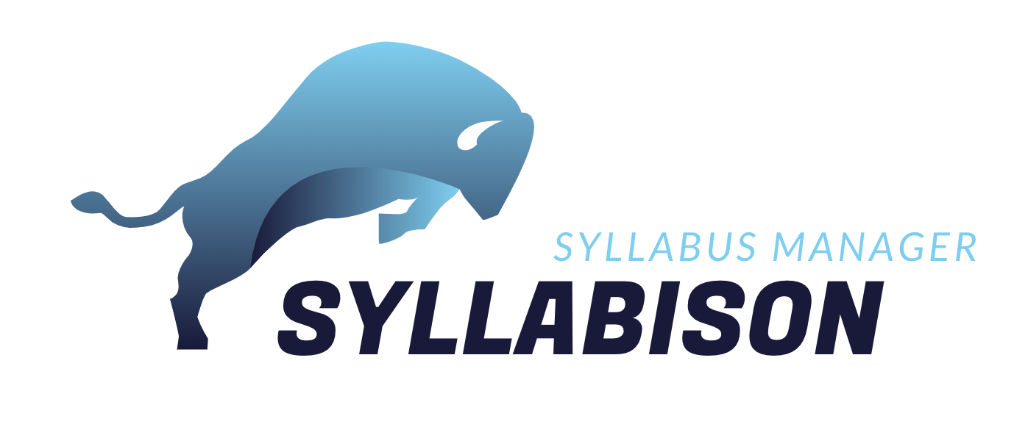

### **Team Members:**

Madeline Manna

Shayne Parker

Koi Stephanos

Chiamaka Chukwuemeka

### **1.** **Project Name:**

Syllabison Syllabus Manager

### **2.** **Contact information of Project Sponsor(s):**

Dr. Evelyn Roach: 439-6821, roache@etsu.edu

Technical Manager, Degree Works & Curriculog

Office of the Registrar, Room 102A

Casey Gardner: 439-4366, gardnerca@etsu.edu

Curriculum & Catalog Coordinator

Office of the Registrar, Room 102

### **3.** **Business Objectives**

*Ø Facilitate a better understanding of students' needs or desires for taking a class.*

### **4.** **Vision Statement**

***For*** *instructors, students, and alumni* ***who*** *need to access their course syllabi,* ***the*** *Syllabison Syllabus Manager* ***is*** *an online platform* ***that*** *will provide access to syllabi for courses taught at East Tennessee State University. The system will be searchable by course number and rubric, and would allow for viewing and printing of course syllabi with the click of a button.*

*This system will save the client the time and effort needed to manually respond to individual requests or inquiries from instructors, students, or alumni concerning requests for copies of course syllabi. In addition, this platform would help the client provide better service to instructors, students, and alumni by reducing the waiting time required to provide course syllabi, as this information would be available on the platform in real time.* ***Unlike*** *the current process of directing students to departments to obtain course syllabi,* ***our*** *system will house syllabi from many different courses taught at ETSU (past or present), and will be accessible on ETSU’s network to browsing users (i.e. instructors, students, and alumni).*

### **5.** **Scope**

*Syllabison will primarily be used by instructors, administrators, the curriculog system, former and current students. Administrators will upload and maintain historical and current syllabi, while all new syllabi will be imported through the Curriculog system. Browsing users will search the system and view/download syllabi at their discretion.*

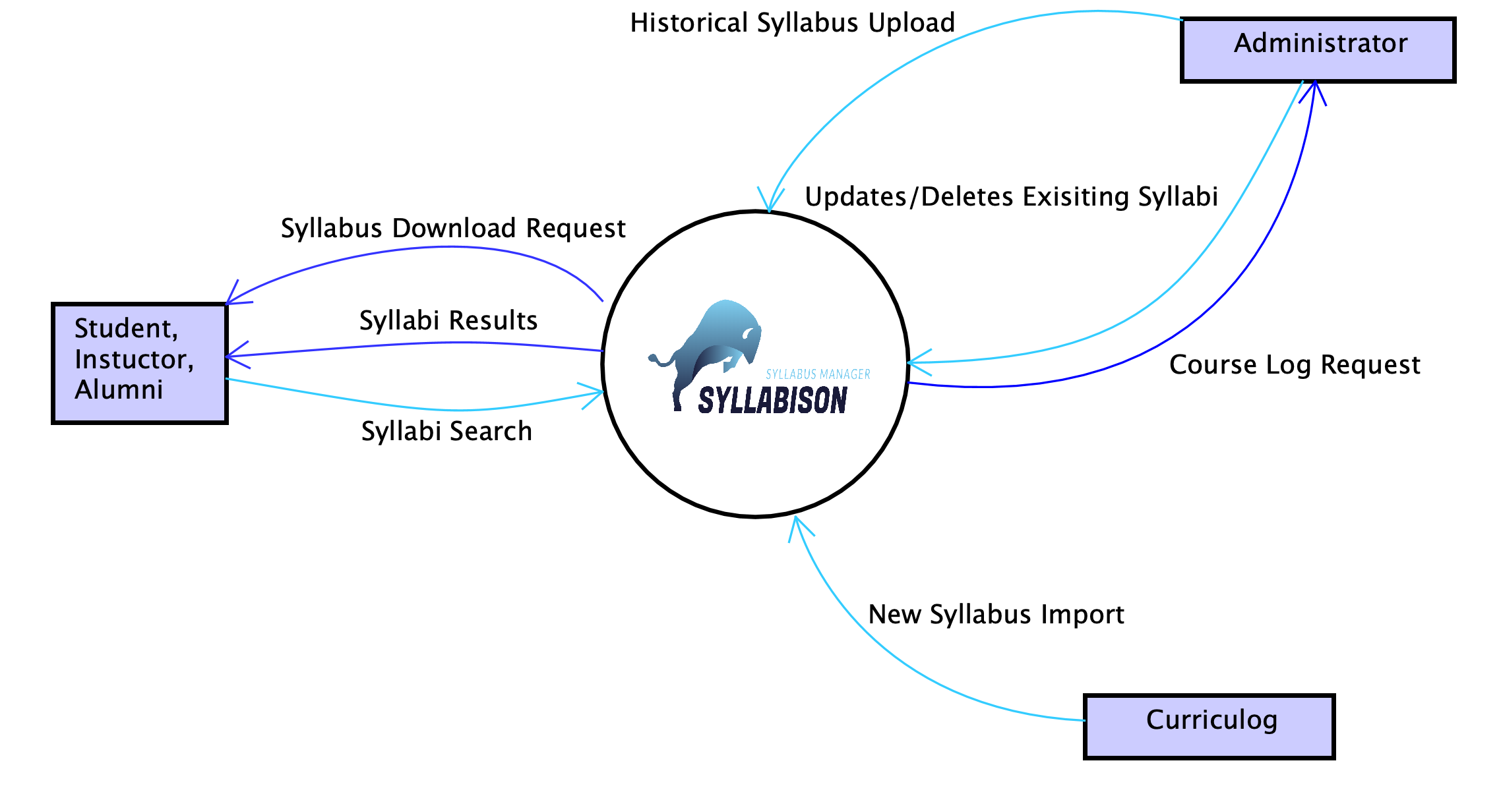

### **6.** **User Roles**

* Administrator
* Browsing User

### **7.** **User Functionalities**

#### An Administrator shall be able to upload an existing syllabus.

#### An Administrator shall be able to create a new syllabus.

#### An Administrator shall be able to edit existing syllabi.

#### An Administrator shall be able to delete existing syllabi.

#### A Browsing User shall be able to search for existing syllabi.

#### A Browsing User shall be able to sort existing syllabi.

#### A Browsing User shall be able to download existing syllabi.

#### A User shall be able to view course details.

#### An Administrator shall be able to toggle an existing syllabus between active and inactive.

#### An Administrator shall be able to log onto the platform.

#### An Administrator shall be able to log off the platform.

#### A Browsing User shall be able to click the Home link to go to the home view.

### **8. Any special issues or considerations. Any limitations and exclusions (not tracking PCs).**

* Priority is to be given to courses that are currently being offered by ETSU. Archived courses would be given secondary priority.
* Current and outdated rubrics would be tied together in searches, as header information should contain both rubrics. Eg COMM 101 formerly known as SPCH 101
* Should be mobile compatible.

### **9.** **Glossary of Terms**

* Rubric:
  + Subject of a course or approved four letter code eg CSCI.
* Curriculog system:
  + A curriculum approval process system used for facilitating changes to course curriculum and policies made by the university faculty.

### **10.** **Priority List of the functionalities**

5. SearchSyllabi

8. ViewSyllabusDetails

7. DownloadSyllabus

2. ImportSyllabus

10. LogOn

11. LogOff

3. EditSyllabus

9. ToggleActive

6. SortSyllabi

1. UploadSyllabus

4. DeleteSyllabus

12. ClickHomeLink

# **Use Case Analysis Documents**

|  |  |
| --- | --- |
|  | |
| Primary Actors: | **Administrator** |
| Importance Level: | **Medium** |
| Stakeholders: | **Administrator-** needs to edit existing syllabi |
| Requirement Id: | **UC-3-EditSyllabi** |
| Requirement: | The system shall allow the administrator to edit existing syllabi. |
| Quality Requirements: | Syllabison shall be able to save the edited syllabus information and return to the syllabus’ information page within 5 seconds. |
| Story: | As an administrator, I want to edit existing syllabi, so that I can make syllabi details accurate. |
| Pre-Conditions: | I am on a syllabus’ information page |
| Post-Conditions: | **Success:** a syllabus’ information has been edited.  **Alternative 1:** a syllabus’ information has not been edited.  **Alternative 2:** a syllabus’ information has not been edited. |
| Trigger: | **Trigger Type:** **External**  I select the ‘Edit Syllabus’ option. |
| Normal Flow of Events: | 1. Syllabison responds with the edit syllabus page 2. I select a text box of information and edit the information 3. I repeat 2. until satisfied 4. I select the ‘Save’ option **(Alternative 1, Exception 1)** 5. Syllabison responds with “Are you sure you want to submit changes to this syllabus?” message box 6. I select “Submit” **(see Alternative 2)** 7. Syllabison makes and saves the changes in the syllabus’ information 8. Syllabison responds with the syllabus information page |
| Sub/Alternative/Exception flows: | **Alternative 1:**   1. I select the ‘Cancel’ option 2. Syllabison responds with the syllabus information page   **Alternative 1:**   1. I select the ‘Cancel option 2. Syllabison responds with the edit syllabus page   **Exception 1 – invalid data entered**   1. Syllabision displays an error message explaining the error 2. I select the ‘OK’ option 3. Syllabison responds with the edit syllabus page |

|  |
| --- |
| **Images of the UI** |

|  |
| --- |
| **Scenarios**  **I successfully update a syllabus**   1. I’m on the syllabus’ information page 2. I scroll down to select Edit Syllabus 3. I see the update syllabus details screen populated with the syllabus’ details    1. Rubric code    2. Course Number    3. Course name    4. Number of credits    5. Catalog Description    6. Prerequisites    7. Corequisites    8. Delivery Method    9. Dept Contact Info    10. Goals    11. Expected Learning Outcomes    12. Major Course Topics    13. Revision Date    14. Is Inactive 4. I enter a new major course topic: Yes 5. I select Submit Changes 6. Syllabison displays a message box asking to confirm my changes 7. I select Submit 8. I see the syllabus’ information page with the syllabus information updated   **I exit syllabus update details**   1. I’m on the syllabus’ information page 2. I scroll down to select Edit Syllabus 3. I see the update syllabus details screen populated with the syllabus’ details    1. Rubric code    2. Course Number    3. Course name    4. Number of credits    5. Catalog Description    6. Prerequisites    7. Corequisites    8. Delivery Method    9. Dept Contact Info    10. Goals    11. Expected Learning Outcomes    12. Major Course Topics    13. Revision Date    14. Is Inactive 4. I select Cancel 5. I see the syllabus’ information page   **I don’t save item details**   1. I’m on the syllabus’ information page 2. I scroll down to select Edit Syllabus 3. I see the update syllabus details screen populated with the syllabus’ details    1. Rubric code    2. Course Number    3. Course name    4. Number of credits    5. Catalog Description    6. Prerequisites    7. Corequisites    8. Delivery Method    9. Dept Contact Info    10. Goals    11. Expected Learning Outcomes    12. Major Course Topics    13. Revision Date    14. Is Inactive 4. I enter a new major course topic: Yes 5. I select Submit Changes 6. Syllabison displays a message box asking to confirm my changes 7. I select Cancel 8. I see the syllabus’ information page but the syllabus is not updated |

|  |  |
| --- | --- |
|  | |
| Primary Actors: | **Administrator** |
| Importance Level: | **Medium** |
| Stakeholders: | **Administrator** – needs to delete existing syllabi |
| Requirement Id: | **UC-4-DeleteSyllabi** |
| Requirement: | The system shall allow the administrator to delete existing syllabi. |
| Quality Requirements: | The administrator shall be able to delete an existing syllabi within 5 seconds. |
| Story: | As an administrator, I want to delete existing syllabi, so that I can remove it from the syllabus list. |
| Pre-Conditions: | I am on a syllabus’ information page |
| Post-Conditions: | **Success:** a syllabus has been removed.  **Alternative 1:** a syllabus has not been removed. |
| Trigger: | **Trigger Type: External**  I select the ‘Edit Syllabus’ option. |
| Normal Flow of Events: | 1. Syllabison responds with the edit syllabus page 2. I select the ‘Delete Syllabus’ option 3. Syllabison responds with ‘Are you sure you want to delete this syllabus?’ message box 4. I select ‘Delete’ **(see Alternative 1)** 5. Syllabison removes the syllabus from the syllabus collection. 6. Syllabison responds with the home page. |
| Sub/Alternative/Exception flows: | **Alternative 1:**   1. I select the ‘Cancel’ option 2. Syllabison responds with the edit syllabus page |

|  |
| --- |
| **Images of the UI** |

|  |
| --- |
| **Scenarios**  **I successfully delete a syllabus**   1. I’m on the syllabus’ information page 2. I scroll down to select Edit Syllabus 3. I see the update syllabus details screen populated with the syllabus’ details 4. I select Delete Syllabus 5. Syllabison displays a message box asking to confirm my choice to delete 6. I select Delete 7. I see the home page   **I don’t delete a syllabus**   1. I’m on the syllabus’ information page 2. I scroll down to select Edit Syllabus 3. I see the update syllabus details screen populated with the syllabus’ details 4. I select Delete Syllabus 5. Syllabison displays a message box asking to confirm my choice to delete 6. I select Cancel 7. I see the update syllabus details screen populated with the syllabus’ details |

|  |  |
| --- | --- |
|  | |
| Primary Actors: | **Administrator** |
| Importance Level: | **High** |
| Stakeholders: | **Administrator -** needs to log out of Syllabison |
| Requirement Id: | **UC-11-LogOut** |
| Requirement: | The system shall allow the browsing user to log out of Syllabison. |
| Quality Requirements: | An administrator shall be able to log out of Syllabison within 5 seconds. |
| Story: | As an administrator, I want to log out of Syllabison, so that I can make sure no one else can access my account on this computer. |
| Pre-Conditions: | I am on the home page. |
| Post-Conditions: | **Success:** I have been logged out of Syllabison.  **Alternative 1:** I am still logged into Syllabison. |
| Trigger: | **Trigger Type:** **External**  I select the ‘Log Out’ option. |
| Normal Flow of Events: | 1. Syllabison deletes my session, logging me out of the platform 2. Syllabison responds with the home page, with administrative privileges removed |
| Sub/Alternative/Exception flows: | **N/A** |

|  |
| --- |
| **Images of the UI** |

|  |
| --- |
| **Scenarios**  **I log out of Syllabison**   1. I’m on the home page 2. I select the ‘Log Out’ option 3. I see the home page, with my administrative privileges removed |