C7 - Compute ABD matrix for Example 2 1
C8 - Compute ABD matrix for Example 3 1
C9 - Calculate strains in Example 4 2
%Derrik Adams
%Homework 4 - Composites 7-10
%2/7/18
clear all

C7 - Compute ABD matrix for Example 2
%Create properties for graphite-reinforced composite (Pa)
E1 = 155e9; E2 = 12.1e9; E3 = E2;
v23 = .458; v12 = .248; v21 = E2*v12/E1;
G12 = 4.4e9; G13 = G12; G23 = 3.2e9;
num_plies = 6;
ply_angles_7 = [30, -30, 0, 0, -30, 30]; %deg
z_7 = [-.45, -.3, -.15, 0, .15, .3, .45]; %in mm
%Call function to create ABD matrix (Pa-mm)
ABD_mat_7 = buildABD_mat(E1, E2, v12, v21, G12, z_7, ply_angles_7, num_plies)
ABD_mat_7 =
1.0e+11 *
1.0240 0.1894 0.0000 0.0000 0 0
0.1894 0.1625 0.0000 0 0 0
0.0000 0.0000 0.2019 0 0 0.0000
0.0000 0 0 0.0578 0.0177 0.0126
0 0 0 0.0177 0.0126 0.0042
0 0 0.0000 0.0126 0.0042 0.0185

C8 - Compute ABD matrix for Example 3
num_plies = 6;
ply_angles_8 = [30, -30, 0, 30, -30, 0]; %deg
z_8 = [-.45, -.3, -.15, 0, .15, .3, .45]; %in mm
%Call function to create ABD matrix (Pa-mm)
ABD_mat_8 = buildABD_mat(E1, E2, v12, v21, G12, z_8, ply_angles_8, num_plies)

ABD_mat_8 =
1.0e+11 *
1.0240 0.1894 0.0000 0.0283 -0.0122 -0.0210
0.1894 0.1625 0.0000 -0.0122 -0.0040 -0.0070
0.0000 0.0000 0.2019 -0.0210 -0.0070 -0.0122
0.0283 -0.0122 -0.0210 0.0705 0.0122 0.0032
-0.0122 -0.0040 -0.0070 0.0122 0.0108 0.0010
-0.0210 -0.0070 -0.0122 0.0032 0.0010 0.0130

C9 - Calculate strains in Example 4
Stress_Res = [0; 0; 0; 12.84; 3.92; 2.8]; %Nm/m
num_plies = 6;
ply_angles_9 = [30, -30, 0, 0, -30, 30];
z_9 = [-.00045, -.0003, -.00015, 0, .00015, .0003, .00045]; %in mm
%Call function to create ABD matrix (Pa-mm)
ABD_mat_9 = buildABD_mat(E1, E2, v12, v21, G12, z_9, ply_angles_9, num_plies);
%Multiply given resultant stress vector by the inverse of the ABD to get
%strains
Strain_vec = inv(ABD_mat_9)*Stress_Res
Strain_vec =
-0.0000
0.0000
0.0000
2.2233
-0.0041
-0.0011
Published with MATLAB® R2015a

C 10) Confirm C6 in ANSYS
Max Strain - .00407
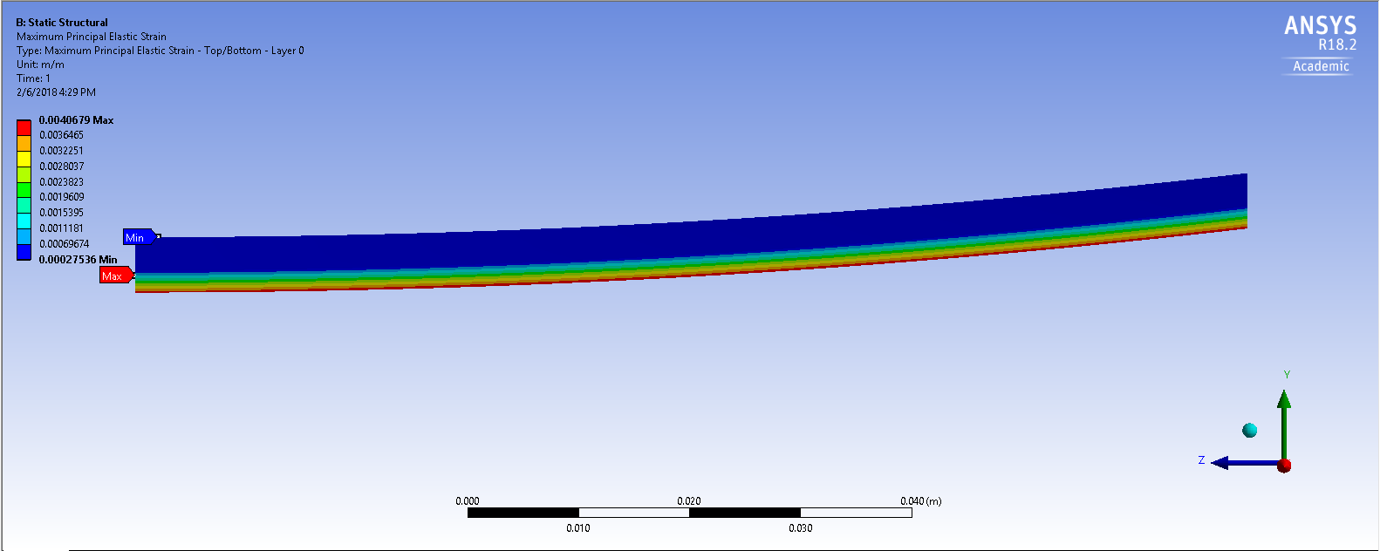

Stress - 494.7 MPa
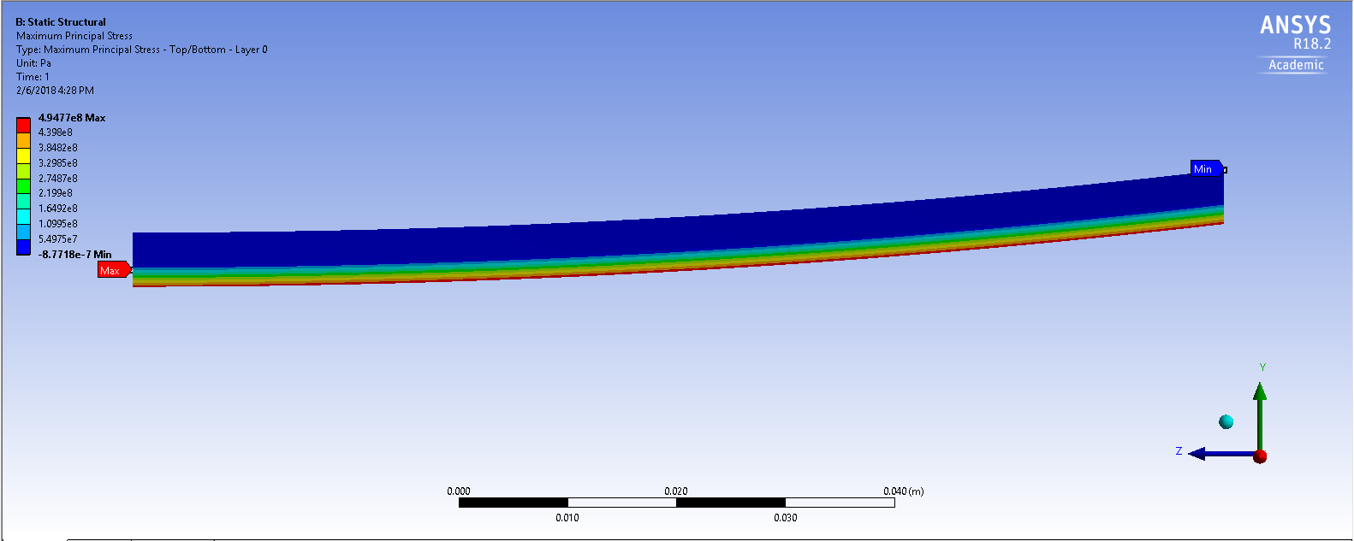
It shouldn’t be bending, but I assume the force is being applied to just one ply since I can’t apply the force to a face but just an edge. The strain is pretty close though.
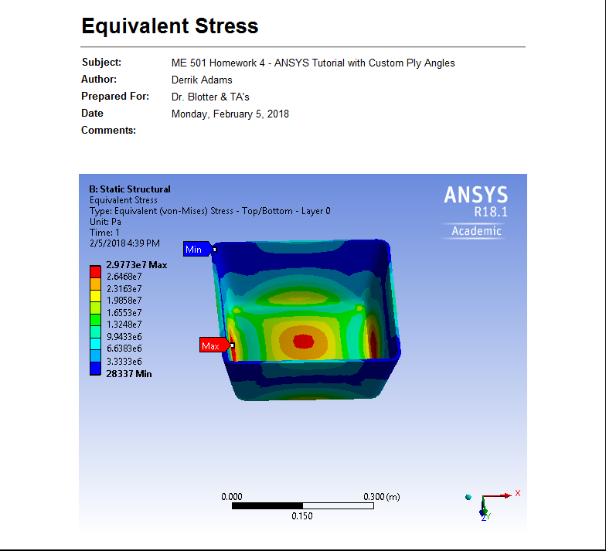
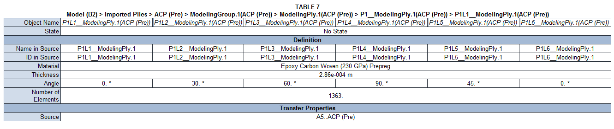
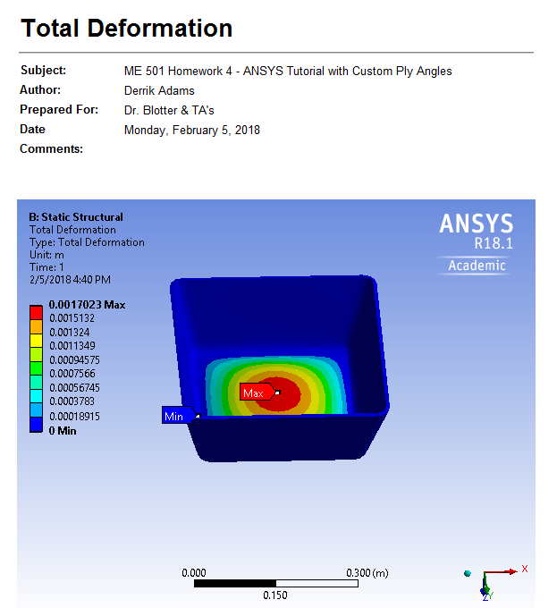
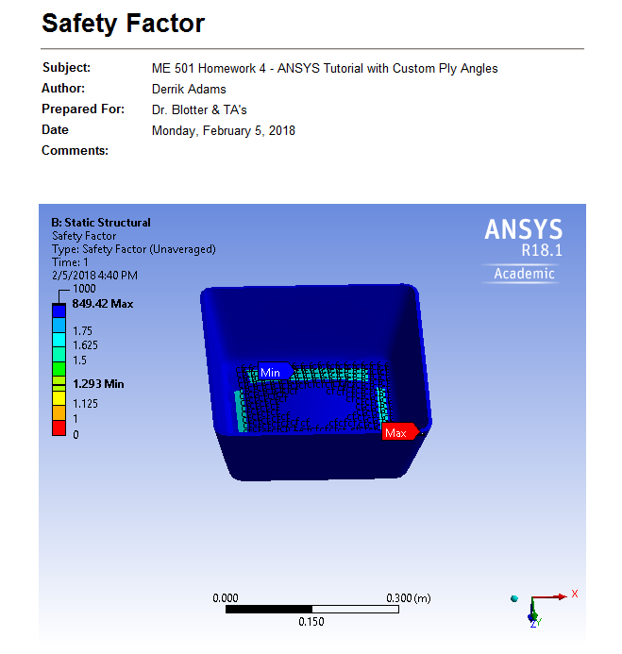
Custom ANSYS Tutorial

