Explain the formula for standard deviation and variance, save the word as Assignment2.doc

**Standard Deviation**

A standard deviation (σ) is a measure of how dispersed the data is in relation to the mean and is calculated as square root of the variance

Low, or small - standard deviation indicates data are clustered tightly around the mean

High, or large - standard deviation indicates data are more spread out.

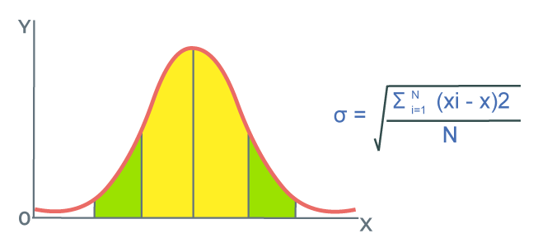

∑ = Summation

µ = Population Average

N = Total number of population

Xi= Individual population Value

Following are the different steps to calculate Standard Deviation:

***Step 1:******Calculate mean of observation using the formula***

*(Mean = Sum of Observations/Number of Observations)*

***Step 2:******Calculate squared differences of data values from the mean***

*(Data Value – Mean)2*

***Step 3:******Calculate average of squared differences***

*(Variance = Sum of Squared Differences / Number of Observations)*

***Step 4: Calculate square root of variance this gives the Standard Deviation.***

*(Standard Deviation = √Variance)*

**VARIANCE**

Variance is a statistical measurement used to determine how far each number is from the mean and from every other number in the set. Variance can be calculated by taking the difference between each point and the mean.Variance is denoted byσ 2

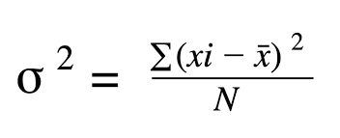

* **Σ**  denotes Summation (adding up)
* **x** represents Each Individual Data Point
* **μ**  is the Mean (Average) of Dataset
* **N** is the Total Number of Data Point
* **Xi**  Individual population Value