**Lab 4: Exploratory Data Analysis**

Experimental Data Analysis (eda) is the process of looking at a data set to see what are the appropriate statistical inferences that can possibly be learned. For univariate data, we can ask if the data is approximately normal, longer tailed, or shorter tailed? Does it have symmetry, or is it skewed? Is it unimodal, bimodal or multi-modal? The main tool is the proper use of computer graphics.

**4.1  Our toolbox**

Our toolbox for eda consists of graphical representations of the data and our interpretation. Here is a summary of graphical methods covered so far:

**barplots**

for categorical data

**histogram, dot plots, stem and leaf plots**

to see the shape of numerical distributions

**boxplots**

to see summaries of a numerical distribution, useful in comparing distributions and identifying long and short-tailed distributions.

**normal probability plots**

To see if data is approximately normal

It is useful to have many of these available with one easy function. The function simple.eda does exactly that.   
  
Here are some examples of distributions with different shapes.

**4.2  Examples**

Example: Homedata  
The dataset [homedata](https://www.rdocumentation.org/packages/UsingR/versions/2.0-5/topics/homedata) contains assessed values for Maplewood, NJ for the year 1970 and the year 2000. What is the shape of the distribution?

> data(homedata) # from simple package

> attach(homedata)

> hist(y1970);hist(y2000) # make two histograms

> detach(homedata) # clean up

On first appearances (figure [35](http://www.math.csi.cuny.edu/Statistics/R/simpleR/stat009.html#fig:eda-homedata-hists)), the 1970 data looks more normal, the year 2000 data has a heavier tail. Let's see using our simple.eda function.

> attach(homedata)

> simple.eda(y1970);simple.eda(y2000)

> detach(homedata) # clean up

The 1970 and year 2000 data are shown (figures [36](http://www.math.csi.cuny.edu/Statistics/R/simpleR/stat009.html#fig:eda-homedata-eda-1970) and [37](http://www.math.csi.cuny.edu/Statistics/R/simpleR/stat009.html#fig:eda-homedata-eda-2000)).

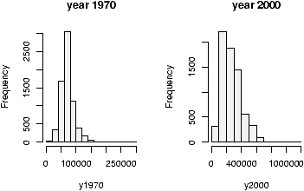

Figure 35: Histograms of Maplewood homes in 1970 and 2000

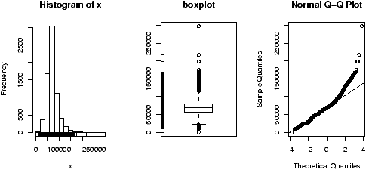

Figure 36: 1970 Maplewood home data

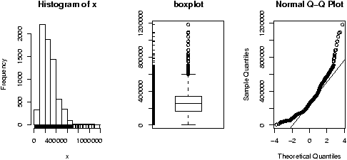

Figure 37: 2000 Maplewood N.J. home data

Neither looks particularly normal -- both are heavy tailed and skewed. Any analysis will want to consider the medians or a transformation.

Example: CEO salaries  
The data set [exec.pay](https://www.rdocumentation.org/packages/UsingR/versions/2.0-5/topics/exec.pay)gives the total direct compensation for CEO's at 200 large publicly traded companies in the U.S for the year 2000 (in units of $100,000). What can we say about this distribution besides it looks like good work if you can get it? Using simple.eda yields

> data(exec.pay) # or read in from file

> simple.eda(exec.pay)

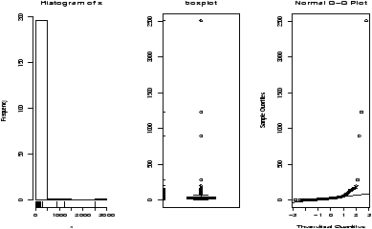

Figure 38: Executive pay data

we see a heavily skewed distribution as we might expect. A transformation is called for, let's try the logarithmic transformation (base 10). Since some values are 0 (these CEO's are directly compensated less than $100,000 or perhaps were forced to return all profits in a plea arrangement to stay out of jail), we ask not to include these.

> log.exec.pay = log(exec.pay[exec.pay >0])/log(10) # 0 is a problem

> simple.eda(log.exec.pay)

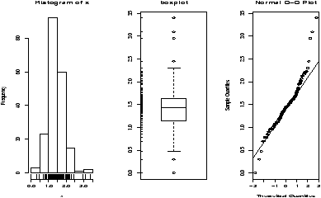

Figure 39: Executive pay after log transform

This is now very symmetric and gives good insight into the actual distribution. (Almost log normal, which says that after taking a logarithm, it looks like a normal.) Any analysis will want to use resistant measures such as the median or a transform prior to analysis.

Example: Taxi time at EWR  
The dataset [ewr](https://www.rdocumentation.org/packages/UsingR/versions/2.0-5/topics/ewr) contains taxi in and taxi out times at Newark airport (EWR). Let's see what the trends are.

> data(ewr)

> names(ewr) # only 3-10 are raw data

[1] "Year" "Month" "AA" "CO" "DL" "HP" "NW"

[8] "TW" "UA" "US" "inorout"

> airnames = names(ewr) # store them for later

> ewr.actual = ewr[,3:10] # get the important columns

> boxplot(ewr.actual)

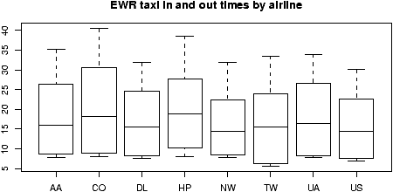

Figure 40: Taxi in and out times at Newark Airport (EWR)

All of them look skewed. Let's see if there is a difference between taxi in and out times.

> par(mfrow=c(2,4)) # 2 rows 4 columns

> attach(ewr)

> for(i in 3:10) boxplot(ewr[,i] ~ as.factor(inorout),main=airnames[i])

> detach(ewr)

> par(mfrow=c(1,1)) # return graphics as is (or close window)

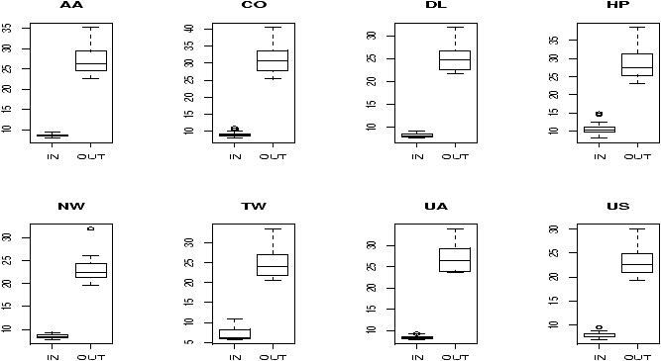

Figure 41: Taxi in and taxi out by airline at EWR

(The third line is the only important one. Here we used the boxplot command with the model notation -- of the type boxplot(y ~ x) -- which when x is a factor, does separate boxplots for each level. The command as.factor ensures that the variable inorout is a factor. Also note, we used a for loop to show all 8 plots.  
  
Notice the taxi in times are more or less symmetric with little variation (except for HP -- America West -- with a 10 minute plus average). The taxi out times have a heavy tail. At EWR, when the airport is busy, the planes can really backup and the 30 minute wait is not unusual. The data for Northwest (NW) seems to be less. We can compare this using statistical tests. Since the distributions are skewed, we may wish to compare the medians. (In general, be careful when applying statistical tests to summarized data.)

Example: Symmetric or skewed, Long or short?  
For unimodal data, there are 6 basic possibilities as it is symmetric or skewed, and the tails are short, regular or long. Here are some examples with random data from known distributions (figure [42](http://www.math.csi.cuny.edu/Statistics/R/simpleR/stat009.html#fig:eda-skewed-short)).

## symmetric: short, regular then long

> X=runif(100);boxplot(X,horizontal=T,bty=n)

> X=rnorm(100);boxplot(X,horizontal=T,bty=n)

> X=rt(100,2);boxplot(X,horizontal=T,bty=n)

## skewed: short, regular then long

# triangle distribution

> X=sample(1:6,100,p=7-(1:6),replace=T);boxplot(X,horizontal=T,bty=n)

> X=abs(rnorm(200));boxplot(X,horizontal=T,bty=n)

> X=rexp(200);boxplot(X,horizontal=T,bty=n)

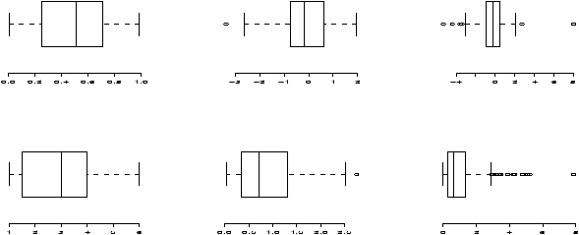

Figure 42: Symmetric or skewed; short, regular or long

**4.3  Problems**

**4.1**

Attach the data set **babies** (dataset is part of UsingR library which must install. The documentation of the library is included in Lab 4 file). Describe the distributions of the variables birth weight (bwt), gestation, age, height and weight.

**4.2**

The Simple data set iq contains simulated scores on a hypothetical IQ test. What analysis is appropriate for measuring the center of the distribution? Why? (Note: the data reads in as a list.)

**4.3**

The Simple data set slc contains data on red blood cell sodium-lithium countertransport activity for 190 individuals. Describe the shape of the distribution, estimate the center, state what is an appropriate measure of center for this data.

**4.4**

The *t* distribution will be important later. It depends on a parameter called the degrees of freedom. Use the rt(n,df) function to investigate the *t*-distribution for n=100 and df=2, 10 and 25.

**4.5**

The 2 distribution also depends on a parameter called the degrees of freedom. Use the rchisq(n,df) function to investigate the 2 distribution with n=100 and df=2,10 and 25.

**4.6**

The R dataset trees contains girth (diameter), height and volume (of boardfeet) measurements for several trees of a species of cherry tree. Describe the distributions of each of these 3 variables. Are any long tailed, short-tailed, skewed?

**4.7**

The Simple dataset dowdata contains the Dow Jones numbers from January 1999 to October 2000 and it is part of the library “UsingR”. To access the dataset you need to install this library and activate it. The Black-Scholes theory is modeled on the assumption that the changes in the data within a day should be log normal. In particular, if *Xn* is the value on day *n* then log(*Xn*/*Xn*-1) should be normal. Investigate this as follows

> install.packages(‘UsingR’)

> library(UsingR)

> data(dowdata)

> x = dowdata[['Close']] # look at daily closes

> n = length(x) # how big is x?

> z = log(x[2:n]/x[1:(n-1)) # This does X_n/X_(n-1)

Now check if z is normal. What do you see?

**4.8**

The children's game of Chutes and Ladders can be simulated easily in R. The time it takes for a player to make it to the end has an interesting distribution. To simulate the game, you can use the Simple function simple.chutes as follows.

> results=c()

> for(i in 1:200) results[i]=length(simple.chutes(sim=TRUE))

> hist(results)

Describe the resulting distribution in words. What percentage of the time did it take more than 100 turns? What is the median and compare it to the mean of your sample.  
  
To view a trajectory (the actual dice rolls), you can just plot as follows

> plot(simple.chutes(1))

**Data set with Mothers and Babies data from Child Health and Development Study**

**Description**

The babies data frame has 1236 rows and 7 columns.

**Usage**

data(babies)

**Format**

This data frame contains the following columns:

bwt

a numeric vector

gestation

a numeric vector

parity

a numeric vector

age

a numeric vector

height

a numeric vector

weight

a numeric vector

smoke

a numeric vector

**Details**

See [http://www.stat.Berkeley.EDU/users/statlabs/labs.html](http://www.stat.berkeley.edu/users/statlabs/labs.html) for a thorough description.

**Source**

Borrowed from Nolan and Speeds StatLabs datasets. [http://www.stat.Berkeley.EDU/users/statlabs/](http://www.stat.berkeley.edu/users/statlabs/)

**Examples**

data(babies)

pairs(babies)