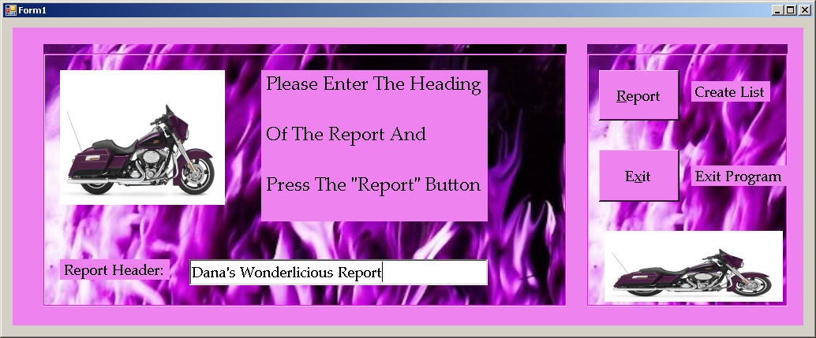

*This Is a GUI User manual.*

*Below are pictures and step by step instructions to help you use this product.*

*STEP 1*

*Type in a report name.*

*STEP 2*

*Click on the Report Button.*

*STEP 3*

*Click on the Exit Button.*

*STEP 4*

*Search the Directory for the output file.*

***STEP 2: Click the Report Button to make an output file***

***STEP 1: Type any Report Heading name in the Text Box HERE. Click on Text Box with curser to clear.***

**The next screen appears:**

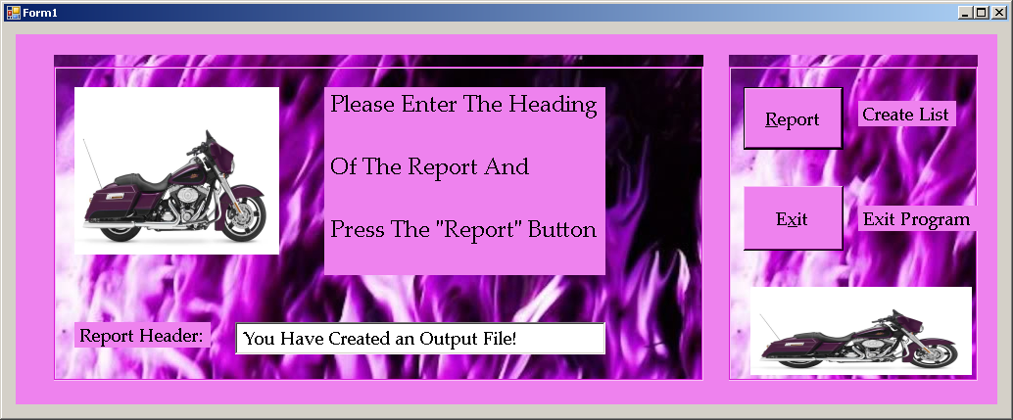

***A message appears, letting you know that you have succeeded in transferring your data. A new output file is created.***

***STEP 3: Click the Exit Button to escape from Application.***

To produce reports, an input file is used. Here is a sample:

***Manufacturer ID Number:***

***4 Digit Number***

***Product Description:***

***Maximum of 31 characters***

***Product ID Number:***

***5 Digit Integer***

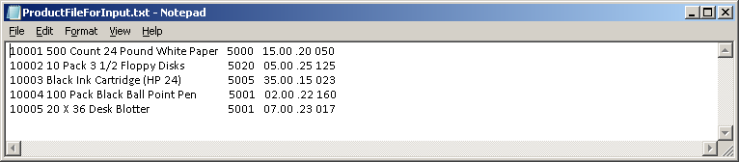

***Product Markup Percentage:***

***2 decimal places***

***Product Wholesale Price:***

***2 decimal places***

***Product Quantity:***

***3 digit integer***