Database Design Document
MoMo SMS Data Processing System
Team 8
Olivier Dusabamahoro
Daniel Kenny Kamanzi
Divin Manzi Mulinda Elvis

Week 2 — Database Design and Implementation
MySQL 8.0 · September 2026
Submission Links
GitHub Repository | https://github.com/dkamanzi-dot/MOMO-Team-8
Scrum Board | https://github.com/users/dkamanzi-dot/projects/1
Team Participation Sheet | [paste the Google Sheets link here]

1. System Overview
The MoMo SMS Data Processing System ingests mobile money SMS records stored in XML, normalises them, classifies each transaction, and stores the result in a relational database that backs an analytics dashboard. This document covers the database layer: the entity-relationship design, the MySQL implementation, the data dictionary, the integrity rules, and the JSON serialisation used by the API.
The schema holds five tables. Four are the entities required by the specification — transactions, users, transaction categories, and system logs — and the fifth is the junction table that resolves the many-to-many relationship between transactions and categories.
Table | Purpose | Primary key
users | Customers, merchants, and agents appearing as parties to a transaction | user_id
transactions | Core transaction facts: amount, parties, status, balances, original SMS | transaction_id
transaction_categories_lookup | Controlled vocabulary of payment and transfer types | category_id
transaction_categories | Junction resolving the transaction-to-category M:N relationship | (transaction_id, category_id)
system_logs | Audit trail of ETL pipeline runs | log_id

2. Entity Relationship Diagram
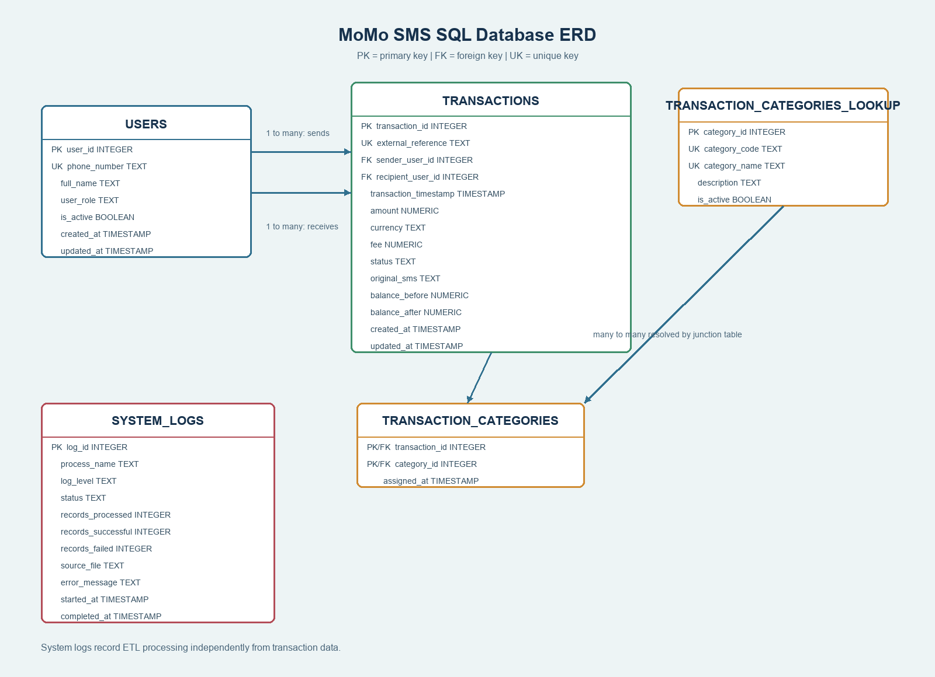
Figure 1 — MoMo SMS database ERD. PK = primary key, FK = foreign key, UK = unique key.

2.1 Relationships and cardinality
Relationship | Cardinality | Meaning
users → transactions (sender) | 1 : M | One user sends many transactions. sender_user_id is nullable because some SMS records omit the paying party.
users → transactions (recipient) | 1 : M | One user receives many transactions. Nullable for transactions with no counterparty, such as airtime purchases.
transactions ↔ transaction_categories_lookup | M : N | Resolved through the transaction_categories junction table. A transaction may carry more than one classification, and each category applies to many transactions.
transactions → transaction_categories | 1 : M | Junction rows cascade on delete, so removing a transaction removes its classifications.
transaction_categories_lookup → transaction_categories | 1 : M | Delete is restricted, so a category in use cannot be removed and history stays interpretable.
system_logs | standalone | Deliberately unrelated to business records — a run can process many transactions and can fail before any transaction is written.

2.2 The many-to-many relationship
A single SMS record often satisfies more than one classification. A reversed bill payment, for example, is both a bill payment and a person-to-person movement of funds. Storing a single category_id column on transactions would force one of those to be discarded, so the relationship is resolved with the transaction_categories junction table. Its composite primary key (transaction_id, category_id) makes duplicate assignment of the same category to the same transaction impossible at the storage level, without any application-side check.

3. Design Rationale
The schema separates people, transaction facts, category definitions, and processing history so that each concept has exactly one owner. A transaction stores its sender and recipient as foreign keys rather than repeating phone numbers and names in every row. This preserves referential integrity, keeps a customer's details in one place when they change, and allows a single customer record to participate in many transactions.
The category lookup table keeps payment types consistent across the pipeline and makes it possible to introduce a new category without altering the transactions table. Because a transaction may need more than one classification while each category applies to many transactions, transaction_categories resolves that many-to-many relationship using a composite key that also prevents duplicate assignments.
system_logs is kept independent of the business records on purpose. One ETL run processes many transactions and may fail before a single transaction row is written, so tying log entries to transaction rows would lose exactly the runs that matter most when something goes wrong. Keeping the table standalone means a failed import is still fully recorded.
Monetary values use DECIMAL(12,2) rather than a floating-point type, so amounts and fees remain exact through repeated aggregation — an essential property for financial data. Identifiers are surrogate INT AUTO_INCREMENT keys, which keep joins narrow and stay stable even if a provider reference is later corrected. The natural key external_reference carries a UNIQUE constraint instead, which makes re-running an import idempotent: a repeated SMS record is rejected rather than silently duplicated.
Referential actions were chosen to protect history. Deletes on users and transaction_categories_lookup are restricted so that historical transactions never lose their meaning, while junction rows cascade when their parent transaction is removed. Users are deactivated through the is_active flag rather than deleted. Indexes cover the columns the dashboard actually filters and joins on — timestamp, both party columns, status, category, and the ETL monitoring pair (process_name, status). Every column carries a MySQL COMMENT, so the schema documents itself through SHOW FULL COLUMNS and the data dictionary in this document can be regenerated directly from the live database.

4. Data Dictionary

4.1 users
Senders and recipients extracted from MoMo SMS records.
Column | Type | Constraints | Description
user_id | INT | PK, AUTO_INCREMENT | Surrogate primary key for a MoMo account holder
phone_number | VARCHAR(15) | NOT NULL, UNIQUE, CHECK | MSISDN in local format; unique so one account maps to one person. Length 10–15.
full_name | VARCHAR(120) | NOT NULL, CHECK | Display name parsed from the SMS body; cannot be blank or whitespace
user_role | VARCHAR(20) | NOT NULL, CHECK | Party type: customer, merchant, agent, or system. Default customer.
is_active | BOOLEAN | NOT NULL | Soft-delete flag; accounts are deactivated, never removed. Default TRUE.
created_at | DATETIME | NOT NULL | Row insertion time. Default CURRENT_TIMESTAMP.
updated_at | DATETIME | NOT NULL | Last modification time, maintained via ON UPDATE CURRENT_TIMESTAMP

4.2 transaction_categories_lookup
Reference list of payment and transfer types.
Column | Type | Constraints | Description
category_id | INT | PK, AUTO_INCREMENT | Surrogate primary key for a transaction category
category_code | VARCHAR(30) | NOT NULL, UNIQUE | Stable machine-readable code used by the ETL categoriser
category_name | VARCHAR(60) | NOT NULL, UNIQUE | Human-readable category label shown in the dashboard
description | VARCHAR(255) | NULL | Explanation of what belongs in this category
is_active | BOOLEAN | NOT NULL | Allows retiring a category without losing historical links. Default TRUE.

4.3 transactions
Core mobile money transaction records.
Column | Type | Constraints | Description
transaction_id | INT | PK, AUTO_INCREMENT | Surrogate primary key for a single transaction
external_reference | VARCHAR(50) | NOT NULL, UNIQUE | Provider reference from the SMS; unique to make imports idempotent
sender_user_id | INT | FK → users | Paying party; NULL when the SMS omits the sender. ON DELETE RESTRICT.
recipient_user_id | INT | FK → users | Receiving party; NULL for airtime and similar. ON DELETE RESTRICT.
transaction_timestamp | DATETIME | NOT NULL | Moment the transaction occurred, per the SMS
amount | DECIMAL(12,2) | NOT NULL, CHECK ≥ 0 | Principal transferred, excluding fee
currency | CHAR(3) | NOT NULL, CHECK | ISO 4217 currency code; exactly three characters. Default RWF.
fee | DECIMAL(12,2) | NOT NULL, CHECK ≥ 0 | Service charge applied to the transaction. Default 0.00.
status | VARCHAR(20) | NOT NULL, CHECK | Lifecycle state: pending, success, failed, or reversed. Default success.
original_sms | TEXT | NOT NULL | Raw SMS body retained for auditing and reprocessing
balance_before | DECIMAL(12,2) | NULL, CHECK ≥ 0 | Sender balance before the transaction, when reported
balance_after | DECIMAL(12,2) | NULL, CHECK ≥ 0 | Sender balance after the transaction, when reported
created_at | DATETIME | NOT NULL | Row insertion time. Default CURRENT_TIMESTAMP.
updated_at | DATETIME | NOT NULL | Last modification time, maintained automatically by MySQL

4.4 transaction_categories (junction table)
Resolves the M:N relationship between transactions and categories.
Column | Type | Constraints | Description
transaction_id | INT | PK, FK → transactions | Classified transaction. ON DELETE CASCADE.
category_id | INT | PK, FK → lookup | Assigned category. ON DELETE RESTRICT.
assigned_at | DATETIME | NOT NULL | When the categoriser assigned this category. Default CURRENT_TIMESTAMP.

4.5 system_logs
Audit trail of ETL pipeline runs.
Column | Type | Constraints | Description
log_id | INT | PK, AUTO_INCREMENT | Surrogate primary key for one ETL run entry
process_name | VARCHAR(60) | NOT NULL | Pipeline stage: xml_import, normalization, categorization, json_export
log_level | VARCHAR(10) | NOT NULL, CHECK | Severity: DEBUG, INFO, WARNING, ERROR, CRITICAL. Default INFO.
status | VARCHAR(20) | NOT NULL, CHECK | Run outcome: started, success, partial_failure, failed
records_processed | INT | NOT NULL, CHECK ≥ 0 | Total records read during the run
records_successful | INT | NOT NULL, CHECK ≥ 0 | Records written without error
records_failed | INT | NOT NULL, CHECK ≥ 0 | Records rejected during the run
source_file | VARCHAR(255) | NULL | Input or output file the run operated on
error_message | TEXT | NULL | Failure detail captured when status is not success
started_at | DATETIME | NOT NULL | Run start time. Default CURRENT_TIMESTAMP.
completed_at | DATETIME | NULL | Run completion time; NULL while still running

4.6 Indexes
Index | Column(s) | Query it supports
idx_transactions_timestamp | transaction_timestamp | Date-range filters and time-series charts
idx_transactions_sender | sender_user_id | Per-customer outgoing history
idx_transactions_recipient | recipient_user_id | Per-customer incoming history
idx_transactions_status | status | Dashboard filters on pending and failed transactions
idx_transaction_categories_category | category_id | Reverse lookup: all transactions in a category
idx_system_logs_process_status | process_name, status | ETL monitoring: failures for a given pipeline stage

5. Sample Queries and CRUD Testing
The database was created by running the setup script against MySQL 8.0:
mysql -u root -p < database/database_setup.sql
mysql -u root -p momo_transactions -e "SHOW TABLES;"

[ SCREENSHOT 1 ]
Terminal output of the setup script running, followed by SHOW TABLES;
listing all five tables.
(delete this box and paste the screenshot here)

5.1 READ — transactions with parties and categories
This join exercises both foreign keys to users and the junction table, returning every transaction with its sender, recipient, and all assigned categories.
SELECT t.external_reference,
s.full_name AS sender,
r.full_name AS recipient,
t.amount,
GROUP_CONCAT(c.category_name ORDER BY c.category_name SEPARATOR ', ') AS categories
FROM transactions t
LEFT JOIN users s ON s.user_id = t.sender_user_id
LEFT JOIN users r ON r.user_id = t.recipient_user_id
JOIN transaction_categories tc ON tc.transaction_id = t.transaction_id
JOIN transaction_categories_lookup c ON c.category_id = tc.category_id
GROUP BY t.transaction_id, t.external_reference, s.full_name, r.full_name,
t.amount, t.transaction_timestamp
ORDER BY t.transaction_timestamp;

[ SCREENSHOT 2 ]
Result set showing five transactions. Note TXN-20260903-0001 returning
two categories, which demonstrates the M:N relationship working.
(delete this box and paste the screenshot here)

5.2 CREATE — insert a new user
INSERT INTO users (phone_number, full_name, user_role)
VALUES ('0781000006', 'Diane Ingabire', 'customer');

SELECT * FROM users WHERE phone_number = '0781000006';

[ SCREENSHOT 3 ]
Insert confirmation and the new row, showing the auto-generated user_id
and the automatic created_at / updated_at timestamps.
(delete this box and paste the screenshot here)

5.3 UPDATE — confirm a pending transaction
UPDATE transactions SET status = 'success' WHERE transaction_id = 4;

SELECT transaction_id, status, created_at, updated_at
FROM transactions WHERE transaction_id = 4;

[ SCREENSHOT 4 ]
The status changed to success, with updated_at now later than created_at —
proving the ON UPDATE CURRENT_TIMESTAMP clause fires.
(delete this box and paste the screenshot here)

5.4 DELETE — remove one classification
DELETE FROM transaction_categories
WHERE transaction_id = 5 AND category_id = 1;

[ SCREENSHOT 5 ]
One junction row removed while the transaction itself survives, demonstrating
that classifications are independent of the transaction record.
(delete this box and paste the screenshot here)

5.5 Aggregate — transaction volume by category
SELECT c.category_name,
COUNT(*) AS transaction_count,
SUM(t.amount) AS total_amount,
ROUND(AVG(t.amount), 2) AS average_amount
FROM transaction_categories tc
JOIN transaction_categories_lookup c ON c.category_id = tc.category_id
JOIN transactions t ON t.transaction_id = tc.transaction_id
WHERE t.status = 'success'
GROUP BY c.category_id, c.category_name
ORDER BY total_amount DESC;

[ SCREENSHOT 6 ]
Aggregated totals per category — the query backing the dashboard's
summary view.
(delete this box and paste the screenshot here)

6. Integrity and Security Rules
The schema enforces correctness at the storage layer rather than relying on application code, so invalid data is rejected regardless of which client writes it. The rules below are grouped by the failure each one prevents.
Rule | Mechanism | What it prevents
Unique phone number | UNIQUE | Two user records for the same MoMo account, which would split one person's history
Unique external reference | UNIQUE | Duplicate imports of the same SMS; makes re-running the ETL idempotent
No self-transfer | chk_transactions_no_self_transfer | A user sending money to themselves — impossible in the business domain and a sign of a parsing error
Non-negative money | CHECK amount ≥ 0, CHECK fee ≥ 0 | Negative amounts or fees corrupting every downstream aggregate
Non-negative balances | CHECK ≥ 0 (nullable) | Impossible reported balances, while still allowing NULL when the SMS omits them
Controlled status | CHECK status IN (…) | Typos such as 'succes' creating a silent extra category in reports
Controlled role | CHECK user_role IN (…) | Undefined party types entering the pipeline
Controlled log level | CHECK log_level IN (…) | Unrecognised severities breaking log filtering and alerting
Valid currency | CHECK CHAR_LENGTH = 3 | Malformed currency codes that would not map to ISO 4217
Non-blank name | CHECK TRIM length > 0 | Whitespace-only names passing a plain NOT NULL check
Log counts balance | chk_logs_counts_balance | A run reporting more successes plus failures than records actually read
Referential integrity | FOREIGN KEY (InnoDB) | Transactions pointing at users who do not exist
Restricted deletes | ON DELETE RESTRICT | Deleting a user or category still referenced by historical transactions
Cascading junction | ON DELETE CASCADE | Orphaned classification rows after a transaction is removed
No duplicate category | Composite PK | Assigning the same category twice to one transaction
Soft delete | is_active flag | Permanent loss of account records; users are deactivated instead

6.1 Demonstrating the rules reject bad data
Each statement below is expected to fail. The error message is the evidence that the rule is enforced by the database itself.
-- Violates chk_transactions_no_self_transfer
INSERT INTO transactions (external_reference, sender_user_id, recipient_user_id,
transaction_timestamp, amount, original_sms)
VALUES ('TXN-FAIL-01', 1, 1, '2026-09-04 10:00:00', 5000.00, 'self transfer');

[ SCREENSHOT 7 ]
ERROR 3819: Check constraint 'chk_transactions_no_self_transfer'
is violated.
(delete this box and paste the screenshot here)

-- Violates the UNIQUE constraint on phone_number
INSERT INTO users (phone_number, full_name)
VALUES ('0781000001', 'Duplicate Account');

[ SCREENSHOT 8 ]
ERROR 1062: Duplicate entry '0781000001' for key
'users.phone_number'.
(delete this box and paste the screenshot here)

-- Violates chk_transactions_amount
INSERT INTO transactions (external_reference, sender_user_id, recipient_user_id,
transaction_timestamp, amount, original_sms)
VALUES ('TXN-FAIL-02', 1, 2, '2026-09-04 11:00:00', -500.00, 'negative amount');

[ SCREENSHOT 9 ]
ERROR 3819: Check constraint 'chk_transactions_amount' is violated.
(delete this box and paste the screenshot here)

-- Violates the foreign key on sender_user_id
INSERT INTO transactions (external_reference, sender_user_id, recipient_user_id,
transaction_timestamp, amount, original_sms)
VALUES ('TXN-FAIL-03', 999, 2, '2026-09-04 12:00:00', 1000.00, 'ghost sender');

[ SCREENSHOT 10 ]
ERROR 1452: Cannot add or update a child row: a foreign key
constraint fails.
(delete this box and paste the screenshot here)

-- Violates ON DELETE RESTRICT
DELETE FROM users WHERE user_id = 1;

[ SCREENSHOT 11 ]
ERROR 1451: Cannot delete or update a parent row: a foreign key
constraint fails.
(delete this box and paste the screenshot here)

7. JSON Data Modelling
The API serialises the normalised relational model into nested JSON. The full schema and examples live in examples/json_schemas.json. Two transformations happen during serialisation: foreign keys become embedded objects, and junction rows become an array.

7.1 SQL-to-JSON mapping
SQL structure | JSON representation | Transformation
users` row | user` object | Direct field mapping
transactions.sender_user_id | transaction.sender | FK expanded into a nested object
transactions.recipient_user_id | transaction.recipient | FK expanded; null when absent
transaction_categories` rows | transaction.categories[] | Junction rows collapsed into an array of category objects
DECIMAL(12,2) | number | Serialised with two decimal places preserved
DATETIME | string | Rendered as an ISO 8601 timestamp
BOOLEAN (tinyint) | boolean | Emitted as JSON true / false
system_logs` row | system_log` object | Direct mapping; stays a flat sibling, never nested under a transaction

7.2 Complete transaction object
This example shows a single transaction carrying its sender, its recipient, and two categories — the full M:N relationship resolved into one API response.
{
"transaction_id": 5,
"external_reference": "TXN-20260903-0001",
"transaction_timestamp": "2026-09-03T14:20:00Z",
"amount": 5000.00,
"currency": "RWF",
"fee": 50.00,
"status": "reversed",
"original_sms": "Reversed bill payment of 5,000 RWF.",
"sender": {
"user_id": 1,
"phone_number": "0781000001",
"full_name": "Aline Uwase",
"user_role": "customer",
"is_active": true
},
"recipient": null,
"categories": [
{
"category_id": 3,
"category_code": "BILL",
"category_name": "Bill Payment",
"description": "Payment to a biller or service provider"
},
{
"category_id": 1,
"category_code": "P2P",
"category_name": "Person to Person",
"description": "Transfer between individual customers"
}
]
}

The recipient: null field reflects the nullable recipient_user_id foreign key, and the two-element categories array is exactly the pair of junction rows for transaction 5. The schema validates these structures with additionalProperties: false, so a field the database does not define cannot silently enter an API response.

8. Repository Contents
Path | Contents
database/database_setup.sql | MySQL DDL, constraints, indexes, and seed data for all five tables
docs/erd_diagram.png | Entity relationship diagram (Figure 1)
docs/erd_diagram.md | Mermaid source for the ERD, rendered by GitHub
docs/AI_USAGE_LOG.md | Record of AI tool use, per the course policy
examples/json_schemas.json | JSON Schema definitions and serialised examples
README.md | Project overview, schema summary, and design rationale
etl/ | XML parsing, normalisation, and categorisation pipeline
api/ | REST API exposing the serialised transaction data

Before submitting: replace each of the eleven screenshot boxes with the real terminal capture, add the team participation sheet link on the cover page, and delete this note. Screenshots 7–11 are the ones the specification asks for under “unique rules added to enhance security and accuracy of the DB”.

