Intetics · SmartLab / DataVest
DataVest Brew
An MES for breweries: the plain-language overview

Document date: 21 October 2026
Prepared by: Dzmitry, Intetics
Classification: Internal
Reading time: About 15 minutes

Exported from the Claude Doc “Brewery Process Intelligence Platform”, tab “Overview (EN)”. Diagrams are images; text and tables are editable.

Contents
Right-click and choose Update Field to build the table of contents.

DataVest Brew: the plain-language overview
This document explains the idea simply, in about fifteen minutes of reading. The detailed architecture and the prototype brief are separate documents.

The idea in one paragraph
DataVest Brew is a cloud MES for breweries. An MES (manufacturing execution system) runs production: it connects equipment, the lab and people on the floor. It is not an accounting system (ERP) like Breww. A brewery gets:
- plug-and-play connection of sensors and equipment: E+H sensors, and controllers over OPC UA, Modbus TCP and Profinet;
- a LIMS-grade lab and quality management: yeast, plating, PCR, tasting panels;
- production functions: tech cards, a CIP log and schedule, tasks, packaging release and excise calculation;
- alerts and forecasts from accumulated data: fermentation progress, deviations, and later taste.
We start with beer and E+H sensors, and build the product together with E+H. The same base fits other fermentation-based production such as wine, cider, kvass and kombucha. That is the next step.
Our goal: the brewery sees all of production in one place: equipment, lab, quality and documents. The system warns about problems itself and shows what will happen next.

The problem we solve
- Equipment and data are not connected. Sensors, tank controllers and the lab work separately. Bringing the data together takes an integrator and long setup.
- Lab data is scattered. Yeast generations, plating, PCR tests and tastings live in notebooks and spreadsheets. They are hard to link to the batch and to sensor data.
- Production processes run by hand. The CIP schedule, shift tasks, packaging release and excise calculation sit on paper or in separate tools.
- Few forecasts. The brewer wants to know when a batch will be ready and how the beer will turn out. Today this is only visible at the end.
- Sensor accuracy needs proof. Sensors are adjusted and checked regularly, but the results are not kept in one log.

What E+H offers today

The QWX43 fermentation monitor
The QWX43 sits inside the tank. It runs continuously and produces time series. It measures four physical values.
Value | What it shows
Density | The rate of fall shows yeast activity. If density stays flat for 1–2 days, main fermentation has ended
Viscosity | Depends on temperature, sugars and high-molecular compounds. It indirectly shows filtration quality and how fast yeast settles
Sound velocity | Helps split density into its “sugar” and “alcohol” parts. A sharp change means pumping or a change of medium: beer, water, cleaning solution. This is how a new batch and a CIP run are recognised
Temperature | The main parameter for controlling fermentation. The cooling automation needs it to prevent overheating
Derived values come from these measurements.
Value | How it is obtained
Alcohol (by volume and by mass) | From the change in density and sound velocity. It shows how alcohol builds up, so the style can be tracked without samples
Residual and original extract | Residual density minus the density of accumulated alcohol, calculated automatically
Degree of fermentation | (original extract − residual extract) / original extract
Fermentable and non-fermentable sugars | One value at the end of fermentation, not a time series
Fermentation rate | How fast density falls

How the sensor is maintained
- According to E+H, the sensor has no limited service life. It only needs replacing after physical damage.
- No calibration is needed.
- The sensor is adjusted against water and a reference wort sample. This is the Offset procedure: the device compares its values with lab values and corrects them.
- E+H recommends checking accuracy regularly against air and distilled water. No interval is given, so recommending one can be part of our product.
- Fouling is unlikely, because the sensor is cleaned with the tank during CIP. Beer stone or a yeast film could form in theory, but a visual check finds them quickly and cheaply.

Other E+H sensors and the app
E+H also makes sensors for pH, oxygen and CO₂, with their own connection system.
The QWX43 has an app, Netilion Fermentation. It shows tanks, batches and recipes, compares a batch with a reference batch, and opens and closes batches automatically. It shows error codes and sends an e-mail when a value crosses a threshold.
What a brewery needs | What E+H offers | Comment
Connect sensors and controllers from different makers | E+H devices only, in their own system | Our main point
Offset and accuracy-check log | Not found; to verify | We can recommend check intervals
Lab: yeast, plating, PCR, tastings | No | Our key module
Production: CIP, tasks, packaging, excise | No | MES functions
Batch readiness forecast and AI assistant | No | From accumulated data
Compare batches of one recipe | Reference batch only | Within the brewery
This table needs checking in a Netilion trial account.

What others offer
- Breww is a brewery management system (ERP). It works on a paid subscription with prices on its website. The only free part is AI-assistant access to the data through MCP.
- PLAATO sells its own fermentation sensors (density and temperature) with analytics.
- FermentIQ is a new brewery management system, still in closed testing.
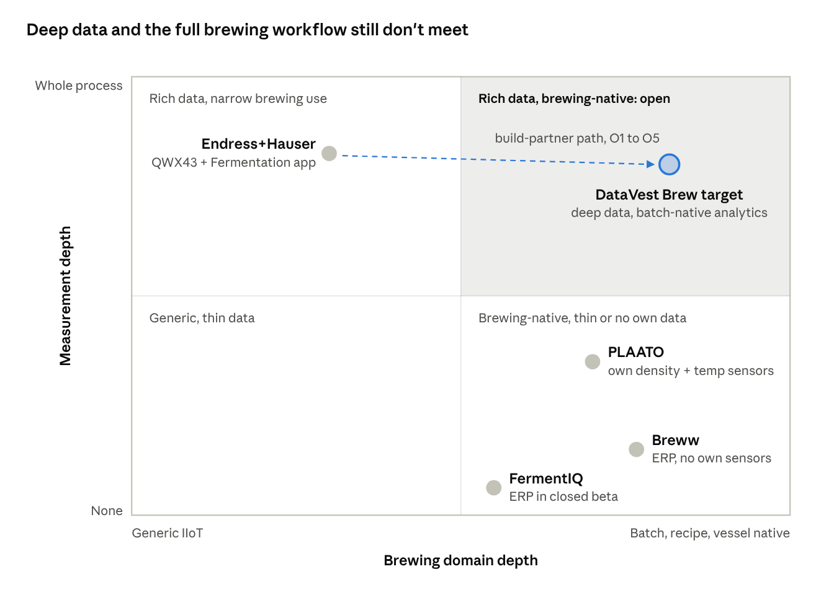
Figure 1. Where the players sit today
E+H has precise data but few services around it. Breww and PLAATO have a convenient workflow for the brewer but a weak link to industrial equipment.

What Breww has, and what we do
Breww module | What it does | What we do
Cleaning & Maintenance (CIP) | Sanitation log | The CIP log and schedule build themselves: the sensor sees the change of medium and its time. The detergent is entered by QR code or picked from an archive
Beer Duty | Tax and excise calculation | We do this too, from volumes and alcohol in the system
Packaging approval | Release to packaging after quality checks | We do this: a responsible person releases based on lab and sensor data
Tech cards | Raw-material norms, stage order | We do this
Planning and Batches | Production plan on a calendar | Later: AI-based planning (APS)
Vessel & Fermentation | Tanks and fermentation | We do this from sensor data
Packaging | Filling into containers | Packaging release in the MVP; packaging records later
Production Tasks | Production tasks | We do this
Reporting | Reports | We do this

Where we are stronger than Breww
- Industrial integration. Breww has no full integration over Modbus TCP, Profinet or OPC UA.
- Lab. In Breww, quality control means checklists and pass/fail fields. There are no yeast generations with viability charts, plating logs, PCR or blind tastings.
- Planning, later. Breww’s calendar is linear. If fermentation runs four days long, the brewer rebuilds all following brews and tank bookings by hand. Our AI-based planning (APS) will recalculate the chain itself.
- Forecasts from sensor data. Batch readiness and deviations are visible in advance.
- Breadth. Breww is tied tightly to beer. Our base also fits other fermentation-based production.

Comparison with Breww and PLAATO
“No data” means we found no public information. These cells need checking in demos.
What we compare | DataVest Brew | Breww | PLAATO
What it is | MES for production | Management system (ERP) | Own sensors plus analytics
Sensors and equipment | E+H sensors; PLCs over OPC UA, Modbus TCP, Profinet | Connects Plaato, Tilt, TankNet; no industrial protocols | Own density and temperature sensors
Lab | LIMS: yeast, plating, PCR, blind tastings | Pass/fail checklists | Intake from lab systems claimed
Production | CIP with auto-detection, tasks, packaging release, tech cards, excise | CIP, tasks, packaging, tech cards, excise, planning | No data
Forecasts | Fermentation and readiness; taste later | Fermentation curves; no forecast found | Deviation detection claimed
Sensor accuracy | Offset and check logs, accuracy analysis | No data | Drift detection claimed
Reports | Yes | Yes, a reporting section | No data
AI | Forecasts and an assistant that cites data | Free AI access through MCP | Copilot
Prices | Published tiers | Paid subscription, prices on the website | On request

Where we win
The order matters: the first item is the most important.
- Plug-and-play integration. Sensors and controllers connect without an integrator: OPC UA, Modbus TCP, Profinet and E+H sensors. This is the most important point.
- A LIMS-grade lab. Yeast generations and viability, plating and PCR logs, blind tasting panels, and tracking strain changes from brew to brew. This matters most to large breweries. Here we build on SmartLab experience.
- MES with alerts. CIP, tasks, packaging release and excise in one system. The system warns about problems itself.
- Forecasts from accumulated data. Batch readiness and deviations. Later, a taste forecast.
- Sensor accuracy service. Offset and accuracy-check logs, and recommended check intervals. Accuracy analysis across many breweries can help E+H engineers improve the sensor.
Some functions are needed but do not set us apart: the tank screen, reports and the batch quality document. Non-alcoholic beer control is one setting of a limit profile, not a main argument; small breweries rarely make such beer.

What the product does
The product has six modules on one platform.
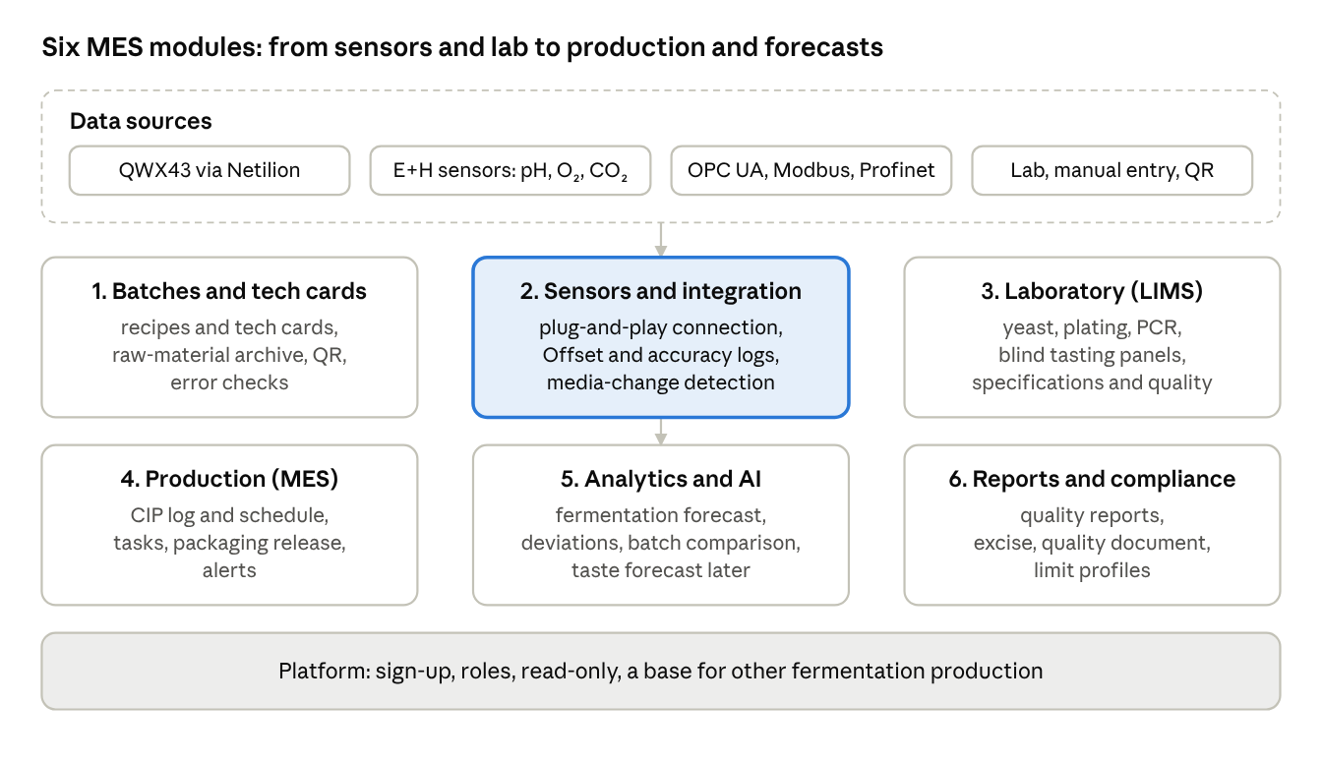
Figure 2. The product: six modules on one platform
- Batches and tech cards. The core entities are the batch, the recipe and the tech card. A tech card sets raw-material norms and stages: brewing, fermentation, dry hopping. Raw materials are recorded with quantity and supplier lot number. Raw-material and standard-component data is kept in an archive, so unchanged entries are picked with one tap. Forms can be filled by QR code. The software checks entries for errors.
- Sensors and integration. Plug-and-play connection:
  - the QWX43 through Netilion;
  - E+H pH, oxygen and CO₂ sensors through the E+H system;
  - controllers over OPC UA, Modbus TCP and Profinet.
- Readings arrive in real time. An Offset log has a form for the composition and properties of the reference wort. An accuracy-check log covers checks against air and distilled water, with reminders. Sound velocity tells the system when the medium changes. Sensors with consumable parts (pH meter, oxygen meter) get replacement recommendations. Offset is a routine procedure, so it raises no warnings.
- Laboratory and quality (LIMS). Yeast generations and viability charts. Plating and PCR logs. Blind tasting panels. Physical and chemical values. Recipe specifications and out-of-spec flags. Results from an outside lab can be entered.
- Production (MES). A CIP log and schedule: the system detects the change of medium itself, and the detergent is entered by QR code or picked from an archive. Production tasks. Packaging release: a responsible person approves after quality checks. Alerts.
- Analytics and AI. Forecast of fermentation and batch readiness. Deviation analysis that tells programmed temperature rests from faults. Comparison of batches of one recipe. An AI assistant that cites the data. Later: taste forecast, recipe recommendations, what-if and ML-based Offset adjustment during fermentation.
- Reports and compliance. Quality reports. A quality document for every batch. Excise calculation. Limit profiles, for example for non-alcoholic beer. An audit log.
Platform. Sign-up without a sales call, users and roles. The base is built on process templates, not hard-wired to beer, so it can move to other fermentation-based production.
One firm rule: the system reads data from equipment but controls nothing. It does not change temperatures, open valves or stop pumps.

Taste forecast (later)
The core is a machine-learning model, a regression or a neural network. It looks for non-linear links between physical and chemical values and tasting scores: bitterness, body, diacetyl, oxidation, viscosity, carbonation, sweetness, and yeast, hop and grain aromas.
The model takes live QWX43 data, such as the rate of density change, extract and temperature. It returns a forecast, for example: “this batch will most likely have bitterness X, body Y and diacetyl risk Z”. The operator can act before the beer is finished and before it reaches the tasting panel. A panel is expensive, infrequent and subjective.
The model needs data from many batches where tasting scores are linked to process data.

Common brewery problems and how to spot them
This is a draft to check with a brewing technologist.
Problem | How to spot it | Type of check | Likelihood
Fermentation runs slow or long | Density barely falls (QWX43) | Sensor | Possible
Wrong original gravity | Original extract (QWX43), hydrometer or refractometer | Sensor, lab | Possible
Under- or over-attenuation | Degree of fermentation and residual extract (QWX43) | Sensor | Possible
Alcohol does not match the label | Alcohol (QWX43), lab analysis | Sensor, lab | Possible
Buttery off-flavour (diacetyl) | VDK test, tasting | Lab, sensory | Possible
Infection | Sour taste, falling pH, plating or PCR | Lab, sensory | Possible
Oxidation (cardboard taste) | Oxygen at packaging (E+H sensor), tasting | Sensor, sensory | Possible
Haze where beer should be clear | Haze meter, viscosity (QWX43), visual check | Sensor, visual | Possible
Carbonation off target | CO₂ (E+H sensor), tank pressure | Sensor | Possible
Temperature out of range | Temperature sensor; the system must tell programmed rests from faults | Sensor | Unlikely: automation prevents it
Weak yeast | Slow start; cell count | Sensor, lab | Unlikely: yeast is tested before pitching
Film on the sensor | Visual check, gap to lab values | Visual | Rare: the sensor is cleaned in CIP

Values for the quality form
Also a draft to check with a technologist. The lab fills in what the brewery measures; other fields can be hidden.
Group | Values
Physical and chemical | Alcohol, original gravity, residual extract, pH, bitterness (IBU), colour (EBC), haze (EBC), CO₂, dissolved oxygen, diacetyl (VDK), foam stability
Yeast | Strain, generation, cell concentration, viability
Microbiology | Plating, PCR: spoilage organisms found or not
Sensory (blind panel) | Appearance, aroma, taste, bitterness, body, sweetness, carbonation, aftertaste, true to style
Off-flavours (tick) | Buttery, cooked corn, green apple, cardboard, lightstruck, sour, medicinal, sulphur, metallic, solvent

A day with DataVest Brew
- Head brewer, 8 a.m. Opens the tank screen. In one tank, density has barely fallen for three days: fermentation is running long. The assistant shows similar batches and suggests checking original gravity and the yeast. For a second tank there is a forecast: ready tomorrow around noon.
- Lab technician. Enters the yeast generation, viability and a plating result. The software shows how viability of this strain changes from generation to generation.
- Cellar operator. A tank has finished CIP. The system saw the change of medium and logged the clean itself. The operator scans the detergent’s QR code.
- Quality manager. Reviews the batch values and releases it to packaging. The quality document is generated automatically.
- Technologist. The system reminds him to check sensor accuracy against air and distilled water. He runs the check, and the result goes into the log.
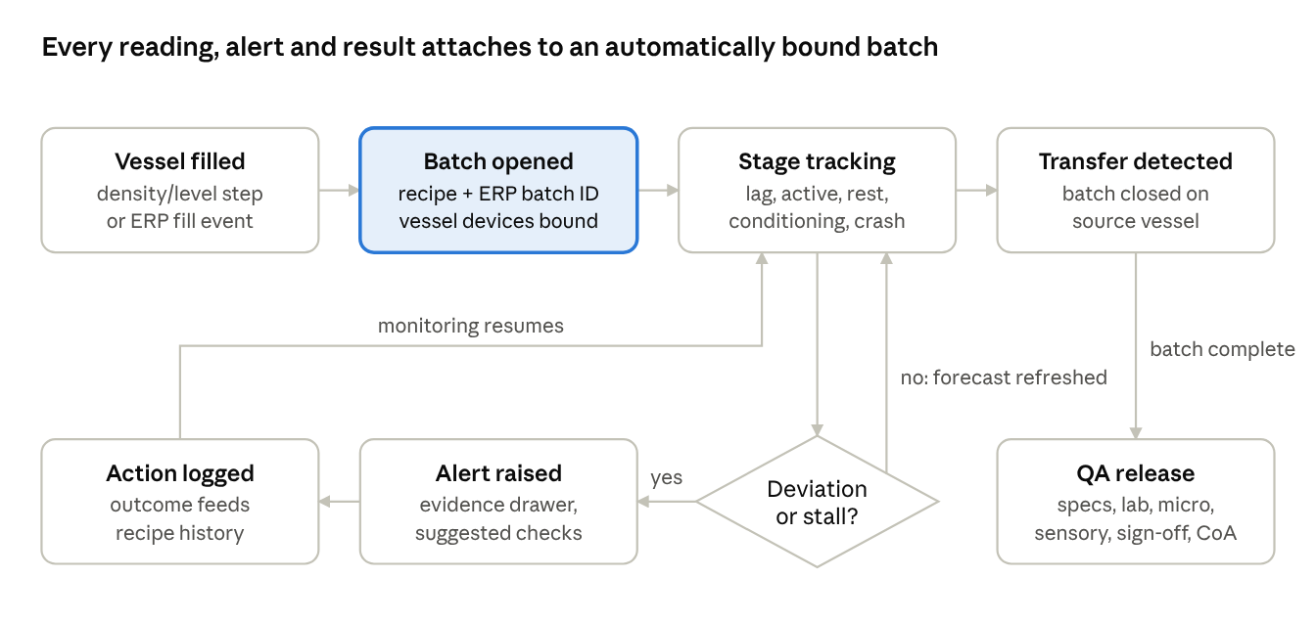
Figure 3. Life of a batch in DataVest Brew
The batch opens itself when the sensor sees the tank being filled. If something goes wrong, the system sends an alert. A person acts, and monitoring continues. When the beer moves on, the batch goes to release.

How it is built
- A cloud service that runs on any major cloud.
- Time series need a specialised time-series database. Options are TimescaleDB, InfluxDB and ClickHouse; the choice is made in Phase 0.
- The QWX43 sends its data to the E+H cloud itself. E+H pH, oxygen and CO₂ sensors connect through the E+H system.
- A small gateway is installed at the brewery for controllers. It reads data over OPC UA, Modbus TCP and Profinet and sends it outward only; nobody connects into the brewery network.
- Profinet is usually read through a gateway or the controller itself; this must be planned per site.
- Late and corrected entries are handled properly. For example, if an operator fixes a transfer time, every reading moves to the right batch.
- The AI assistant only reads data, and every answer names the records it relies on.
- Each brewery’s data is kept separate.

What we reuse from SmartLab and DataVest
DataVest is a pilot-stage product with one active engagement. We reuse designs and experience, not finished code:
- document management and quality control designs;
- SmartLab’s approach to lab data and audit trails;
- the data model and the approach to connecting equipment;
- monitoring screens;
- machine-learning experience.
The synthetic prototype data needs to be extended with media changes and CIP, lab data and production tasks.

Plan, cost and team
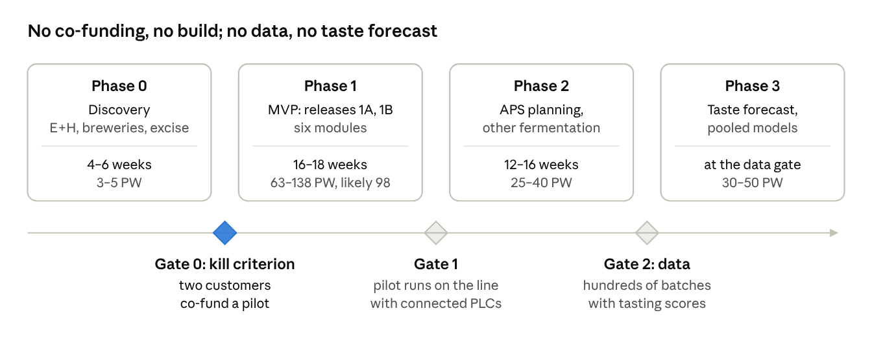
Figure 4. Plan: four phases, three decision gates
Phase | What happens | Time | Effort and cost at $60/hour
0. Discovery | Talk to E+H and breweries. Check excise and quality requirements. Build a clickable prototype. Find two pilot customers | 4–6 weeks | 3–5 person-weeks, $7,200–$12,000
1. Pilot product (MVP) | Six modules in two releases, 1A and 1B | 16–18 weeks | 63–138 person-weeks, most likely 98 ($235,200); about 113 with 15% contingency (about $270,000)
2. Wider product | AI-based planning (APS), other fermentation production, other sensor brands, sites of one company, strain change tracking | 12–16 weeks | 25–40 person-weeks
3. Learning models | Taste forecast, recipe recommendations, what-if, ML-based Offset, pooled models | when enough data exists | 30–50 person-weeks
Two releases inside the MVP:
- Release 1A, about 10 weeks: QWX43, OPC UA and Modbus TCP, batches and tech cards, the lab core (yeast, physical and chemical values), the CIP log, the Offset and accuracy logs, the fermentation forecast.
- Release 1B, a further 6–8 weeks: Profinet, E+H pH, oxygen and CO₂ sensors, excise calculation, packaging release, plating, PCR and tasting panels.
Largest pieces of Phase 1 work (most likely, in person-weeks):
Work | PW
Equipment connection: connectors and on-site gateway | 13
Laboratory (LIMS) | 8
Production: tech cards, CIP, tasks and release, excise | 13
User interface | 9
Analytics, forecasts and AI assistant | 9
Data model and batch context | 9
Offset and accuracy logs | 4
Platform, reports, alerts, raw-material entry | 15
Management, discovery, testing and security | 18
The pilot needs a team of about six: an architect, two integration and backend engineers, a frontend developer, a data and ML engineer, and a half-time tester and analyst. Hosting, AI usage and on-site gateways are paid separately.
We will judge the pilot by five numbers:
- connecting a sensor or controller takes less than a day, without an outside integrator;
- manual gravity samples fall by at least half;
- after 3 days of fermentation the readiness forecast is off by less than 12 hours;
- brewers find at least 70% of alerts useful;
- every batch has a quality document and a packaging release in the system.

What we need to check
Question | How we check
How does E+H handle Offset and QWX43 accuracy checks? Is there a log in Netilion? | Netilion trial, talk to E+H
How do E+H pH, oxygen and CO₂ sensors connect? | Documentation, ask E+H
Which controllers and protocols do the pilot breweries use? | Site surveys
Which country comes first for excise, and what are its rules? | Study the rules
What quality requirements apply in the EU and US? Who inspects, and how often are reports due? | Study the rules, check with the consultant
Who needs a LIMS: small, mid-sized or large breweries? | Brewery interviews
Does E+H want integration with Breww? | Talk to E+H
Which fermentation industries come next: wine, cider, kvass, kombucha? | Market analysis, talk to E+H
Who will be the first pilot customers? | Candidate list with E+H

What we already know about requirements
- EU, labels. Drinks above 1.2% alcohol must state it. For beer up to 5.5% the tolerance is ±0.5% vol.; for stronger beer ±1% vol. (Regulation (EU) 1169/2011, Annex XII).
- US, regulator. Beer is regulated by the TTB at the US Treasury; the FDA covers food safety.
- US, labels and reporting. The alcohol tolerance is ±0.3% vol. Brewers file a production report with the TTB, monthly at 10,000 barrels a year or more; smaller brewers may report quarterly.
- Excise. In some EU countries beer excise is based on original extract (degrees Plato), which the QWX43 measures. This needs checking by country.

Main risks
- E+H builds this itself. What we do: offer to build it for them.
- Integration over three protocols costs more than it looks. What we do: OPC UA and Modbus TCP in release 1A, Profinet in 1B; proven libraries and gateways.
- The MVP is large. What we do: two releases and a kill criterion before build starts.
- Overlap with Breww. What we do: no accounting features; focus on integration, the lab and forecasts.
- Excise rules differ by country. What we do: start with the pilot’s country.
- The LIMS mainly matters to large breweries, and small ones may not pay. What we do: pricing by module.
- The taste forecast needs a lot of data. What we do: place it in Phase 3 and say so openly.
- Forecasts are weak early in fermentation. What we do: show a range.
- We oversell DataVest. What we do: always describe it as pilot-stage.

What we need to decide now
- Open the conversation with E+H as build partner. Lead with Intetics’ ready groundwork in document management and quality control (SmartLab, DataVest), broad machine-learning capability and industrial integration.
- Get trial access to Netilion; check Offset and E+H sensor connectivity.
- Choose the first excise country and check its requirements.
- Find two pilot customers with E+H sensors willing to share costs. No build money is spent before that.
- Update the prototype and synthetic data to the six modules.

Glossary
Term | Meaning
MES | Manufacturing execution system: connects equipment, the lab and people on the floor
ERP | Business management system: orders, stock, finance
LIMS | Laboratory information management system: samples, tests, results
APS | Production planning that recalculates the schedule automatically
CIP | Cleaning equipment in place, without taking it apart
Offset | Sensor adjustment against water and reference wort: the device compares its values with lab values and corrects them
OPC UA, Modbus TCP, Profinet | Industrial protocols that controllers use to share data
PLC | Industrial controller that runs tanks and valves
ABV | Alcohol by volume, in percent
Extract, °P (degrees Plato) | How much sugar and other solids are in wort or beer; it falls as yeast turns sugar into alcohol
Degree of fermentation | The share of original extract already fermented
Yeast generation | How many times the yeast has been reused
PCR | A test that finds the DNA of spoilage organisms
IBU, EBC | Units of bitterness, colour and haze
VDK (diacetyl) | A buttery-tasting compound that should be gone by the end of maturation
MCP | Open standard that lets AI assistants read data from other software

Sources
- E+H: QWX43 Operating Instructions, BA02162F/00/EN/03.24.
- E+H: QWX43 introduction.
- Regulation (EU) 1169/2011, Annex XII.
- TTB: alcohol content on malt beverage labels.
- TTB: Brewer’s Report of Operations instructions.
- Input from a brewing domain expert.

