Intetics · SmartLab / DataVest
DataVest Brew
Brewery Process Intelligence Platform: solution architecture

Document date: 21 October 2026
Prepared by: Dzmitry, Intetics
Classification: Internal

Exported from the Claude Doc “Brewery Process Intelligence Platform”, tab “Solution architecture”. Diagrams are images; text and tables are editable.

Contents
Right-click and choose Update Field to build the table of contents.

Brewery Process Intelligence Platform — Solution Architecture

Executive summary
DataVest Brew is a cloud MES (manufacturing execution system) for breweries. It connects equipment, the lab and people on the production floor. It is not an ERP: orders, stock and finance stay in systems such as Breww. Beer is the first vertical; the platform is built on process templates so that other fermentation-based production (wine, cider, kvass, kombucha) can follow.
The product has six modules:
- Batches and tech cards.
- Sensors and integration.
- Laboratory and quality (LIMS).
- Production (MES).
- Analytics and AI.
- Reports and compliance.
What sets it apart, in priority order:
- Plug-and-play integration: E+H sensors (QWX43, pH, oxygen, CO₂) and controllers over OPC UA, Modbus TCP and Profinet, without an outside integrator.
- A LIMS-grade lab: yeast generations and viability, plating and PCR, blind tasting panels, strain tracking.
- MES functions tied to sensor data: a CIP log and schedule built from detected media changes, tasks, packaging release, tech cards, excise calculation.
- Forecasts from accumulated data: fermentation readiness and deviations now, taste later.
- Sensor accuracy service: Offset and accuracy-check logs, recommended check intervals, fleet-level accuracy analysis that can help E+H improve the sensor.
The tank board, reports, batch quality documents and limit profiles (for example non-alcoholic beer) are baseline features, not differentiators.
Commercial vehicle: Intetics as build partner to E+H. The main arguments are Intetics’ groundwork in document management and quality control (SmartLab, DataVest), machine-learning capability and industrial integration.
Effort: Phase 1 is 63–138 person-weeks, most likely 98 PW ($235,200 at $60/hour). With a 15% contingency the planning figure is about 113 PW (about $270,000). The team is about 6 FTE over 16–18 weeks, delivering two releases, 1A and 1B. Build spend starts only after two organisations agree to co-fund a pilot.

Inputs and scope boundary
The solution is based on:
- internal Intetics analyses: the E+H brewing gap analysis, the brewery software feasibility analysis, the Data Vest report, the SmartLab expert analysis and the SmartLab report;
- E+H documentation for the QWX43;
- input from a brewing domain expert;
- public regulatory sources.
Fixed scope decisions:
- Software only. The edge gateway runs on standard industrial hardware.
- Read only. The system reads from sensors and controllers and never writes setpoints, starts or stops equipment.
- MES, not ERP. No sales, stock or finance modules; excise calculation is included because it depends on production data.
- Beer first. Process templates keep the core independent of beer.
Effort figures use the DataVest work-package model (1 PW = 40 h × $60 = $2,400). Vendor claims are self-published. Numeric defaults are design placeholders to confirm in discovery.

Market and E+H baseline

The QWX43 fermentation monitor
The QWX43 sits inside the tank, runs continuously and produces time series.
Measured value | What it shows
Density | Its rate of fall shows yeast activity. Flat density for 1–2 days marks the end of main fermentation
Viscosity | Depends on temperature, sugars and high-molecular compounds; indirectly shows filtration quality and yeast settling
Sound velocity | Splits density into sugar and alcohol parts. A sharp change marks pumping or a change of medium (beer, water, cleaning solution), which reveals a new batch or a CIP run
Temperature | The main control parameter; the cooling automation uses it to prevent overheating

Derived value | How it is obtained
Alcohol (by volume and mass) | From the change in density and sound velocity; tracks ethanol formation without samples
Residual and original extract | Residual density minus the density of accumulated alcohol
Degree of fermentation | (original extract − residual extract) / original extract
Fermentable and non-fermentable sugars | One value at the end of fermentation, not a time series
Fermentation rate | Dynamics of the fall in density
Maintenance facts:
- According to E+H, the sensor has no limited service life and is replaced only after physical damage.
- It needs no calibration.
- It is adjusted against water and a reference wort sample (Offset): the device compares its values with lab values and corrects them.
- E+H recommends periodic accuracy checks against air and distilled water, without a fixed interval.
- Fouling is unlikely because the sensor is cleaned in CIP with the tank; beer stone or yeast film can form in theory and is found by a quick visual check.
Other E+H sensors and Netilion. E+H also makes pH, oxygen and CO₂ sensors with their own connection system. Netilion Fermentation shows tanks, batches and recipes, compares with a reference batch, opens and closes batches automatically, shows diagnostic codes and sends threshold e-mails. Where values are calculated (device or cloud) is to be confirmed.

Gaps DataVest Brew closes
# | Gap | Impact | Priority
G1 | No plug-and-play integration of mixed equipment: PLCs over OPC UA, Modbus TCP and Profinet, and E+H sensors in one place | Integration needs an outside integrator and long setup | Critical
G2 | No LIMS-grade lab: yeast generations, plating, PCR, blind tasting panels | Lab data stays in notebooks and is not linked to batches | High
G3 | No MES functions tied to sensor data: CIP from media changes, tasks, packaging release, tech cards, excise | Production runs on paper and separate tools | High
G4 | No forecasting of readiness, deviations or taste | Problems are seen late | High
G5 | No Offset or accuracy-check log, no recommended check intervals, no fleet accuracy analysis | Accuracy cannot be shown or improved | Medium–high
G6 | No AI assistant or open access | Data cannot be queried in plain language | Medium
G7 | No published pricing or self-service sign-up | Hard for small and mid-sized buyers | Medium (commercial)

Competitors
E+H owns precise measurement but has few services around it. Breww and PLAATO own the brewer’s workflow but have a weak link to industrial equipment.
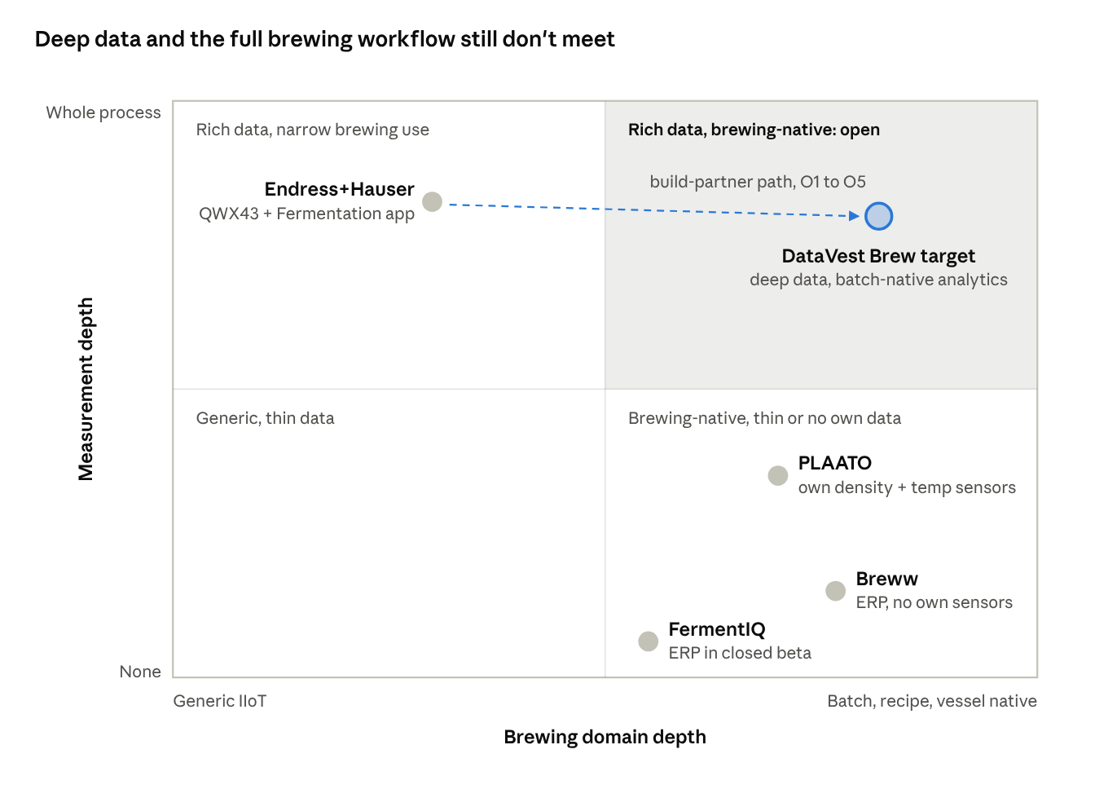
Figure 1. Market map — measurement depth vs brewing domain depth
Breww module | What it does | DataVest Brew
Cleaning & Maintenance (CIP) | Sanitation log | CIP log and schedule built from detected media changes; detergent by QR code or archive
Beer Duty | Tax and excise calculation | Included, from production volumes and alcohol
Packaging approval | Release after quality checks | Included, based on lab and sensor data
Tech cards | Raw-material norms, stage order | Included
Planning and Batches | Production plan on a calendar | Phase 2: AI-based planning (APS) that recalculates the chain when a step slips
Vessel & Fermentation | Tanks and fermentation | Included, from sensor data
Packaging | Filling | Release in the MVP; packaging records later
Production Tasks | Tasks | Included
Reporting | Reports | Included
Where DataVest Brew is stronger than Breww:
- Industrial integration: Breww has no full integration over Modbus TCP, Profinet or OPC UA.
- Lab: Breww’s quality control is checklists and pass/fail fields, with no yeast generations, plating, PCR or blind panels.
- Planning: Breww’s calendar is linear; when fermentation slips, the brewer reschedules by hand.
- Forecasts: readiness and deviation forecasts from sensor data.
- Breadth: Breww is tied to beer; DataVest Brew can extend to other fermentation production.
What we compare | DataVest Brew | Breww | PLAATO
What it is | MES for production | ERP | Own sensors plus analytics
Equipment | E+H sensors; PLCs over OPC UA, Modbus TCP, Profinet | Plaato, Tilt, TankNet; no industrial protocols | Own density and temperature sensors
Lab | LIMS: yeast, plating, PCR, blind panels | Pass/fail checklists | Intake from lab systems claimed
Production | CIP with auto-detection, tasks, release, tech cards, excise | CIP, tasks, packaging, tech cards, excise, planning | No data
Forecasts | Readiness and deviations; taste later | Curves; no forecast found | Deviation detection claimed
Sensor accuracy | Offset and check logs, fleet analysis | No data | Drift detection claimed
Reports | Yes | Yes | No data
AI | Forecasts and a citing assistant | Free MCP access | Copilot
Prices | Published tiers by module | Paid subscription, published prices | On request

Value propositions
Priority | Proposition | Buyer | What the platform delivers | Modules
1 | Plug-and-play integration | Breweries with PLC-controlled tanks and E+H sensors | Connection to OPC UA, Modbus TCP, Profinet and E+H sensors without an integrator | 2
2 | LIMS-grade lab | Mid-sized and large breweries | Yeast generations and viability, plating, PCR, blind panels, strain tracking | 3
3 | MES with alerts | Production managers, cellar teams | CIP log and schedule, tasks, packaging release, tech cards, excise | 1, 4, 6
4 | Forecasts from accumulated data | Head brewers | Readiness forecast with range, deviation analysis; taste forecast later | 5
5 | Sensor accuracy service | Technologists; E+H engineers | Offset and accuracy logs, recommended check intervals, fleet accuracy analysis | 2
Baseline features: tank board, reports, batch quality document, limit profiles (non-alcoholic beer is one profile; small breweries rarely produce it).
Later: AI-based planning (APS), other fermentation industries, other sensor brands, sites of one company, taste forecast, recipe recommendations.

Regulatory baseline
- EU labelling: drinks above 1.2% alcohol must state it; tolerance for beer up to 5.5% is ±0.5% vol., above 5.5% ±1% vol. (Regulation (EU) 1169/2011, Annex XII).
- US: the TTB regulates beer; the FDA covers food safety. The label tolerance is ±0.3% vol. Brewers file a production report with the TTB, monthly at 10,000 barrels a year or more; smaller brewers may report quarterly.
- Excise: in some EU countries beer excise is based on original extract (degrees Plato), which the QWX43 measures. The first excise jurisdiction is chosen in Phase 0.
Compliance outputs are decision support, not certification; each quality document names its lab results and signer.

Product: six modules
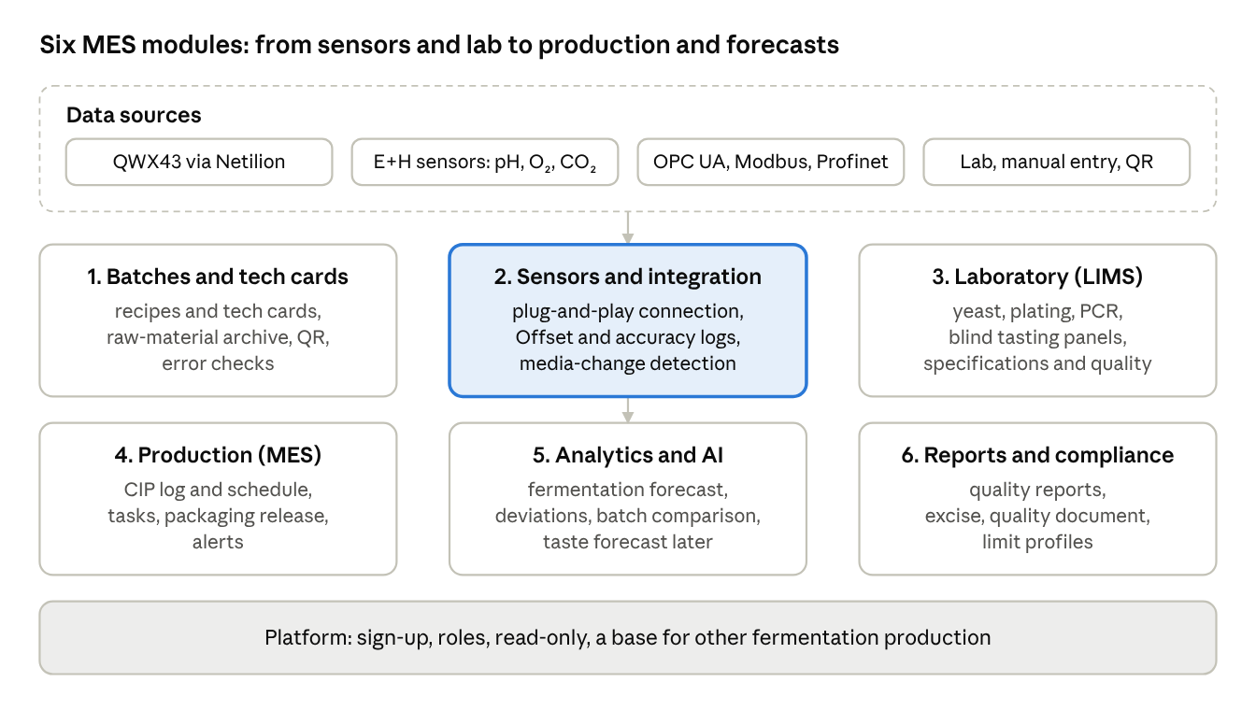
Figure 2. Product — six modules on one platform
Module | Features | Technical components | Release
1. Batches and tech cards | Batch, recipe and tech card (raw-material norms, stages: brewing, fermentation, dry hopping); raw-material quantities and supplier lots; archive of raw materials and standard components; QR form filling; error checks; batch opens on detected fill | Data model, batch context engine, tech-card service | 1A
2. Sensors and integration | QWX43 via Netilion; E+H pH, oxygen and CO₂ via the E+H system; PLCs over OPC UA and Modbus TCP (1A) and Profinet (1B); live values; Offset log with reference-wort form; accuracy-check log (air, distilled water) with reminders; media-change detection; replacement advice for sensors with consumables | Connector hub, edge gateway, protocol drivers, sensor accuracy service | 1A, 1B
3. Laboratory and quality (LIMS) | Yeast strains, generations, cell counts and viability charts; physical and chemical results; plating and PCR logs; blind tasting panels; recipe specifications and out-of-spec flags; outside-lab results | LIMS service | Core 1A; plating, PCR, panels 1B
4. Production (MES) | CIP log and schedule from detected media changes, detergent by QR or archive; production tasks; packaging release by a responsible person; alerts | MES service, alert engine | CIP 1A; tasks and release 1B
5. Analytics and AI | Stage, lag and stall detection; readiness forecast with range; deviation analysis that separates programmed temperature rests from faults; same-recipe comparison; read-only assistant with citations | Fermentation intelligence, analytics, assistant and MCP server | 1A
6. Reports and compliance | Quality reports; batch quality document; excise calculation and declaration export; limit profiles; audit log | Reports, compliance profiles, excise engine | Reports 1A; excise 1B
Platform | Self-service sign-up, users and roles, module-based pricing tiers, data isolation per brewery, process templates | Tenancy, identity, template engine | 1A

Feature notes
- Media-change detection. A sharp change in sound velocity marks the switch between beer, water and cleaning solution. It opens and closes batches and writes CIP events automatically; the operator only confirms the detergent.
- Temperature rests versus faults. Tech cards define programmed temperature steps, so deviation rules compare readings with the planned profile, not a fixed band.
- Offset and accuracy. Offset is routine adjustment and raises no warnings. Accuracy checks against air and distilled water are tracked with recommended intervals. A difference beyond tolerance between sensor and lab lowers the reading’s trust score.
- Fleet accuracy analysis. With consent, anonymised accuracy-check and Offset results across breweries are aggregated into an accuracy report for E+H engineers.
- LIMS depth. Yeast viability is charted per strain across generations; plating and PCR results attach to the batch; blind panels record scores per taster and aggregate them. Strain change tracking across brews comes in Phase 2.
- Excise. Rates and rules are configured per jurisdiction; the first jurisdiction is chosen in Phase 0. Original extract and alcohol come from the QWX43, volumes from packaging release.
- Taste forecast (Phase 3). A regression or neural-network model finds non-linear links between physical and chemical values (rate of density change, extract, temperature) and tasting scores (bitterness, body, diacetyl, oxidation, carbonation, sweetness, yeast, hop and grain aromas). It predicts the likely profile before the beer reaches the tasting panel. It needs many batches with tasting scores linked to process data.
- Dynamic Offset (Phase 3). An ML model adjusts the Offset during fermentation as wort composition changes; it is a research item.
- Read only. No API, connector or tool writes to equipment.

Users and flows

Personas
Persona | Main question | Primary screens
Head brewer | Is every tank on track, and when will each batch be ready? | Tank board, batch view, forecasts, assistant
Cellar operator | What do I do today, and how do I record it? | Tasks, CIP log, batch and raw-material entry by QR
Lab technician | Are yeast and microbiology in order? | LIMS: yeast, plating, PCR, panels
Quality manager | Can this batch go to packaging? | Batch quality, packaging release, quality document
Technologist | Are sensors accurate, and are tech cards right? | Offset and accuracy logs, tech cards
Production manager | Is production running to plan? | Dashboards, tasks, alerts, reports
Finance or compliance | Is excise correct and on time? | Excise calculation and export

Key use cases
ID | Use case | Release
UC1 | Connect a PLC over OPC UA or Modbus TCP and map tags to vessels | 1A
UC2 | Connect a PLC over Profinet through a gateway | 1B
UC3 | Connect the QWX43 (1A) and E+H pH, oxygen and CO₂ sensors (1B) | 1A, 1B
UC4 | Create a tech card; batch opens on detected fill and follows it | 1A
UC5 | Enter raw materials from the archive or by QR, with error checks | 1A
UC6 | Morning review: stage, curve against plan, readiness forecast | 1A
UC7 | Deviation alert with evidence; temperature rests are not flagged | 1A
UC8 | CIP logged automatically from media change; detergent by QR | 1A
UC9 | Offset log and accuracy check with reminders | 1A
UC10 | Yeast generation and viability; physical and chemical results | 1A
UC11 | Plating, PCR and blind tasting panels | 1B
UC12 | Production tasks and packaging release; quality document | 1B
UC13 | Excise calculation and declaration export | 1B
UC14 | Ask the assistant; same-recipe comparison | 1A
UC15 | AI-based planning (APS) | Phase 2
UC16 | Other fermentation process templates; strain change tracking | Phase 2
UC17 | Taste forecast, recipe recommendations, what-if | Phase 3

Core flow: batch lifecycle
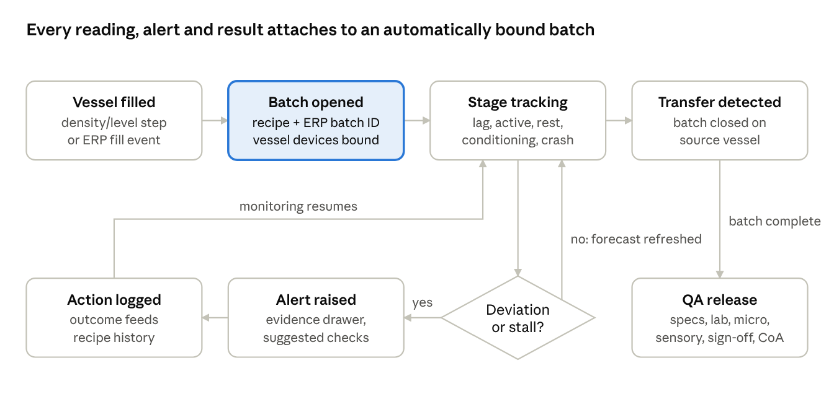
Figure 3. Batch lifecycle — auto-binding, supervision loop, release
The batch opens from the detected fill and follows the tech card. Deviations loop through alert and action; transfer hands the batch to quality and packaging release.

Supporting flows
CIP (UC8)
- Sound velocity shows the change from beer to water and cleaning solution.
- The system writes a CIP event with start and end times.
- The operator scans the detergent’s QR code or picks it from the archive.
- The CIP schedule updates; overdue cleans raise an alert.
Accuracy check (UC9)
- The system reminds the technologist when a check is due.
- He checks the sensor against air and distilled water and records the result.
- For Offset, he enters the reference-wort composition and lab values.
- Results feed the trust score and, with consent, the fleet accuracy report.
Lab and release (UC10–UC12)
- The lab records yeast generation, viability, plating and PCR results.
- A blind panel scores the beer.
- Out-of-spec values are flagged against the recipe.
- The quality manager releases the batch to packaging; the quality document is generated.

Domain baseline
Both tables are drafts for validation with a brewing technologist.
Problem | How to detect | Type of check | Likelihood
Fermentation slow or long | Density barely falls (QWX43) | Sensor | Possible
Wrong original gravity | Original extract; hydrometer or refractometer | Sensor, lab | Possible
Under- or over-attenuation | Degree of fermentation, residual extract | Sensor | Possible
Alcohol off the label value | Alcohol (QWX43), lab | Sensor, lab | Possible
Diacetyl | VDK test, tasting | Lab, sensory | Possible
Infection | Sour taste, falling pH, plating or PCR | Lab, sensory | Possible
Oxidation | Oxygen at packaging, tasting | Sensor, sensory | Possible
Unwanted haze | Haze meter, viscosity, visual | Sensor, visual | Possible
Carbonation off target | CO₂, tank pressure | Sensor | Possible
Temperature out of range | Temperature against the tech-card profile | Sensor | Unlikely: automation prevents it
Weak yeast | Slow start, cell count | Sensor, lab | Unlikely: tested before pitching
Film on the sensor | Visual check, gap to lab | Visual | Rare: cleaned in CIP

Quality-form group | Values
Physical and chemical | Alcohol, original gravity, residual extract, pH, IBU, colour (EBC), haze (EBC), CO₂, dissolved oxygen, VDK, foam stability
Yeast | Strain, generation, cell concentration, viability
Microbiology | Plating, PCR
Sensory (blind panel) | Appearance, aroma, taste, bitterness, body, sweetness, carbonation, aftertaste, true to style
Off-flavours | Buttery, cooked corn, green apple, cardboard, lightstruck, sour, medicinal, sulphur, metallic, solvent

Architecture
The platform is a multi-tenant, event-driven cloud service with an edge gateway at each brewery. The gateway reads PLC tags over OPC UA, Modbus TCP and Profinet and sends them outward only. QWX43 data arrives from Netilion and other E+H sensors through the E+H system. Lab results and manual entries come through forms, files and QR codes. The batch context engine attaches every reading to a batch, stage and tech-card step; domain services, models and the assistant work only on contextualised data.
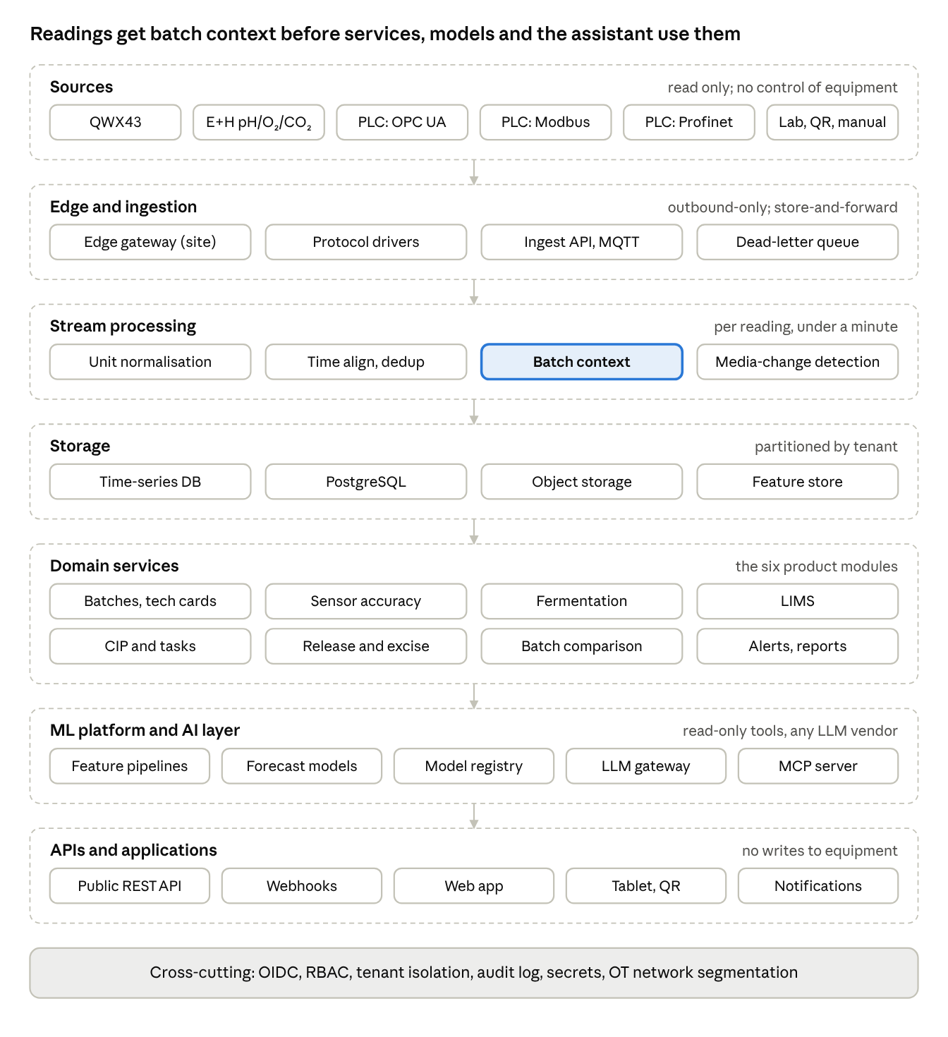
Figure 4. Platform architecture — seven layers plus cross-cutting controls

Layers and components
Layer | Components | Technology direction
Sources | QWX43 via Netilion; E+H pH, oxygen and CO₂ via the E+H system; PLCs over OPC UA, Modbus TCP, Profinet; lab files; QR and manual entry. Later: other sensor brands, ERP | External
Edge | Gateway per site: protocol drivers, tag mapping, store-and-forward buffer, NTP, outbound-only connection. Profinet is read through a Profinet-capable gateway or the PLC | Containerised agent on an industrial PC
Ingestion | Connector workers (Netilion, E+H system), ingest API and MQTT, dead-letter queue | Event stream; one worker type per adapter
Stream processing | Unit normalisation, time alignment, de-duplication, batch context resolution, media-change detection, rule evaluation | Stateless consumers plus a context cache
Storage | Specialised time-series database for readings; PostgreSQL for batches, tech cards, lab, MES records and audit; object storage for files and documents; feature store for ML | TimescaleDB, InfluxDB or ClickHouse (chosen in Phase 0); PostgreSQL
Domain services | Batches and tech cards, sensor accuracy, fermentation analytics, LIMS, CIP and tasks, packaging release and excise, batch comparison, alerts and reports | One service per module behind an internal API
ML platform | Feature pipelines, forecast models, drift and accuracy models, model registry | Batch training jobs and a registry
AI layer | Model-agnostic LLM gateway, tools over domain APIs, remote MCP server | MCP over HTTPS with OAuth; tenant-scoped tools
API and applications | Public REST API, webhooks, web app, tablet PWA with QR scanning and offline entry, notifications | SPA and PWA
Cross-cutting | OIDC, RBAC, tenant isolation, audit log, secrets, OT network segmentation | ISO 27001 and IEC 62443-aligned controls

Technology options (cloud-neutral)
Concern | Portable default | AWS | Azure | GCP
Containers | Kubernetes | EKS | AKS | GKE
Event stream | Kafka or Redpanda | MSK | Event Hubs (Kafka API) | Pub/Sub
Time series | TimescaleDB, InfluxDB or ClickHouse | Timestream or self-managed | Data Explorer or self-managed | Bigtable or self-managed
Relational | PostgreSQL with row-level security | RDS / Aurora | Azure Database for PostgreSQL | Cloud SQL
Edge runtime | Docker on an industrial PC; open-source OPC UA and Modbus libraries | IoT Greengrass | IoT Edge | Partner edge
Object storage | S3-compatible | S3 | Blob Storage | Cloud Storage
ML tooling | MLflow + Python | SageMaker | Azure ML | Vertex AI
LLM access | Model-agnostic gateway | Bedrock | Foundry | Vertex AI
Identity | Keycloak (OIDC) | Cognito | Entra ID | Identity Platform
Observability | OpenTelemetry, Prometheus, Grafana | CloudWatch | Azure Monitor | Cloud Operations
Azure aligns with Netilion for the E+H partnership. Data residency (EU, US) is a tenant attribute.

Core data model
Entity | Key attributes
Organisation / site | Region, time zone, units, residency, excise jurisdiction
Vessel | Type, volume, site
Device / tag | Vendor, model, serial number, protocol, address or node ID, unit, vessel mapping, trust score
Offset record | Device, date, reference wort composition and properties, lab values, applied correction
Accuracy check | Device, medium (air, distilled water), result, tolerance, next due date
Recipe / tech card | Style, raw-material norms, stages with temperature profile, specifications, limit profile
Batch | Tech card version, batch number, status
Vessel occupancy | Batch, vessel, from / to, recorded at (bitemporal)
Raw-material lot | Material, supplier, supplier lot, quantity, batch; archive entry
Reading | Parameter, value, unit, source, provenance, quality flags, trust, batch, stage
Event | Fill, transfer, CIP start and end, temperature step, dry hop, packaging
CIP record | Vessel, start, end, detected media, detergent, operator
Yeast strain / generation | Strain, generation, cell count, viability, source batch
Lab result | Parameter, value, method, lab, file
Microbiology test | Type (plating, PCR), organism, result, batch
Tasting panel | Batch, tasters, attribute scores, off-flavours, aggregate
Production task | Type, vessel or batch, assignee, due, status
Packaging release | Batch, checks, decision, signer, time
Excise declaration | Jurisdiction, period, volumes, alcohol or original extract, rate, amount
Alert, forecast, report, quality document | Rule and evidence; model version and range; snapshot, signer, version

Integration patterns
Source | Pattern | Latency | Main risk
QWX43 via Netilion | REST polling or subscription | Minutes | API access terms with E+H
E+H pH, oxygen, CO₂ | Through the E+H system | Minutes | Connection path to confirm with E+H
PLC over OPC UA | Gateway subscribes to nodes | Seconds | Certificates, tag discovery
PLC over Modbus TCP | Gateway polls registers | Seconds | Register maps differ per vendor
PLC over Profinet | Profinet gateway or PLC exposes data to the edge | Seconds | Hardware and configuration per site
Lab files | CSV or PDF upload with mapping | Per sample | Format variety
QR and manual | Tablet PWA, offline sync | Immediate | Late entries
Later: other sensors, ERP | HTTP, MQTT, REST | Minutes | Many systems

ML and forecasting
- Fermentation forecast: curve fit per tech card with Bayesian updating from history; end time and final gravity with ranges.
- Media-change detection: change-point detection on sound velocity and density, confirmed against occupancy and CIP schedule.
- Deviation analysis: readings compared with the tech-card temperature profile and the recipe envelope, so programmed rests are not flagged.
- Accuracy analysis: residuals between sensor and lab per device; fleet report for E+H with consent.
- Phase 3: taste forecast, recipe recommendations and what-if, dynamic Offset, pooled models trained on consenting tenants.
- Governance: model registry, back-testing, published accuracy.

Batch context
Occupancy and device assignments carry business-time validity and a system-time record date. At ingest, batch and stage are resolved from the current occupancy. When a record changes, the affected window is recomputed, including alerts, forecasts and CIP events.

Sizing and service targets (to confirm)
Dimension | Pilot | Year-2 target
Breweries | 2–3 | 100
Vessels | up to 100 | 3,000
Tags per vessel | about 20 (PLC plus sensors) | about 20
Reading interval | 10 s–1 min | same
Peak ingest | about 200 readings/s | about 6,000 readings/s
Dashboard freshness | under 1 min | under 1 min
Availability | 99.5% | 99.9%

Security, AI safety and data ownership
- OT security: the gateway sits in a segmented OT network, makes outbound connections only, and uses signed images and per-device certificates.
- Read-only AI: MCP tools come from read endpoints; every claim cites a record; inputs are treated as data, not instructions; per-tenant cost caps.
- Data ownership: each brewery owns its data. Fleet accuracy analysis for E+H uses anonymised data with consent. Pooled models use opt-in data.
- Compliance: ISO 27001-aligned controls from the start; GDPR for personal data.

Testing and simulation
- A fermentation simulator generates batches with media changes, CIP, temperature rests, lab results and faults.
- Protocol simulators (OPC UA server, Modbus slave) feed the gateway in tests.
- Contract tests run against recorded Netilion payloads; replay tests cover late data; load tests run at target ingest.

What we reuse from SmartLab and DataVest
DataVest is a pilot-stage product with one active engagement. It contributes designs and experience, not production code:
- document management and quality control designs;
- SmartLab’s approach to lab data, specifications and audit trails, which underpins the LIMS module;
- the data model and connector abstraction;
- monitoring screens;
- machine-learning practice.

Implementation
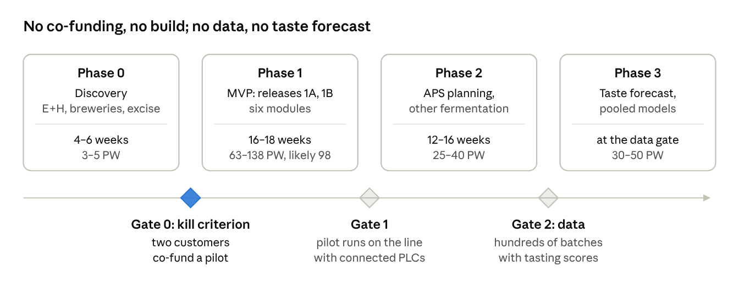
Figure 5. Delivery roadmap — four phases, three gates (not to scale)

Phase 1 work packages
Work package | Min | Likely | Max
Program and product management | 4 | 6 | 8
Discovery and requirements (excise, quality, site surveys) | 2 | 3 | 4
Connectors: Netilion, E+H sensors, OPC UA, Modbus TCP, Profinet | 6 | 9 | 13
Edge gateway | 3 | 4 | 6
Data model and parameter catalog | 3 | 5 | 7
Batch context engine | 2 | 4 | 6
Sensor accuracy service | 3 | 4 | 6
Fermentation intelligence | 3 | 5 | 7
LIMS | 5 | 8 | 11
Tech cards | 2 | 3 | 5
CIP log and schedule | 2 | 4 | 6
Production tasks and packaging release | 2 | 3 | 4
Excise calculation | 2 | 3 | 5
Limit profiles | 1 | 2 | 3
Raw-material entry (archive, QR) | 2 | 3 | 4
Alerts | 2 | 3 | 4
User interface | 6 | 9 | 12
Assistant and MCP server | 2 | 4 | 5
Reports and quality documents | 2 | 3 | 4
Platform: sign-up, roles, tiers, templates | 3 | 4 | 6
Simulators (fermentation, protocols) | 2 | 3 | 4
QA, performance and security | 4 | 6 | 8
Total (PW) | 63 | 98 | 138
With 15% contingency |  | about 113

Phases
Phase | Scope | Effort (PW) | Budget at $60/h | Duration
0: Discovery | E+H and brewery talks, Netilion trial, excise and quality requirements, site surveys, clickable prototype, two co-funding pilots | 3–5 | $7,200–$12,000 | 4–6 weeks
1: MVP | Six modules. Release 1A (about 10 weeks): QWX43, OPC UA, Modbus TCP, tech cards, LIMS core, CIP log, Offset and accuracy logs, forecast. Release 1B (6–8 weeks): Profinet, E+H pH/O₂/CO₂, excise, packaging release, plating, PCR, panels | 63–138 (likely 98; about 113 with contingency) | $151,200–$331,200 (likely $235,200; about $270,000) | 16–18 weeks
2: Wider product | AI-based planning (APS), other fermentation templates, other sensor brands, sites of one company, strain change tracking | 25–40 | $60,000–$96,000 | 12–16 weeks
3: Learning models | Taste forecast, recipe recommendations, what-if, dynamic Offset, pooled models | 30–50 | $72,000–$120,000 | from the data gate
Not included: hosting, LLM usage, on-site gateway hardware.
Team for Phase 1: about 6 FTE:
- architect 1.0;
- integration and backend 2.0;
- frontend 1.0;
- data and ML 1.0;
- QA 0.5;
- product owner and analyst 0.5.

Pilot KPIs
KPI | Target
Time to connect a sensor or PLC | Under one day, without an outside integrator
Manual gravity samples | At least 50% fewer
Forecast error 72 h after pitch | Under 12 h
Alert usefulness | 70% or more marked useful
Batch documentation | Every batch has a quality document and packaging release in the system
Sensor accuracy | Every connected sensor has a current accuracy check

Risks, open questions and recommendations
Risk | Mitigation
E+H builds this itself | Offer to build it as partner
Three-protocol integration costs more than expected | OPC UA and Modbus TCP in 1A, Profinet in 1B; proven libraries and gateways
Large MVP scope | Two releases; kill criterion before build
Overlap with Breww | No ERP features; focus on integration, LIMS and forecasts
Excise rules differ by country | Start with the pilot’s jurisdiction
LIMS matters mainly to large breweries | Module-based pricing
OT security concerns at the brewery | Outbound-only gateway, segmentation, IEC 62443-aligned controls
Taste forecast needs much data | Phase 3; stated openly
Weak forecasts early in fermentation | Ranges and disclosed limits
DataVest maturity overstated | Always describe it as pilot-stage

Open questions
- How does E+H handle Offset and accuracy checks today; is there a log in Netilion?
- How do E+H pH, oxygen and CO₂ sensors connect?
- Which PLCs and protocols do pilot breweries use?
- Which jurisdiction comes first for excise?
- Which EU and US quality requirements apply, and how often are reports due?
- Who needs the LIMS most: small, mid-sized or large breweries?
- Does E+H want integration with Breww?
- Which fermentation industry comes next?
- Who will be the first two co-funding pilots?

Recommendations
- Open the E+H conversation as build partner, leading with Intetics’ groundwork in document management and quality control, ML capability and industrial integration.
- Get a Netilion trial; confirm Offset handling and E+H sensor connectivity.
- Survey pilot sites for PLCs and protocols before scoping connectors.
- Choose the first excise jurisdiction.
- No Phase 1 without two co-funding pilots.
- Update the prototype and synthetic data to the six modules and use them in every discovery call.
- Publish module-based pricing from launch.

Sources
- Intetics internal analyses (E+H gap analysis, feasibility analysis, Data Vest report, SmartLab expert analysis, SmartLab report).
- E+H: QWX43 Operating Instructions, BA02162F/00/EN/03.24.
- E+H: QWX43 introduction.
- Regulation (EU) 1169/2011, Annex XII.
- TTB: alcohol content on malt beverage labels.
- TTB: Brewer’s Report of Operations instructions.
- Input from a brewing domain expert.

