PROJECT MILESTONE REPORT FOR

FINANCIAL TRADING STRATEGY

Table of Contents

INTRODUCTION 3

THE DATA SET 3

PRELIMINARY EXPLORATION 3

APPROACH 5

# INTRODUCTION

The goal is to design a simple financial trading strategy that will yield profit.

# THE DATA SET

Two datasets will be used here in moving time windows to test the strategy:

* The American Electric Company (AEP) dataset from Quandl
* The Chesapeake Energy Corporation (CHK) from Quandl.

An initial exploration of the AEP dataset reveals 5 important fields:

* The date
* The Open price
* The High price
* The Low price
* The Close price

Some of the issues encountered with the data:

* The presence of the adjusted closing price was confusing for some methods in the packages Quandstrat and xts. I had to remove it from my data set
* Some functions and arguments were not found because the Quandstrat package is not yet stable.

# PRELIMINARY EXPLORATION

There are some periods of time were none of the indicators seem to be right. Also, the SMA50 (Simple Moving Average) seems to better mimic the trend in the AEP data set.

* SMA AEP:

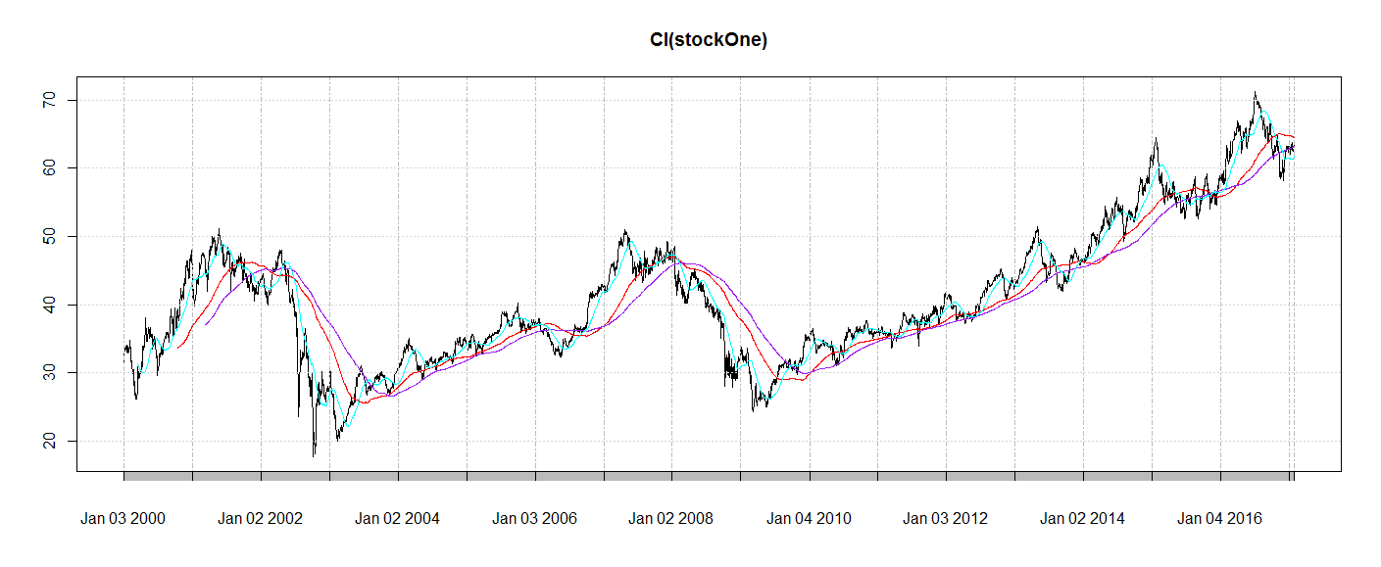

* SMA CHK:

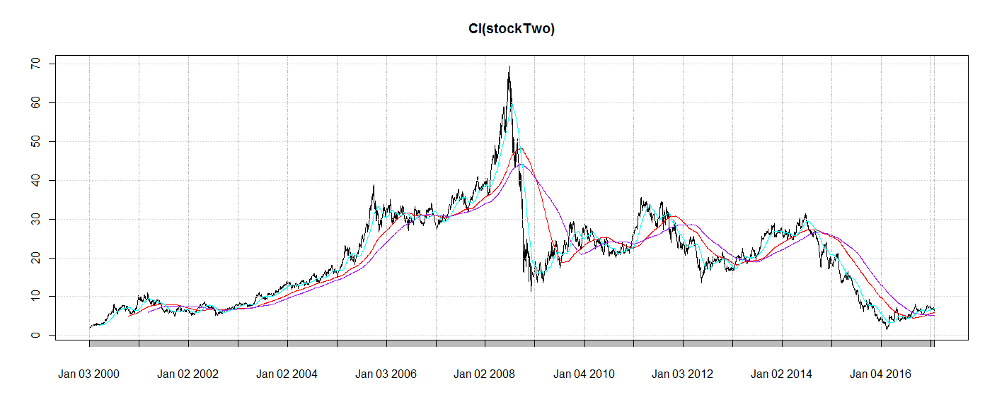

* RSI AEP:

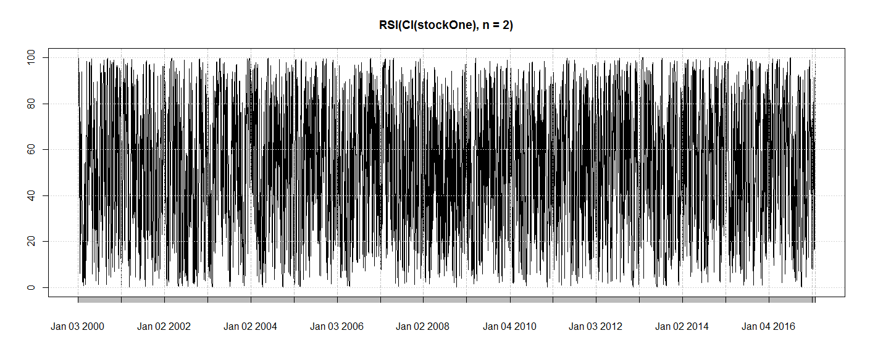

* RSI CHK

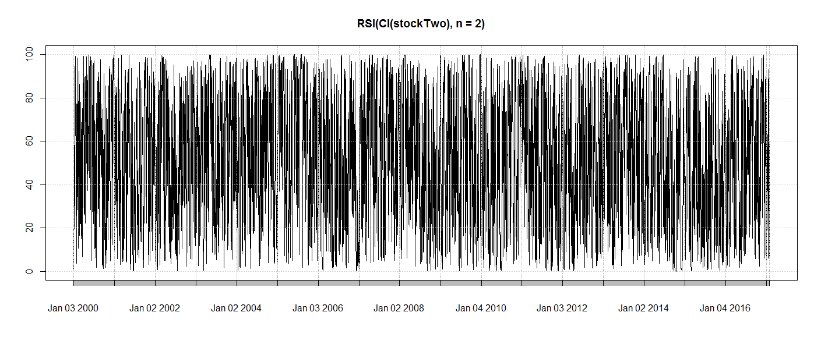

# APPROACH

The approach here would be to combine both SMA50 and SMA200 with an oscillator to avoid false signals. The trend-following indicators would help catch up a move and remain in a move.

One of the objectives here is to obtain a profit factor above 1 after running the strategy on each of the data sets.