To avoid false buy or sell signals, I combined an oscillator (lagging indicator) with lagging/trend-following indicators (50 and 200). For momentum indicators such as RSI, usually, a value above 70 indicates overbought conditions (pullback -> buy) while a value below 30 indicates undersold conditions (price bounce -> sell).

*“An oversold asset is often considered to have a selling price that is too low in comparison to the actual value of the asset. This can be based on certain metrics including the current price-to-earnings (P/E) ratio. For example, the Dow Industrial had a P/E ratio of 19.07 on July 1, 2016.*

*If a particular stock had a P/E ratio below 19.07 while other stocks from the same industry were above 19.07, the first stock may be considered oversold. This belief may be strengthened if the stock also shows higher-than-average earnings or growth when compared to others in its sector.”*

Read more: [Oversold Definition | Investopedia](http://www.investopedia.com/terms/o/oversold.asp#ixzz4ZzhUIXfl) <http://www.investopedia.com/terms/o/oversold.asp#ixzz4ZzhUIXfl>   
Follow us: [Investopedia on Facebook](http://ec.tynt.com/b/rf?id=arwjQmCEqr4l6Cadbi-bnq&u=Investopedia)

*“The relative strength index is calculated using the following formula:*

*RSI = 100 - 100 / (1 + RS)*

*Where RS = Average gain of up periods during the specified time frame / Average loss of down periods during the specified time frame/*

*The RSI provides a relative evaluation of the strength of a security's recent price performance, thus making it a momentum indicator. RSI values range from 0 to 100. The default time frame for comparing up periods to down periods is 14, as in 14 trading days.”*

Read more: [Relative Strength Index - RSI Definition | Investopedia](http://www.investopedia.com/terms/r/rsi.asp#ixzz4Zzev3nF0) <http://www.investopedia.com/terms/r/rsi.asp#ixzz4Zzev3nF0>   
Follow us: [Investopedia on Facebook](http://ec.tynt.com/b/rf?id=arwjQmCEqr4l6Cadbi-bnq&u=Investopedia)

David Varadi Oscillator

Sharpe Ratio = (Rx – Rf) ÷ StdDev(Rx)

Where:

Rx = average rate of return from investment X

Rf = risk-free rate

StdDev(Rx) = standard deviation of Rx

When analyzing the Sharpe ratio, the higher the value, the more excess return investors can expect to receive for the extra volatility they are exposed to by holding a riskier asset. Similarly, a risk-free asset or a portfolio with no excess return would have a Sharpe ratio of zero.

REFERENCES

* <http://stockcharts.com/school/doku.php?id=chart_school:technical_indicators:introduction_to_technical_indicators_and_oscillators>
* <http://www.aaii.com/computerizedinvesting/article/interpreting-the-sharpe-ratio>
* <http://www.investopedia.com/articles/07/sharpe_ratio.asp>

Table of Contents

INTRODUCTION 4

DATA SET 4

PRELIMINARY EXPLORATION 4

APPROACH 7

# INTRODUCTION

This project aims at building a model that will ideally always output successful bids in the stock market. For that, it builds a model which gives better results when constantly trained in a sliding-time window. Of course, the model advises buying when the prices are low and selling when they are going up.

The goal is to design a simple financial trading strategy that will be profitable and that will provide a good risk-adjusted measure of return.

# DATA SET

Two datasets will be used here to test the strategy:

* The American Electric Company (AEP) dataset from Quandl
* The Chesapeake Energy Corporation (CHK) from Quandl.

An initial exploration of the AEP dataset reveals 5 important fields:

* The date
* The Open price
* The High price
* The Low price
* The Close price

Some of the issues encountered with the data:

* The presence of the adjusted closing price was confusing for some methods in the packages Quandstrat and xts, as those methods kept throwing errors. I had to remove the adjusted closing price from my data sets and just keep the closing price
* Some functions and arguments were not found because the Quandstrat package is not yet stable.

# PRELIMINARY EXPLORATION

Using trend-following indicators and oscillator/reversion indicators give some insights into the data. On one hand, the preliminary oscillator used is an RSI (Relative Strength Index) with a 3-days lookback period. On the other hand, the preliminary trend indicators are 3 SMA (Simple Moving Average). There are some periods of time were none of the indicators seem to be right. Also, the SMA50 (Simple Moving Average) seems to better mimic the trend of the closing prices for both data sets.

* SMA AEP:

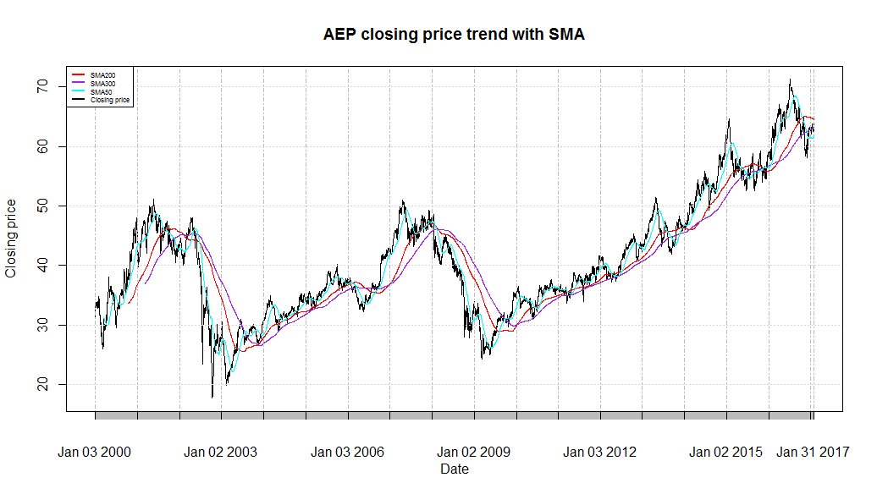

* SMA CHK:

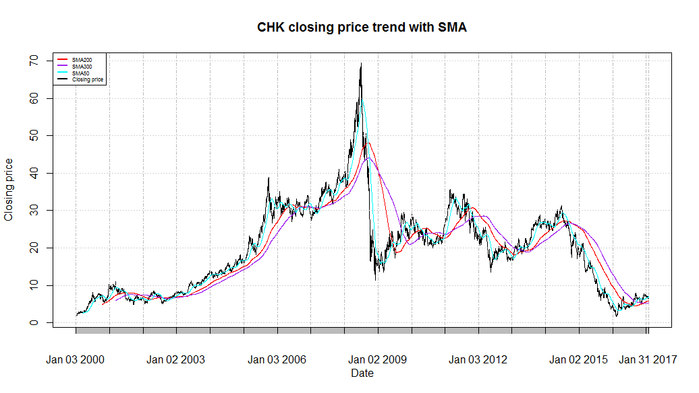

An observation of the graphs of the stocks’ RSI reveal that there are effectively periods of reversion (2013-09-03 to 2013-9-05 for example) that won’t be captured by a trend-following indicator:

* RSI AEP:

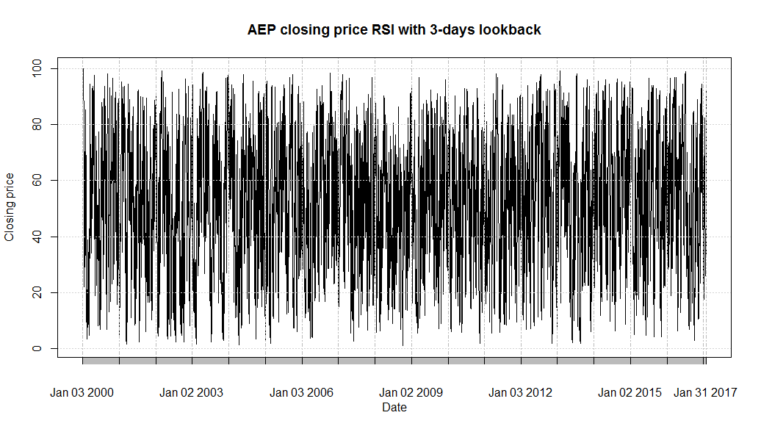

* RSI CHK

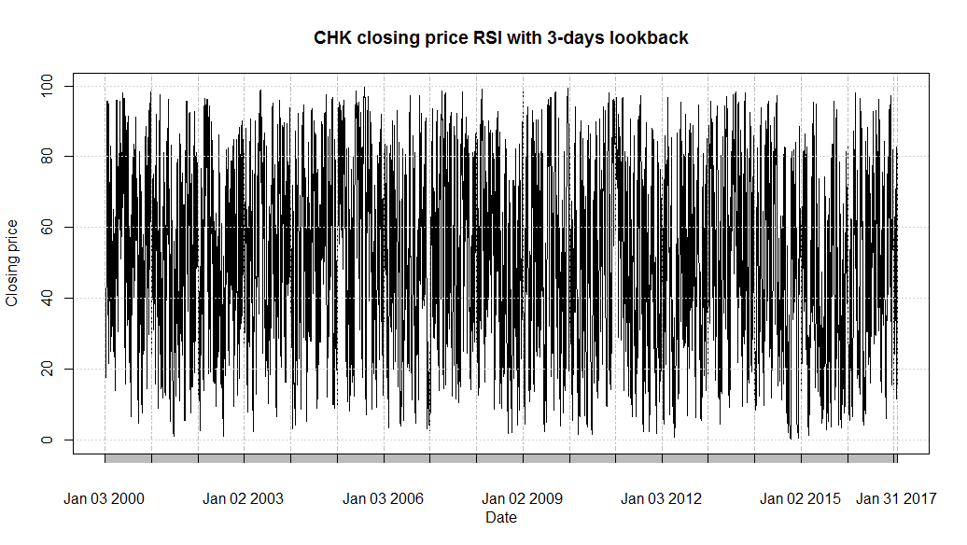

# APPROACH

The main objective is to obtain a profit factor above 1 after running the strategy on each of the data sets.

The approach here would be to combine both SMA50 and SMA200 with an oscillator to avoid false signals. The trend-following indicators would help catch up a move and remain in the move.