

U.S. Department of Education
U.S. Department of Labor
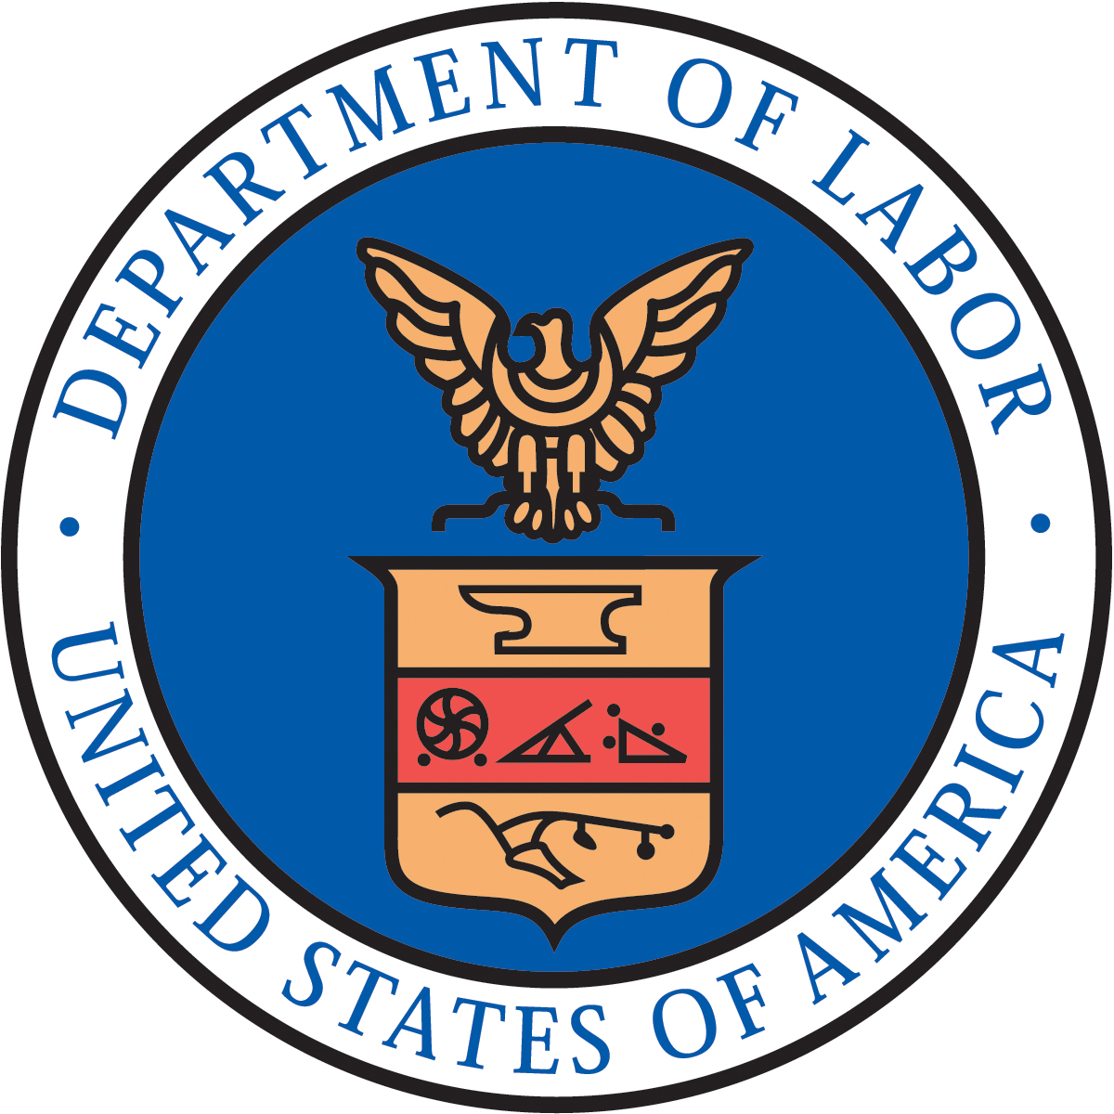

Fact Sheet: A Commitment to Youth Entrepreneurship
We can’t wait to grow the economy and create jobs. And we know that virtually all newly created jobs in America come from new companies. That’s why the Obama Administration is breaking down barriers to innovation and entrepreneurship and working across Federal agencies and non-Federal partners to support the start-up and success of new, high-growth businesses. At the U.S. Department of Education (ED) and the Department of Labor (DOL), we understand how critical it will be for our 21st century economic success that we do not just prepare students to take jobs, but to create jobs. In order to put this commitment into action ED and DOL are pleased to announce a number of steps that will have real impact for millions of young and aspiring entrepreneurs across our country.

The U.S. Department of Education and Youth Entrepreneurship
Entrepreneurship education as a building block for a well-rounded education not only promises to make school rigorous, relevant, and engaging, but it creates the possibility for unleashing and cultivating creative energies and talents among students who might launch the next Teach For America, Kahn Academy, or Blackboard – entrepreneurial ideas such as these are the seed for our future economic growth and competitiveness.

Part of a Well-Rounded Education
All students deserve a world-class, well-rounded education that provides effective instruction across the academic content areas. And entrepreneurship is an integral aspect of this complete education as we meet the goal of ensuring that all students graduate from high school ready for college and career success. In response to teacher, parent and student concerns across the country that No Child Left Behind has overly narrowed the curriculum, the Administration’s Blueprint for Reform, our proposal to reauthorize the Elementary and Secondary Education Act (ESEA), calls for a new competitive program, Effective Teaching and Learning for a Well-Rounded Education, made possible by consolidating existing programs. Under this program, States would have the opportunity to develop and support student learning in personal finance and economics through entrepreneurship education – where students identify problems, build teams, develop solutions, and make their business case.

But even as we wait for congressional action on ESEA, some of this work is already underway. The Excellence in Economic Education (EEE) program, which would be incorporated into our proposed Effective Teaching and Learning for a Well-Rounded Education program, currently provides over $1,000,000 each year in sub-grants for economics, financial literacy, and entrepreneurship education at the elementary and secondary. Listed below are current sub-grantees that are conducting entrepreneurship education activities, which will continue to be a focus of this program going forward:

- Youth Opportunities Unlimited (Y.O.U.), Entrepreneurship Training for Cleveland High School Students: Provides participants with an introduction to entrepreneurship through the National Foundation for Teaching Entrepreneurship (NFTE) - an internationally recognized, research-based course which focuses on entrepreneurial, business, and life skills, targeting students from economically vulnerable backgrounds. In addition, local business volunteers provide one-on-one coaching and mentoring to help students complete business plans and prepare presentations. During the 2011-12 school-year, Y.O.U. will offer this program at seven high schools in the greater Cleveland area, recruiting a total of 105 students in 11-12th grade.

- EconomicsPennsylvania, Youth Entrepreneurship Challenge: Recruits 9-12th grade teachers of business, economics & AP economics courses, personal finance and consumer education, to prepare their students to attend the Youth Entrepreneurship Challenge Day - a two-day program designed to challenge student teams to develop a feasible business concept, and learn to write a corresponding plan. Selected local judges evaluate the presentations and award prizes for the top three plans. The program impacts 350 teachers and over 600 students.

- Network for Teaching Entrepreneurship (NFTE) New York Metro, Teacher Training & Professional Development: Provides training and professional development to teachers in the New York Metro area. Participants are required to attend NFTE University, where teachers receive intensive training on business and entrepreneurship content and develop a business plan of their own to experience the lessons they will teach students. Upon completion, they are recognized by NFTE as Certified Entrepreneurship Teachers (CETs). Ongoing Professional Development workshops are also offered throughout the school year to support the active corps of close to 60 CETs.

- New York State Labor-Religion Coalition, Inc., Rural Entrepreneurship: Introduces thirty 15-19 year-old participants to entrepreneurship education through an immersion program consisting of a six-day boot camp, two days working at a fair trade cooperative, and the experience of developing an income-generating business that will be handed over for new students entering the program to operate and build on. The first half of the boot camp also involves modules covering economic and business fundamentals, while focusing on opportunity recognition.

- Network for Teaching Entrepreneurship (NFTE) Greater Los Angeles, Wholesale Field Trip: Provides 376 middle school students with an experiential activity culminating in a wholesale trip and selling event. In preparation for their trip, students conduct market research to determine the types of products that would be attractive to their consumers. During their trip to LA’s Wholesale District, students receive $25 of grant funds to negotiate with vendors and purchase inventory based on the findings from their market research. Students then bring the products back to school and resell them for a profit during a campus selling event. The Wholesale Trip Grant Project will be matched with funding from the Bank of America Charitable Foundation and Goldman Sachs to support an additional 376 students for a total of 752 students.

- Network for Teaching Entrepreneurship (NFTE) Fairchester Region, Middle School Expansion: Will expand its experiential learning activities for approximately 750 Yonkers Public Middle Schools students. NFTE experiential learning activities connect the relevance of academic learning to the real world. Additionally, the activities teach students to be more educated consumers and provide a better understanding of the market economy as they experience the fundamentals of creating wealth.

Crucial to Emerging Sectors within Career and Technical Education
Whether students are preparing for college and careers in health care or education, business or technology, construction or architecture, all students should have the opportunity to develop entrepreneurial skills. Aspiring doctors need to know how to start and manage their own medical practices, just as aspiring electricians and auto technicians need to learn how to launch their own contracting businesses and auto shops. Career and Technical Education (CTE) can help students develop the skills necessary to become successful entrepreneurs by integrating entrepreneurship education with an academic and technical focus.

In addition to other Federal resources to support CTE at the postsecondary level amounting to nearly $25 billion, there is approximately $1.1 billion in Federal funding to support CTE at the secondary and postsecondary levels through the Carl D. Perkins Career and Technical Education Act. The Perkins Act promotes entrepreneurship at many different levels. States can use their leadership funds to support entrepreneurship education and training. Local grantees can work with businesses to provide work experiences related to entrepreneurship for students in CTE programs. Postsecondary institutions can partner with small business development and assistance centers to create incubators that provide start-up and financial management technical assistance to CTE graduates. Secondary and postsecondary institutions can create dual major programs that combine entrepreneurship and technical fields of study.

ED is encouraged by state and school district efforts to incorporate entrepreneurship education within their current CTE framework. Virtually every state has special initiatives, programs, and courses on entrepreneurship at both secondary and postsecondary levels. To name a few:

- Utah Public Schools: Utah schools offer career pathways in Economics and Entrepreneurship. In these programs, students gain an understanding of the business/marketing principles necessary to start and operate a business. Students develop an awareness of the opportunities for small business ownership and develop the planning skills needed to open a small business.

- Indiana Public Schools: Indiana schools offer career and technical education programs of study in Marketing, Management, and Entrepreneurship. The Entrepreneurship Academy is designed as the capstone course in a specialized sequence of marketing and marketing related courses, which provide instruction in marketing, management, and entrepreneurial fundamentals as they relate to starting and operating a business.

- North Dakota Community College System: Turtle Mountain Community College offers a one year career and technical education certificate program in Entrepreneurship. The Entrepreneurship Certificate program applies entrepreneurial principles to establishing, organizing and managing a small business. Current business owners and employees find particular courses helpful in strengthening skills to assist in the effectiveness of the business. Completion of an Entrepreneurship option leads to an Associates of Applied Science degree in Small Business Management.

California Community College System: The California Community Colleges Chancellor's Office, the California Department of Education, and Coast Community College District, and the California Community College Economic and Workforce Development Program partnered to develop the Career and Technical Education Pathways Initiative. This initiative funded the San Diego Young Entrepreneurs Project (YEP), the purpose for which is to help young people ages 14 – 27 replace misconceptions of vocational education and blue collar jobs with increased awareness of and aspirations to self-employment as a legitimate lifetime career path providing reliable living wages.

Leveraging Work-Study
Over 2,000 postsecondary education institutions administer the nearly $1 billion-per-year Federal Work-Study program that provides part-time work opportunities to students who need additional funds to help pay for college. The Department of Education is encouraging participating colleges and universities – and campus student employment offices outside the Federal Work-Study program – to place students in positions related to their learning and career interests and goals. Connecting students with small businesses and local startups – whether budding businesses or new social ventures – related to their college experience is one way to achieve this goal while also helping students develop skills for starting a company or a non-profit organization of their own. In the coming months, we will partner with the National Association of Student Financial Aid Administrators (NASFAA) and other stakeholders to encourage this approach.

National Education Startup Challenge
If we’re going to tackle tough education challenges to once again be the best educated country in the world, we need all hands on deck. That includes students themselves. The Department of Education will launch the National Education Startup Challenge. We’ll be inviting students to develop an innovative solution to an education problem and prepare a business plan for a new company or non-profit organization to deliver that solution. Students will enter the competition as individuals or in teams and submit their business plans and a link to a short video describing it. Proposals will be judged by a national panel of educators and entrepreneurs will identify the top proposals in three categories:

- 6th – 8th grade students
- 9th – 12th grade students
- Undergraduate postsecondary students

Winning students will be celebrated by senior White House and ED officials and may qualify for additional recognition opportunities. Students will retain the intellectual property for their submissions, though submissions may be used by ED for informational purposes. Look for an announcement soon on http:www.ed.gov.

Making Student Loans More Affordable for Entrepreneurs
We know that for some entrepreneurs, keeping up with student loan payments while trying to get a new venture off the ground can be difficult. The Department of Education has a program in place – Income-Based Repayment (IBR) – that can help. IBR caps a borrower’s monthly payments on Federal student loans at just 15% of discretionary income. For example, an entrepreneur who has $20,000 in Federal student loans and has income of $20,000 per year would have Federal student loan payments of about $45 per month under IBR, instead of over $200 per month under a standard repayment plan. That’s more than a $150 reduction monthly federal student loan payments that will help her better manage federal student loan debt and keep the focus on starting and growing her new enterprise. Once her business gets off the ground, she could begin paying down the loans more quickly to avoid paying more in interest over the life of the loan.

Since the amount of a borrower’s IBR payments is determined initially based on the borrower’s income from her IRS returns, it may appear that some borrowers may not immediately qualify for IBR. However, if a borrower’s income is reduced as a result of life changes like a change in occupation, a layoff, or the establishment of a business or non-profit organization, the Department can help. If requested by the borrower, the federal student loan servicer will provide the borrower with a process to document alternative income. We’ve put a special message on the studentaid.ed.gov website to alert entrepreneurs who are in this situation and encourage them to ask their Federal loan servicer for that assistance.

In addition to IBR, Public Service Loan Forgiveness (PSLF) is an additional benefit for borrowers, including social entrepreneurs trying to start a new non-profit organization. Under the PSLF Program, after ten years of qualified payments, any remaining debt will be forgiven. Coupled with IBR, PSLF can help social entrepreneurs with federal student loans who launch an eligible non-profit pursue their passions, whether in education or another field.

The U.S. Department of Labor and Youth Entrepreneurship
The Department of Labor’s Employment and Training Administration (ETA) is working to support small- and mid-sized businesses by supporting entrepreneurs. Many Americans have the motivation and skills to develop a small business on their own, but may lack business experience or more importantly the access to financing.

Project GATE and Encouraging Entrepreneurial Training
To help emerging entrepreneurs, the Project GATE (Growing America Through Entrepreneurship) demonstration project teamed ETA training and assistance programs with economic development entities such as local small business development centers, local Chambers of Commerce, small business loan providers, and other such entities. Current grantees in four states are helping older and dislocated workers launch and grow successful businesses. A random-assignment evaluation of Project GATE, completed in December 2009, found that compared to the control group, participants started their first business sooner, and their businesses had greater longevity.

ETA remains committed to the guidance it issued in November of 2010 to the One-Stop Career Center system which encouraged states to establish parameters for funding entrepreneurial training (http://wdr.doleta.gov/directives/corr_doc.cfm?DOCN=2957).

Creating Partnerships to Build Entrepreneurial Opportunities
ETA is also developing a new Self-Employment Training Demonstration focused on the role of One-Stop Career Centers in supporting self-employment in coordination with Small Business Administration programs. In collaboration with Small Business Development Centers, Chambers of Commerce, economic development leaders, business incubators, and higher education, ETA developed a technical assistance toolkit to help local communities build a strong network for start-up entrepreneurs and small businesses, from their first hires through their first expansion.

Creating an Entrepreneurship Competency Model
In collaboration with the Consortium for Entrepreneurship Education (CEE), ETA created an entrepreneurship competency model in 2009. A competency model is a collection of knowledge, skills, and abilities that define successful performance in a particular work setting. Working collaboratively, the partnership brought together nationally-recognized experts to review the model and ensure that it reflected the skills essential to succeed as a budding entrepreneur. The Entrepreneurship Competency Model is a helpful guide for educators and trainers in the workplaces of America, providing entrepreneurial skills that optimize workers' technical and professional skills. The competency model is located at: http://www.careeronestop.org/competencymodel/pyramid.aspx?ENTRE=Y

Providing Entrepreneurship Training Opportunities to Youth
The Department of Labor’s Employment and Training Administration, through the Job Corps Program, provides youth ages 16 through 24 years of age from economically disadvantaged backgrounds, and often times high school dropouts, with additional education or career technical training. The typical Job Corps student is an 18-year-old high-school dropout who reads at the seventh grade level and has never held a full-time job. Approximately 73% of Job Corps enrollees are members of minority groups, 65% are high school dropouts, and more than 30% are from families on public assistance.

In order to provide Job Corps students additional educational opportunities, Job Corps is looking at pilot options for entrepreneurial training at interested centers. Two current projects include:

- NFTE Training in Los Angeles: In July 2011, a partnership was launched between Job Corps LA and The Network for Teaching Entrepreneurship (NFTE) LA. The collaboration resulted in a ten-day accelerated business camp (Biz Camp) that was offered to approximately 40 Job Corps students who were selected via an application process. Biz Camps take place during the summer or during school breaks. They are offered free of charge to all participants who meet household income requirements. The students learned about the basics of business ownership, the critical role of entrepreneurs in the economy, supply and demand, how to present themselves professionally, understand the economics of one unit, how to set pricing, build budgets, sell product, invest and make a profit, as well as complete and present a business plan to community leaders.

- “Start Young Initiative” Partnership with SBA: ETA’s Job Corps and the Small Business Administration have partnered together to create the Start Young Initiative. Through this partnership, the SBA will work with their network of resource partners on a specialized entrepreneurship training curriculum to be taught at selected Job Corps Centers. This pilot highlights the importance of providing economically disadvantaged youth who often are not exposed to entrepreneurship with the opportunity to gain the skills to one day start their own business.

ETA looks forward to exploring opportunities like these and other creative ideas to find suitable local partnerships with interested Job Corps Centers to provide entrepreneurial education.

