**3-dimensional Boolean functions**

**Task 1:** There should be 256 3D boolean functions, since for each dimension/variable (out of N dimensions) there are two positions (i.e. $2^{N}$ variations) and each position can take on two values. Consequently, we get that there are $2^{(2^{N})}= 2^{2^{3}}= 2^{8}=256$ functions in total.

**Task 2:** In the figure below, the leftmost cube is denoted by 1, the second leftmost by 2 etc. To find a symmetry, I successively displaced one of the green dots (corresponding to one of the two values) further and further away from the position when all green dots are on the same side of the cube (1). This since neither any rotation nor reflection can change this relative displacement. This method gave me three more symmetries (2-4). Thereafter I moved two dots at a time from the “1 setting” with the two respective relative displacements that could not be achieved by rotation/reflection. All in all, 6 symmetries are obtained.

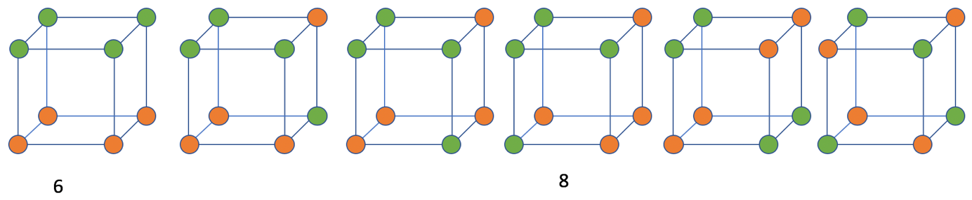

**Task 3:** First I counted all the possible configurations within each of the two linearly separable symmetries, 1 and 4, for the case of k=4 input patterns being equal to one (the result is written below each symmetry in the figure above). For the leftmost cube, the 4 green dots can be on any of the 6 sides of the cube and for symmetry nbr. 4 the displaced dot can be in any of the 8 positions of the cube (and the rest of the dots rotated accordingly). Doing equivalent steps as in task 2 and task 3, we obtain for k=3, 2, 1 and 0 input patterns:

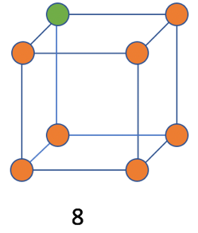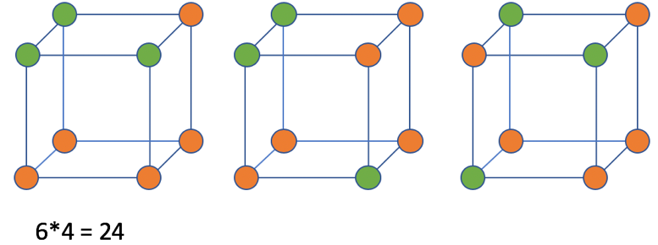

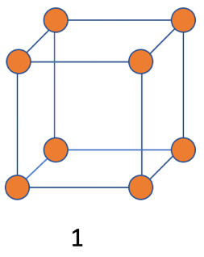

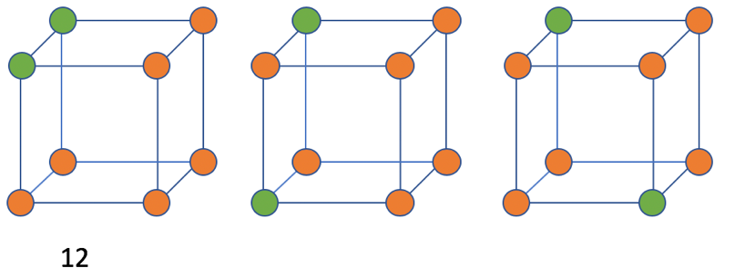

Here 6*4 configurations were obtained since the orange dot on the top side could be in all four places of that side and that side could be rotated into any of the 6 sides. Since k = 3 is equivalent with k=5 and the same goes for 2-6, 1-7, and 0-8 respectively, the total number of linearly separable functions is equal to (6+8) + 2*(24 + 12 + 8 + 1) = 104.