Assignment 1 of BridgeLabz 06/08/26 submitted by Yashika Agrawal 73 3CA
1. Frontend vs. Backend vs. Full-Stack Development
Frontend Development: This is everything a user sees and interacts with directly on their screen—the layout, buttons, text, fonts, and animations.
Example: On Amazon, the product catalog, search bar, item images, and "Add to Cart" buttons are part of the frontend.
Backend Development: This is the behind-the-scenes logic, servers, and business operations. It processes user requests, runs security checks, and handles payments or data calculations.
Example: On Amazon, when you click "Place Order," the backend processes your credit card, updates inventory count, and creates a shipping request.
Full-Stack Development: This covers both the client-side (frontend) and server-side (backend) parts of an application. A full-stack setup connects the interface directly with the server logic and database.
Example: Building an entire web application from scratch like creating both the user login form and the backend system that saves user accounts to a database.

2. Client-Server Model Diagram
Client: the browser that sends requests (e.g., asking for a URL).
Server: Processes requests and sends back resources (HTML, CSS, JSON, images).

3. How a Browser Requests and Displays a Web Page
- URL Input & DNS Lookup: When you type a website URL into your address bar, your browser contacts a DNS (Domain Name System) server to translate the domain name into an IP address.
- TCP/IP Connection: The browser establishes a secure network connection with the server at that IP address.
- HTTP Request: The browser sends an HTTP GET request to the web server asking for the requested web page resources.
- Server Response: The web server handles the request and sends back an HTTP response containing the raw HTML code, alongside CSS, JavaScript, and image files.
- Parsing & Rendering: The browser reads the HTML to build the DOM tree, loads CSS to apply styling rules, executes JavaScript for interactive elements, and draws the final rendered page onto your screen.

4. Web Development Environment Tools
Code Editor / IDE (e.g., VS Code): Provides a text interface to write, edit, and organize code with features like syntax highlighting, auto-completion, and extension support.
Web Browser (e.g., Google Chrome): Used to test and preview your web pages. It includes built-in Developer Tools (DevTools) to inspect elements, debug code, and review network traffic.
Version Control System (e.g., Git & GitHub): Tracks changes in your code history, allows you to revert to previous versions, and lets multiple developers collaborate smoothly without overwriting each other's work.
Runtime Environment / Package Manager (e.g., Node.js & npm): Allows running JavaScript outside the browser (on the server side) and lets you install external libraries, frameworks, or utility packages.

5. What is a Web Server?
A web server is a system (computer hardware running specialized server software) that stores website files (HTML, CSS, JavaScript, media) and delivers them across the internet whenever a user requests them via HTTP/HTTPS.
Examples of Commonly Used Web Servers:
Apache HTTP Server: An open-source, flexible, and widely used traditional web server.
Nginx: Known for high performance, low resource usage, and handling high concurrent traffic or acting as a reverse proxy.
Node.js (Express): Allows developers to create custom light-weight web servers directly using JavaScript.

6. Project Roles: Frontend, Backend, and DBA
Frontend Developer: Focuses on the client side. They build responsive, user-friendly layouts using HTML, CSS, and JavaScript (or frameworks like React) so users can interact with the app seamlessly.
Backend Developer: Focuses on server-side logic, API design, authentication, and core business functionality using languages like Java, Python, Node.js, or C#.
Database Administrator (DBA): Manages, maintains, optimizes, and secures the database system. They design data schemas, manage backups, optimize slow queries, and ensure data integrity.
7. Installing and Configuring VS Code
Download & Install: Go to the official Visual Studio Code website, download the installer for your OS, and complete the installation.
Extensions Setup:
Open VS Code and navigate to the Extension
Search for and install Live Server (for running local HTML pages live).
(Optional) Install extensions like Prettier for formatting and ESLint for code checks.
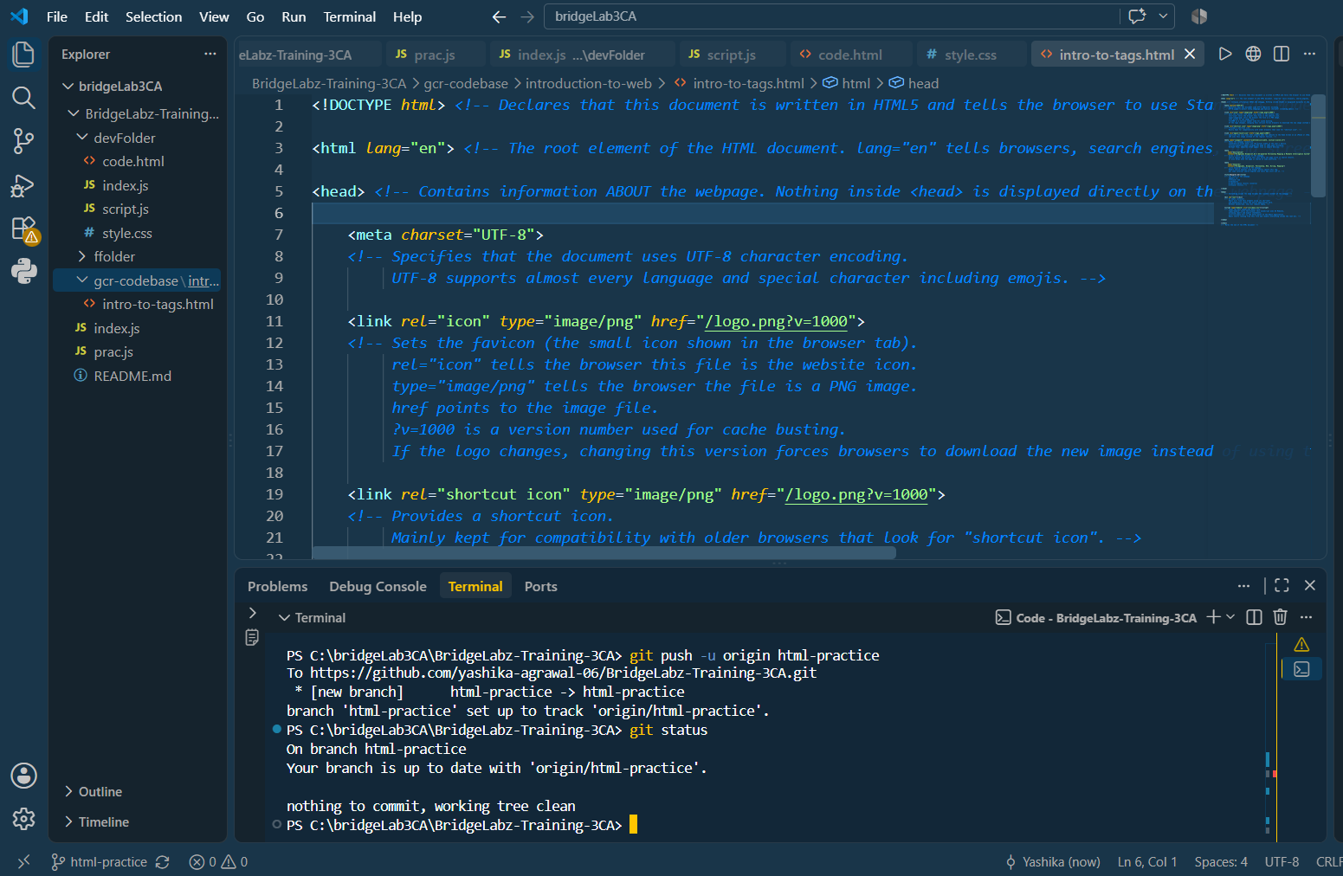

8. Static vs. Dynamic Websites
Static Website:
Description: Displays the exact same pre-written content (HTML/CSS) to every visitor. The files stored on the server are served directly without processing.
Example: A simple personal portfolio or local restaurant menu page.
Dynamic Website:
Description: Generates content on the fly based on user inputs, database records, login sessions, or real-time data.
Example: Netflix or Twitter, where content changes based on who is logged in and what actions they take.

9. Five Web Browsers & Their Rendering Engines
Web Browser | Rendering Engine | Key Differences / Notes
Google Chrome | Blink | Fast, highly modular engine developed by Google; power-efficient and heavily optimized for modern web standards.
Mozilla Firefox | Gecko | Open-source engine focused on security, standards compliance, and parallelized CSS rendering via Quantum.
Apple Safari | WebKit | Lightweight engine optimized specifically for Apple hardware, prioritizing battery performance and memory efficiency.
Microsoft Edge | Blink | Uses the same Chromium/Blink base as Chrome, integrated tightly with Windows features and enterprise tools.
Brave | Blink | Chromium-based rendering engine with built-in ad-blocking and privacy shields integrated directly into the networking layer.

10. Basic Web Architecture Flow DiagramFlow Breakdown:
- Client sends a request (via web browser or API client).
- Web Server / API processes the request, checks permissions, and queries the Database.
- Database runs the query and sends the raw data back to the server.
- Web Server / API formats that data (into HTML or JSON) and returns the HTTP response back to the Client.

