SYSTEM ANALYSIS & DESIGN REPORT
SynapX GymOS
End-to-End System Analysis
A reverse-engineered analysis of the SynapX GymOS codebase — a multi-tenant gym operations platform — covering its architecture, entity-relationship model, class structure, use cases, application screenshots, and a ready-to-write final report chapter outline.
ATTRIBUTE | VALUE
Sub-systems | 3 (Backend API, Biometric Service, Frontend)
Database tables | 14 (PostgreSQL via Prisma)
Staff roles | 6 (Super Admin -> Read-Only)
Backend stack | Node.js, Express, Prisma, PostgreSQL
Frontend stack | React 18, Vite
Biometric stack | Python, FastAPI, InsightFace, WebAuthn

Generated from a direct read of the project source: prisma/schema.prisma, all route / controller / service files, and app.py.

01 System overview
__________________________________________________________________________________________
SynapX GymOS is a multi-tenant gym operations platform. A single deployment serves many gyms (tenants), each with one or more physical locations (branches). Staff run the business - members, billing, classes, equipment - from an admin dashboard, while members check themselves in at an unattended kiosk using QR, face recognition, fingerprint, or manual lookup.
The codebase is split into three independently deployable services:
SERVICE | DESCRIPTION
Backend API | SynapX_Backend_API - Node.js + Express REST API. Owns all business data via Prisma ORM over PostgreSQL. Issues JWTs, enforces role-based access, talks to Stripe and the biometric service.
Biometric Service | SynapX_Biometric_Service - Python + FastAPI microservice. Runs face embedding/matching (InsightFace) and bridges an optional ZKTeco fingerprint reader. Never touches the main database directly.
Frontend | SynapX_GymOS_Frontend - React 18 + Vite admin dashboard (Members, Classes, Payments, Staff, Attendance, Reports) plus the public Kiosk check-in screen.

ACTORS
ACTOR | NATURE | WHAT THEY DO
Super Admin | internal | Full control, incl. enrolling/removing member biometrics.
Admin | internal | Runs day-to-day operations: members, billing, classes, staff.
Manager | internal | Membership plans, equipment, branch operations.
Trainer | internal | Own class schedule, booking attendance.
Receptionist | internal | Front-desk: check-in support, bookings, member lookup.
Read-Only | internal | View-only access, e.g. auditors.
Member | external | Self-service kiosk check-in; no login account.
Biometric Device | external | Webcam, ZKTeco reader, or the device's own platform sensor (Windows Hello / Touch ID via WebAuthn).
Stripe | external | Sends payment-status webhooks back to the API.

02 System architecture
__________________________________________________________________________________________
Three services, three storage roles: PostgreSQL for the business record, an in-memory/disk face index inside the biometric service, and Stripe as the external payment authority.
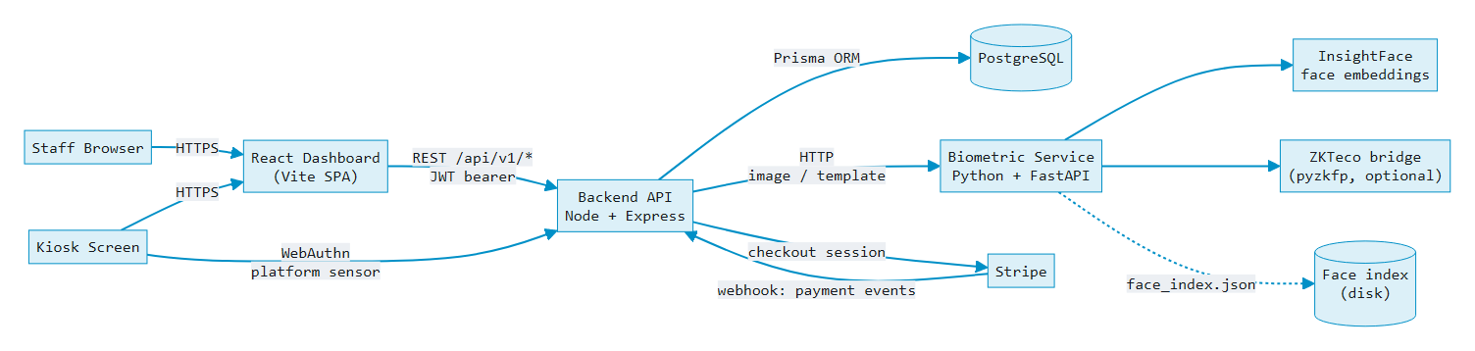
Fig. 1 - Service topology. The backend never stores or matches biometric data itself; it forwards captures to the Python microservice and persists only the bytes returned.
NOTABLE DESIGN DECISIONS
- Two independent fingerprint paths. A legacy path forwards raw templates to a ZKTeco desk reader bridged by pyzkfp; the primary path uses WebAuthn so a laptop’s own sensor (Windows Hello, Touch ID) can authenticate a member - the server only ever sees a public key, never a template.
- Attendance is denormalized on purpose. AttendanceLog has no foreign keys to Member/Branch - it stores copies of the name/code at check-in time, so kiosk logging never fails even if a lookup or a later data change would otherwise block it.
- Multi-tenancy is scoped through the data model, not separate databases: every Branch hangs off a Tenant, and most staff/report queries are scoped to req.user.branchId.
- Role gating is middleware-based (protect, then adminOnly / adminUp / managerUp / trainerUp / receptionUp), stacking cleanly on top of route handlers rather than being re-checked inside each controller.

03 Entity-relationship diagram
__________________________________________________________________________________________
Derived directly from prisma/schema.prisma - 14 tables. Fields are trimmed to the ones that carry the relationships and business meaning.
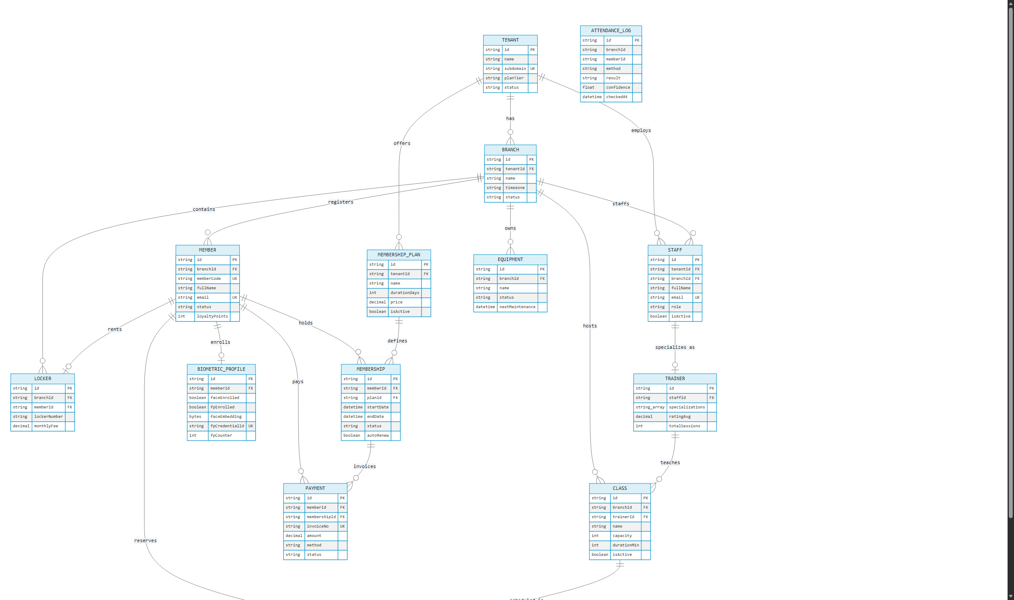
Fig. 2 - 13 relational tables plus the intentionally standalone ATTENDANCE_LOG (no enforced FK - see architecture notes above).
ENUMERATED TYPES
ENUM | VALUES
PlanTier | STARTER, PRO, ELITE, ENTERPRISE
MemberStatus | ACTIVE, FROZEN, SUSPENDED, EXPIRED, CANCELLED
PaymentStatus | PENDING, PAID, OVERDUE, REFUNDED, CANCELLED
PaymentMethod | CASH, CARD, ONLINE, BANK_TRANSFER
StaffRole | SUPER_ADMIN, ADMIN, MANAGER, TRAINER, RECEPTIONIST, READ_ONLY
BookingStatus | CONFIRMED, WAITLIST, CANCELLED, ATTENDED, NO_SHOW
EquipmentStatus | ACTIVE, MAINTENANCE, BROKEN, RETIRED

04 Class diagrams
__________________________________________________________________________________________
Two views: the persistent domain model (mirrors the Prisma schema as UML classes, with the operations each entity’s routes actually expose), and the service-layer collaboration behind biometric check-in.
4.1 - DOMAIN MODEL
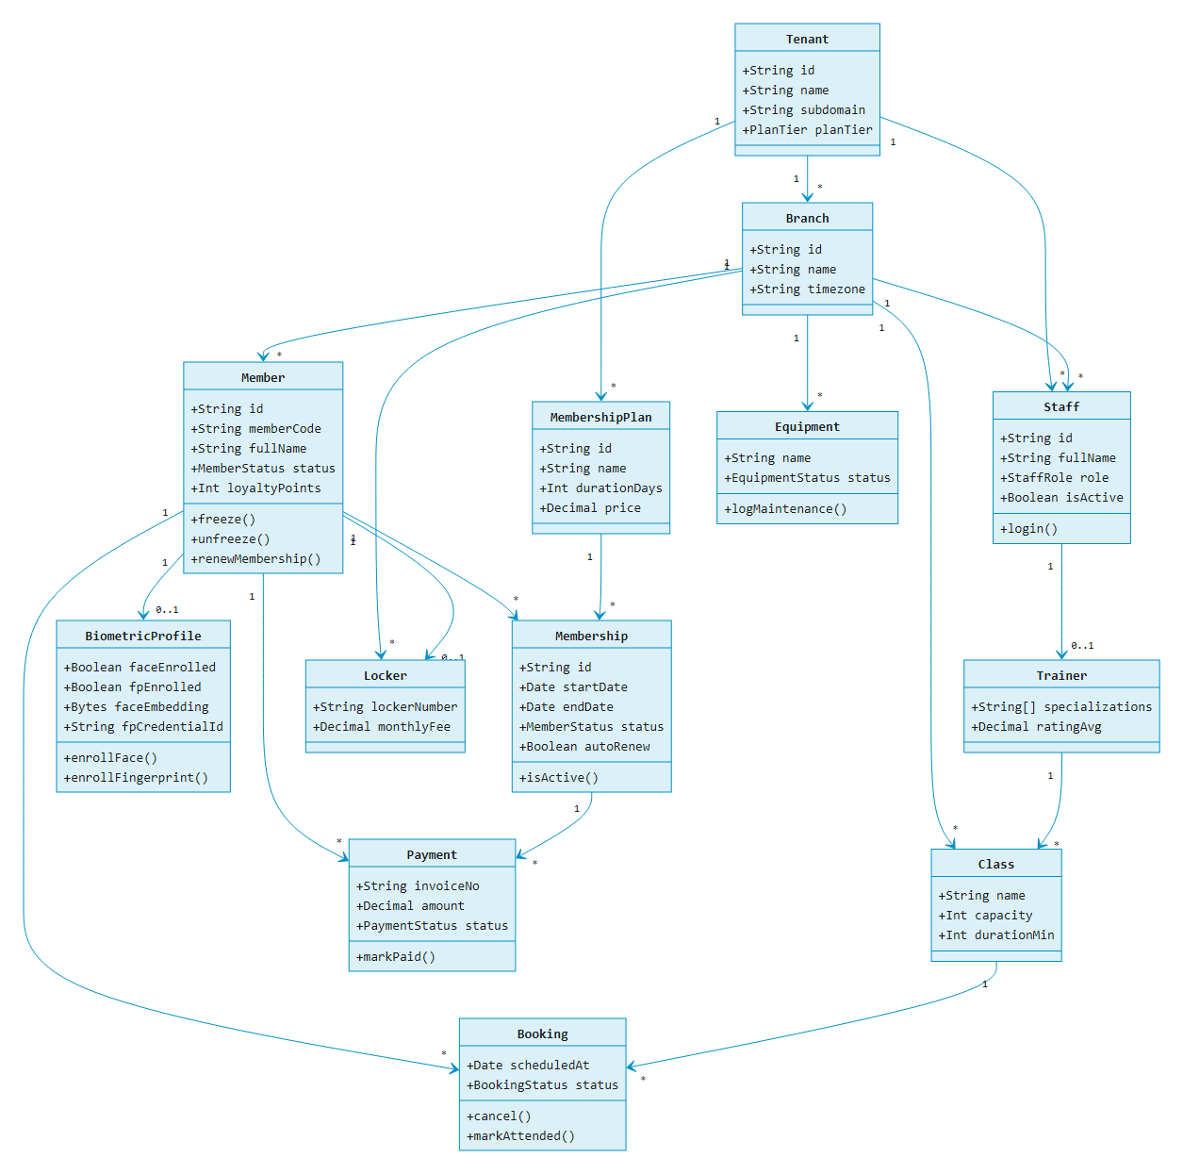
Fig. 3 - Operations shown on each class are the real mutations its controller exposes (e.g. PATCH /members/:id/freeze -> Member.freeze()), not invented behavior.
4.2 - BIOMETRIC CHECK-IN: SERVICE COLLABORATION
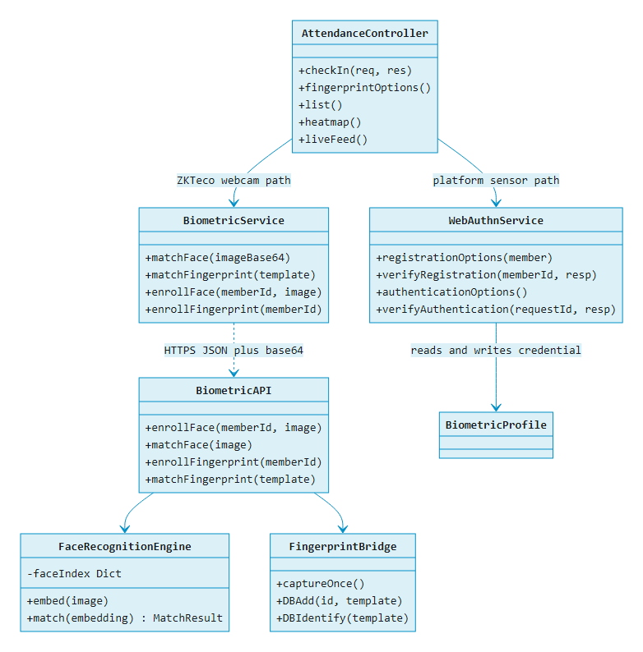
Fig. 4 - Two parallel fingerprint strategies converge on one checkIn() pipeline; the WebAuthn path never leaves member devices with a template, only a public key.

05 Use case diagram
__________________________________________________________________________________________
Actors and use cases grouped by module, plus the complete role-accurate endpoint mapping below.
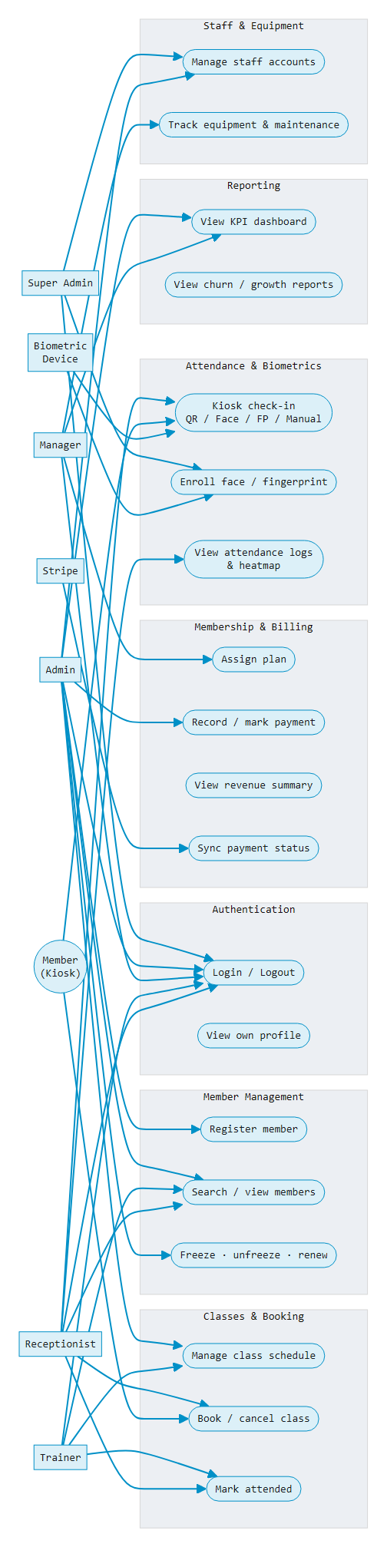
Fig. 5 - Actor-to-module use case overview. Precise per-endpoint role gates in the table below.
FULL USE-CASE -> ROLE MAPPING
MODULE | USE CASE | ACTOR(S) | ENDPOINT
Auth | Log in / refresh / log out | any staff | POST /auth/login
Auth | View own profile | any staff | GET /auth/me
Members | Search / list / view member | any staff | GET /members
Members | Register, update, delete, freeze, renew | Admin+ | POST/PUT/DELETE /members
Memberships | List plans / view member's plan | any staff | GET /memberships
Memberships | Define plan, assign, renew | Manager+ | POST /memberships
Payments | View invoices / revenue summary | any staff | GET /payments
Payments | Record payment, mark paid | Admin+ | POST /payments
Payments | Stripe payment sync | Stripe (external) | POST /webhooks/stripe
Attendance | Kiosk check-in (QR/Face/FP/Manual) | Member (unauthenticated) | POST /attendance/checkin
Attendance | View logs, today stats, heatmap, live feed | staff | GET /attendance/*
Biometrics | Enroll / verify / remove profile | Super Admin | POST/DELETE /biometric/:id
Classes | View schedule | any staff | GET /classes
Classes | Create, update, delete class | Admin+ | POST/PUT/DELETE /classes
Bookings | Book, cancel, mark attended | Member / Receptionist / Trainer | POST /bookings
Staff | List / view staff | any staff | GET /staff
Staff | Create, update, delete staff | Admin+ | POST/PUT/DELETE /staff
Equipment | View equipment | any staff | GET /equipment
Equipment | Add, update, log maintenance | Manager+ | POST/PATCH /equipment
Reports | KPI dashboard, revenue/growth/plan charts | any staff | GET /dashboard/*
Reports | Member, revenue, churn, monthly reports | any staff | GET /reports/*

06 Application screenshots
__________________________________________________________________________________________
Captured from the running system: backend API on PostgreSQL, frontend dashboard on Vite, seeded demo data for FitNation Gym.
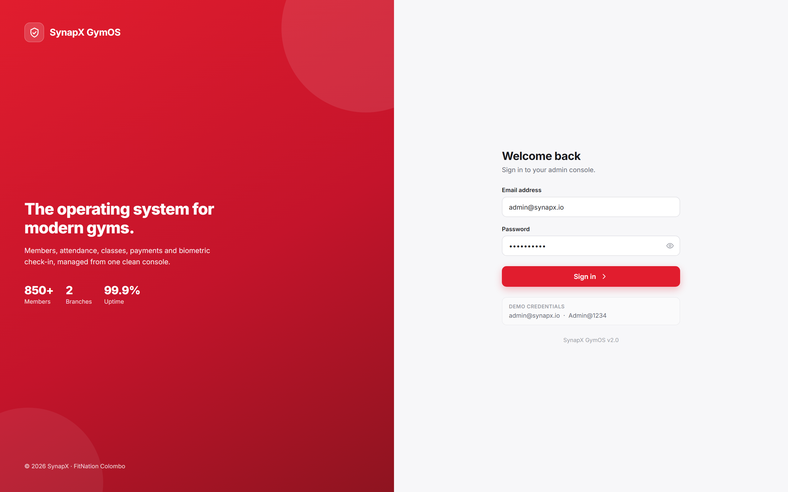
Fig. 6 - Staff sign-in, JWT issued on submit.
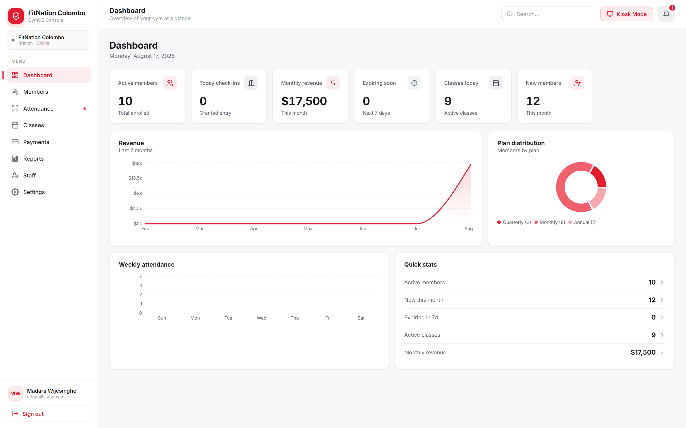
Fig. 7 - KPI dashboard: active members, revenue, plan distribution, weekly attendance.
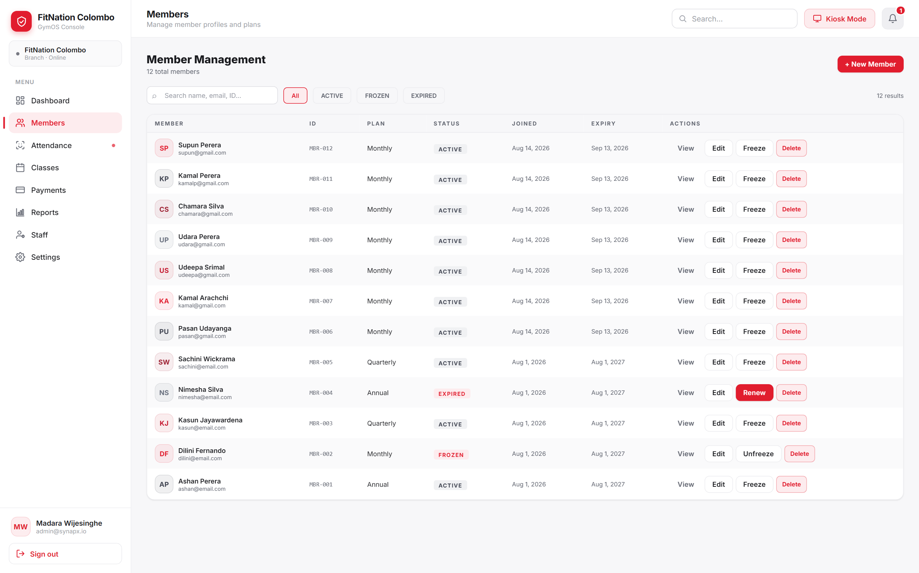
Fig. 8 - Member management: search, status filters, freeze/renew actions.
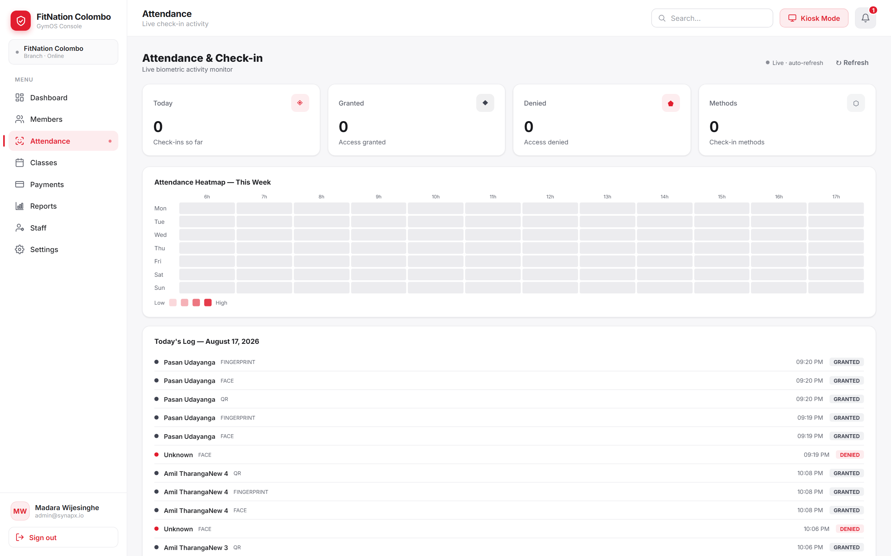
Fig. 9 - Live attendance monitor with weekly heatmap and check-in log.
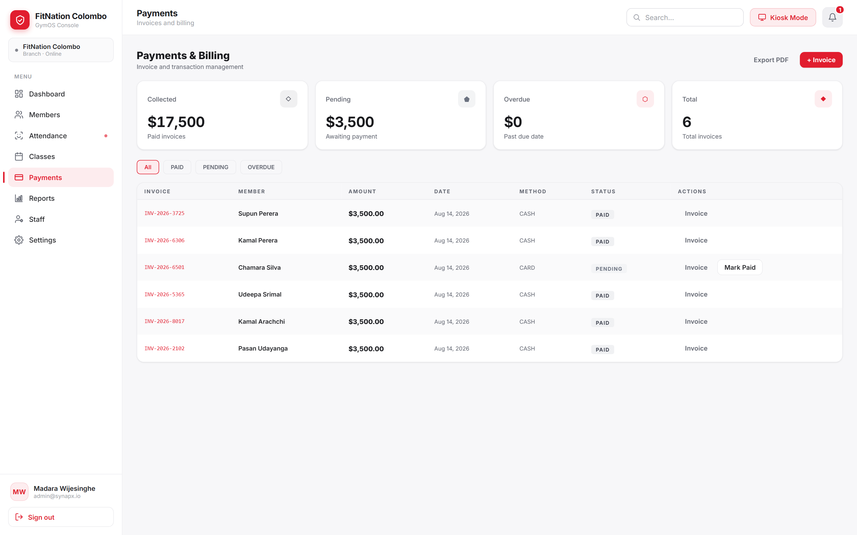
Fig. 10 - Payments & billing: invoice list, status filters, mark-paid action.
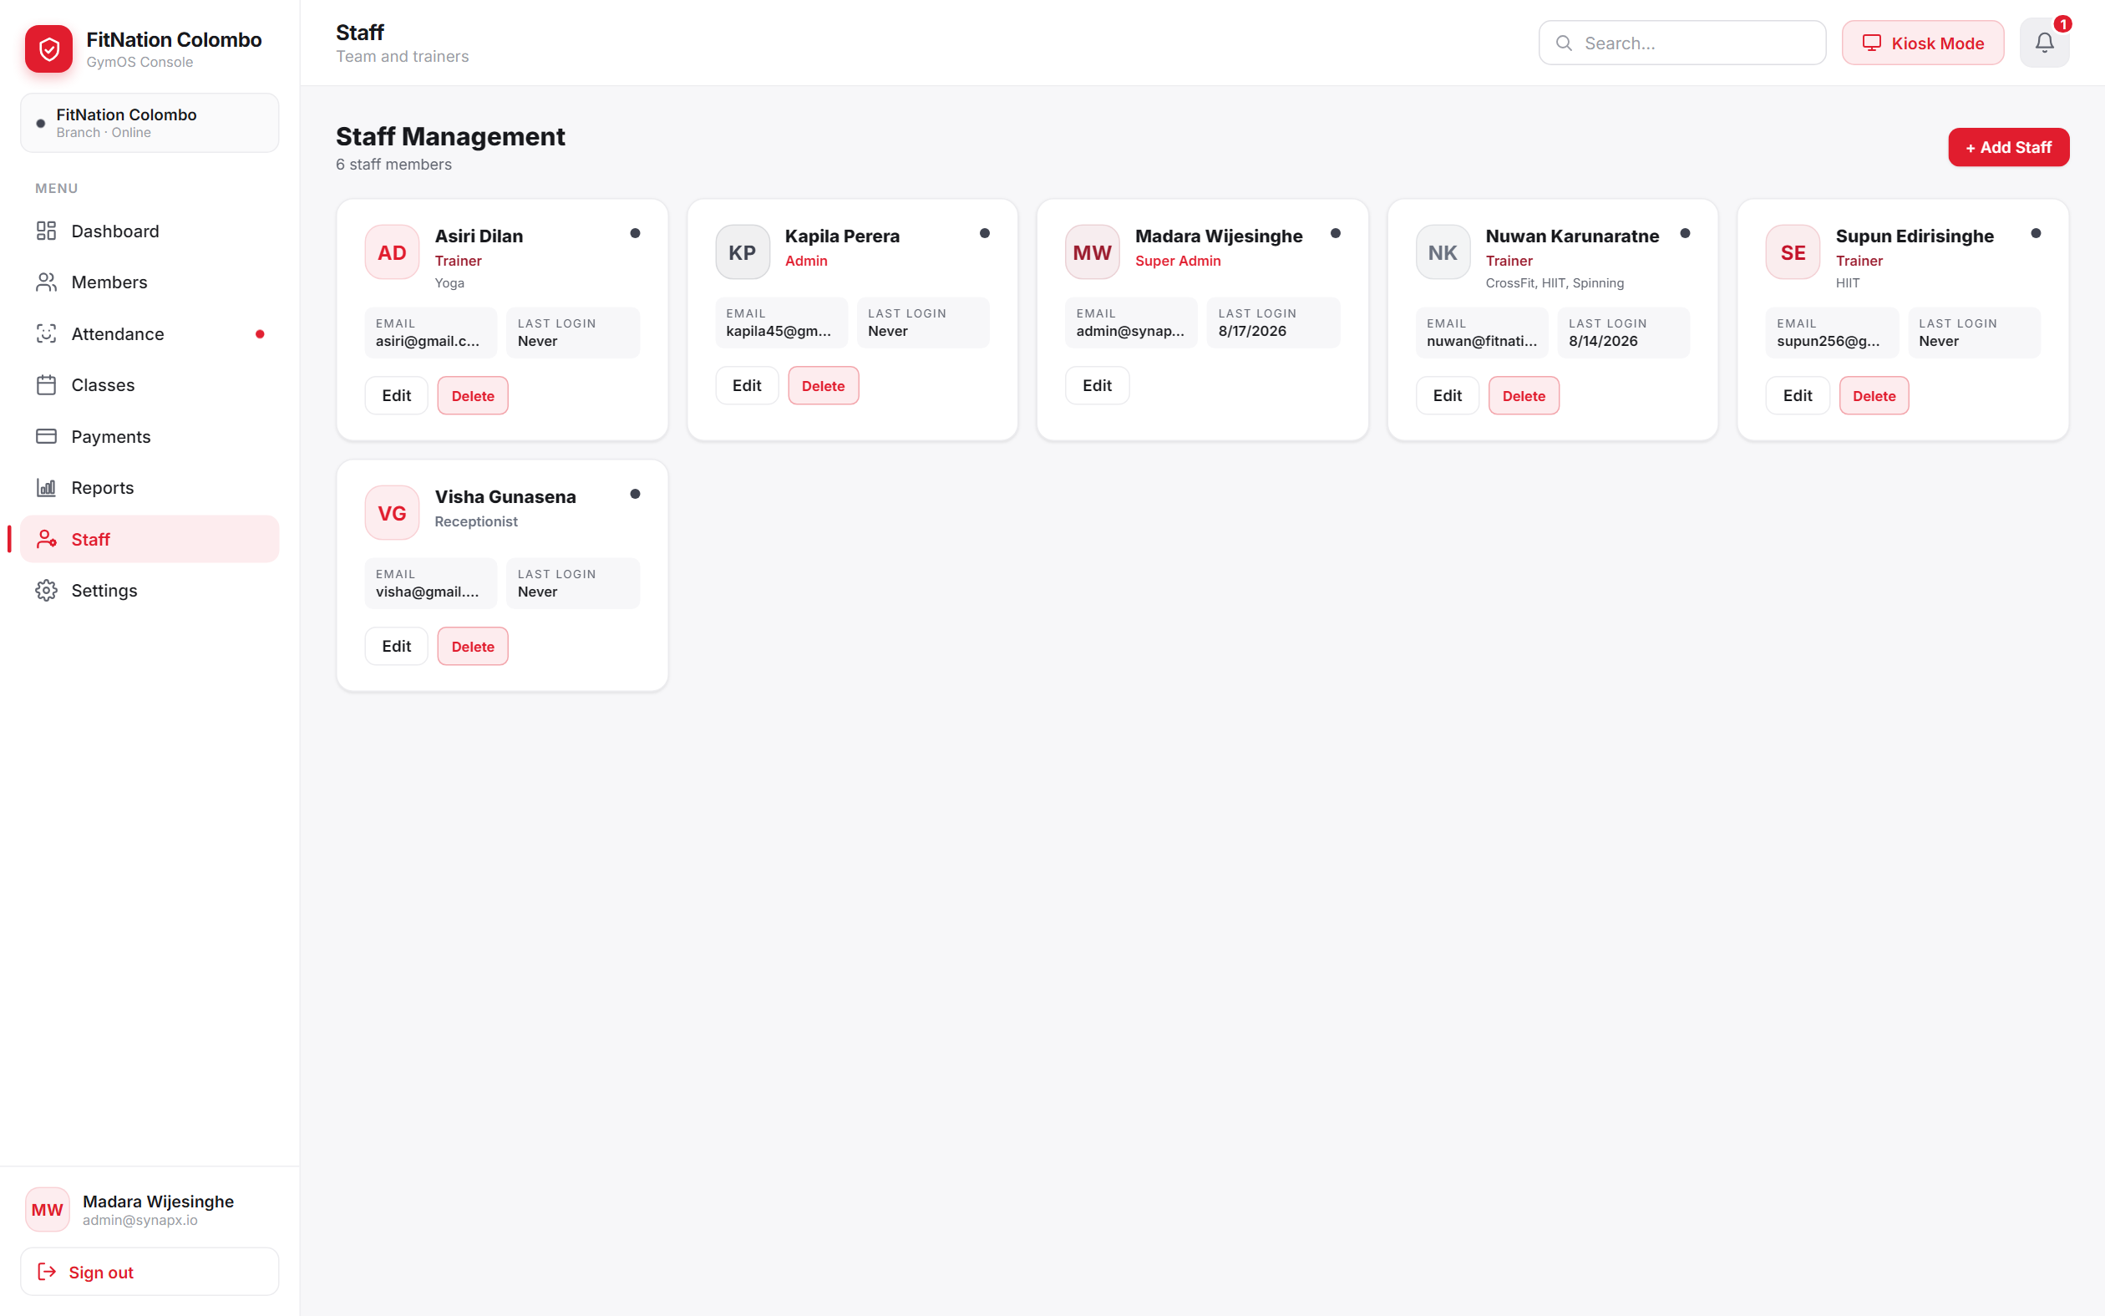
Fig. 11 - Staff management: role badges (Trainer / Admin / Super Admin / Receptionist).
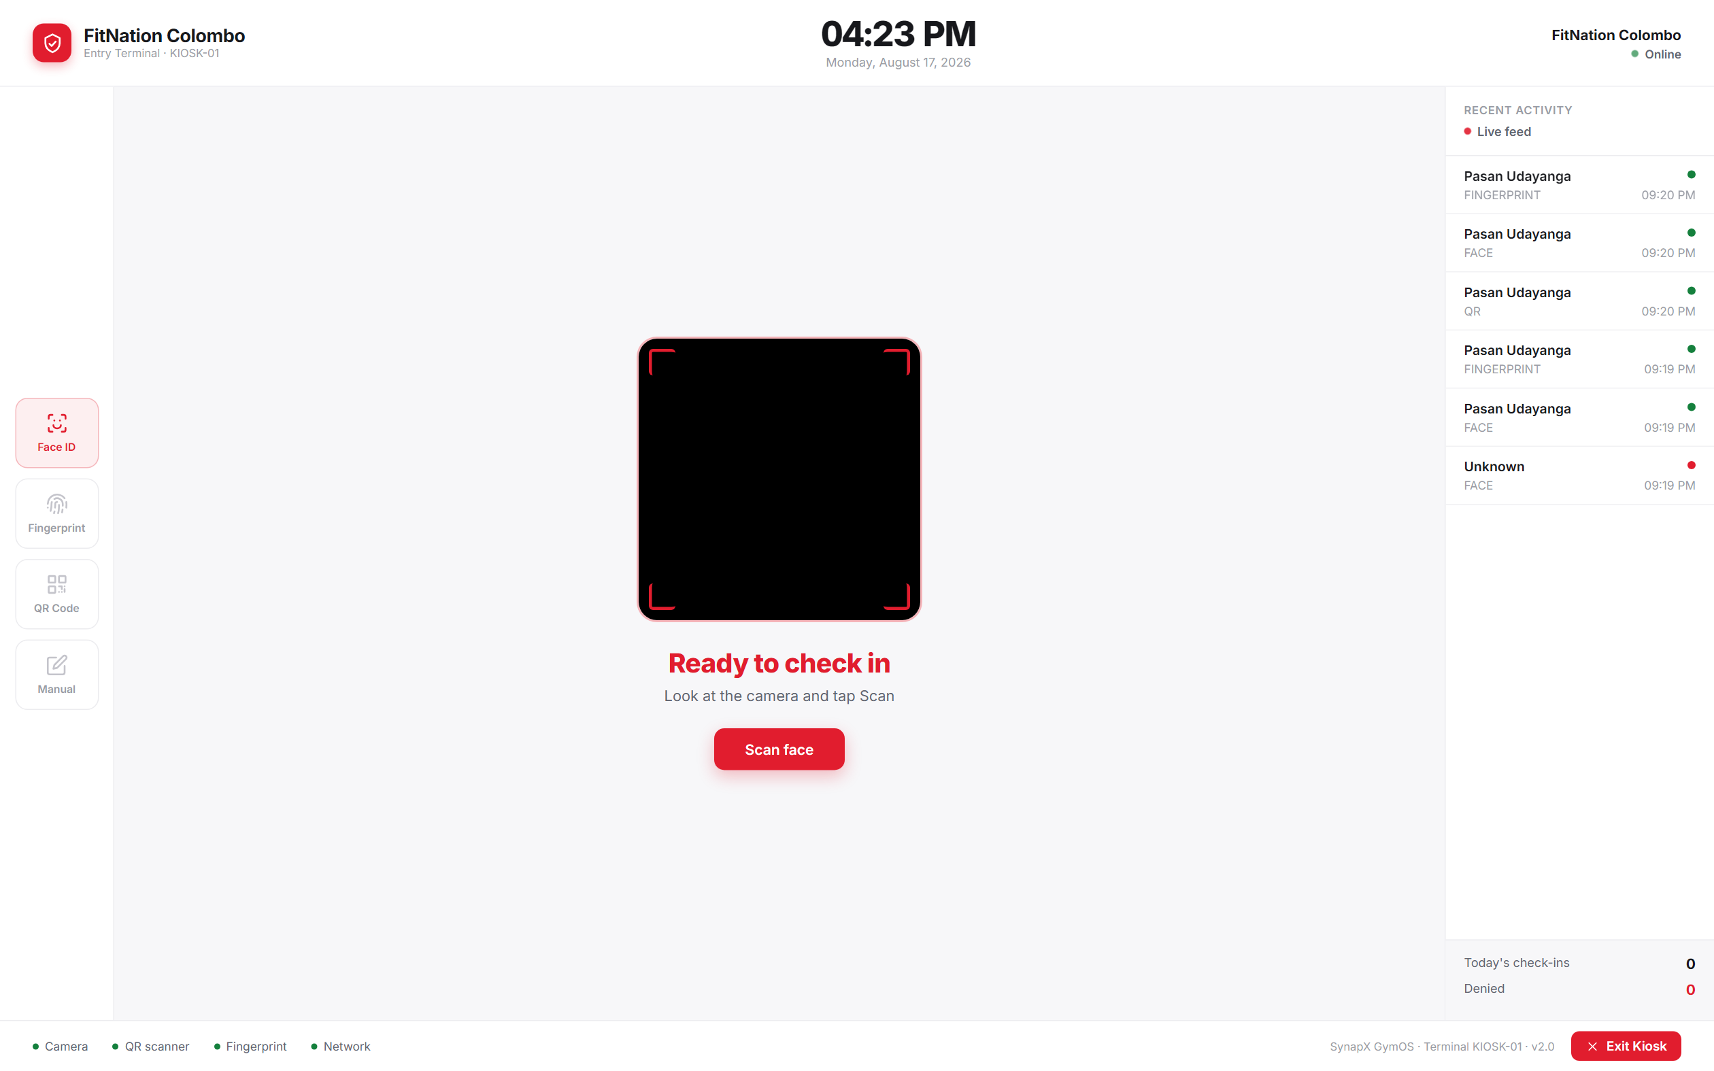
Fig. 12 - Unattended kiosk: Face ID / Fingerprint / QR / Manual check-in, with a live activity feed.

07 Final report - chapter outline
__________________________________________________________________________________________
A working skeleton for the written report, with content bullets grounded in what the codebase actually does.
01 Introduction
- Background: gyms managing members, billing, and attendance across paper/spreadsheets or disconnected tools.
- Problem statement: no single system ties membership status, billing, and physical access (check-in) together in real time.
- Objectives: multi-tenant member/billing management; biometric + QR attendance without extra hardware cost; role-based staff operations; live KPI reporting.
- Scope: single-organisation gym chains (tenant -> branches); web dashboard + unattended kiosk; out of scope: native mobile app, member self-service portal.
02 Literature / comparable systems
- Compare against commercial gym-management SaaS (e.g. Mindbody, Glofox) - what they offer for billing/attendance/scheduling.
- Biometric access control precedent - face recognition (ArcFace/InsightFace embeddings) and WebAuthn/FIDO2 as a template-free alternative to dedicated fingerprint hardware.
03 Requirements
- Functional: the 20 use cases in §05, grouped by module (Auth, Members, Billing, Attendance, Classes, Staff, Equipment, Reporting).
- Non-functional: multi-tenant data isolation; RBAC across 6 roles; JWT-based stateless auth; kiosk check-in must degrade gracefully when the biometric service is unreachable.
04 System design
- Architecture diagram and rationale for splitting the biometric workload into its own Python service (Fig. 1).
- ER diagram and schema rationale - why AttendanceLog is denormalized (Fig. 2).
- Class diagrams - domain model and the biometric service collaboration (Figs. 3-4).
- Use case diagram and role/permission matrix (Fig. 5).
- Recommended addition: a sequence diagram for the kiosk check-in flow, since it is the system's most stateful interaction.
05 Implementation
- Backend: Express 4, Prisma 5 over PostgreSQL, JWT, bcrypt password hashing, Stripe SDK, PDFKit for invoices, Winston logging.
- Biometric service: FastAPI, InsightFace (buffalo_l, cosine similarity threshold 0.45), optional pyzkfp ZKTeco bridge, disk-persisted face index.
- Frontend: React 18 + Vite, React Router, Recharts, @simplewebauthn/browser, jsqr for QR scanning.
- Note the two-generation architecture visible in the repo: the backend README still documents a MongoDB/Redis-era design, while the current schema moved attendance logging into PostgreSQL.
06 Testing
- No automated test suite was found in any of the three services - flag this and either add one (Jest/Supertest, Pytest) or document manual test cases per use case in §05.
- Suggested manual cases: expired-membership check-in is denied; frozen member check-in is flagged; face match below threshold falls back to manual; role-gated routes reject a lower-privilege token with 403.
07 Results & discussion
- Screenshots of the dashboard, kiosk check-in, and a sample invoice (§06).
- Discuss the WebAuthn-over-ZKTeco decision as a cost/UX trade-off worth highlighting as a contribution.
08 Conclusion & future work
- Objectives met vs. §01; limitations (single-currency assumptions, no mobile app, no automated tests).
- Future work: member self-service portal, automated test coverage, multi-currency billing, class waitlist promotion logic.

Generated from a direct read of SynapX_Backend_API, SynapX_Biometric_Service, and SynapX_GymOS_Frontend - prisma/schema.prisma, all route/controller/service files, and app.py.

