**F1-score plot**

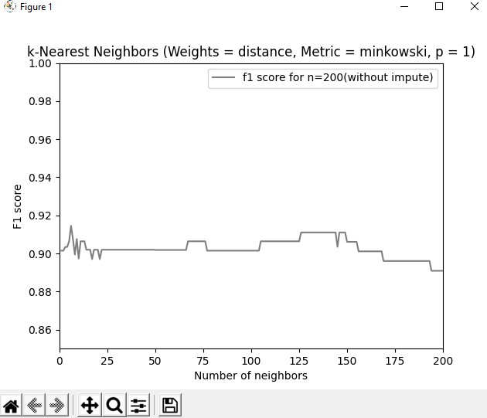

The f1 score metric has the highest value when the neighbors are counted as **5**, as we can see from the Python console below. The parameters I used for the plot are appearing above the plot.

