Echo chambers on Twitter networks

RAW DATA 1

**NETWORK CREATION 2**

Edges 2

Nodes 2

Notes to consider 2

Network stats 2

The goal of the project is to find groups of users that are exposed only to information and opinions that reinforce their existing beliefs and values, while ignoring or rejecting information that challenges them. To unveil these echo chambers we will use different graph algorithms, ranging from community detection to link prediction and sentiment analysis.

# RAW DATA

We have access to two datasets containing a large number of tweets from two different contexts:

* During the Baltimore riots caused by the killing of…
* Related to the Covid19 vaccination programs…

[TO COMPLETE WITH MORE INFORMATION ABOUT THE EVENTS]

We collected rich information about each recorded tweet, from which we extract the following attributes that will be used in the following sections:

* ID string: Unique tweet ID
* Public metrics
  + Number of retweets
  + Number or replies
  + Number of likes
  + Number of times it has been quoted
* Referenced tweets
  + ID of the quoted tweet (if any)
  + ID of the tweet that it replies to (if any)
* User that tweeted
  + Unique user ID
  + Username

# NETWORK CREATION

We create a network of users as follows:

## Edges

* We create an edge between two users if UserA has quoted a tweet of UserB or vice versa.
* Each created edge has an associated weight that is the sum of the number of interactions between the two users. One interaction (a tweet quote) in any direction (userA→userB or userB→userA) adds 1 to the weight of the edge.

## Nodes

For each user we save the following information:

* User ID
* Username
* Public metrics
* List of the texts of their tweets, including their hashtags (for further topic and sentiment analyses)

## Notes to consider

* Please note that the only information that we have about users comes from our collection of tweets. Without any tweet from a user, we are not able to use them for any content-related analysis such as topic modeling or sentiment analysis. Therefore, we only create edges when our dataset contains at least one tweet of each of the two users.

## Network stats

| **Network** | **Nodes** | **Edges** |
| --- | --- | --- |
| Baltimore Riots | 9,260 | 9,087 |
| Vaccination | 20172 | 20078 |
|  |  |  |

# COMMUNITY DETECTION

Community detection in networks is the process of extracting densely connected groups of nodes that are loosely connected to other parts of the network. Here we want to find communities in which a certain side of the debate is highly overexpressed. We want to demonstrate that there are certain communities of Twitter users that are echo chambers, meaning that they only read and talk to other users with their same views of the given topic.

To detect communities in the network we use the widely popular Louvain algorithm (<https://iopscience.iop.org/article/10.1088/1742-5468/2008/10/P10008/meta>). This is a multilevel (hierarchical) algorithm that extracts multiple network partitions at different levels. Here we use the highest level partition (the one with fewer number of communities) for all subsequent analyses.

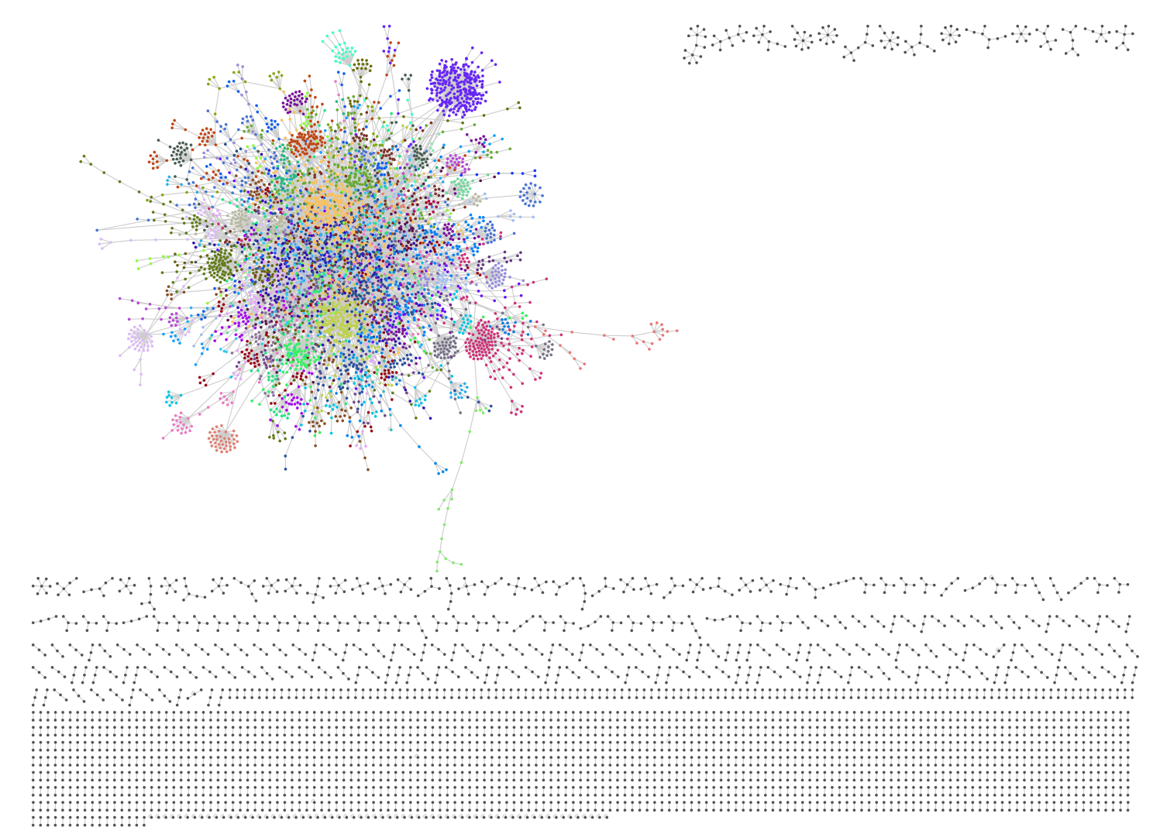

The network built from the Baltimore riots’ dataset is composed of dozens of isolated components. Therefore, we focus on the analysis of the largest connected component, that contains 5,802 of the 9,260 nodes. The Louvain algorithm split this subnetwork into 58 communities of different sizes, which several of them seem to be well differentiated from the rest of the network.

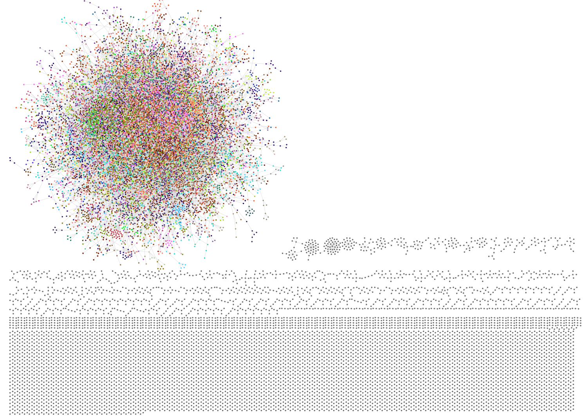

In the case of the vaccination dataset we find the same pattern - a large number of very small isolated components and a large component that we split into communities. In this case, communities seem to be more interlinked, at least visually.

# CONTROVERSY ANALYSIS

We want to analyze what communities are more biased towards one side of the debate. To do so, we select hashtags that only one side (and rarely the other side) uses.

In the Baltimore riots dataset, we selected the following hashtags:

* **Pro Black Lives Matter movement:** #PoliceBrutality, #RacismInAmerica, #BlackLivesMatter
* **Pro Police movement:** #BlueLivesMatter, #UniteBlue, #AllLivesMatter

Then, for each of the largest 25 communities, we calculate the observed probability that one of their users has used, at least once in their tweets, one of the hashtags in both sets.

The figure below shows that around 90% of users from community 9 have used, at least once, one or more of the pro-police movement hashtags. On the contrary, only around half of them have used one of the pro-BLM movement hashtags. This is among the lowest use of pro-BLM hashtags in this set of 25 communities. We could then conclude that most users in this community seem to support the police in the Baltimore riots related tweets. And may be creating an echo chamber where the only information they consume is that generated and propagated within the same community.

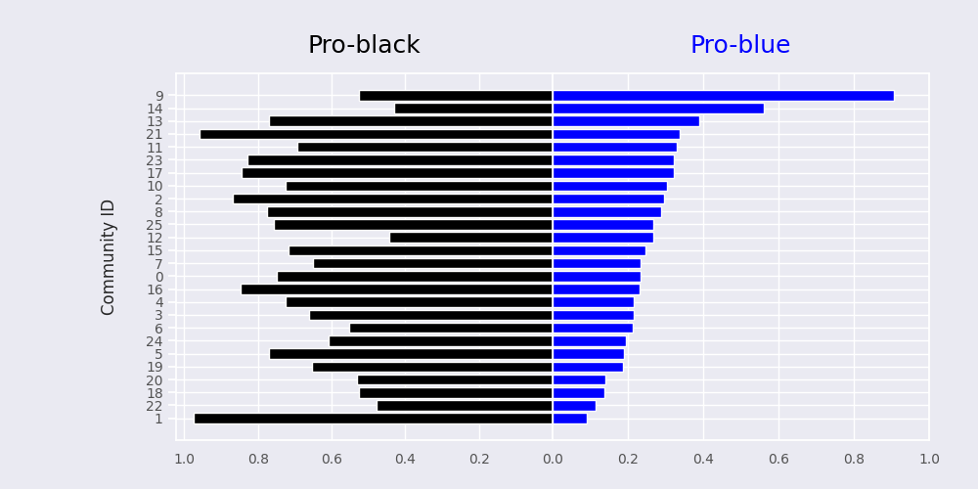

On the other hand, community 1 has both the largest pro-BLM and lowest pro-police related hashtags used by the Twitter accounts in that community. This suggests that community 1 could be an echo chamber where only pro-BLM information and opinion is interchanged.

For the vaccination case, we chose the following hashtags:

* **Pro vaccination movement:** #ProVaccination, #VaccinesWork, #Vaccinated
* **Anti vaccination movement:** #AntiVaccine, #ForcedInjections #VaccinesCauseAutism

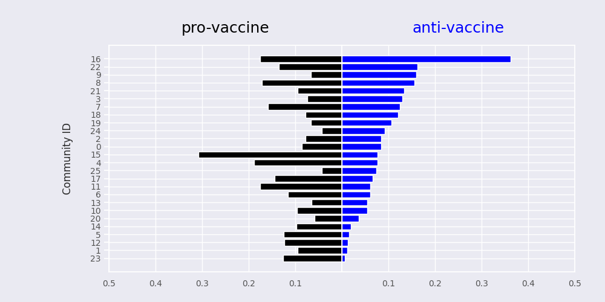

We found that community 15 is the most pro-vaccine while community 16 is the most anti-vaccine

## WORDCLOUDS FOR OPPOSED COMMUNITIES

If we then plot a wordcloud based on the frequency of hashtags in each of those communities, we observe a clear pattern about what side of the debate they support.

Community 9 hashtags wordcloud:

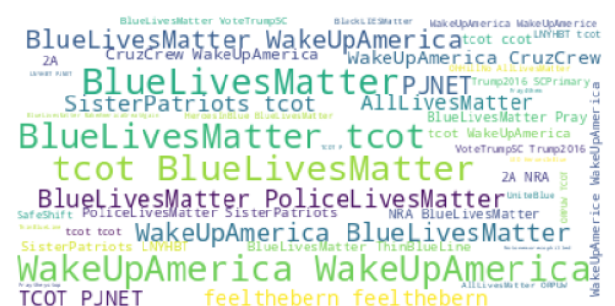

Community 1 hashtags wordcloud:

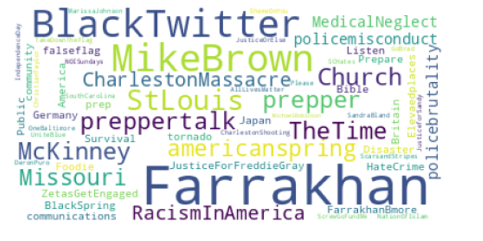

We also calculated wordclouds based on the frequency of all words in each community’s tweets. In this case, all hashtags have been removed from the analyses.

Community 9 words wordcloud:

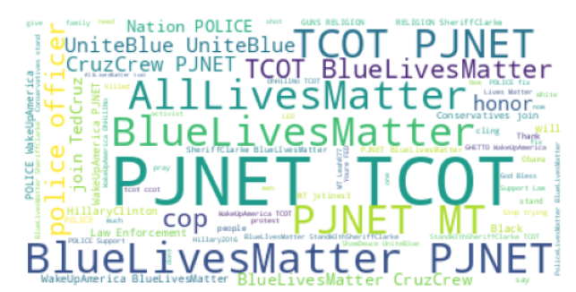

Community 1 words wordcloud:

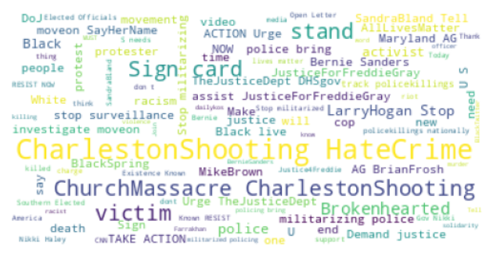

## NETWORK METRICS FOR ECHO CHAMBERS

The figure below shows the largest component of the network with community 1 (in black) and community 9 (in blue) highlighted. We observe their relative isolation from the core of the network and the large distance between them, suggesting that they could indeed form echo chambers of opinion.

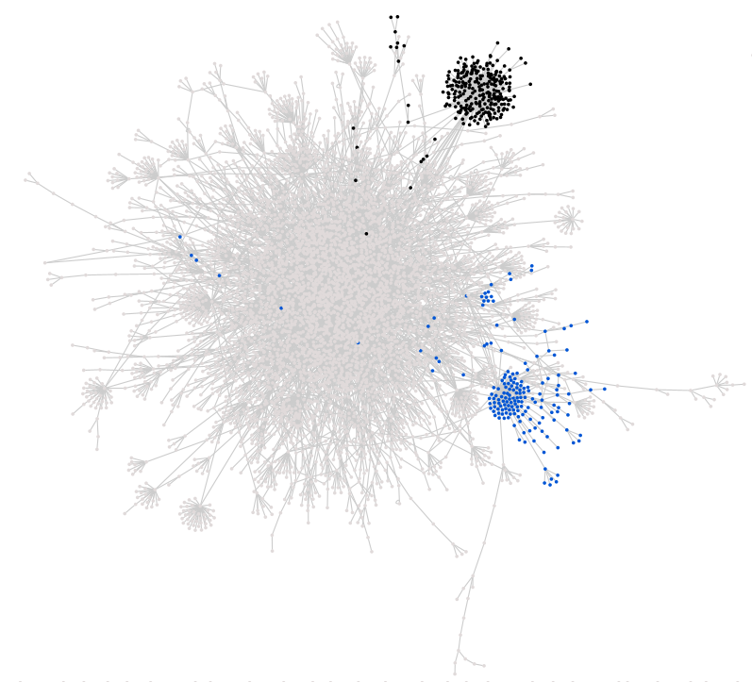

Isolated communities often display a short average path length, which allows information to travel fast within the community and large closeness of all nodes. Closeness centrality measures how “close” a given node is to all other nodes in the network.

We plotted both network metrics for each of the largest 25 communities in the network and effectively found that communities 1 and 9 were among those with lowest average path length and largest closeness.

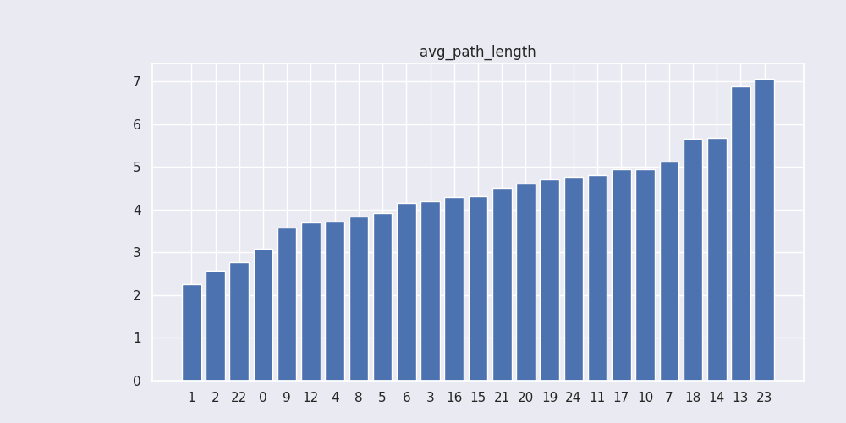

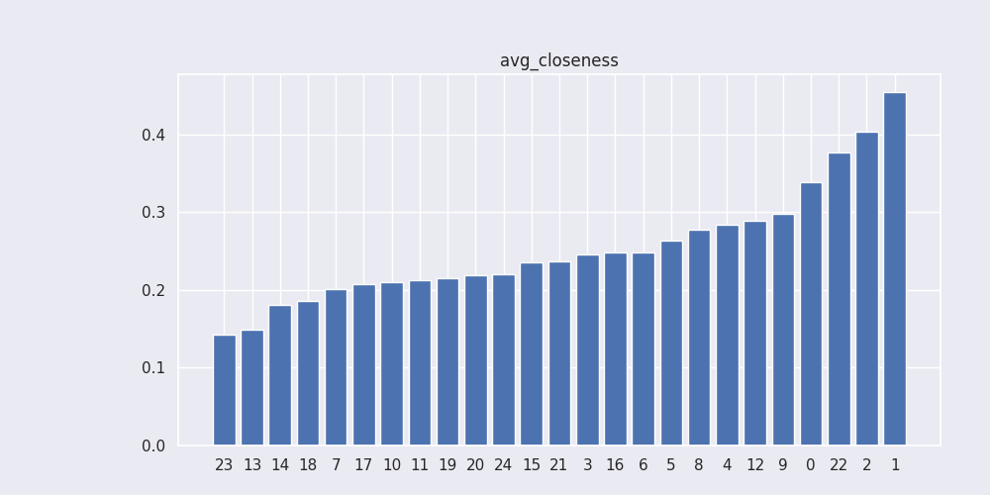

And, the same analysis for the vaccination dataset and communities 15 and 16:

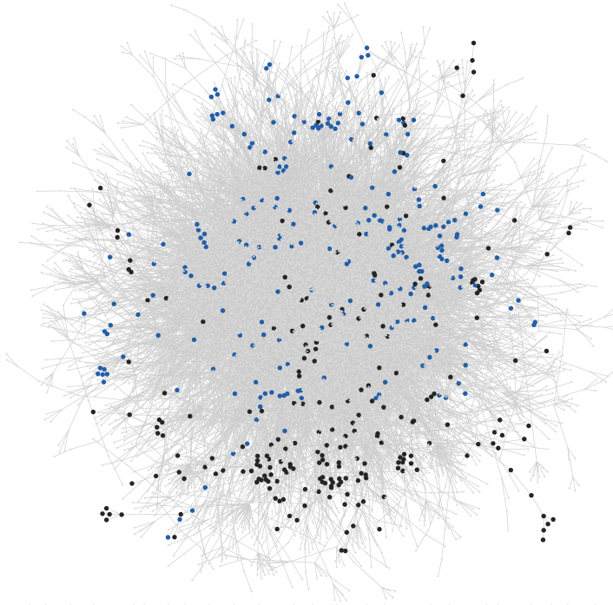

Here both communities are not as separated from the core of the network as in the Baltimore example, likely because the network is larger and, as shown in figure [the figure with black and blue bars], the opposite sides are not as much differentiated as in the Baltimore dataset [figure with black and blue bars from Baltimore]. The probability of a user actively participating with pro or anti hashtags in their tweets (x-axis) is lower in the vaccination dataset than in the Baltimore one.

Moreover, the average path length and closeness of communities 15 and 16 are among the average communities.

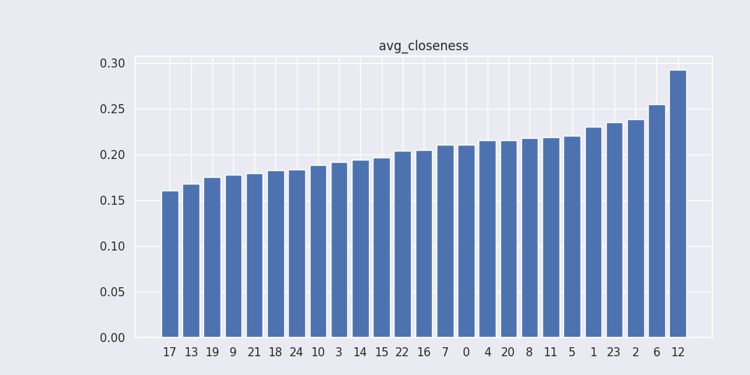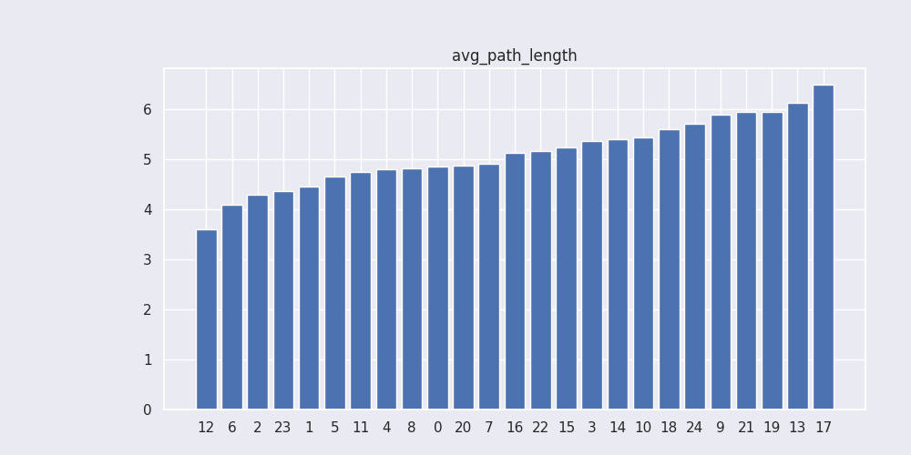

## RANDOM WALK CONTROVERSY

Following REF THESIS, we define as influencers in each community the 15% of users with the highest degree (number of connections to other users). A sign that a community is an echo chamber is that influencers’ power from one side of the debate (from one community) rarely, or with difficulty, reach the users from the other side.

To find out whether that was the case in our communities, we first calculated the average distance (shortest path length) from users in community 9 to influencers in community 1 and from users in community 1 to influencers in community 9.

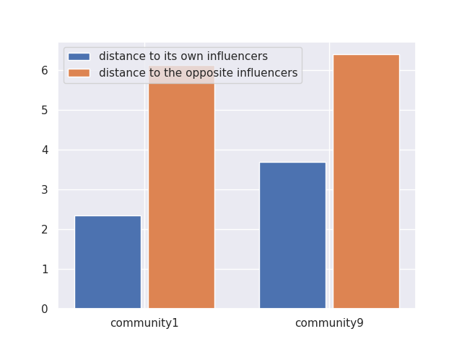+

In the figure above we clearly see that there is a long path (around 6 steps) to cross for a given message to go from a given influencer to users in the other community. On the contrary, in less that 3 and less than 4 steps in communities 1 and 9 respectively, influencers’ messages reach their target audience.

To further validate the presence of echo chambers, we apply the Random Walk Controversy (RAWC) REF AND EQUATIONS to both communities to see the probability that a user from one community receives messages from influencers in their own community before receiving messages from the influencers from the other community.

The figure below shows the RAWC score between communities 1 and 9 compared to two randomly assigned communities with the same number of nodes as community 1 and 9.

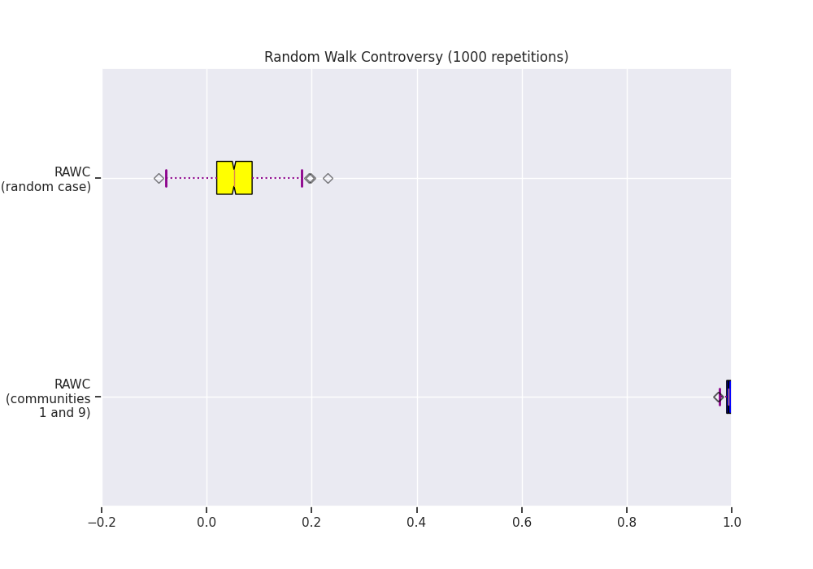

The value of this metric varies between -1 and 1, the closer it is to -1 the more likely it will be to switch to the other partition (absence of dispute), the closer it is to 1 the more likely it will be to remain in the starting partition (presence of dispute).

In the random case, as expected, no switching is expected for users or messages between communities. However, for communities 1 and 9, around 100% of the times, messages from a users’ own community influencer will reach them faster than from users’ in the other community.

The analyses provided here show that communities 1 and 9 behave like echo chambers, where the only voice that is heard and listened to is that of the same community which a user belongs to.

Now, as expected, in the vaccination dataset, the distance from a user from community 15 to influencers in community 16 is not as drastic as in the Baltimore dataset.

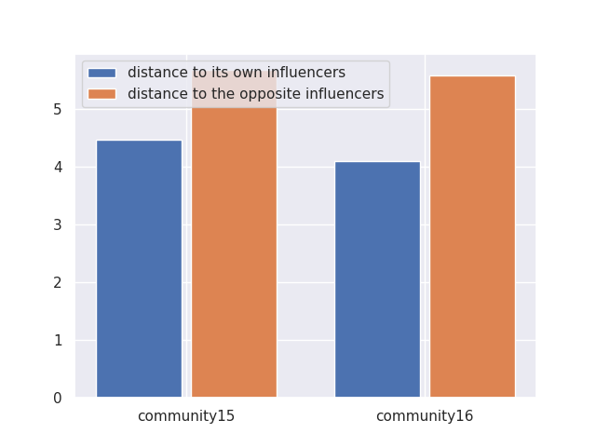

However, the RAWC score, although not as close to 1 as in the Baltimore dataset, it does show that it is very unlikely that messages from influencers in the opposite community reach to a given user

