Care Approval IQ Technical Design Document · v2
Proof beats paperwork.
Zynara Health (fictional) · Deepak Kumar · Architect Track · Microsoft Agent-a-thon 2026 · built on the Microsoft Agent Framework

The whole system in one line: five reasoning agents build and challenge a prior-authorisation case, deterministic code decides, a human authorises, and one adapter talks to the payer — with the payer's own denial history telling us which appeals win.

1 · The problem, in one number
62% of physicians don't appeal a denied prior-authorisation. They think they'll lose. They're wrong — 80.7% of appeals win.
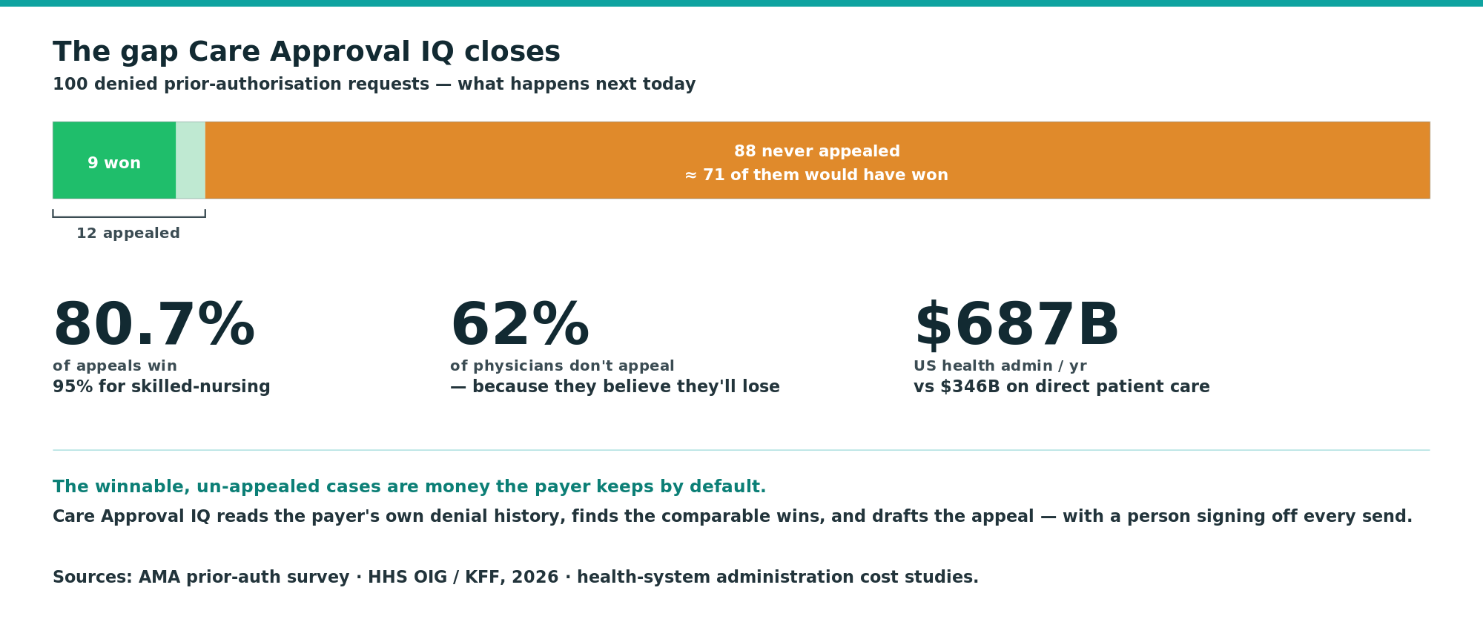
- Prior authorisation is the single largest automatable cost in US health admin — $687B/yr on administration against $346B on direct patient care.
- Nobody reads the clinical chart against this specific payer's, this specific plan's criteria before the request goes in.
- Nobody checks the payer's own recorded outcomes to see whether the case wins on appeal.
- So the clinician gives up, and the winnable-but-un-appealed cases stay as money the insurer keeps by default.

2 · The solution
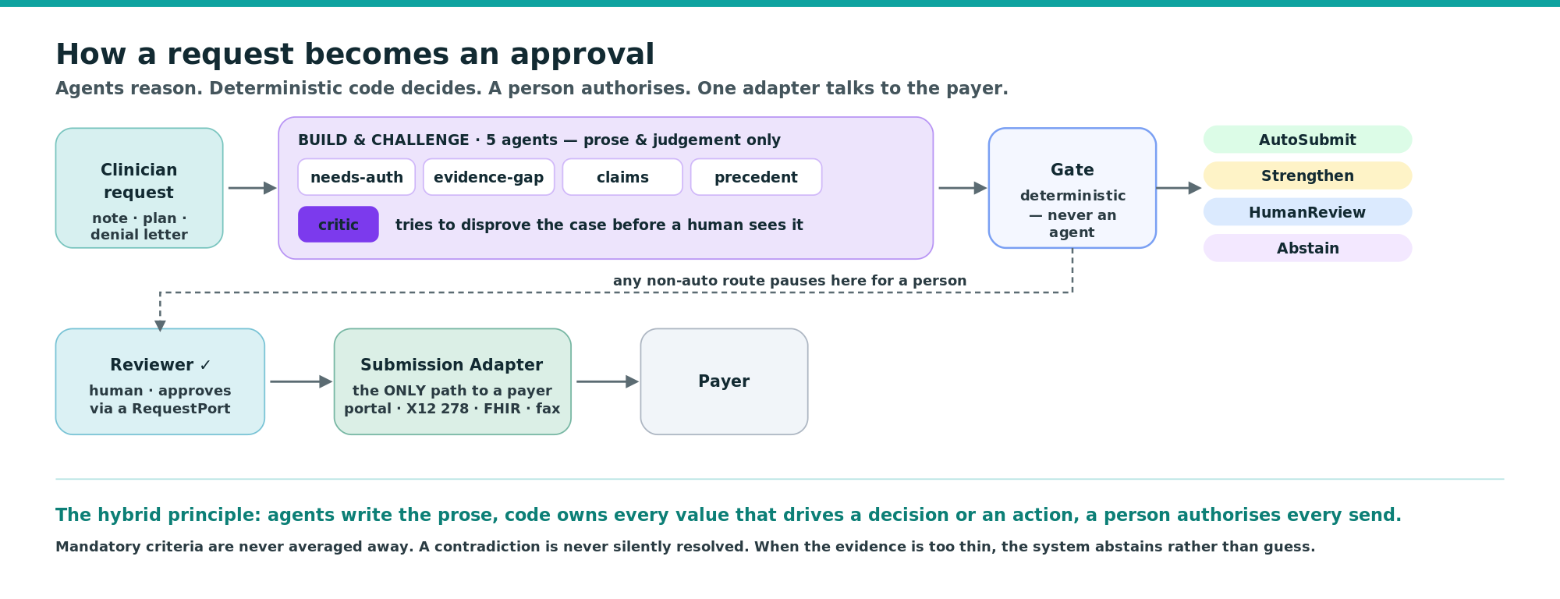
- Build the submission — needs-auth, evidence-gap and claims-extraction map the free-text note onto the numbered criteria, per criterion, with the supporting quote.
- Find the winning argument — precedent-strategist matches the fact pattern against recorded outcomes and drafts the appeal citing the exact clause and the comparable cases.
- Challenge it — critic never builds; it only tries to disprove the recommendation — unsupported claims, non-comparable precedents, over-strong conclusions, hidden contradictions — before a human ever sees it.
- Decide, then authorise — a deterministic Gate (never an agent) routes to AutoSubmit / Strengthen / HumanReview / Abstain, each with its working; every outbound action is human-approved; the Submission Adapter is the only path to a payer.

3 · Built on the four core skills
The four skills the course is built around — Build, Monitor, Evaluate, Orchestrate — each maps to one challenge, and each is carried end to end into a system that runs live.
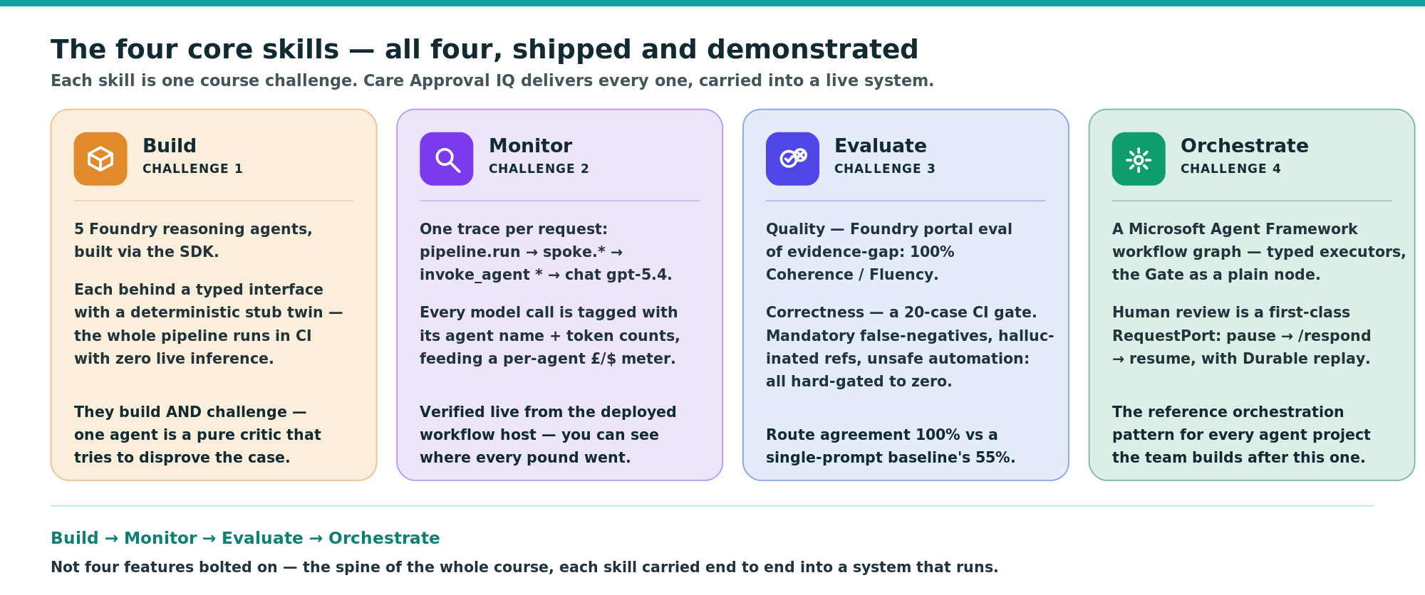

4 · The business value
Impact as a number the payer can check — not a marketing figure.
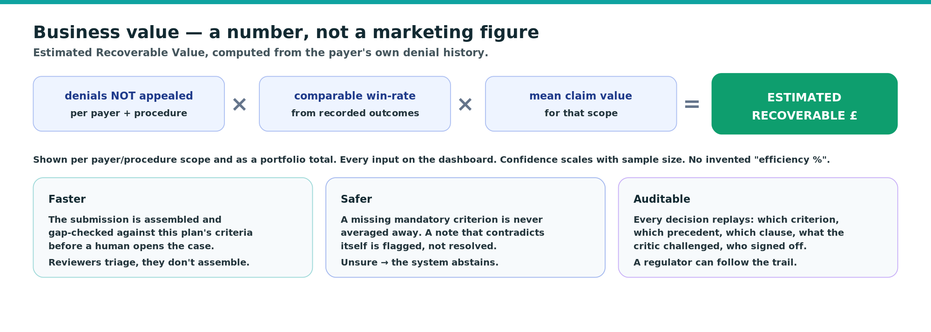
Estimated Recoverable Value is built (RecoveryEstimator + GET /api/recovery + its own dashboard tab): the headline number, the four inputs, the arithmetic spelled out, and a confidence level set by the sample size. No invented improvement percentage.

5 · Architecture
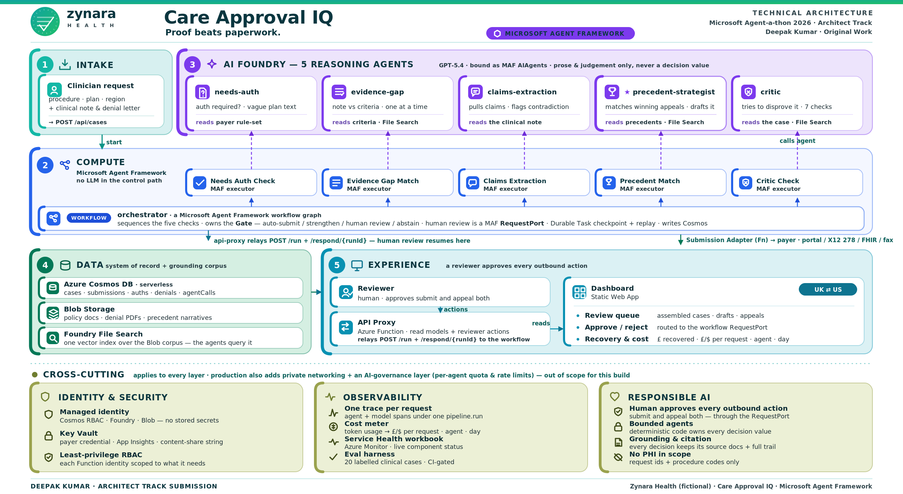
Care-Approval-IQ-Architecture_DesignV2.svg is the authoritative source.
# | Layer | Components
1 | Intake | POST /api/cases on the API Proxy → starts a workflow run (runId = request id).
2 | Compute · Orchestration — Microsoft Agent Framework | CareApprovalWorkflow, a typed executor graph hosted on Zynara.WorkflowHost (Azure Functions + ConfigureDurableWorkflows). Executors run as Durable Task activities — checkpointed, retried, replay-safe. The orchestrator owns the Gate; human review is a MAF RequestPort.
3 | AI Foundry · Agent Service | needs-auth · evidence-gap · claims-extraction · precedent-strategist · critic — bound as MAF AIAgents to the existing server-side Foundry agents (bind-to-existing, never re-create).
4 | Data | Submission Adapter (Azure Function · the only outbound path) → Azure Cosmos DB serverless (cases · submissions · auths · denials · agentCalls, + precedents / policies metadata) → Azure Blob Storage (policy docs · denial PDFs · precedent narratives) → Foundry File Search (one vector index).
5 | Experience | Reviewer (human) → Dashboard (Static Web App + linked backend): review queue · approve/reject (routed to the workflow RequestPort) · recovery & cost, with a UK ⇄ US header control → API Proxy (read models + relays /run + /respond/{runId}).

Cross-cutting: managed identity everywhere (the reasoning identity holds no payer secret; the submission identity has no model access); Key Vault for the payer credential and the two unavoidable strings; App Insights via OpenTelemetry; the Zynara.Eval CI gate. Production hardening — private networking, an AI-governance enforcement layer, a CI/CD deploy pipeline, HA/DR, PHI handling — is named in §7, not built.

6 · Verified live
Deployed to zynara-spike-rg and run end to end against real GPT-5.4:
• Auto-submit path — Gate → AutoSubmit → the system records a decision and submits; no human pause.
• Human-review path — Gate → HumanReview → the workflow pauses on the review RequestPort → a reviewer approves → the workflow resumes, the authority check passes, the case is submitted.
• No CustomStatus error with real agents (the coarse-graph design keeps the workflow snapshot under Durable Task's 16 KB cap).
• App Insights shows the full pipeline.run → spoke.* → invoke_agent * → chat gpt-5.4 → submission.send trace tree from the workflow host.

7 · Technology decisions
# | Decision | Why (one line)
TD-1 | Orchestration is a Microsoft Agent Framework workflow graph, not agent-to-agent chaining | The Gate, the pipeline order and the audit trail must be deterministic and inspectable; the framework gives the typed graph, the HITL port and durable replay as primitives — less bespoke code than a hand-rolled Durable Functions hub for the same properties.
TD-2 | Pipeline steps are MAF executors with a deterministic wrapper, each with a stub twin | Per-step retry isolation; the prose→typed-value boundary is a named unit; zero-inference CI runs; replay-safe resume.
TD-3 | No request queue — the workflow's HTTP /run is the async boundary | Low volume, no burst; /run returns 202 and the workflow runs on Durable Task's own control queues.
TD-4 | Operational store is Azure Cosmos DB serverless, not Azure SQL | A case is a nested aggregate that maps to one JSON document; partition by /requestId; serverless billing fits spiky demo volume; no migrations.
TD-5 | Corpus is Blob Storage + Foundry File Search (one vector index), separate from Cosmos | Retrieval over policy / precedent text is semantic, not a query; File Search owns the index natively; Cosmos keeps only the structured metadata.
TD-6 | Foundry Agent Service (persistent hosted agents) bound as MAF AIAgents | Versioned, portal-visible assets with File Search + tracing wired; AsAIAgent binds to the existing agent; each stays behind a Zynara.Core interface.
TD-7 | C# / .NET 8 · azd + Bicep · one resource group · managed-identity-first · W3C trace context | First-class Agent Framework SDK; static types make the prose→contract boundary a compile-time guarantee; one azd up provisions and deploys; one trace per request feeds the audit trail and the cost meter.

8 · Scope & roadmap
Deliberately not built (production hardening, named so the gap is understood): network isolation with a subnet boundary between the reasoning plane and the payer plane; an AI-governance enforcement layer (per-agent quota, rate limits, spend caps); a CI/CD deploy pipeline with a staging slot; model/prompt versioning linked to outcomes; live quality monitoring on de-identified traffic; HA/DR; secret rotation; a full PHI-handling design (the demo carries none by design).
Roadmap: real payer connectivity (FHIR Prior Authorization / Provider Access APIs, X12 278 clearinghouse, portal RPA — CMS-0057-F, Jan 2027); FHIR bundle intake; an eligibility / active-coverage check; the Early Warnings monitors (expiry-date math, policy-version diff — interfaces and stubs exist, feature unwired); peer-to-peer prep; learning from reviewer edits.

Zynara Health (fictional) · Care Approval IQ · Microsoft Agent Framework · Architect Track Submission · Deepak Kumar

