Care Approval IQ
Microsoft Agent-a-Thon 2026 — Architect Track
Independent Evaluator Review & Critical Architecture Assessment
Zynara Health · Healthcare Prior Authorisation · Deepak Kumar

1. Executive Verdict
This is a strong architecture, but it should not be submitted unchanged. The technical foundation is credible and several design decisions are genuinely strong. The biggest risk is not architectural weakness; it is that the solution may look like a deterministic workflow with five specialised LLM workers rather than a compelling multi-agent system.
The strongest opportunity is the precedent-driven appeal capability: the system can reason over historical fact patterns and recorded appeal outcomes rather than simply generating an appeal. The strongest safety decision is the separation between AI reasoning, deterministic policy gates, and human authorisation.
Evaluator conclusion: shortlist-worthy today; potentially exceptional with targeted changes.

2. Evaluator Scorecard
Area | Score | Assessment
Problem / Impact | 9/10 | Excellent, relevant and easy to understand
Architecture | 8.5/10 | Strong production thinking
Microsoft Foundry usage | 8/10 | Good alignment, but can be stronger
Multi-agent justification | 6.5/10 | Biggest weakness
Safety / Responsible AI | 8.5/10 | Strong foundations
Technical execution | 8.5/10 | Serious pro-code architecture
Evaluation / evidence | 6.5/10 | Needs more quantitative proof
UX / demo potential | 8/10 | Very promising
Innovation | 8/10 | Precedent-driven appeal is interesting
Production credibility | 8/10 | Good, with several hardening gaps
Overall | ~8.0/10 | Strong submission with clear route to 9+/10

3. What the Current Design Gets Right
- Clear end-to-end healthcare prior-authorisation problem and business outcome.
- Five specialised reasoning areas are separated instead of putting every task into one giant prompt.
- Deterministic Durable Functions orchestration owns sequencing and the Gate.
- The Submission Adapter is the sole outbound path to a payer.
- Human approval is required for outbound submission and appeal.
- Policy and precedent grounding is retained with the recommendation.
- Cosmos DB is used for operational state while Blob/File Search handles unstructured corpus content.
- The design deliberately excludes real PHI from the demo.
- The design includes evaluation, observability, trace correlation and per-agent cost metering.
- Production gaps are explicitly documented rather than being hidden.
The TDD itself states that the architecture uses Microsoft Foundry Agent Service, Durable Functions, Cosmos DB, Blob Storage/File Search and a Static Web App dashboard. fileciteturn0file0L68-L74
It also explicitly establishes the hybrid principle: deterministic code owns values that drive decisions/actions, while agents handle prose and judgement over unstructured text. fileciteturn0file0L88-L95

4. Critical Finding #1 — Five Agents Do Not Automatically Make a Multi-Agent System
This is the first question I would attack as an evaluator. The current architecture has needs-auth, evidence-gap, appeal-builder, expiry-watch and policy-drift agents. However, Durable Functions owns most of the sequencing. A judge could reasonably ask: “Why couldn't these simply be five functions calling five prompts?”
Current conceptual model:
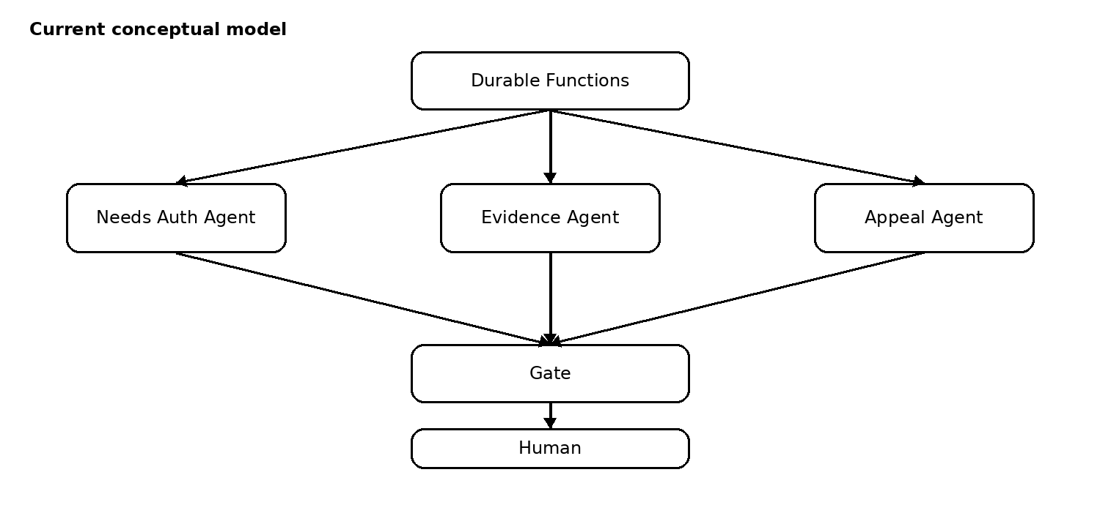
- Durable orchestrator
- → Needs Auth Agent
- → Evidence Agent
- → Appeal Agent
- → deterministic Gate
- → Human
Recommended model:
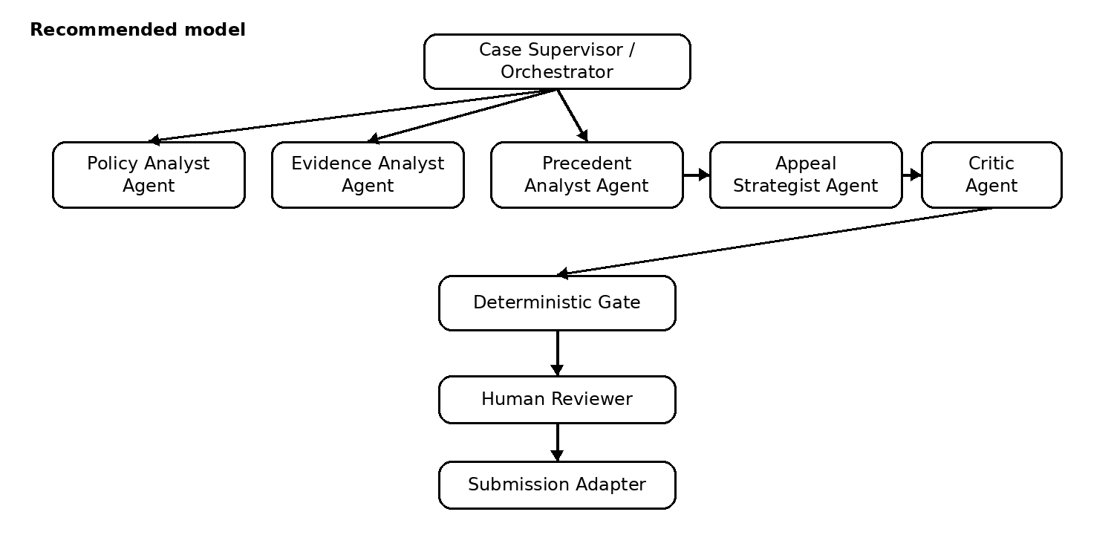
- Case Supervisor / Orchestrator
- → Policy Analyst Agent
- → Evidence Analyst Agent
- → Precedent Analyst Agent
- → Appeal Strategist Agent
- → Critic Agent
- → deterministic Gate
- → Human
The key distinction should be: agents reason and challenge one another; deterministic code decides; humans authorise.
The TDD currently describes five purpose-built agents and explicitly says Durable Functions sequences the pipeline. fileciteturn0file0L80-L95

5. Critical Finding #2 — Make Precedent-Driven Appeal the Killer Feature
The precedent capability is arguably the most innovative part of the solution. The design filters precedent metadata and then reasons over precedent narratives. fileciteturn0file0L156-L160
Turn this into an explicit evidence-based experience:
- Show the top 3 comparable precedent cases.
- Show a fact-pattern similarity score for each.
- Show whether each precedent was initially denied and whether it later won on appeal.
- Show which facts matched the current case.
- Show the policy clause that was involved.
- Show exactly which precedents influenced the appeal recommendation.
- Allow the reviewer to inspect the underlying evidence.
This changes the message from “AI recommends an appeal” to “AI found three comparable cases, two won on appeal, and these specific facts and policy clauses support the recommendation.”

6. Critical Finding #3 — Replace the Generic Readiness Score
A single readiness score such as 6/7 can be misleading. A missing mandatory criterion should not be averaged away by several supporting criteria.
Recommended decision model:
- MANDATORY CRITERIA: PASS / FAIL
- SUPPORTING CRITERIA: PASS / PARTIAL / MISSING
- EVIDENCE QUALITY: HIGH / MEDIUM / LOW
- CONTRADICTIONS: NONE / DETECTED
- PRECEDENT SUPPORT: STRONG / MODERATE / WEAK / NONE
- FINAL ROUTE: SUBMIT / STRENGTHEN / HUMAN REVIEW / ABSTAIN
The current TDD describes readiness as a deterministic value and shows an example such as 0.82 = 6/7 criteria met. That should be changed to avoid implying that all criteria have equal importance. fileciteturn0file0L161-L163

7. Critical Finding #4 — Add Contradiction Detection
The system interprets clinical notes against payer criteria. Even though the design explicitly excludes clinical decision-making, ambiguous or conflicting evidence can still cause an unsafe administrative recommendation.
- Extract claims from the clinical evidence.
- Check for contradictory claims within the supplied evidence.
- If conflicting evidence is detected, do not silently resolve it.
- Route the case to human review.
- Expose the conflict to the reviewer.
Recommended flow:
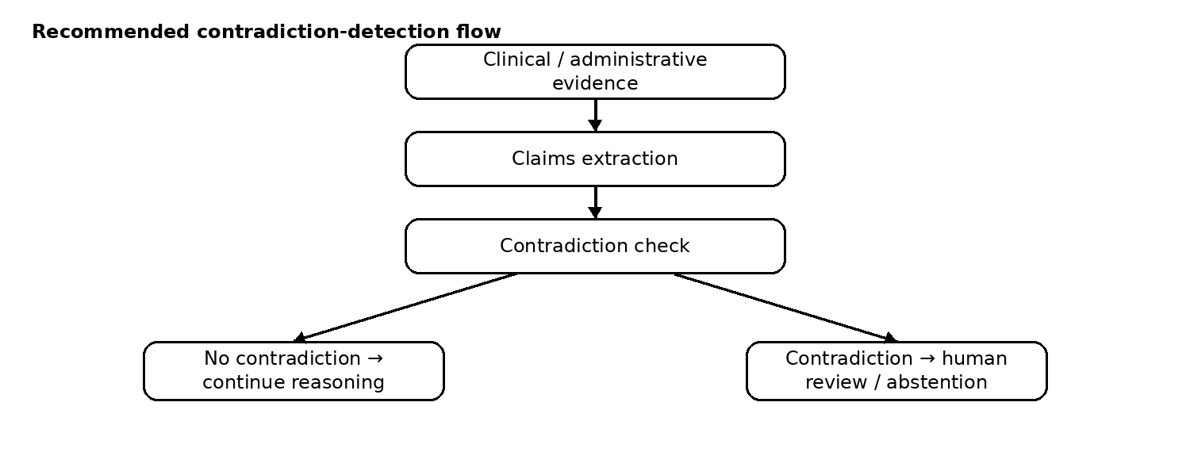
- Clinical evidence → claims extraction → contradiction check
- No contradiction → continue
- Contradiction → human review / abstention
This is more valuable than adding another generic agent because it directly improves safety and trust.

8. Critical Finding #5 — Make Human-in-the-Loop a Professional Workspace
The current design correctly requires human approval for outbound actions. fileciteturn0file0L257-L263 The next step is to make the reviewer experience evidence-first rather than approval-button-first.
- WHY: Why is prior authorisation required?
- EVIDENCE: Which clinical statement satisfies each criterion?
- SOURCE: Where did that evidence come from?
- POLICY: Which exact policy clause applies?
- VERSION: Which policy version was used?
- PRECEDENT: Which comparable cases were considered?
- CONFIDENCE: How strong is the evidence?
- CONFLICTS: Are there contradictions?
- AI ACTION: What does the system propose?
- HUMAN CONTROL: Approve, edit, request evidence, reject.

9. Critical Finding #6 — Reframe UK ⇄ US as Regulatory Profiles
The region abstraction is visually compelling, but a simple region switch can imply that UK and US differences are mostly a matter of changing policy documents. They are broader than that.
- Policy pack
- Terminology
- Workflow
- Regulatory profile
- Appeal/escalation path
- Coding and payer conventions
- Integration profile
Recommended positioning: “Policy + Regulatory Profile” rather than simply “Region Switch.”
The current design already treats payer knowledge as versioned data by region, payer and procedure. fileciteturn0file0L310-L314

10. Critical Finding #7 — Strengthen Evaluation
A CI evaluation based mainly on classification accuracy is a good start, but it is not enough for a high-risk healthcare administrative workflow.
- Evidence extraction precision
- Evidence extraction recall
- Mandatory-criterion false-positive rate
- Mandatory-criterion false-negative rate
- Policy citation accuracy
- Precedent citation accuracy
- Hallucination / unsupported-claim rate
- Appeal recommendation agreement on labelled cases
- Safe abstention rate
- Unsafe automation rate
The strongest additional capability is safe abstention: the system should know when it does not have enough evidence to make a reliable recommendation.
The TDD currently identifies Zynara.Eval and a labelled clinical-case set, but the evaluation should be expanded beyond classification accuracy. fileciteturn0file0L245-L250

11. Recommended Architecture Upgrade — Add a Critic Agent
This is the single change I would most strongly recommend.
Proposed flow:
- Case arrives.
- Policy Analyst determines applicable criteria.
- Evidence Analyst maps clinical evidence to criteria.
- Precedent Analyst finds comparable outcomes.
- Appeal Strategist builds the proposed recommendation.
- Critic Agent tries to disprove the recommendation.
- Deterministic Gate validates mandatory conditions and action limits.
- Human reviewer authorises or changes the action.
- Submission Adapter executes only after approval.
The Critic should explicitly ask:
- Is every claim supported?
- Does the cited policy clause actually support the claim?
- Are the precedent cases genuinely comparable?
- Is there contradictory evidence?
- Is any mandatory criterion missing?
- Is the recommendation stronger than the evidence allows?
- Should the system abstain?

12. Recommended Agent Rationalisation
I would not add agents simply to increase the count. In fact, I would consider removing expiry-watch-agent and policy-drift-agent as standalone “agents” if their substantive logic is deterministic.
Current capability | Recommended treatment | Reason
Needs Auth | Agent + deterministic validation | Useful for ambiguous plan language
Evidence Gap | Core reasoning agent | High-value interpretation task
Appeal Match | Deterministic filter + reasoning agent | Strong precedent capability
Appeal Builder | Reasoning agent | High-value generative task
Expiry Watch | Deterministic monitor + AI narrator | Date calculation should not require an agent
Policy Drift | Deterministic diff + AI analyst | Text diff can remain deterministic
Critic | Add as reasoning agent | Adds genuine agent collaboration and safety

13. Security / Identity Improvements
- Define reviewer roles and approval authority.
- Use least-privilege identities for every component.
- Make payer connectivity inaccessible to reasoning agents.
- Ensure only the Submission Adapter has the required external integration permissions.
- Consider approval thresholds by financial or operational risk.
- Audit reviewer identity, timestamp, decision and edits.
- Make the agent identity and version part of the case audit record.
The current design already makes managed identity the default and limits the Submission Adapter as the sole outbound path. That is a strong foundation. fileciteturn0file0L116-L134

14. Improve the Recovery £ Metric
The current Recovery £ calculation is attractive, but it can be challenged as a marketing estimate if its assumptions are not visible.
Recommended name: Estimated Recoverable Value
- Number of denied cases
- Number not appealed
- Comparable historical appeal win rate
- Average recoverable value
- Estimated opportunity
- Confidence level
- Transparent calculation
The TDD currently defines the headline calculation as denied × (1 − appeal rate) × win probability × mean claim value. Keep the concept, but expose the assumptions and confidence. fileciteturn0file0L382-L386

15. Demo Strategy — Create One WOW Moment
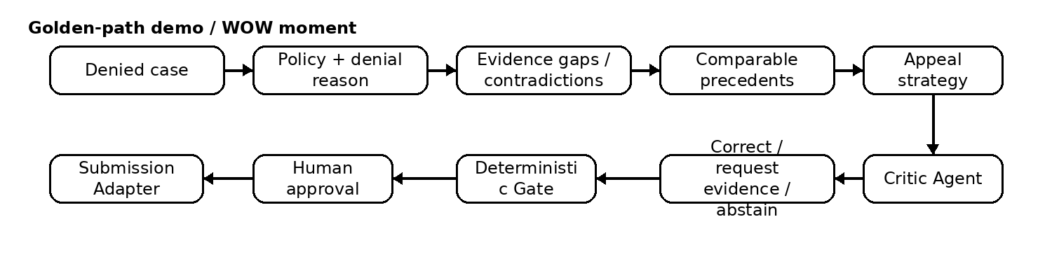
Do not spend the three-minute demo walking judges through Azure resources. Demonstrate the business problem being solved.
Recommended golden-path demo:
- Start with a prior-authorisation denial.
- Show the denial reason and cited policy clause.
- Evidence Agent identifies what is missing or contradictory.
- Precedent Agent finds comparable cases.
- Show that comparable cases have historically succeeded on appeal.
- Appeal Strategist drafts the appeal.
- Critic Agent challenges an unsupported claim.
- System corrects the draft or requests evidence.
- Deterministic Gate validates the case.
- Human reviewer approves.
- Submission Adapter sends the approved action.
- Show the complete evidence trail and trace.
The memorable moment should be: “The AI did not simply write an appeal. It found historical evidence, challenged its own recommendation, and presented the human reviewer with an auditable case for action.”

16. Add Measurable Before / After Evidence
Metric | Manual baseline | Care Approval IQ
Case preparation time | Measure | Measure
Criteria checking time | Measure | Measure
Evidence gaps found | Measure | Measure
Precedent search time | Measure | Measure
Reviewer effort | Measure | Measure
Cost per case | Measure | Measure
Unsupported recommendation rate | Measure | Measure
Do not invent improvement figures. Measure the demo pipeline and, where a manual baseline is estimated, label it explicitly.

17. Prioritised Improvement Plan
Priority | Change | Value | Recommendation
P0 | Strengthen the multi-agent story | Very High | Must fix
P0 | Add Critic Agent | Very High | Must fix
P0 | Replace generic readiness score | Very High | Must fix
P0 | Expand evaluation metrics | Very High | Must fix
P1 | Evidence-first HITL workspace | High | Strongly recommended
P1 | RBAC and approval authority | High | Strongly recommended
P1 | Technically enforce agent isolation | High | Strongly recommended
P1 | Reframe UK/US as regulatory profiles | Medium/High | Recommended
P2 | Estimated Recoverable Value with confidence | Medium | Recommended
P2 | Benchmark real performance | High | Recommended
P2 | Contradiction detection | High | Recommended
P2 | Convert deterministic monitoring into services | Medium | Consider

18. What NOT to Do
- Do not add more agents merely to increase the agent count.
- Do not add more Azure services just to make the architecture look enterprise-grade.
- Do not add autonomous payer submission.
- Do not replace the deterministic Gate with an LLM decision.
- Do not make the region switch the centrepiece of the product.
- Do not spend the demo explaining infrastructure instead of demonstrating outcomes.
- Do not claim business impact without showing the calculation or measurement.

19. Final Evaluator Judgement
If I were sitting on the judging panel today, my feedback would be:
“Very strong engineering submission with unusually good deterministic safety boundaries and a credible production architecture. The precedent-driven appeal capability is genuinely interesting. However, the multi-agent justification is currently weaker than the architecture suggests: several agents appear to be specialised LLM functions rather than collaborating agents, and some capabilities could be deterministic services. The evaluation methodology also needs stronger quantitative evidence, particularly around false positives, citation accuracy and safe abstention. The submission would become significantly stronger by introducing a critic/reviewer agent, making evidence provenance first-class in the UI, and demonstrating measurable improvement against the manual process.”
Would I reject it? No.
Would I shortlist it? Yes.
Would I call it a winner today? Not yet.
Could it become a winner? Absolutely.
The underlying idea, architecture and Microsoft technology alignment are strong enough. The next stage is precision, evidence and demonstration.

20. The Four Questions You Need to Win
Prove that the agents make better decisions together than one generalist agent.
Prove that the system knows when it is uncertain.
Prove why a human should trust the recommendation.
Prove the business value with measurable evidence.

Evaluator conclusion: strong 8/10 foundation → targeted changes can push this toward 9–9.5/10.

Visuals added to the original review
The evaluator-review wording, ordering, tables and recommendations above are retained from the original review document. The flow diagrams have been added visually at the relevant points so the Word document matches the diagrams shown during the assessment.

