GO Enrichment Analysis Report
Overview:
mRNA half-lives were calculated for 6,146 yeast genes from a 60-minute decay time series experiment with three biological replicates. Genes were ranked by their average half-life, and the top 10% (most stable transcripts) and bottom 10% (least stable transcripts) were submitted to gProfiler for Gene Ontology (GO) enrichment analysis.
Saccharomyces cerevisiae was used as the reference organism, and all 6,146 genes with calculated half-lives were used as the statistical background to ensure unbiased enrichment analysis.
Top 10% -Long-Lived Transcripts:
615 genes with the most stable mRNA were enriched for 8 significant GO terms, mainly in metabolic and stress-related processes. Fewer and less extreme signals reflect the functional diversity of stable transcripts.
A total of 615 genes with the most stable mRNA transcripts were enriched for 8 significant GO terms, primarily associated with metabolism and stress-related processes. The smaller number of enriched terms likely reflects the broader functional diversity of stable transcripts.
Key Enriched Terms
- Carbohydrate metabolic process (GO:BP)
The strongest biological process signal. Core metabolic enzymes involved in glycolysis and related pathways require stable transcripts to maintain a continuous enzyme supply.
- Generation of precursor metabolites and energy (GO:BP)
Energy production pathways (ATP, NADH) depend on constitutively expressed, stable mRNAs to meet the cell’s ongoing energy demands.
- Oxidoreductase activity & antioxidant activity (GO:MF)
Stable enzyme transcripts allow the cell to maintain a ready pool of metabolic and protective proteins without repeatedly initiating transcription.
- Cellular response to toxic substance & chemical stress (GO:BP)
Stress-response genes benefit from transcript stability, enabling rapid protein production without waiting for new mRNA synthesis.

Interpretation:
Long-lived transcripts encode proteins required continuously over time, particularly those involved in core metabolic functions and maintaining baseline stress defense. In this context, mRNA stability is an adaptive feature that ensures sustained protein production for essential cellular processes.

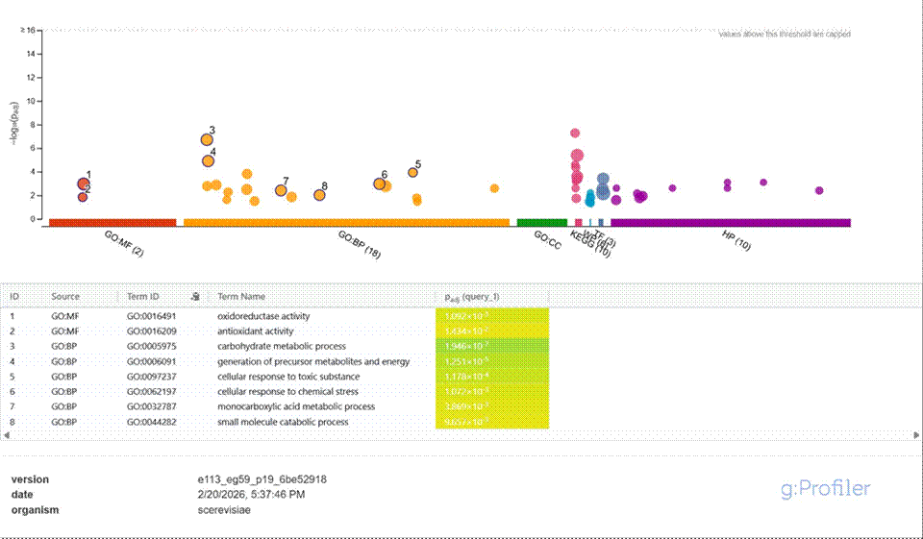
Figure 1. gProfiler results for top 10% (long-lived) genes

Bottom 10% — Short-Lived Transcripts :
A total of 615 genes with the fastest-decaying transcripts were enriched for 16 significant GO terms across all three GO namespaces. The strongest enrichment signals were associated with RNA biology, chromatin organization, and cell cycle regulation.
Key Enriched Terms
- Nucleolus (GO:CC)
The strongest enrichment overall. Genes localized to the nucleolus, the site of ribosome production, exhibit short transcript half-lives to allow rapid adjustment of ribosome biogenesis.
- rRNA metabolic process (GO:BP)
Ribosomal RNA processing is tightly regulated and highly responsive to nutrient availability, requiring fast mRNA turnover.
- Nucleic acid binding (GO:MF)
This category includes transcription factors and RNA-binding proteins, which must be rapidly degraded to enable dynamic regulation of gene expression.
- Chromatin organization & nucleosome (GO:BP / GO:CC)
Histone and chromatin remodeling transcripts are short-lived, allowing rapid restructuring of chromatin architecture.
- Mitotic spindle assembly & microtubule-based process (GO:BP)
Cell cycle genes require precise timing, and rapid mRNA degradation ensures accurate progression through mitosis.

Interpretation:
Short-lived transcripts encode proteins involved in highly dynamic, tightly regulated processes. Rapid mRNA degradation functions as a regulatory mechanism, allowing the cell to quickly alter gene expression in response to growth conditions, environmental signals, or cell cycle stage.
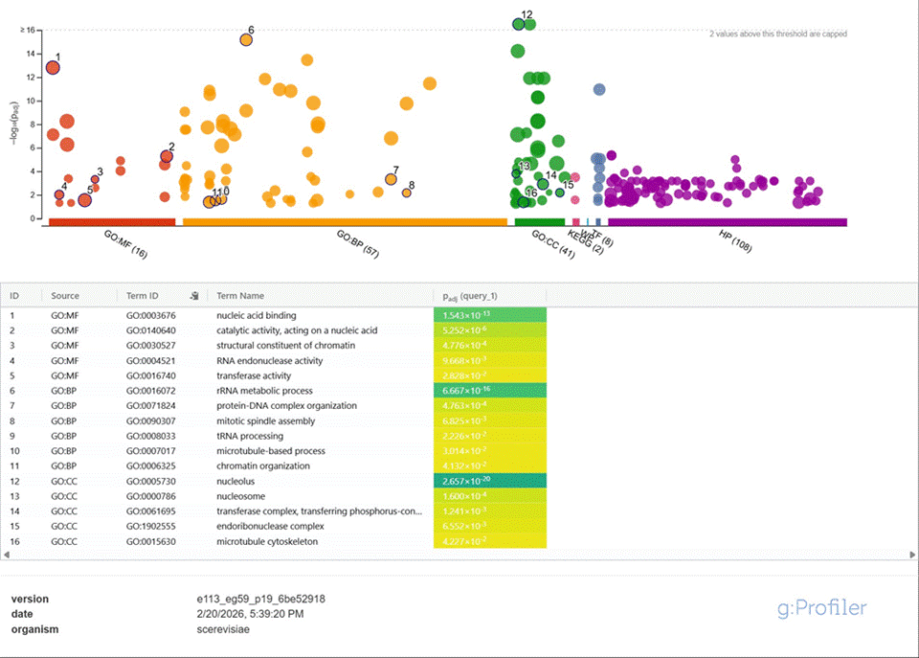
Figure 2. gProfiler results for bottom 10% (short-lived) genes
Conclusion:
The functional enrichment analysis demonstrates that transcript stability in Saccharomyces cerevisiae is strongly associated with gene function. Short-lived transcripts are enriched for metabolic and stress-response pathways, reflecting the need for rapid transcriptional adaptation. In contrast, long-lived transcripts are enriched for chromatin organization, ribosomal biogenesis, and structural cellular components, consistent with their essential and constitutive roles in cellular maintenance. These findings support the biological principle that mRNA stability is functionally regulated according to gene role.

