Stack Data Structure (Introduction and Program)

Stack is a linear data structure which follows a particular order in which the operations are performed. The order may be LIFO(Last In First Out) or FILO(First In Last Out).

Mainly the following three basic operations are performed in the stack:

* **Push:**Adds an item in the stack. If the stack is full, then it is said to be an Overflow condition.
* **Pop:** Removes an item from the stack. The items are popped in the reversed order in which they are pushed. If the stack is empty, then it is said to be an Underflow condition.
* **Peek or Top:** Returns top element of stack.
* **isEmpty:**Returns true if stack is empty, else false.

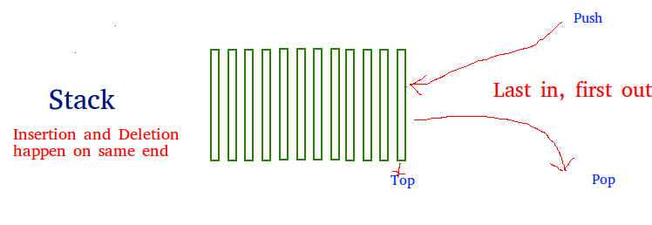

push(), pop(), isEmpty() and peek() all take O(1) time. We do not run any loop in any of these operations.

**Applications of stack:**

* [Balancing of symbols](https://www.geeksforgeeks.org/check-for-balanced-parentheses-in-an-expression/)
* [Infix to Postfix](http://quiz.geeksforgeeks.org/stack-set-2-infix-to-postfix/) /Prefix conversion
* Redo-undo features at many places like editors, photoshop.
* Forward and backward feature in web browsers
* Used in many algorithms like [Tower of Hanoi,](https://www.geeksforgeeks.org/recursive-functions/)[tree traversals](https://www.geeksforgeeks.org/618/), [stock span problem](https://www.geeksforgeeks.org/the-stock-span-problem/), [histogram problem](https://www.geeksforgeeks.org/largest-rectangular-area-in-a-histogram-set-1/).
* Backtracking is one of the algorithm designing technique .Some example of back tracking are Knight-Tour problem,N-Queen problem,find your way through maze and game like chess or checkers in all this problems we dive into someway if that way is not efficient we come back to the previous state and go into some another path. To get back from current state we need to store the previous state for that purpose we need stack.
* In Graph Algorithms like [Topological Sorting](https://www.geeksforgeeks.org/topological-sorting/) and [Strongly Connected Components](https://www.geeksforgeeks.org/strongly-connected-components/)
* In Memory management any modern  computer uses stack as the primary-management for a running purpose.Each program that is running in a computer system has its own memory allocations
* String reversal is also a another application of stack.Here one by one each character get inserted into the stack.So the first character of string is on the bottom of the stack and the last element of string is on the top of stack. After Performing the pop operations on stack we get string in reverse order.

**Implementation:**   
There are two ways to implement a stack:

* Using array
* Using linked list