COMP 116
Oct 24, 2007
differential equations and driving

Driving is one of the many situations in which we control a derivative (velocity or even acceleration) to achieve a desired value (position). Mathematically, we use first-order, ordinary differential equations to describe a system by its initial conditions and a how the derivative over time changes.

Here are four scenarios from the lecture for driving a car from initial position x(0)=0. In each, we control the derivative x’(t) or the acceleration x’’(t) by writing a function of time and position: x’(t) = f(t,x). MATLAB graphs the position over time when we call ode45(@functionname, time interval, initial condition).

The first two scenarios do the same thing in two different ways---driving 50mph for 100 miles or 2 hours from initial position x=0. Notice that the function f(t,x) can depend on time or position (or both).
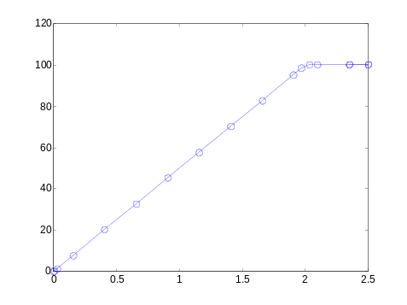% simulate for 2.5 hours, a drive
% of 50mph for 100mi, then 0mph
ode45(@speed50m, [0 2.5], 0);
function result = speed50m(t,x)
% Travel at 50mph for 100 miles

if (x < 100) result = 50;
else result = 0;
end
% simulate for 2.5 hours, a drive
% of 50mph for 2 hours, then 0mph
ode45(@speed50t, [0 2.5], 0);
function result = speed50t(t,x)
% Travel at 50mph for 2 hours

if (t < 2) result = 50;
else result = 0;
end
The next scenario is more complicated because we control the acceleration, but need to tell MATLAB how the velocity changes. For the first hour, we increase in velocity from 0 to 60mph by going 1 more mph every minute: x’(t) = 60t. For the second hour, we start by going 60mph, then slow down 1mph every minute: x’(t) = 60(2-t).
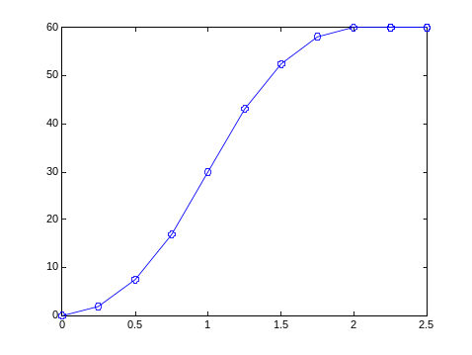
% simulate for 2.5 hours, a drive that accelerates 1mph every minute
% for 1 hr, then -1mph/min for 1 hour.
ode45(@accel1t, [0 2.5], 0);
function result = accel1t(t,x)
% accel 60 mph every hour for 1 hour,
% then decel 60 mph/hr for 1 hour

if (t < 1) result = 60*t;
elseif (t < 2) result = 60*(2-t);
else result = 0;
end

Note that we only made it 60 miles, which makes sense because in each hour we averaged 30mph.
In this last scenario there is a trick that you can use to change second derivatives into first derivatives. For the first 50 miles, we increase in velocity from 0 to 60mph by going 1 more mph every minute x’’(t) = 60. As in the previous scenario, we could figure out that the velocity x’(t) = 60t, but we’ll let MATLAB do that for us. For the second 50 miles, we slow down 1mph every minute: x’’(t) = -60. Here we don’t know what speed we started at, so we can’t work out our velocity like we did in the previous scenario.

The first part of the trick is to introduce a new variable w(t) = x’(t), so that we control a first derivative: w’(t) = x’’(t)=±60. The second part is to record the state of the system by a vector, u = [x(t); w(t)] = [x(t); x’(t)], with both position and velocity.

We need to tell MATLAB a vector for the initial condition of u=[0;0], and a function for the derivative u’ = [x’(t); w’(t)] = [x’(t); x’’(t)] = f(t, u).
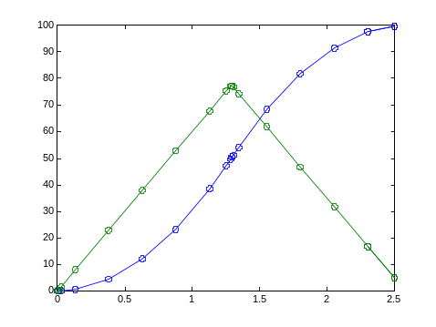
% simulate for 2.5 hours, a drive that
% accelerates 1mph/min for 50 mi, then
% decelerates 1mph/min for 50 mi
ode45(@accel1m, [0 2.5], [0;0]);
function result = accel1m(t, u)
% accel 1 mph every minute for 50 miles,
% then decel 1 mph every min for 50 miles

if (u(1) < 50) result = [u(2); 60];
elseif (u(1) < 100) result = [u(2); -60];
else result = [0; 0];
end

In this case MATLAB plots both x(t) and w(t), which are the first and second elements of the vector u. In the figure, x(t) is in blue and w(t) is in green.

