Science 9 Year Review
Unit A: Biological Diversity

1. The scientific classification system of organisms is broken down in the following order, starting from the most general category to the most specific:
- kingdom, phyla, class, order, family, genera, species
- kingdom, phyla order, class, genera, family, species
- species, family genus, order, class, kingdom, phyla
- species, genera, family class, order, phyla, kingdom

2. Which of the following 2 organisms has the most common physical characteristics?
      - Rana clamitans
      - Clamitans rana
      - Rana castebeiana
      - Castebeiana rana

A i, ii

i, iii

ii, iii

iii, iv

3. Three species of perch are found in one lake. One species is found in the deepest part of the lake, the second type skims the top and the third species lives in the area that empties into a river. They all feed on small fish. What allows these species to coexist in the lake without depleting their food source?
- genetic diversity
- resource partitioning
- variation
- interspecies competition

4. Ted’s fat rabbit has red eyes. Other rabbits have only brown eyes. Identify the variations in the order described.
- discrete, continuous
- continuous, discrete
- discrete, discrete
- continuous, continuous

5. Which of the following does a scientists look at to better help understand variation?
- genetics and environment
- physical characteristics and survival techniques
- color and environment
- genetics and physical characteristics

6. During science class we were able to see an amoeba split in two. The teacher said this was called _________________ and was a method of _______________ reproduction.
- budding, asexual
- egg/sperm unification, sexual
- binary fission, asexual
- spore production, sexual

Use the following diagrams to answer the next question.

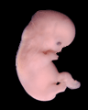

1 2 3 4

7. What process is occurring first in picture 1 and then in picture 2?
- cleavage and embryo formation
- embryo formation and cleavage
- zygote formation and fertilization
- fertilization and zygote formation

Use the diagram below to answer the next question

Red parent flower
Pink parent flower

Offspring
Both flowers are pink
8. The process involved in producing the new flowers is
- asexual reproduction
- binary fission
- sexual reproduction
- cuttings

9. DNA contains the
- chemicals necessary for the break-down of genetic information
- genetic material found in every cell in the human body
- materials found only in gamete cells which pass on traits to the offspring
- arrangement of thousands of chemicals which form traits

Use the following diagram to answer the next two questions.

1
3

10. What process is occurring in the above diagram?
2
- Mitosis
- Meiosis
- gamete production
- zygote formation

11. What will occur in the diagram labeled 1?
- the two chromosomes will combine and then divide
- the two chromosomes will double
- the two chromosomes will move to opposite ends of the splitting cell
- the two chromosomes will divide in half

Use the following drawing to answer the next two questions.

Purebred black
dog
Purebred white
dog



12. What would happen if we crossed a dominant purebred black dog with a recessive purebred white dog?
- all the dogs would be white
- the dogs produced would be of various sizes
- all the dogs would be black
- the dogs would be black with white spots

13. The dogs resulting from the two purebreds crossing would be called
- recessive traits
- purebreds
- hybrids
- traits
Unit B: Matter and Chemical Change

1. The chart below represents the steps in classifying matter.

Matter

Mixtures

Pure Substances
Colloid

Suspension
B
A
Elements
Solutions

What do the categories labeled A & B, respectfully (in order) represent
a. compound & mechanical mixture
b. homogenous & heterogeneous
c. mechanical mixture & filtrate
d. mechanical mixture & compound

2. A piece of chalk is crushed into a powder. It is then mixed with hydrochloric acid; and the chalk disappears as bubbles form. Which describes the sequence of changes that take place?
a. chemical, physical
b. physical, chemical
c. chemical, chemical
d. physical, physical

3. The most recent theory of the atomic structure describes electrons as existing in a charged cloud around a nucleus. The model relates to the
a. quantum atom
b. Dalton atom
c. Bohr atom
d. Democritus atom

4. The most numerous category of elements in the periodic table represents
a. halogens
b. non-metals
c. metals
d. noble gases

5. Ashton noticed that Cu, Zn, and Ga are in the same horizontal row in the periodic table. She concluded that these three elements belong to the same
a. family
b. period
c. group
d. section

Use the following information to answer question 6.

Element | Atomic Number | Atomic Mass
Sodium | 11 | 23.0
Vanadium | 23 | 50.9
Carbon | 6 | 12.0
Bromine | 35 | 79.9

6. Using the above information, which one of the statements below is correct.
a. Sodium has 11 protons and 11 neutrons
b. Vanadium has 23 protons and 23 electrons
c. Carbon has 6 protons and 12 electrons
d. Bromine has 35 electrons and 79.9 neutrons

7. As you move from the left side of the periodic table to the right side, the elements become
a. less reactive
b. liquid
c. more conductive
d. solid in state

8. The following diagram represents:
H

H
H
C

H

a. H₄
b. CH
c. CH CH CH CH
d. CH₄

9. MSG or monosodium glutamate is a flavour enhancer. It consists of 5 atoms of carbon, 8 atoms of hydrogen, 1 atom of nitrogen, 4 atoms of oxygen, and 1 atom of sodium. What is the chemical formula for MSG?
a. C₈H₅N₄ONa_{(S)}
b. CH₈NO₄Na(_{S})
c. C₅H₈NO₄Na(_{S})
d. 5CH₈NO₄Na_{(S)}

10. Magnesium combines with chlorine to form an ionic compound. What is the correct name of this compound?
a. magnesium chlorine
b. magnesium chloride
c. magnesium chlorate
d. magnesium chlorite

11. Jenny was given a chart shown below with the boiling and melting points of several compounds.

Number | Compound | Melting  Point º C | Boiling  Point º C
1 | Baking soda | 455 | 1550
2 | Water | 0 | 100
3 | Ethanol | - 114 | 78
4 | Salt | 801 | 1413

With a good knowledge of common properties of compounds, Jenny was able to identify the molecular compounds as numbers
a. 2 and 3
b. 3 and 4
c. 1 and 4
d. 2 and 4

12. Janet is concerned about the local coal burning power plant. She knows that the sulfur oxide emission from the plant combines with water vapour to produce acid rain. The word equation that describes this reaction is:
a. water + air sulfuric acid
b. water + sulfuric acid acid rain
c. sulfuric acid water + sulfur oxide
d. water + sulfur oxide acid rain

13. Marble buildings are affected by acid rain. Calcium chloride, carbon dioxide, and water are products formed when marble (CaCO3) reacts with Hydrochloric (HCl) acid. The equation that describes this reaction is
a. CaCl2 + H2O CaCO3 + 2HCl + CO2
b. H2O + 2HCl CaCl2 + CO2 + CaCO3
c. CaCO3 + 2HCl CaCl2 + H2O + CO2
d. CaCO3 + H2O CaCl2 + 2HCl + CO2

Unit C: Environmental Chemistry

1. The amount of nitrogen in the soil can be reduced by
A. lightning
B. decomposers
C. fertilizers
D. intake by plants

2. There is concern about the burning of fossil fuels because of the release of
A. carbon dioxide
B. carbon monoxide
C. nitrogen oxides
D. oxygen

3. Lime is sometimes added to acidic lakes to
A. lower the pH
B. neutralize the water
C. lessen water contamination
D. increase the dissolved oxygen content

4. The nitrogen in the air has to be broken apart so that it can be combined
with other compounds. The breakdown of nitrogen gas into individual atoms of nitrogen is called

A. a cycle and involves bacteria
B. nitrogen fixation and involves the Sun
C. nitrogen fixation and involves bacteria
D. a cycle and involves the Sun

5. A crop of potatoes can be quickly destroyed by the larval stage of the potato beetle. Farmers often protect their crops from the beetle by spraying with
A. herbicide
B. insectide
C. fungicide
D. phosphide

6. The breakdown of large organic molecules by inserting water into the bonds that hold smaller particles together is known as
A. hydrolysis
B. photolysis
C. hydrosynthesis
D. photosynthesis

Use the following information to answer questions 19 and 20.

Residents around Amber Lake noticed a large number of dead fish washing up on the shore. Biological sampling was done at four sites to determine the cause. The results of the sampling are shown in the table.
Sampling Site | Mayflies/sample | Midge larva (chironomids)/sample | Worms/sample
1 | 124 | 97 | 43
2 | 0 | 123 | 220
3 | 56 | 180 | 198
4 | 195 | 135 | 55

7. The source of the problem was most likely at site
A. 1
B. 2
C. 3
D. 4

8. A survey was completed in the nearby community. The question asked was, “Are people interested in paying more taxes for cleaning up the water?” The question represents a viewpoint that is
A. economic
B. scientific
C. technological
D. legal

9. An LD50 of 1500 mg/kg means that 50% of
A. laboratory animals are killed by that dose of chemical
B. laboratory animals are killed by 50% of the chemical
C. the chemical kills all of the animals
D. the chemical kills 50% the animals

10. A lab group was in charge of analyzing the pH of different substances.

Solution P Q R S T U V

pH 7 4 8 6 4 1 9

The group concluded that
A. 1 substance was basic, 5 were acidic, and 1 was neutral
B. 4 substances were acidic, 2 were basic, and 1 was neutral
C. 3 substances were acidic, 3 were basic, and 1 was neutral
D. 2 substances were acidic, 3 were basic, and 2 were neutral

11. Living organisms are compared in two ponds with different water pH levels.

A Pond pH 6.8 B Pond pH 4.2

Pond B most likely has
A. more organisms and a greater diversity of species
B. fewer organisms and a greater diversity of species
C. fewer organisms and a lower diversity of species
D. more organisms and a lower diversity of species

12. Ground-level ozone levels must be carefully monitored because they contribute to
A. smog and pollution
B. acid rain
C. rapid plant growth
D. global warming

13. All organic compounds have the element ____ in their structure.
A. hydrogen
B. oxygen
C. carbon
D. nitrogen

14. The increase in concentration of a chemical as it moves up the food chain is called
A. phytoremediation
B. biodegradation
C. biomagnification
D. bioremediation

Unit D: Electrical Principles

- Ohms law, which shows a mathematical link between voltage, current and resistance can be used to find each variable in the formula. Calculate the current passing through a light fixture that is powered by a 120V outlet and has a resistance of 160 ohms.
- 0.75
- 1.33 A
- 0.75 A
d. 1.33
- Your teacher asks you to calculate the resistance in ohms (Ώ) of a piece of unknown wire. When you make a circuit consisting of a brand new 12V battery, two pieces of the unknown wire and an ammeter, you get a reading of 0.5A on the Ammeter. What is the resistance of the wire in (Ώ)’s
a. 240 Ώ
b. 24 Ώ
c. .04 Ώ
d. 240
3. You walk across a carpeted floor and, when you reach for the doorknob, you see a spark
and get a small shock. What is the explanation for what you have just experienced?

a. Walking across the carpet, you gained protons on your body and when you touched the doorknob there was an electrical discharge.
b. Walking across the carpet had nothing to do with the spark and shock, the doorknob must have been positively charged to create the spark and shock.
c. Walking across the carpet, you became negatively charged. As you approach the doorknob the current flows from you to the doorknob.
d. Walking across the carpet, you picked up a static charge and touching the doorknob resulted in an electrical discharge from your hand to the doorknob

4. The definition of current electricity is

a. the steady flow of charged particles
b. the build up of electric charges on an object
c. the loss of electric charges through a conductor
d. the flow of electrons in all directions through an insulator

5. In the figure shown below, what is considered the load?

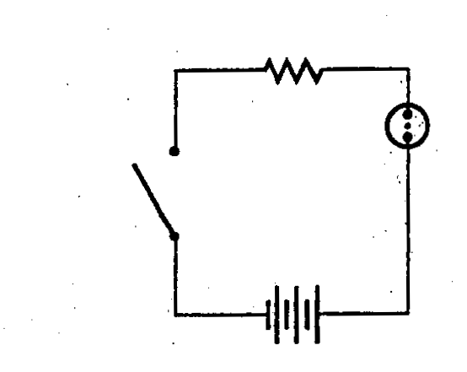

a. the wires connecting the motor to the battery
b. the switch
c. the battery
d. motor

6. Many pieces of jewellery are not solid gold, but are plated with a thin coating of gold over a cheaper, and often stronger, metal. This process is referred to as electroplating. How is this process carried out?

a. When electricity flows through the cell, gold from a gold bar that is connected to the cell’s positive terminal passes through an electrolyte onto the cheaper metal, which is connected to the cell’s negative terminal.
b. Atoms of gold found in an electrolyte are deposited on the cheaper metal when the electrical current is disconnected.
c. Gold dissolves in an electrolyte solution and becomes deposited on the cheaper metal when an electric current is passed through the cell.
d. Passing large amounts of electricity through the gold causes it to melt. The cheaper metal is then dipped into the liquid gold.

7. Neil wants to determine the voltage passing through a circuit composed of a battery and
a length of wire. The problem is that he does not have a voltmeter. He does, however, have an ammeter. Neil also knows that the wire has a resistance of 25 (Ώ). When Neil connects the ammeter to the circuit he records a current of 10 A. What is the voltage passing through the circuit?

a. 250 V
b. 2.5 V
c. 0.4 V
d. 35 V

8. In the circuit shown below, the source is a
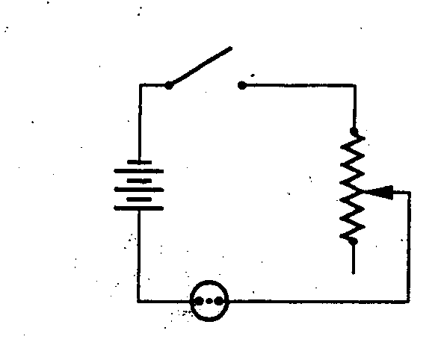

a. battery consisting of 3 cells
b. battery consisting of 6 cells
c. cell consisting of 3 batteries
d. cell consisting of 6 batteries

9. The diagram below is a schematic drawing of a circuit consisting of four switches and three bulbs.

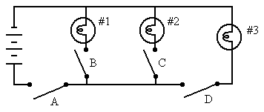

C

If switches A and C are closed, and switches B and D are opened, then
a. none of the bulbs will light up
b. bulbs 1 and 3 will light up
c. bulbs 2 and 3 will light up
d. only bulb 2 will light up

10. Power companies provide electricity to homes in the form of alternating current (AC), yet many devices in our homes require direct current (DC). What is the difference between alternating current and direct current?

a. Direct current is less expensive to produce than alternating current.
b. Direct current cannot be conducted through overhead power lines.
c. Direct current is electricity that flows in only one direction.
d. Direct current requires only a single wire to pass through.

Unit E: Space Exploration

1. An early model of planetary motion was the geocentric model. In this model

a. Earth and planets move around the Sun
b. the Sun and planets move around Earth
c. the Sun, planets, and stars move around Earth
d. Earth, planets, and the stars move around the Sun

2. In 1530, Copernicus proposed a heliocentric model of the solar system. His model
had the planets orbit the

a. Sun
b. Earth
c. stars
d. galaxies

3. Which type of galaxy is our Milky Way galaxy?

a. elliptical
b. circular
c. spiral
d. irregular

4. Which of the following stages of a star's life cycle will our Sun most likely experience?

a. supernova and neutron star
b. red giant and white dwarf
c. neutron star and black dwarf
d. nova and black hole

5. All the planets formed at approximately the same time and from the same basic
materials. Hydrogen and helium are likely to be found in large quantities in the
atmospheres of planets which are

a. very small
b. extremely hot
c. gas giants
d. rotating the slowest

6. Light travels at 300 000 km/s, and Venus is 112 500 000 km away from the Sun. How many minutes does it take light from the Sun to reach Venus?

a. 6.25 minutes
b. 0.0027 minutes
c. 375 minutes
d. 0.162 minutes

7. The "payload" of a rocket describes the

a. cost of the rocket
b. materials a rocket carries
c. price customers will be charged to fly in the rocket
d. amount of thrust power a rocket exerts

8. Unmanned spacecrafts that are sent to explore other planets are called

a. probes
b. explorers
c. space ships
d. satellites

9. The Sun releases high energy particles in every direction. These particles travel at
great speeds and are called the solar wind. What protects Earth from the effects of
the solar wind?

a. the Moon
b. green house gasses
c. Earth's ozone layer
d. Earth's atmosphere

10. If astronauts are to spend long periods of time in space and travel great distances, their spacecraft must be entirely self-sufficient. This means that all their day-to-day needs and supplies must either be brought on the trip, or materials must be recycled during their journey. For the list below which is an example of recycling on board a space craft

a. nitrogen from the breath and sweat of the astronauts
b. hydrogen retrieved from splitting water molecules for oxygen
c. the carbon dioxide exhaled by the astronauts
d. waste water (including urine) and other waste water

11. Which of the following electromagnetic waves is in the correct order from
smallest wavelength to the largest wavelength?

- radio waves, visible light, X-rays, microwaves
- Visible Light , X-rays, radio waves, microwaves
- X-Rays, visible light, microwaves, radio waves
- Microwaves, visible light, radio waves, X-rays

13. Which of the following describes the term parallax?

a. the apparent movement of closer objects compared to distant objects
b. the apparent movement of closer objects due to the viewer's change in position
c. the change in image between a viewer and a distant object
d. the change in size between a closer object and a distant object

14. Other than astronauts, one of Canada’s most famous contributions to NASA’s space program has been the

a. rocket booster assemblies
b. Canadarm
c. environmental control systems
d. solar panels for the space station

  - Thomas wanted to know how far away the boat on the other side of the lake was. He decided to use the triangulation method he learned in science class to help him. He measured a baseline of 20 meters and calculated one angle, from one end of the baseline to the boat to be 35 ° and the other angle to be 50 ° How far away is the boat from shore.

- 8.5m
- 8.5cm
- 11.5m
- 11.5cm

