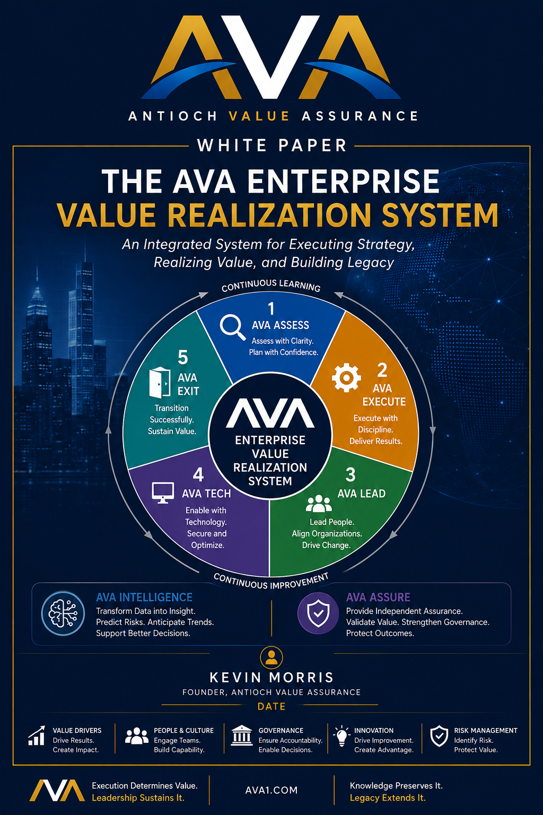

The AVA Enterprise Value Realization System™

A Framework for Creating, Protecting, and Sustaining Enterprise Value

White Paper
Author: Kevin Morris
Founder, Antioch Value Assurance

Executive Summary
Organizations invest billions of dollars each year in mergers and acquisitions with the expectation of creating lasting enterprise value. Yet despite advances in strategy, financial modeling, due diligence, and project management, many transactions fail to deliver the value promised to shareholders. The problem is rarely the strategy itself—it is the execution that follows.
Traditional methodologies provide valuable guidance for managing projects, technology, organizational change, and governance. However, they were never designed to integrate these disciplines into a unified operating model focused on one objective: realizing enterprise value.
The AVA Enterprise Value Realization System™ (EVRS) was developed to address this challenge. It introduces Enterprise Value Realization as a management discipline that integrates leadership, governance, technology, execution, assurance, and artificial intelligence into a comprehensive framework for managing mergers and acquisitions from opportunity framing through sustained benefits realization.
At the center of the framework are five execution pillars:
- AVA Assess™
- AVA Execute™
- AVA Lead™
- AVA Tech™
- AVA Exit™
Supporting these pillars are two enterprise-wide capabilities:
- AVA Assure™, providing continuous enterprise value assurance
- AVA Intelligence™, an AI-powered enterprise intelligence platform
Together, these capabilities provide organizations with a repeatable operating model for creating, protecting, measuring, and sustaining enterprise value.

The Enterprise Execution Problem
For decades, organizations have become increasingly sophisticated at identifying acquisition opportunities. Investment bankers produce comprehensive valuation models. Consultants conduct extensive due diligence. Legal advisors negotiate complex agreements. Executive teams spend months developing integration strategies before transactions close.
Yet the results remain remarkably inconsistent.
Organizations continue to experience delayed synergies, technology integration failures, cultural challenges, governance issues, and operational disruptions. While transactions may close successfully, the expected enterprise value often erodes during execution.
This occurs because most organizations focus heavily on buying companies, but far less on building enterprise value after closing.
Enterprise value is rarely destroyed by one catastrophic event. Instead, it leaks away through delayed decisions, unresolved dependencies, fragmented governance, technology complexity, organizational misalignment, and shifting priorities.
The challenge is no longer selecting the right acquisition.
The challenge is consistently executing it.

Enterprise Value Realization
Traditional management disciplines have evolved to solve increasingly complex business problems.
Project Management improved the delivery of individual initiatives.
Program Management coordinated related projects.
Portfolio Management aligned investments with strategic priorities.
Benefits Realization shifted attention from project outputs to business outcomes.
Each discipline represented meaningful progress.
However, none fully addressed the complete enterprise execution lifecycle.
Enterprise Value Realization extends beyond delivering projects or measuring benefits. It focuses on creating, protecting, measuring, and sustaining enterprise value from the moment an opportunity is identified until the expected business outcomes have been achieved and institutionalized.
Enterprise Value Realization is therefore not another project management methodology.
It is an enterprise management discipline.

The AVA Enterprise Value Realization Philosophy
The AVA Enterprise Value Realization System is built upon several foundational principles.
Enterprise value is the ultimate measure of success. Organizations do not acquire companies simply to complete integrations; they invest to create measurable business value.
Execution determines value. Strategy identifies opportunities, but disciplined execution transforms opportunity into results.
Due diligence never truly ends. Organizations learn more during the first one hundred days after closing than they can discover during months of pre-close analysis. Execution must therefore remain adaptive.
Leadership creates execution capability. Executive alignment, governance, and decision-making determine whether organizations execute with clarity or confusion.
Technology enables enterprise value. Modern acquisitions depend upon technology integration, cybersecurity, data migration, and digital transformation.
Continuous assurance protects value. Enterprise value must be monitored continuously rather than evaluated only after implementation.
Intelligence accelerates decision-making. Artificial intelligence enables organizations to transform enterprise information into actionable insight.
Together these principles define the AVA philosophy and guide every aspect of the Enterprise Value Realization System.

The AVA Enterprise Value Realization System™
The AVA Enterprise Value Realization System is not another methodology layered on top of existing practices.
It is an enterprise operating model.
Rather than replacing established disciplines such as project management, change management, enterprise architecture, or governance, AVA integrates them into a unified framework focused on realizing enterprise value.
The architecture consists of three integrated components.

The Five Execution Pillars
The operational foundation of the system.

AVA Assure™
Continuous enterprise value assurance across every execution capability.

AVA Intelligence™
An AI-powered enterprise intelligence platform that continuously supports executive decision-making.
Together these components create an integrated system for managing mergers and acquisitions from opportunity framing through sustained benefits realization.

The Five Execution Pillars

AVA Assess™
AVA Assess establishes the Value Blueprint before execution begins.
It evaluates strategic alignment, business readiness, technology readiness, leadership alignment, governance maturity, organizational readiness, execution capability, and value realization risks.
Rather than asking, "Should we acquire this company?", AVA Assess asks, "Can we successfully realize the value this acquisition promises?"

AVA Execute™
AVA Execute transforms strategic intent into disciplined execution.
It integrates governance, planning, dependency management, executive reporting, milestone management, benefits realization, and enterprise coordination into a single execution framework.
Its objective is simple:
Transform plans into measurable business outcomes.

AVA Lead™
AVA Lead recognizes that leadership is one of the most important determinants of execution success.
It provides executive governance, decision frameworks, organizational communications, stakeholder engagement, cultural alignment, and change leadership.
Leadership becomes an enterprise capability rather than an individual responsibility.

AVA Tech™
Technology is now inseparable from enterprise execution.
AVA Tech integrates technology planning directly into business execution by addressing cybersecurity, infrastructure, cloud transformation, ERP integration, application rationalization, data migration, AI readiness, and Transitional Service Agreement planning.
Technology becomes a strategic enabler of enterprise value.

AVA Exit™
AVA Exit ensures that enterprise value becomes sustainable.
Although originally developed around Transitional Service Agreement exit, the framework now encompasses operational stabilization, capability transition, knowledge transfer, benefits realization, and continuous improvement.
Execution is not complete when integration ends.
It is complete when enterprise value has become institutionalized.

AVA Assure™
One of the defining characteristics of the AVA Enterprise Value Realization System is that AVA Assure™ is not one of the execution pillars.
The execution pillars create enterprise value.
AVA Assure protects enterprise value.
It continuously monitors:
- Governance effectiveness
- Enterprise risks
- Benefits realization
- Executive decision-making
- Organizational readiness
- Technology health
- Value leakage indicators
Rather than performing periodic audits, AVA Assure provides continuous enterprise oversight.
It enables organizations to identify emerging risks while corrective action remains possible.
Governance becomes proactive rather than retrospective.

AVA Intelligence™
Enterprise execution generates enormous volumes of information.
Business cases.
Contracts.
Project schedules.
Technology inventories.
Risk registers.
Financial reports.
Emails.
Meeting notes.
Executive presentations.
Most organizations possess more information than they can effectively use.
AVA Intelligence transforms this information into enterprise understanding.
Built upon a seven-layer architecture, it continuously:
- Collects enterprise knowledge.
- Extracts information from documents.
- Connects relationships through a Knowledge Graph.
- Integrates operational data.
- Creates a trusted execution repository.
- Builds an Enterprise Object Model.
- Delivers executive intelligence through dashboards, predictive analytics, Digital Twins, and Executive Copilots.
Rather than simply reporting what has happened, AVA Intelligence helps executives understand why it happened, what is likely to happen next, and what actions should be considered.
Artificial intelligence becomes an advisor that enhances executive judgment rather than replacing it.

Applying AVA Across the M&A Lifecycle
The AVA Enterprise Value Realization System applies continuously throughout the M&A lifecycle.
During Opportunity Framing, AVA Assess establishes the Value Blueprint.
During Due Diligence, execution readiness becomes as important as financial validation.
During Planning, AVA Execute develops the integrated execution strategy while AVA Lead aligns leadership and AVA Tech prepares technology integration.
During Day One, all capabilities coordinate to ensure operational continuity.
During Integration, the five execution pillars work together to manage enterprise transformation while AVA Assure continuously monitors execution health and AVA Intelligence continuously analyzes enterprise performance.
Finally, during Operational Stabilization and Benefits Realization, AVA Exit ensures that temporary integration activities transition into permanent organizational capability.
The lifecycle is continuous rather than linear.
Each transaction strengthens the organization's ability to execute future transactions.

Building the Value Realization Enterprise
The ultimate objective of AVA extends beyond improving individual transactions.
It is to build organizations that consistently realize enterprise value.
A Value Realization Enterprise treats execution as a permanent organizational capability.
Governance becomes standardized.
Leadership becomes repeatable.
Technology integration becomes disciplined.
Knowledge becomes institutional.
Artificial intelligence becomes an enterprise capability.
Organizations continuously improve through learning rather than relying upon isolated successes.
At the center of this evolution is the Enterprise Value Realization Office (EVRO).
Like a Project Management Office or Integration Management Office, the EVRO provides centralized governance, standards, executive reporting, benefits management, organizational maturity assessment, and continuous improvement.
Execution excellence becomes embedded within the enterprise.

The Future of Enterprise Value Realization
Although AVA was developed through decades of M&A experience, its principles extend far beyond acquisitions.
Digital transformations.
ERP implementations.
Capital projects.
Business reorganizations.
Artificial intelligence initiatives.
Every strategic initiative seeks to create enterprise value.
Every strategic initiative depends upon disciplined execution.
As organizations become increasingly interconnected and AI becomes more deeply integrated into enterprise operations, the need for Enterprise Value Realization will continue to grow.
The future belongs to organizations that compete through execution rather than strategy alone.
AVA Intelligence points toward a future in which enterprise knowledge, Digital Twins, predictive analytics, and Executive Copilots enable leadership to manage organizations with unprecedented visibility and confidence.
Enterprise execution becomes measurable.
Enterprise learning becomes continuous.
Enterprise value becomes increasingly predictable.

Conclusion
Organizations have spent decades improving strategy, governance, technology, and project delivery. Yet the challenge of consistently realizing enterprise value remains.
The AVA Enterprise Value Realization System™ was developed to address that challenge.
Rather than introducing another methodology, it establishes a comprehensive management discipline that integrates execution, leadership, governance, technology, assurance, and intelligence into a unified enterprise operating model.
The five execution pillars provide the capabilities required to execute successfully. AVA Assure continuously protects enterprise value. AVA Intelligence transforms enterprise information into executive insight.
Together they enable organizations to create, protect, measure, and sustain enterprise value throughout the M&A lifecycle.
The long-term vision extends beyond mergers and acquisitions.
Enterprise Value Realization has the potential to become a recognized management discipline—one that organizations deliberately build, executives intentionally lead, and universities eventually teach as a core component of modern enterprise management.
Because organizations are ultimately not remembered for the strategies they develop.
They are remembered for the value they realize.

About the Author
Kevin Morris is the Founder of Antioch Value Assurance and the creator of the AVA Enterprise Value Realization System™. With more than 30 years of global experience leading mergers, acquisitions, divestitures, and enterprise transformations, he has managed transactions ranging from single-site acquisitions to multi-billion-dollar international integrations. His work has focused on helping organizations transform strategic intent into measurable business outcomes through disciplined execution, leadership, governance, technology, and continuous value realization.

About Antioch Value Assurance
Antioch Value Assurance (AVA) is dedicated to advancing the discipline of Enterprise Value Realization. Through thought leadership, advisory services, executive education, and AI-enabled innovation, AVA helps organizations create, protect, measure, and sustain enterprise value across mergers and acquisitions and other strategic transformations. The AVA Enterprise Value Realization System™ represents the foundation of this vision, providing an integrated operating model for building organizations that consistently execute with excellence.

