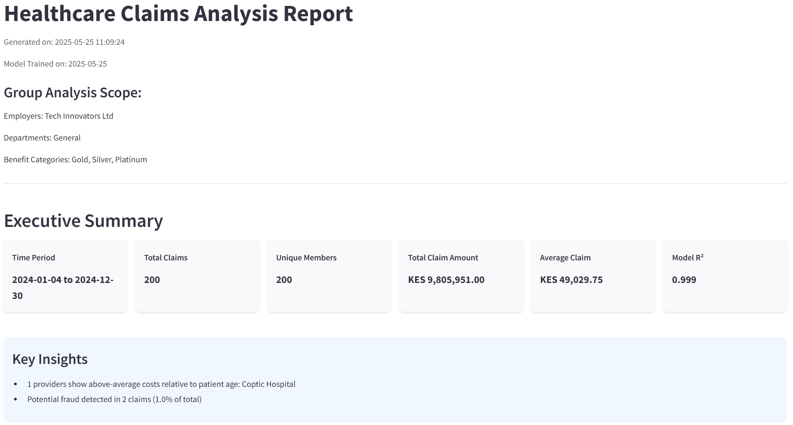
Advanced Analysis
1.1 Claim Amount Distribution by Category
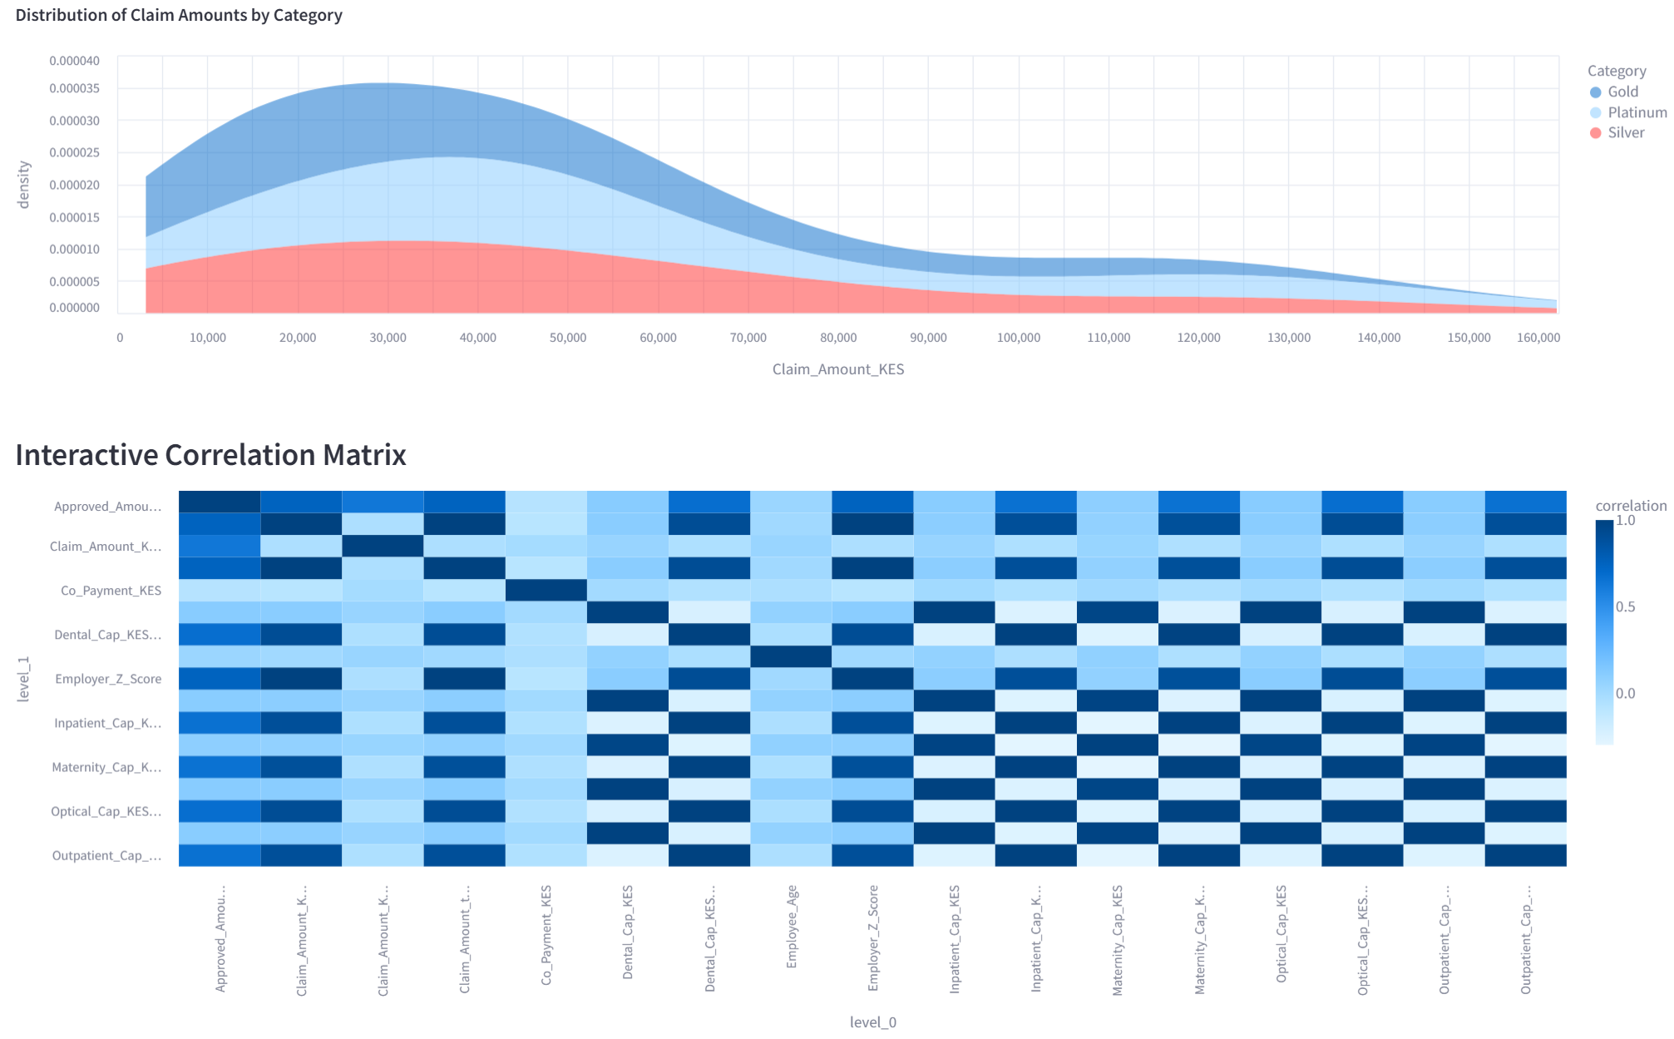

1.2 Temporal Analysis
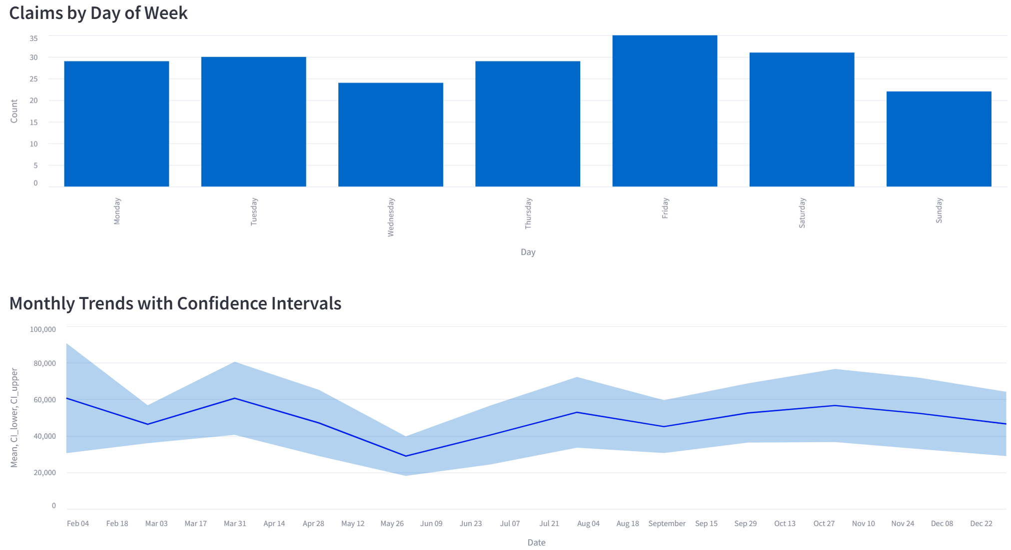
1.3 Provider Analysis
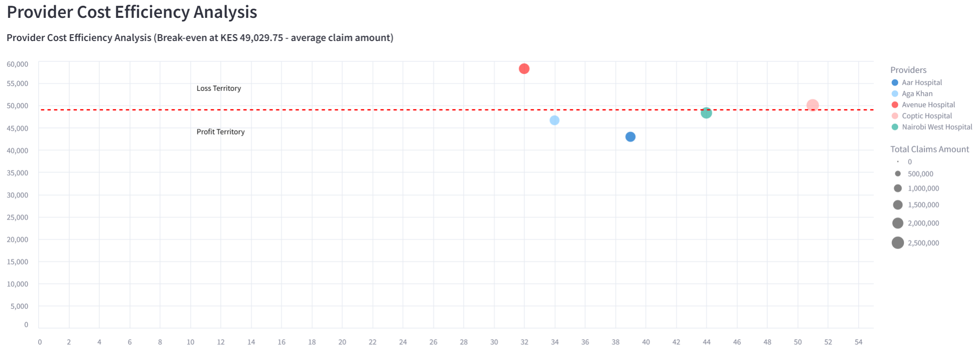
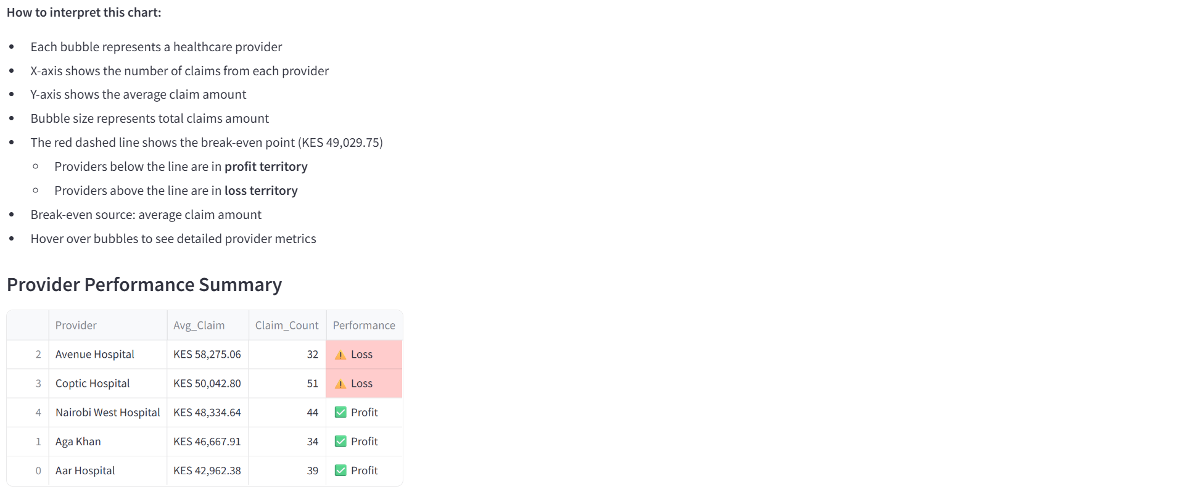

1.3 Diagnostic Patterns
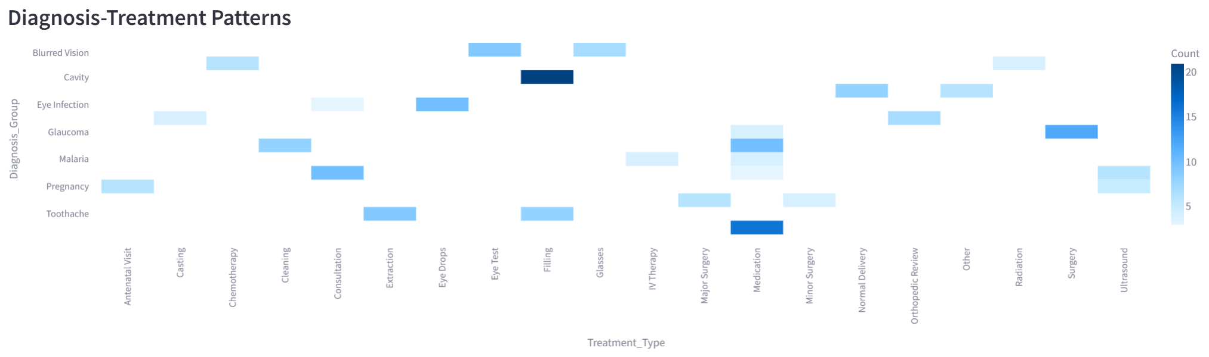
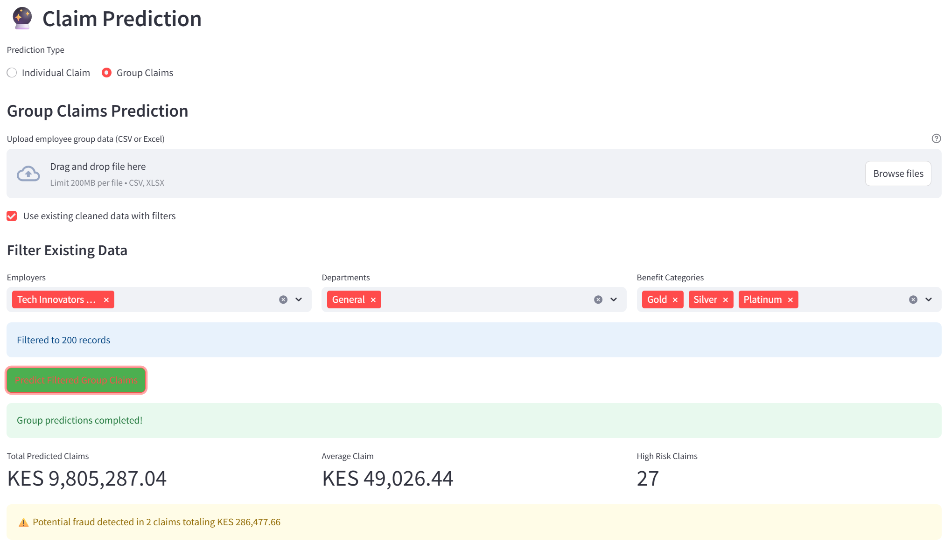
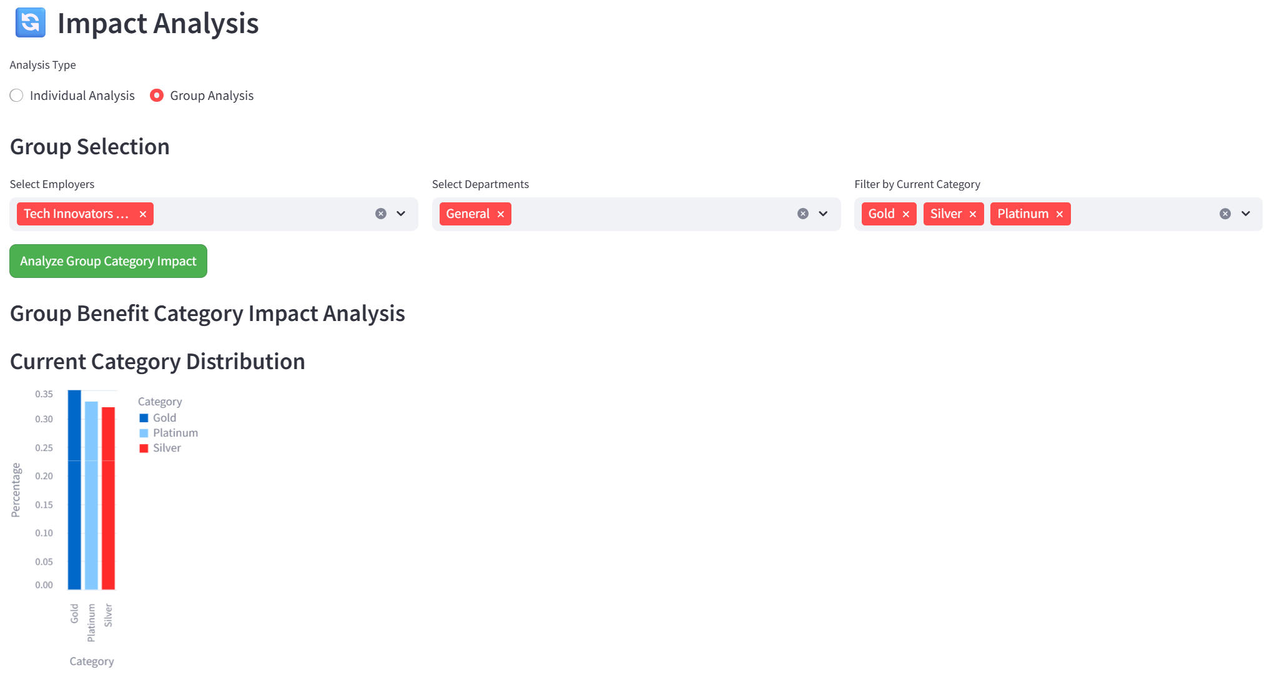
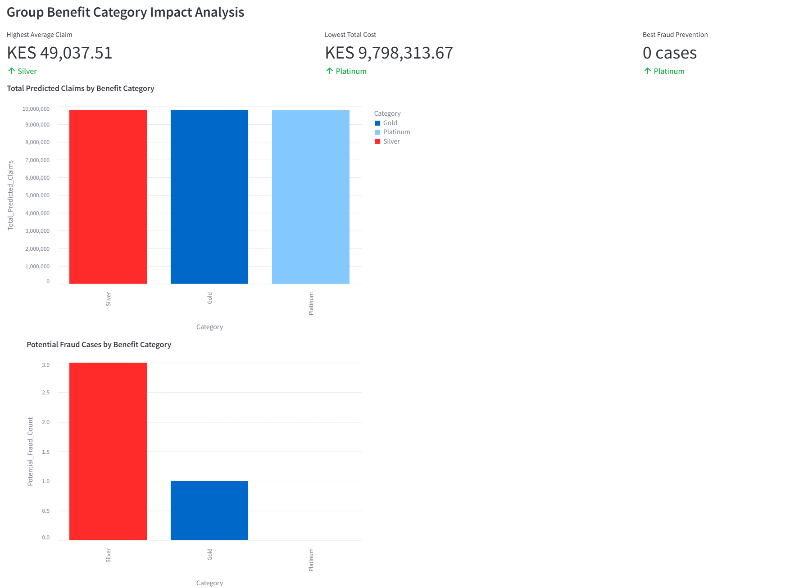
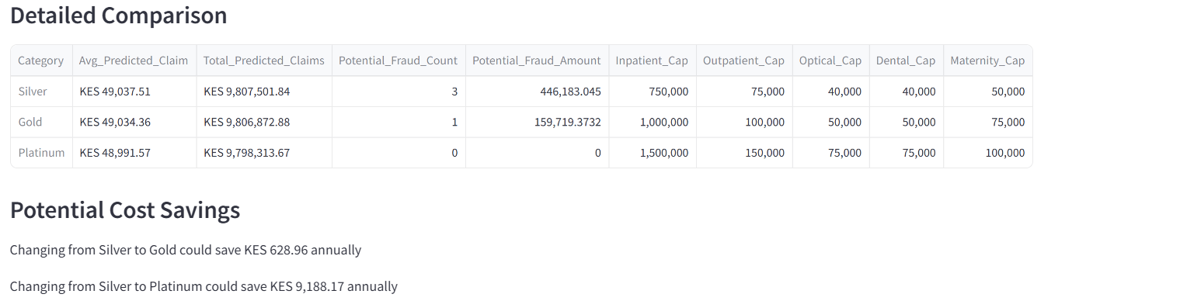
Actionable Recommendations
- Consider renegotiating contracts with high-cost providers: Avenue Hospital. Potential savings up to 288,592.09 KES annually
- Implement enhanced fraud detection measures focusing on: duplicate claims, unusually high-cost procedures, and providers with abnormal billing patterns
- Review benefit design to align with actual utilization patterns
- Implement member education programs for high-utilization members
- Conduct provider performance reviews quarterly
- Evaluate network adequacy based on geographic distribution of claims
