Dan Ficek

March 6th, 2022

Foundations of Programming

Assignment 08

[Github Link](https://github.com/dkficek/IT-FND100-Mod8)

**Classes**

**Summary**

In this module we learned how to use classes. Classes are the foundation of object-oriented programming. They help organize code and make it much more efficient by storing attributes and methods within them that can be called or stored by creating objects with that class.

**Assignment Exercise: Create a program that uses Classes**

To demonstrate Classes, I used the assignment 08 starter text and added some code to flesh it out. The goal of the program we’re trying to create is to offer a user a menu and way to build a list of products and their associated prices. Each of the products needs to be an object with the class “product” that has a name and a price as associated attributes.

I started by declaring some global variables:

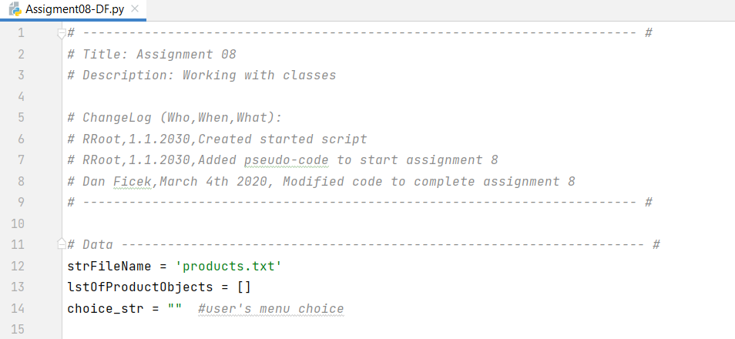

Figure 1: Declaring Variables in Initial Code Block

Once the variables were declared, it was time to define the classes. For this program, we want to define 3 different types of classes: The Product, the FileProcessor, and the IO. The Product class code is shown below.

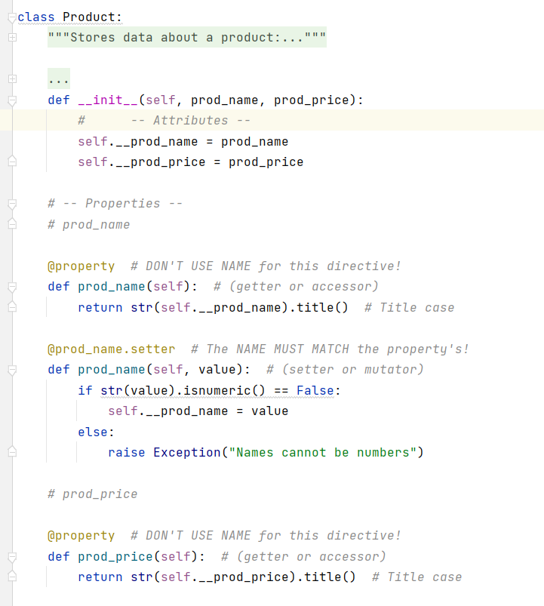

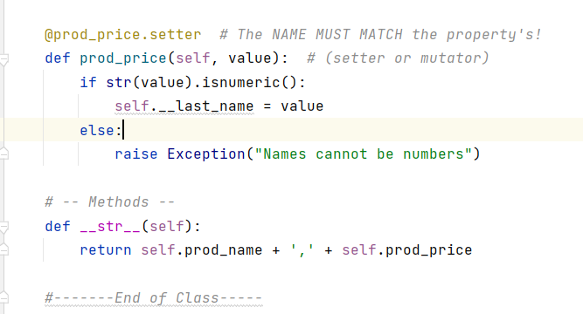

Figure 2: The Product Class

The Product Class is used to define a product with 2 attributes: a product name and a price.

The FileProcessorClass is shown below:

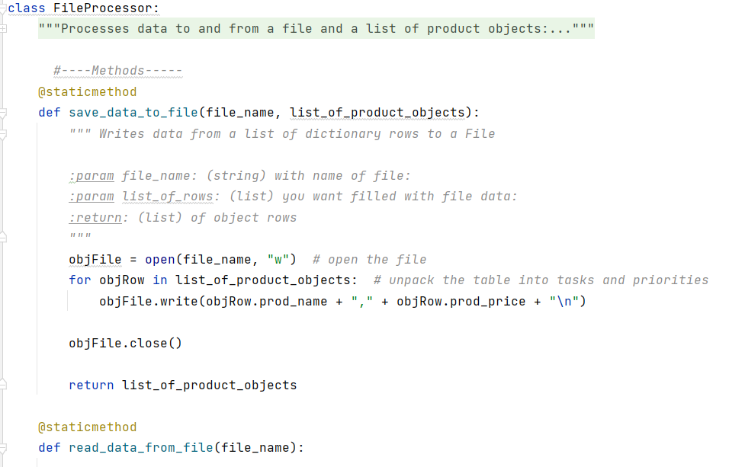

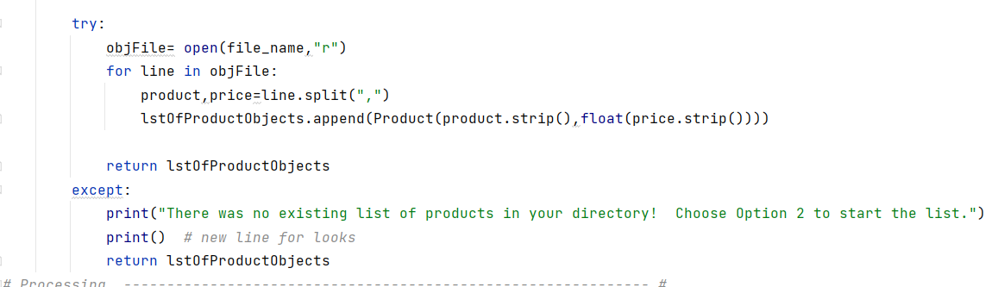

Figure 3: The FileProcessor Class

The FileProcessor Class is one with only static methods; its only purpose is to either read data from files and add them to a list of objects, or to save that list of objects to a file.

The final class in the assignment was the IO class, shown below:

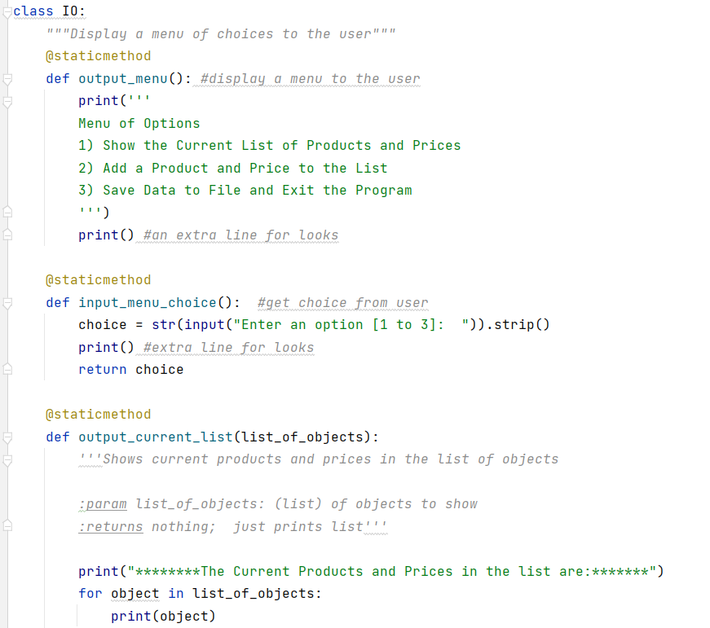

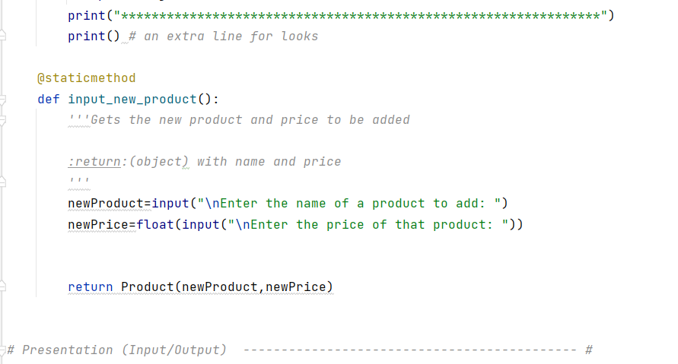

Figure 4: The IO Class

The IO class is used for the program to interact with a user. It takes inputs from the user in the form of menu choices and, if selected, additional products and their prices. It outputs the menu to the user as well as the current list of products and prices, if requested.

These 3 classes are all called within the main script body, which is contained within a while loop. The program repeatedly generates a menu until the user chooses the menu option to exit the program.

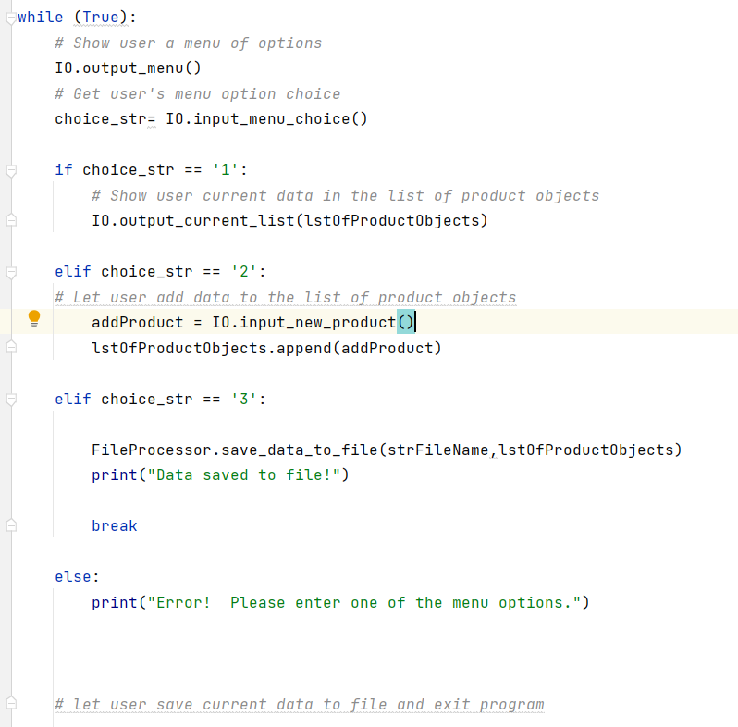

Figure 5: Main While loop section of script

The figure below shows the program being run and loading an initial file that contains several Product Class objects.

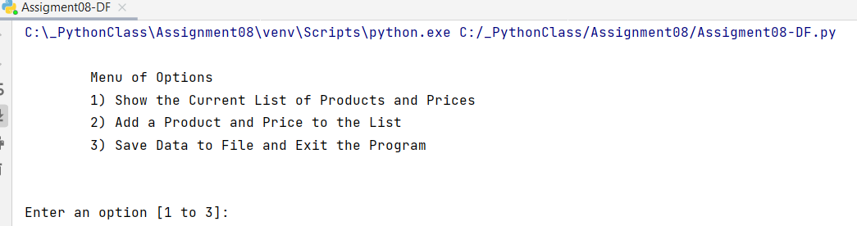

Figure 6: Running the program

If the user chooses the first option, it shows the current list:

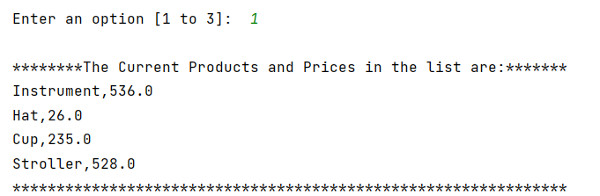

Figure : User choosing menu option 1

If the user chooses the second option, the program requests a product and price using the IO class and adds it to the existing list:

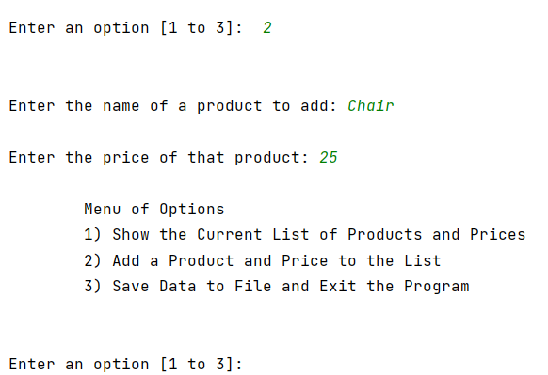

Figure : Menu option 2: Add a Product and Price

If the user chooses the third option the program saves the data to a file titled “products.txt” and exits. We can see in the figure below that the “Chair” item we added was saved to the text file.

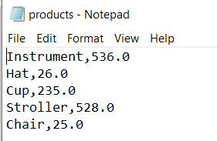

Figure : Text file updated with entry from program

**Summary**

In this module we learned the benefits of uses Classes and got our first real experience with Object Oriented Programming. We were able to make 3 different types of classes: one that was mainly about storing attributes and methods (the Product class), another that contained static methods to only perform some behind-the-scenes processing (FileProcessor), and lastly another that was used to interact with a user (IO).