BackRow Sports Database Setup

The database is named brs. The tables are USERS, EVENTS, and ROSTER.

1. Open up xampp and start the Apache and SQL server, then click “admin” next to the SQL server.
2. Click databases at the top of your browser, closer to the left and side and create the database brs. Once created click on the database you made.
3. Now you should see a box to create a table. USERS has 9 columns: id, username, password, location, FName, LName, SOC, sports, and pic (these are case ensitive). EVENTS is 7 columns. ROSTER is 2 columns.
4. When creating the USERS table make sure these options are selected next to the appropriate column: id – TYPE: int LENGTH: 5 (also click the box under A_I for autoincrement). username, password, location, FName, LName, SOC, sports and pic are TYPE: varchar. SOC and sports are length 4, pic is length 200, and the rest are length 25. Id, username, password, and SOC are Default: None, the rest are Default: NULL (which also means the NULL checkbox is checked for these 4 options. PLEASE MAKE SURE THAT ID, USERNAME AND SOC ARE “UNIQUE”. Below is a picture for you to verify your USERS setup. If you click “Structure” you can verify these options and make sure id is set as primary.
5. 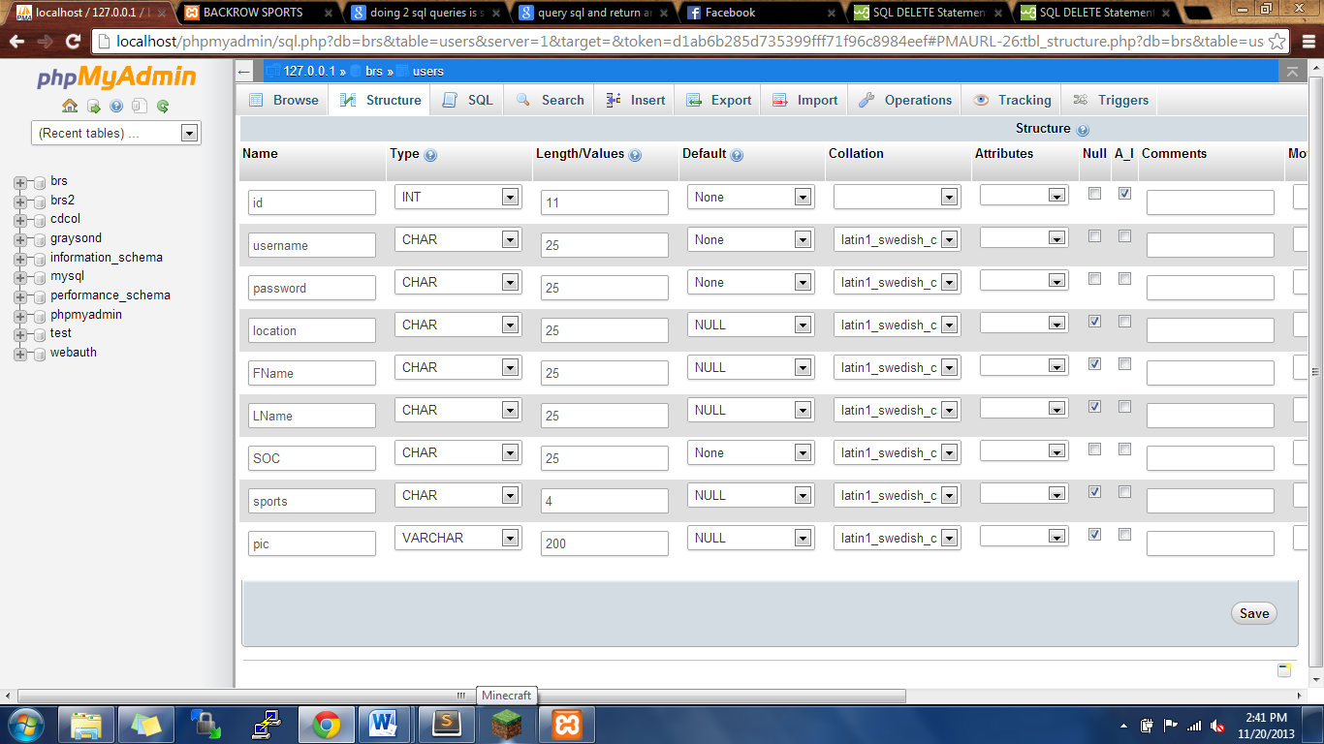

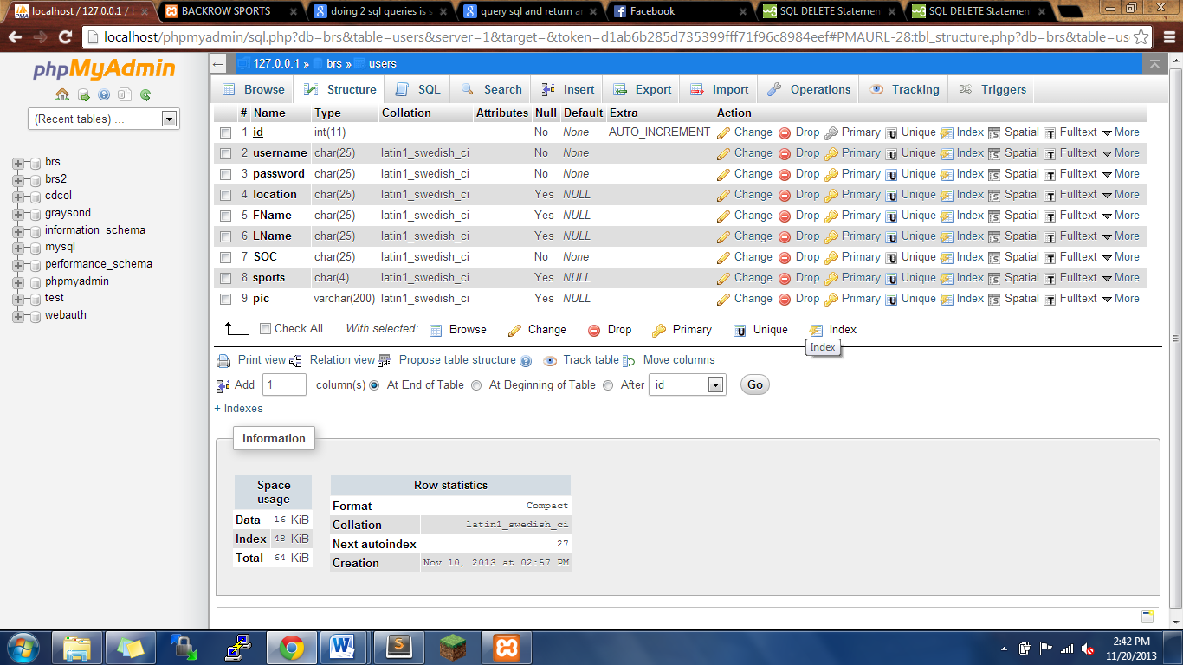

1. For the sake of brevity, I have attached a picture of the events setup. If you have any questions email me. Note, id is auto incremented here.
2. 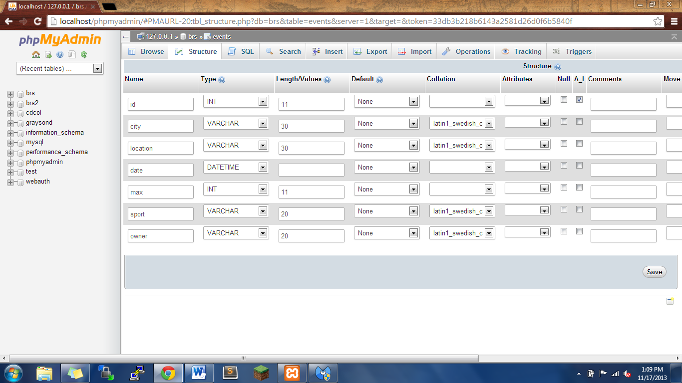

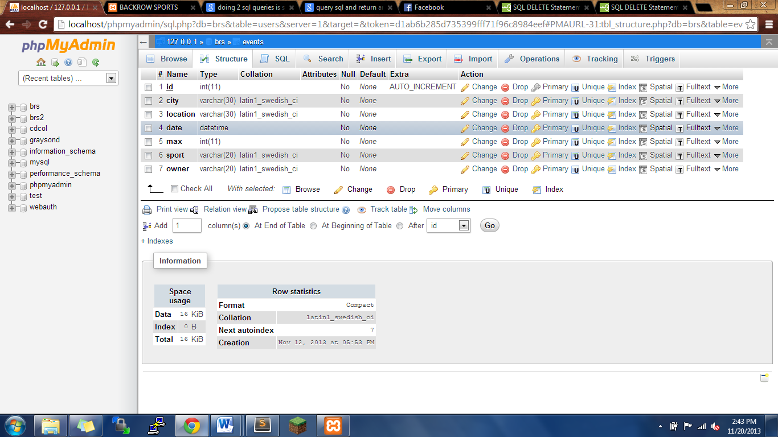

1. I have also attached a picture of ROSTER. It is very very simple, nothing should be unique, and nothing needs to be auto incremented.
2. 