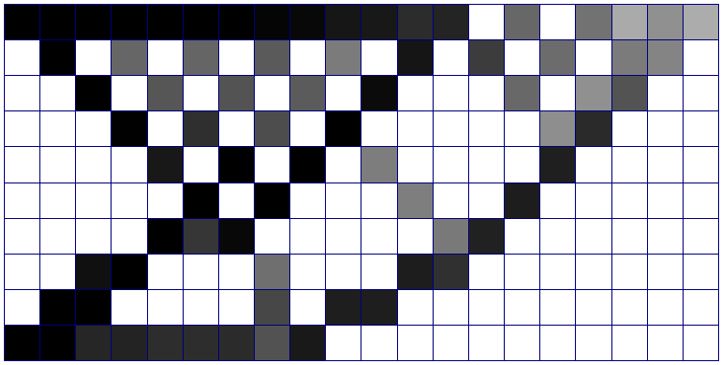
p = 1, d = 1, no filter
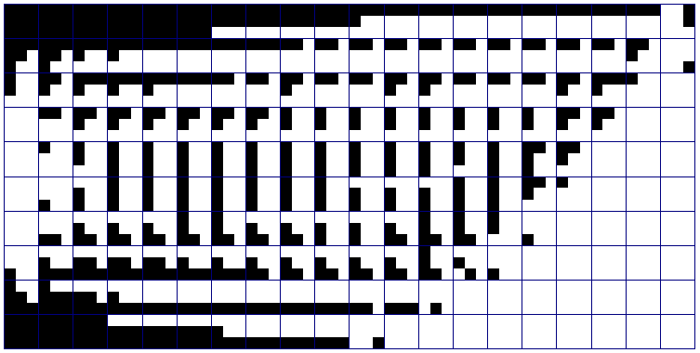
p = 1, d = 3, no filter
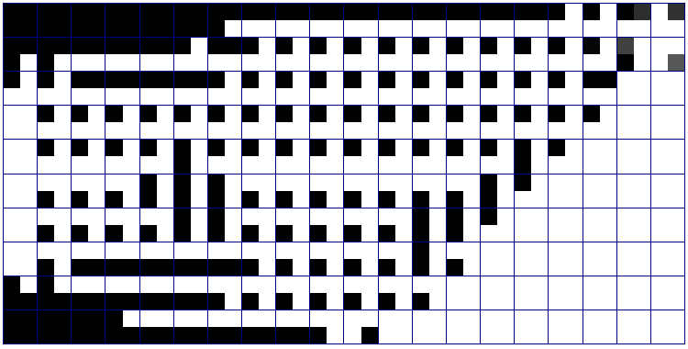
p = 1, d = 2, no filter
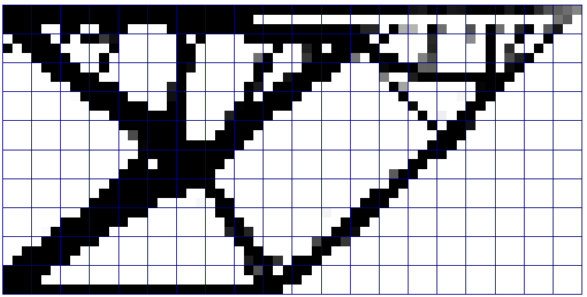p = 2, d = 3, no filter
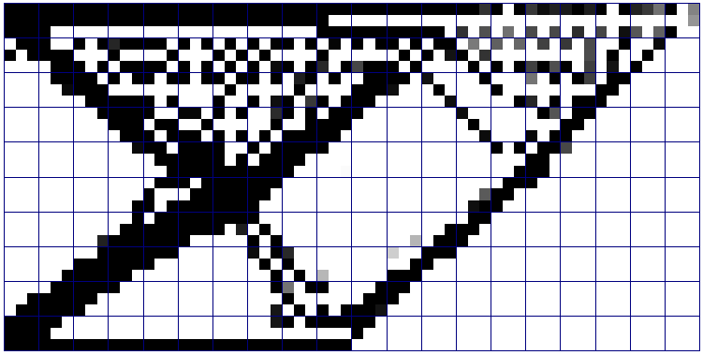
p = 5, d = 3
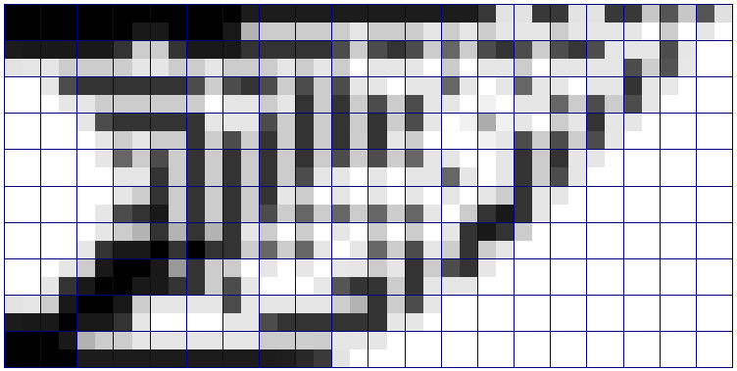p = 1, d = 2, r = 1.2 voxels
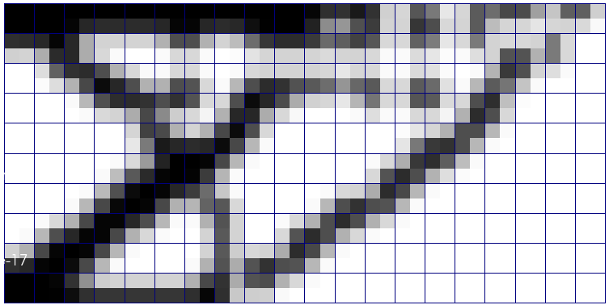p = 1, d = 2, r = 1.5 voxels
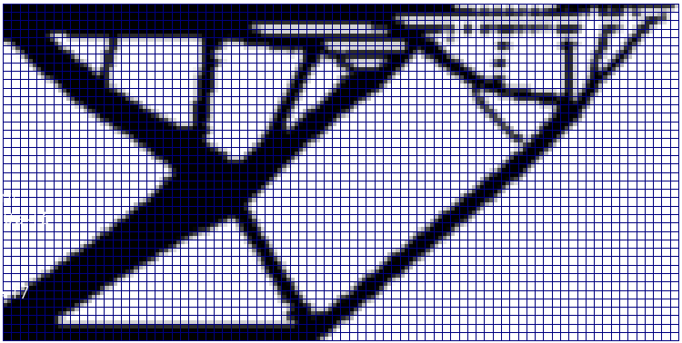p = 1, d = 2, r = 1.5 voxels

