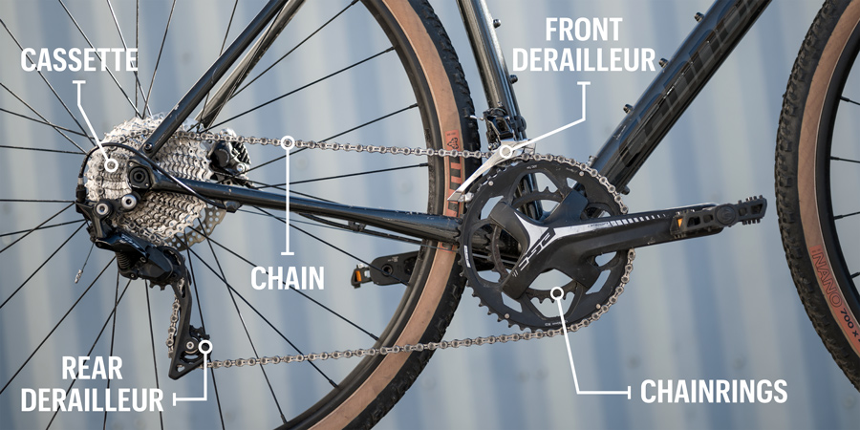

Roger, A. How to Use Bike Gears. Retrieved from <https://www.rei.com/learn/expert-advice/bike-gears-and-shifting.html>

# Technical terms

**Cog** – tooth on a sprocket or gear

**Cogwheel** – any ring with teeth/cogs

**Gear** – a ring with teeth/cogs that mesh with teeth/cogs of another ring

**Sprocket** - a ring with teeth/cogs that mesh with a chain

# Biking nomenclature

**Crankset** – drivetrain component attached to pedals

**Chainring** – sprocket in a crankset

**Cassette** – stack of sprockets mounted on the rear wheel. Although technically inaccurate, sprockets in the cassette are often called **cogs**.

**Gear ratio** – number of rear wheel rotations per one full turn of the pedals. When taking into account the rear wheel size, also indicates the distance covered by the rear wheel for one full turn of the pedals. Smaller number means easier pedaling and slower speed.