Git installation



Web-231 directory



Git recognizing directory

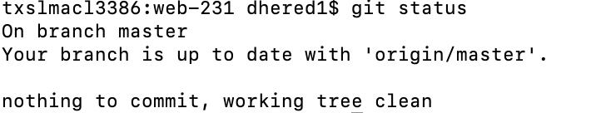

GiHub repo

<https://github.com/dkheredia/web-231>