System: Enterprise Notification Service

1. Problem Statement
Enterprise applications frequently need to notify users through one or more communication channels such as Email and SMS.
Multiple applications (Fleet Management, Inventory, Payment, Billing, etc.) should be able to submit notification requests without knowing:
- Which provider sends the notification
- Retry policies
- Delivery status tracking
- Callback implementation
- Future provider changes
The Notification Service acts as a reusable enterprise platform responsible for reliable notification delivery.

2. High Level Architecture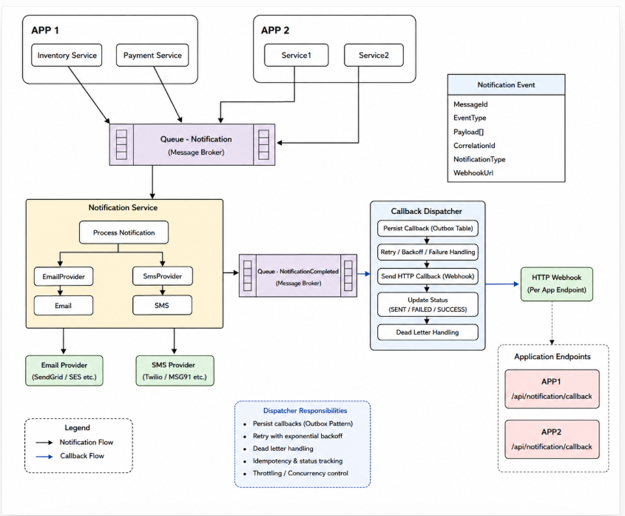

3. Implementation Plan
- Feature 1 Solution Structure
  - Src
    - Notification.Api
    - Notification.Application
    - Notification.Domain
    - Notification.Infrastructure
    - Notification.Worker
    - Callback.Dispatcher
    - SharedKernel
  - Folder structure
Notification.Api
Endpoints
Middleware
Notification.Application
Commands
Handlers
Validators
Notification.Domain
Entities
Events
Notification.Infrastructure
Providers
Persistence
Notification.Worker
Callback.Dispatcher
  - Deliverables
    - Solution
    - Projects
    - Docker
    - Configuration
    - Logging
    - Health Checks

- Feature 2

  - Create Notification
-------------------
POST /notifications
↓
Validation
↓
Queue
↓
Metadata
  - Deliverables
    - POST /notifications
    - Validation
    - Queue publisher
    - Metadata persistence

- Feature 3

Notification Worker
↓
Read queue
↓
Resolve Provider
↓
Send notification
↓
Update metadata
↓
Publish completion event
  - Deliverables
    - Queue consumer
    - Provider resolution
    - Status updates
    - Publisher for
      - Completion event
      - Completion queue

- Feature 4 Providers
  - File Providers
    - Deliver notification
    - Return status
  - POC implementation
    - Persist Email
    - Persist SMS
- Feature 5 Callback Dispatcher
  - Deliverables
    - Queue consumer
    - HTTP callback
    - Retry
    - Status persistence
- Feature 6 Testing
  - Deliverables
    - Unit tests
    - Integration tests
    - Docker Compose
- Out of Scope (POC)
    - - Template Management
    - - Subscription Management
    - - Scheduling
    - - Push Notifications
    - - Provider Failover
    - - Attachments
    - - Multi-tenancy
    - – UI
- Technology stack
    - .NET 10
    - ASP.NET Core
    - SQL Server
    - Azure Service Bus
    - Docker Compose
    - OpenTelemetry
    - Serilog
    - xUnit

