System: Enterprise Notification Service

1. Problem Statement
Enterprise applications frequently need to notify users through one or more communication channels such as Email and SMS.
Multiple applications (Fleet Management, Inventory, Payment, Billing, etc.) should be able to submit notification requests without knowing:
- Which provider sends the notification
- Retry policies
- Delivery status tracking
- Callback implementation
- Future provider changes
The Notification Service acts as a reusable enterprise platform responsible for reliable notification delivery.

2. Functional Requirements

Consumers
Any application can submit notification requests.
Examples:
- Inventory
- Payment
- Fleet Management
- External Applications

Supported Channels (POC)
- Email
- SMS
Future
- Push Notification
- Teams
- Slack
- WhatsApp

Notification Request
Consumer provides
- SourceId
- MessageId
- EventType
- NotificationChannel
- Recipient
- Payload
- Subject (Email)
- Body

Processing
The service shall
- Validate request
- Persist metadata
- Publish request to queue
- Process asynchronously
- Dispatch to provider
- Update delivery status
- Publish NotificationCompleted event

Callback
Callback Dispatcher shall
- Receive NotificationCompleted event
- Persist callback request
- Retry failed callbacks
- Invoke registered consumer webhook
- Update callback status

3. Non Functional Requirements

Reliability
- At least once delivery
- Idempotent processing
- Retry with exponential backoff
- Dead Letter Queue

Scalability
Scale independently
- Notification Workers
- Callback Workers

Availability
Target
- 99.9%

Performance (Initial)
Notification API
P95
< 200 ms
(only queueing)
Notification Processing
P95
< 5 seconds

Security
- Internal authentication
- Webhook authentication
- Audit trail

4. High Level Architecture
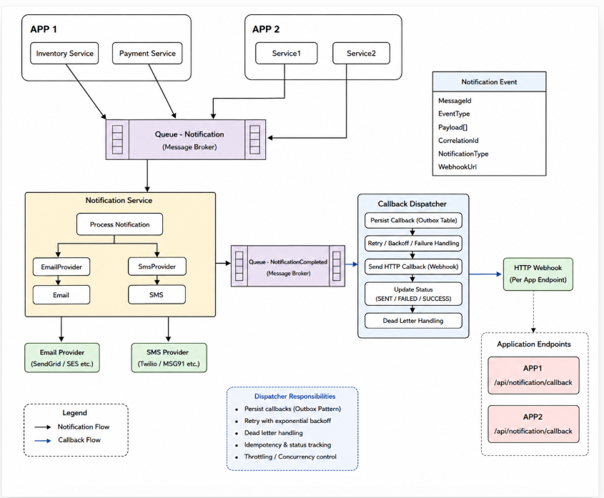

5. Responsibilities

Notification API
- Validate request
- Persist metadata
- Queue message

Notification Worker
- Read queue
- Resolve provider
- Send notification
- Update metadata
- Publish completion event

Provider
Responsible only for
- Deliver notification
- Return status
POC implementation
- Persist Email
- Persist SMS
Later
- SendGrid
- Twilio

Callback Dispatcher
Responsible for
- Persist callback
- Retry
- HTTP callback
- Callback status

6. Event Contract
NotificationRequest,
MessageId, SourceId, EventType, NotificationChannel, Recipient, Subject, Body,Payload

NotificationCompleted
MessageId, Status, Provider, CompletedTime, FailureReason

7. Storage
Notification
Id, MessageId, SourceId EventType, Channel, Status, Created, Completed

Callback
Id, NotificationId, Webhook, RetryCount, Status, LastAttempt

POC Email Storage
notifications/
email/
sms/

8. Sequence
Inventory
↓
POST Notification
↓
Queue
↓
Notification Worker
↓
EmailFileProvider
↓
NotificationCompleted
↓
Callback Dispatcher
↓
Webhook
↓
Inventory

9. Failure Handling
Notification Failure
↓
Retry
↓
DLQ
↓
Alert

Callback Failure
↓
Retry
↓
DLQ
↓
Manual Investigation

10. Decisions
Decision | Why
Queue-based processing | Decouple producers from notification latency
Provider abstraction | Replace providers without changing consumers
Callback Dispatcher | Isolate callback delivery from notification delivery
File-based provider (POC) | Validate architecture before integrating external providers
Metadata in SQL | Efficient querying and status tracking
NotificationCompleted event | Decouple delivery from callback processing

11. Open Questions
- Multiple recipients?
- Notification priority?
- Scheduled notifications?
- Attachments?
- Provider failover?
- Batch notifications?
- Rate limiting?
- Multi-tenancy?

12. Implementation Plan
- Feature 1 Solution Structure
  - Src
    - Notification.Api
    - Notification.Application
    - Notification.Domain
    - Notification.Infrastructure
    - Notification.Worker
    - Callback.Dispatcher
    - SharedKernel
  - Folder structure
Notification.Api
Endpoints
Middleware
Notification.Application
Commands
Handlers
Validators
Notification.Domain
Entities
Events
Notification.Infrastructure
Providers
Persistence
Notification.Worker
Callback.Dispatcher
  - Deliverables
    - Solution
    - Projects
    - Docker
    - Configuration
    - Logging
    - Health Checks

- Feature 2

  - Create Notification
-------------------
POST /notifications
↓
Validation
↓
Queue
↓
Metadata
  - Deliverables
    - POST /notifications
    - Validation
    - Queue publisher
    - Metadata persistence

- Feature 3

Notification Worker
↓
Read queue
↓
Resolve Provider
↓
Send notification
↓
Update metadata
↓
Publish completion event
  - Deliverables
    - Queue consumer
    - Provider resolution
    - Status updates
    - Publisher for
      - Completion event
      - Completion queue

- Feature 4 Providers
  - File Providers
    - Deliver notification
    - Return status
  - POC implementation
    - Persist Email
    - Persist SMS
- Feature 5 Callback Dispatcher
  - Deliverables
    - Queue consumer
    - HTTP callback
    - Retry
    - Status persistence
- Feature 6 Testing
  - Deliverables
    - Unit tests
    - Integration tests
    - Docker Compose
- Out of Scope (POC)
    - - Template Management
    - - Subscription Management
    - - Scheduling
    - - Push Notifications
    - - Provider Failover
    - - Attachments
    - - Multi-tenancy
    - – UI
- Technology stack
    - .NET 10
    - ASP.NET Core
    - SQL Server
    - Azure Service Bus
    - Docker Compose
    - OpenTelemetry
    - Serilog
    - xUnit

