TITLE LINE 1  
title line 2:

Subtitle

Darren Kidney

02 December 2016

Table of Contents

# Heading 1

Normal text.

* Bullet point

verbatim text

**bold**

*italic*

## Heading 2

### Heading 3

#### Heading 4

##### pagebreak

Link to the Creditinfo website:

<http://creditinfo.com>

Here is some R code:

"a string"

[1] "a string"

x = rnorm(100)  
mean(x)

[1] 0.05853

Here is a kable

data.frame(x = month.abb[1:5], y = 1:5) %>%   
 set_rownames(letters[1:5]) %>%   
 kable

|  |  |  |
| --- | --- | --- |
|  | x | y |
| a | Jan | 1 |
| b | Feb | 2 |
| c | Mar | 3 |
| d | Apr | 4 |
| e | May | 5 |

Here is a plot

hist(x)

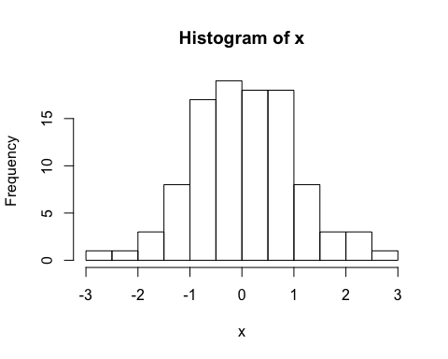

a caption