Email Mining Toolkit User Manual
Department of Computer Science
Columbia University
New York, NY
Shlomo Hershkop, Ke Wang, Wei-Jen Li, Olivier Nimeskern, Germán Creamer, and Ryan Rowe
Version 3.8.5 – January 2007
Table of Contents

Email Mining Toolkit User Manual Department of Computer Science Columbia University New York, NY 1
1 Introduction 5
1.1 EMT Features 5
1.2 Capabilities 6
1.3 EMT Installation 7
1.4 Where to Start 7
2 GUI Components 8
2.1 Configuration Bar 8
2.2 Load Data Window 9
2.1.1 Database 10
2.2 Messages Window 11
2.3 Attachment Statistics Window 15
2.4 Cliques 16
2.4.1 Enclave Cliques 16
2.4.2 User Cliques 16
2.5 Account Behavior 19
2.6 Similar Users 19
2.7 Usage Histogram 22
2.8 Recipient Frequency 24
2.8.1 Profile 24
2.8.2 Chi Square 26
2.8.3 Chi Square + Cliques 27
2.8.4 Virus Simulation 28
2.9 Email Configuration 32
2.10 Supervised Learning 32
2.10.1 Training Area 32
2.10.2 Testing Area 34
2.10.3 Email Features 34
2.11 Report and Forensic Window 34
2.12 Email Flow 35
2.13 Average Communication Time 37
2.13 Virus Scanning 39
2.14 Attachment Analyzer 41
2.15 Search Window 43
2.16 Social networks 44
2.16.1. Using database with file creation 44
2.16.2. Using database without file creation 46
2.16.3. Using external datasets 46
2.17 Social Hierarchy Detection 47
3 System Walk Through 49
3.1 Importing Data 49
3.2 Viewing Data 49
3.3 Viewing Attachment Information 49
3.4 Learning 49
3.4.1 Common Learning Errors 50
3.5 “Interesting” Users 51
3.6 Screen Capture / Printing 51
4 FAQ 51
5 References 53
Appendix A: Capabilities 54

List of Figures

Figure 1 – EMT Menu bar 7
Figure 2 - Email Import 8
Figure 3 - Clean Up Tool 9
Figure 4 - Message Window 11
Figure 5 - Model Building 13
Figure 6 - Graphical Timeline 14
Figure 7 -User cliques 16
Figure 8 - Visual cliques 19
Figure 9 – Similar Users 20
Figure 10 – Usage Histogram 23
Figure 11 - Main Recipient Frequency Window. 26
Figure 12 – Hellinger Test 28
Figure 13 - chi Test 29
Figure 14 - Clique chi Test 31
Figure 15 - Virus Test Setting 32
Figure 16 - Results Virus Simulation 33
Figure 17 - Results of Virus Detection 34
Figure 18 - EMT Configuration Window 35
Figure 19 - Forensic and Reports 39
Figure 20 - Email Flow 41
Figure 21 - VIP communication 42
Figure 22 - Virus Analyses 45
Figure 23 - Result of Virus Tests 47
Figure 24 - Email social network window. In the top panel, network file can be generated with sender and recipient email accounts. In the intermediate panel, text files can be converted to Pajek format, and several types of social networks and clusters can be generated with email or external files. The bottom “No graph loaded” becomes green and indicates the type of graph when a graph is loaded. In the bottom panel, social network information can be merged with corporate fundamental information. 52
Figure 25 - Clusters of users created according to the quality of connection between networks. The labels of the nodes are the permnos or identifiers of each company. 54

1 Introduction
Welcome to the Email Mining Toolkit (EMT) User Manual. EMT comprises a graphical user interface (GUI) that works with a Database (DB) backend, allowing fast, convenient, and automated analysis of email data. The GUI’s tools facilitate the analysis of email flow data, user relationships, and unusual email activity. The EMT system demonstrates the core principles and capabilities of a fully deployed MET system [1].

1.1 EMT Features
EMT enables the security analyst to perform a variety of tasks and print reports and graphs using the system’s core features, including:
- Inspect an email archive and compute the statistics and attributes of email attachments contained in that archive.
- View user account profiles, including the count-frequency distributions between email account senders and recipients and the stationary temporal statistics showing a user's average email behavior.
- Develop classifiers to mark emails matching particular criteria as “interesting.”
- Analyze and modify the classifier and various profile models in order to manage the training and learning processes.
- Print reports and graphs by using right mouse clicks (over tables) or copying to the clipboard for insertion into documents. In addition a reporting window is provided to help in creating and managing reporting items.
- Search through emails using keywords (specified manually), or automatically extracted email keywords.
- Explore a social network level analysis between specific users and cliques of users.
EMT assists security analyst in analyzing and tracking (suspicious) emails in several ways. First, EMT provides a set of models that the analyst can use to understand and glean important information about individual emails, user account behaviors, and abnormal attachment behaviors for a wide range of analysis and detection tasks. Second, EMT’s Alert Function enables the analyst to specify certain conditions identifying abnormal events for further inspection, such as potential account misuses, self-propagating viral worms in email attachments, bulk SPAM messages, and, potentially, email accounts that are used to send SPAM. In addition, EMT can identify similar user accounts in order to detect groups of SPAM accounts that may be used by a sophisticated “SPAMbot.” The forensic and search section allows the analyst to find a starting point for pinpointing interesting user or account activities over time.
This project is an extension of previous work done at Columbia University with the Malicious Email Filter project [2] and Malicious Email Tracking project [1]. Please see the Technical Manual [3] for a more extensive description of system functionality.

1.2 Capabilities
All additions to the system since Version 1.0 are denoted by the “vX.X” symbol. The X.X refers to version number. Please refer to Appendix A: Capabilities for a more detailed version/capability breakup.
The following capabilities exist:
- Native Java email parser to extract features from offline email log files.
This has replaced the old perl script. (since v3.0)
- Native machine learning algorithms including a Naïve Bayes classifier, gram based and other document modelers to produce a classifier over email data.
- Capability to find a cluster of email accounts according to a distance computation over a feature set using subject, content, or behavior.
- The system is compatible with Windows 2000, XP and Linux. Most of the code is Java based, and some native executables for each system dynamically invoked as needed.
- All alerting capabilities available in the previous MET system over live email traffic are available with EMT over archived data. These capabilities include alert models that distinguish between red alerts and yellow alerts over attachment and account activities, as well as keyword detection.
- Graphical clique exploration and detection is available over archived data with EMT.
- Email account histograms are computed and graphically displayed (see the Similar Users and User Histograms windows). In addition, histogram comparison functions are computed to detect anomalous account usage change over time and similar user behavior.
- Email account profile and behavior visualization is computed and displayed by a recipient frequency histogram, a chart of recipient address list size over time, as well as a table of the number of distinct recipients per unit block of emails sent over time, and moving averages thereof (see the Recipient Frequency window). In addition, recipient accounts and clique frequencies are compared by Chi Square tests in order to detect anomalous account usage behavior changes over time.
- For ease of use the included Java Database classes (DERBY) is embedded in EMT so MYSQL is not necessary for the database backend although recommended for very large email collections. Requires separate install and setup of Mysql
- Forensic window for aiding in forensic email analysis. Allows pointed exploration of interesting account relationships
- Search interface to facilitate flat keyword search and visualization. Emails once indexed are easily searched.
- Social network level exploration

The use of EMT’s capabilities may be accomplished by following the instructions in this manual. The technical, mathematical, and conceptual underpinnings of EMT’s capabilities are described in further detail in the EMT Technical Manual [3].

1.3 EMT Installation
EMT is currently packaged as a system independent zip file. Unzip the contents of the emt_XXXX.zip to a directory of your choice (example c:\emt), and read the accompanying README file for further instructions. The emt zip file will have a version number and sequence letter to denote what version it is. For Example EMT_3_8_5c.zip denotes version 3.8.5 version c. Letter upgrades are due to small bug fixes found after official versions are set.

In general first time use is (java -jar emt.jar) file which will ask for details, and allow the system to generate the appropriate emtclient.bat for subsequent uses.

1.4 Where to Start
Generally the main windows can be divided as follows:

- Data Gathering
  - Load Data window
- Message Content Level View
  - Message window
  - Search window
  - Attachment Statistics window
  - Attachment Analyzer window
  - Email Flows window
  - Virus Scanning
- User Level Views
  - Usage Histogram window
  - Enclave Cliques window
  - User Cliques window
  - Similar Users window
  - Average Communication Time window
  - Recipient Frequency window
- Social Networks
  - Graphic Cliques window
  - SocNetwork Window
  - Social Heirarchies window
- Configuration & other
  - Configuration window
  - SQLView window
  - Experiment window
  - Reports and Forensics window

2 GUI Components
Each of the following components of the GUI (graphical user interface) is accessible via a drop down menu at the top of the screen. Each window component is a menu item bearing their respective names. Select the appropriate window item to display the window. Section 2, GUI Components, primarily acts as a reference for the interface windows. For a tutorial, see Section 3, System Walk Through, which guides first-time users through the EMT system.

Configuration Bar
The Configuration Bar allows us to select corresponding data to analyze. It is located at the top of the GUI. It includes:
- A drop-down list allows user to select different GUI windows. This drop down has been moved to the top center labeled “switch windows”.
- Email button decides the category of email account to be shown in next list.
- A drop-down list and two date bars allow user to select an email account and beginning and ending date (date range) that will be analyzed in the appropriate windows. Some window components will use a different set of dates (example two subsets of the entire range for modeling and testing).
- Info button displays the email distribution of selected account.
Email Accounts
Switch GUI windows
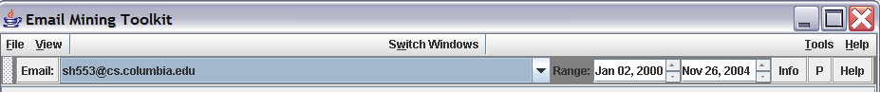
Date Range
Figure 1 – EMT Menu bar

We will now iterate through the list of windows and describe each in turn.

Load Data Window
Email data must be imported into EMT, to be analyzed by the user. The GUI allows selection files for importation through either a browse button or manual typing of file locations (Figure 2). One may also select folders for importation, and the parser will recursively search for all files within a given folder or directory.
A tool called “readdbx,” which converts Outlook Express .dbx files to mbox files, is bundled with EMT and invoked automatically by EMT. NOTE: do not convert the files manually, simply choose the “.dbx” file or directory to process, and choose “outlook express format” before clicking on “import”.
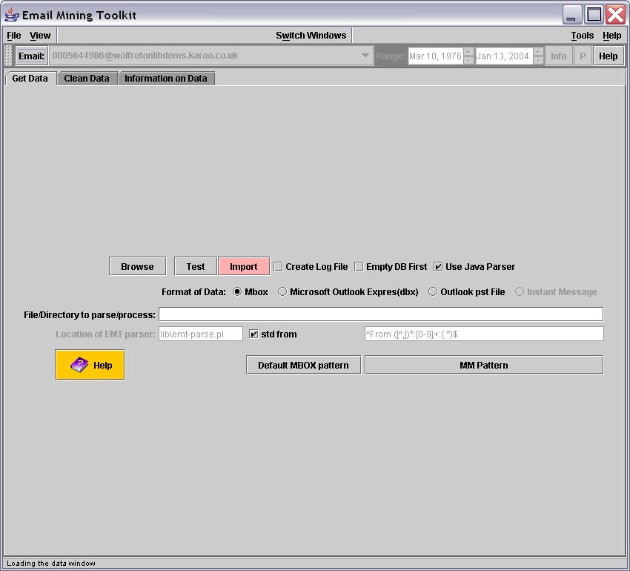
Browse and Import buttons
Domain
Cleanup Tools
Database
Statistics
Java Parser Checkbox
Email file location
Figure 2 - Email Import
The Load Data window has two important buttons, Browse and Import, at the top left corner. The “test” button can be used on individual mbox files to see how many emails the parser will import when done, the output is generated in the dos window.
The user can make sure that the file path listed in the File to process text box is correct. Click Import to call the parser on the file, thus processing and importing it into the database. Note that some of the statistical properties of EMT must be recaliberated once new data is introduced into EMT. Two additional options are available while the database is parsing. The Create Log File button opens a file in the parser directory that can log the size and subject of the emails as they are being parsed. Creating a log facilitates a diagnosis in the case of parser. The second option, Empty DB First, allows the database to be purged before starting an import. Selecting this option removes all the old records.
Domain CleanUp Tools a tab in the same window, may be used to clean up domain names once the data is aquired. For example, machines often are named name1.domain.com, name2.domain.com, etc. To clean a domain, click Refresh DB Statistics to retrieve a list of seen domains. Select a domain, and then click the Copy to list in order to add it to the list. Once you have completed your selections, fill out the Target Domain text label on the right side. The target domain will replace all of those domains selected on the list. To finish the conversion, click the Click to Convert button (V2.1). the “help” sort simply sort the list backwards, allowing flame.cs.columbia to appear near fish.cs.columbia.edu
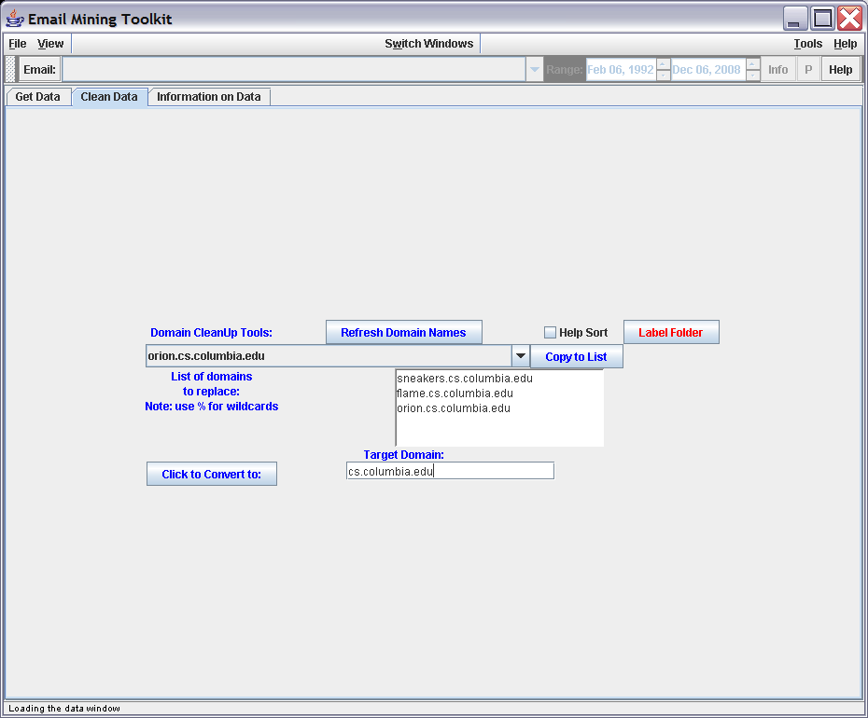
Figure 3 - Clean Up Tool

Database statistics be viewed by clicking on the next tab. You may refresh the information at any time by manually pressing Refresh db stats. NOTE: please use the “clean dates” functionality in the SQL view window, for cleaning up the dates emails after importing the data. This is mostly required for non compliant email clients.

2.1.1 Database
The EMT system is comprised of a GUI as acts as an interface to an underlying Database (DB) scheme. Please see the Technical Manual [3] for more details. Once data have been inserted into an empty database, all of the GUI components are fully functional.
As mentioned before the MYSQL data base option is more appropriate for large email collections, while the native java database is appropriate for small to medium collections (less than 100,000 messages). See the tech manual for more details [3].

2.2 Messages Window
The Message window represents a partial view of the data in the database. Partial views of the data were used in order to allow the system to scale. The initial view of the data shows the last calendar month. The data are retrieved from the database and organized by each unique email message.
Train/Test
Models
Graphical
Save labels
Reload info
Date info
More Info
Type of Email
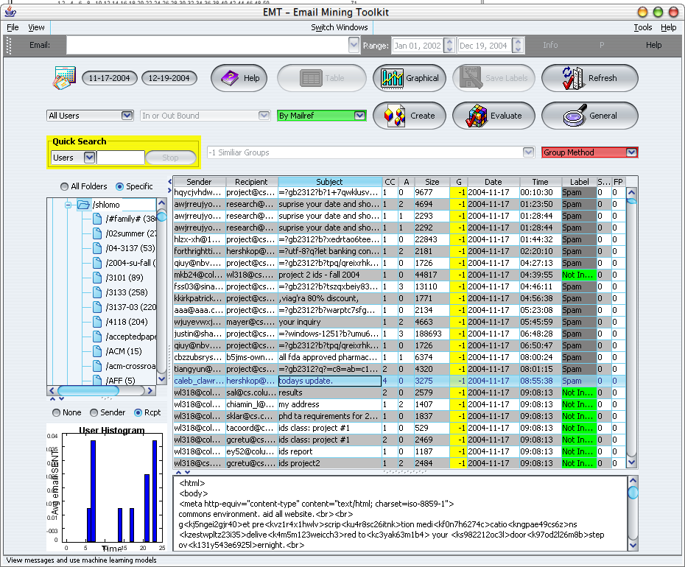
Specific User
Class labels
Cluster emails
Similar Email Groups

Select Email Folder
Group Threshold
Setting
Help info
Selected Email Body
(Sender) Usage History
Search through current msgs
Adjustable Tab Sections
Figure 4 - Message Window
The following columns are displayed in the Message window: Sender, Recipient, Subject, Number of Recipients, Number of Attachments, Size, Group, Date, Label, and Score. The Sender is the originator of the email, and the Recipient is the receiver. Subject is the description of the email’s contents. Size refers to the size of the body, after removing all header information. Label indicates the class in the database to which the email belongs. You may sort the column in ascending order by clicking on the top of any column.
Mailref refers to a unique Email ID generated at parse time. The system refers to email exchanges by this unique identifier, which is for intents and purposes transparent to the user.
One may customize both view and amount of visible data. To time-bound the information viewed, first choose the start and end dates. There also is an option to select all data in the database, thus eliminating the need for a start date and an end date. By clicking on the small calendar picture, the date boxes fade to gray, indicating no date selection (i.e. all dates).
Once a period is chosen, one may also retrieve data by label type by clicking the down-arrow of the leftmost field in the second line (in the screenshot on page six, this field reads “By Mailref” and is colored green). The down-arrow displays a menu of labels; simply select the label that describes the data you wish to retrieve. For example, you can retrieve data by unique email type (mailref); thus, if a single email goes to 30 recipients, it will only appear once in the table as a default. Click Unique send→rcpt to generate a row for each unique sender-recipient pair within a single email.
The second row of buttons is a field that concentrates the data view on per user basis. The default is for all users, but you may select specific user using the down-arrow.
The next button on the second line allows one to view only inbound email (to a specific address), only outbound email, or both.
Click General info to see the number of emails that could be retrieved by the current configuration of the table. This configuration of the data may be updated by clicking Refresh.
Click Save Changes to save classification changes to the database, once any label changes are made either manually or automatically (through machine learned models).
One may change an email’s classification by clicking on it in the Label column. This displays a selection box, in which you may change the selected email’s class from “Unknown” to either “Interesting” or “Spam.” These classes are used by the learning component to distinguish between interesting and uninteresting email messages.
Once a specific view of email is selected (by refresh), single click on any email row will highlight the chosen email, and will preview the email body on the lower portion of the window, for fast preview.
Double-click on any row to bring up a pop-up box with more information about the specific email, including part of the actual body of the email, in some cases.
Choose from Group by Subject/Content/Keyword to classify emails by similar subject using an ngram modeling or list of keywords. When this drop down list is selected, the emails in the table are sorted according to the group number, and the “group” column in the table is updated and displayed. Group by Subject uses a threshold between zero and one from the threshold slider (v2.2). At zero (‘more’ label on the slide bar), each message is considered a unique group. At one, the other end of the threshold spectrum, messages are grouped into a single group. Changes to groups are not saved to the database in EMT v2.1.
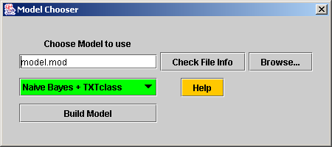
Model Name
Find Files
Model Type
Files Info
Figure 5 - Model Building
Click Create Model to bring up the model chooser window. This allows you to build a machine-learning model with the current data and labels shown in the window. If any labels have been changes, a pop up window asking for input to save or not, will be shown. See the section 1.10.1, Training, for more details.
Click Evaluate Model to classify the currently displayed data using a pre-computed model. Again, labels must be saved manually if you wish to retain changes.
A quick search window provides a quick way to search for specific terms across specific parts of the displayed messages.
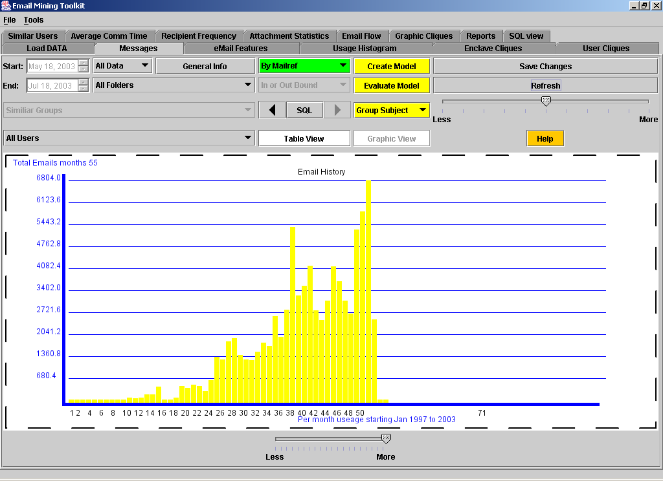
Emails Over Time in Graphic View
Figure 6 - Graphical Timeline
Graphic view (Figure 6) allows the user to graphically display the spread over time of the email data. A slider on the bottom allows bin collapsing. Future releases will take advantage of this navigation aid. This view is useful in visualizing where interesting data is concentrated. Helpful information on the bottom lets you know which dates are covered in the view.
The Table view is the default view of the data.

Note that the tab sections between the sections can be configured to allow one specific component to be very large etc.

2.3 Attachment Statistics Window
The Attachment Statistics window allows movement of attachments to be analyzed. One can generate alerts based on manually specified thresholds for different attachment statistics. The thresholds are accessed via the ToolsAlert Options menu (in the upper right of the menu bar). The statistics are defined as follows:
- Overall: All accounts are considered;
- Internal: Only local accounts (as determined during mail parsing) are included;
- “OR” Thresholds: Any one of these must be true for an alert to occur;
- “AND” Thresholds: At least one “OR” threshold and all of these (that are set) must be true for an alert to occur;
- Birthrate/min: Number of times attachment was seen in any given minute;
- Birthrate/hour: Number of times attachment was seen in any given hour;
- Birthrate/day: Number of times attachment was seen in any given day;
- Speed: Number of incidents per minute over the lifetime of the attachment;
- Saturation: Percentage of accounts affected (25% represented as 0.25);
- Size: Minimum attachment size in bytes
- Lifespan: Maximum lifespan of attachment;
- Origin: Whether the attachment was sent from an internal or external account.
Separate thresholds can be set for red and yellow alerts.
NB: Birthrate/min and Birthrate/hour are very slow operations.
To run the tests in the Attachment Statistics window, first click on “Refresh attachments” and then click on “Compute Statistics”. Alerts will appear in the Alerts window.
In addition the attachments can be organized by name, type, and size. When selecting individual attachments, the lower pane displays all exchanges with the specific attachment. Double clicking on an exchange pops up the email message. “Open attachment” button, will save and attempt to open the attachment. Care should be taken when trying to open virus or malicious attachments.

2.4 Cliques

2.4.1 Enclave Cliques
A clique is a group of accounts that, pair-wise, have exchanged some minimal number of messages. To find cliques in the dataset, set the minimum message threshold on the top of the screen, and click Refresh Users. If you set the threshold to 30, for example, each pair of accounts in the clique will have exchanged at least 30 messages, perhaps 13 in one direction and 17 in the other. The results will also show the most common subject words for messages exchanged within each clique.

2.4.2 User Cliques
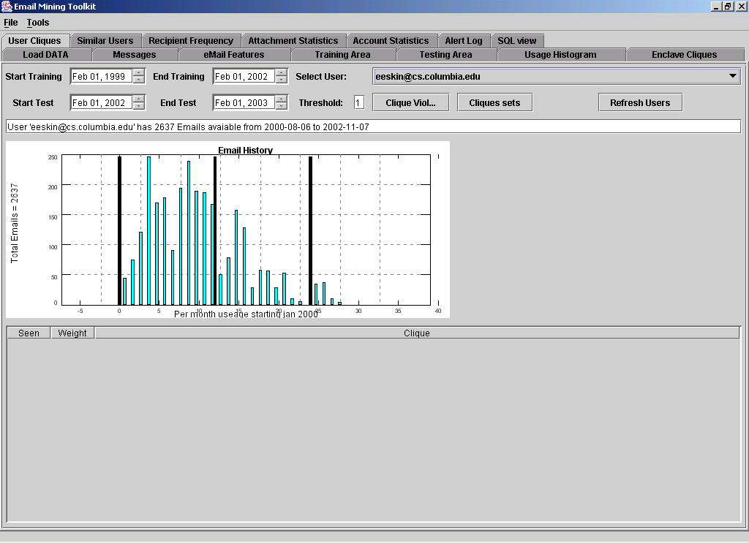
User’s email distribution over time. Tall black lines are year-end markers.
Figure 7 -User cliques
We define a clique as a group of users that an individual mail account in each message has a relationship with involving at least k emails. For example, if User X sends emails to A, B, and C, then we can say that {A, B, C} form a clique with respect to user X. In this definition, a clique consists of two or more users.
The threshold box specifies the k value. The training period refers to the time frame necessary to learn the user’s cliques. The testing period refers to the time needed to test the learned cliques. These can be changed in order to study the behavior of an individual over time with respect to his or her cliques. The Clique Sets button shows the cliques generated from the training period. The Clique Violation button shows the cliques that were seen in the testing period but not seen in the training period.
When results are displayed, additional information is available on a per clique basis. The first column shows the number of times that the clique was observed. The weight column computes the weight of the users in the cliques. Then, the actual clique is shown.
A graphical representation of the users email over time, is displayed for each user (v2.1). This enables you to visualize how the training and testing sets are related.
2.4.3 Graphic Cliques
The Visual Clique window is a user interface that displays graphics showing the activities of a group of cliques and of a single clique.
The top part of the interface enables you to configure the display using the following components:

- Algorithm features two radio buttons that enable you to select which algorithm you wish to apply. EMT utilizes two different algorithms to calculate clique, With Keyword (Common Subject Wors) or Without.
- Display Panel Size features three radio buttons that change the scale of the graph. This is useful when there are too many cliques and connections to display clearly on a small screen. Select the scale, either Small, Medium, or Large, to configure the graph size.
- Minimum Connection text box sets a threshold for connection. EMT creates a connection between two email account pairs when they have exchanged more emails than the minimum threshold.
- Use Frequent Users checkbox configures EMT to display only cliques calculated by the “frequent email account.” The Limit text box, to the right of the Use Frequent Users checkbox, determines the minimum number of emails in this test. For example, if you enter a limit of 200, then EMT only displays email accounts with more than 200 emails saved in the database.
- Enclave Clique and User Clique buttons use the configurations in order to create the graphs. To calculate and display the enclave clique, click Enclave Clique. To calculate and display the user clique, click User Clique.
- Get Statistics Info. Displays the statistical information of selected user.
- Attachment type restricts the type of emails to be analyzed.

When the graphic cliques executes, it produces data in three panels. These panels, the Information Board, the Clique, and the User, are discussed below.

Clique panel:
This panel displays results for all of the cliques that met your specifications. Each dot on the graph represents a clique (N.B. not an email account) and has an identifying reference number. The different sizes and shapes of the dots indicates different types of cliques. Circles indicate 2-clique, triangles indicate 3-clique, squares indicate 4-clique, and so on.

The lines portray the connection (i.e. the relationship) between cliques. A line connecting two dots signifies that these two cliques share the same email account(s) (i.e. clique members).
The color of the lines represents the percentage of members that the two cliques share. The table below defines which percentage is associated with which color. For example, a red line between two dots means that these two cliques share 30% of their clique members.

Color | Percentage
Orange | <10%
Yellow | > 10%, <= 20%
Red | > 20%, <= 30%
Cyan | > 30%, <= 40%
Blue | > 40%, <= 50%
Magenta | > 50%, <= 60%
Green | > 60%, <= 70%
Gray | > 70%, <= 80%
Pink | > 80%, <=90%
Black | > 90%

User panel:
This graph displays all of the email accounts. The blue dots represent cliques; they are the same as the dots in the Clique panel, The dots use the same identifying reference number as in the Clique graph; each number indicates a particular clique.

Black dots represent all of the email accounts. The leftmost column of black dots indicates that each of these email accounts is involved with only one clique. The second left column indicates that each of these email accounts is involved with two cliques, etc. The rightmost dot(s) (i.e. email accounts) are involved with the most number of cliques. Thus, EMT displays which email account(s) is involved with the greatest number of cliques.

The colored lines indicate connections between email accounts and cliques. A line connects an account with a clique thus showing that the account is in this particular clique. A clique may contain more than one account, and an account may be involved in more than one clique. Different columns use different colors.

Zoom is controlled by either clicking on the “+” or “-“ buttons, or spinning the mouse wheel. When “picking” is chosen from the bottom list, one can move and pick any vertex or edge. You can use the mouse to choose multiple vertices. In addition when the “transform” choice is chosen, one can manipulate the entire graph.

Information Board:
The Information Board enables you to retrieve more information about the cliques. Use your mouse to click on a particular clique in the Clique panel. Details about this clique will display in the Information panel.

When you click on a dot (clique), the Information panel displays the email accounts and “Common Subject Words” associated with this clique. It generates a small picture showing what a clique looks like. If there are too many email accounts or “Common Subject Words”, it also pops up a small window to display all the information.

In the Clique panel, the selected dot turns red (the others remain blue). In the User panel, the selected clique and its email accounts also turn red. Note that if you select Without Keyword, the program does not generate common subject words.
To learn which email account(s) that two cliques share, click on the connecting line. The Information Board displays information about the shared accounts, and the selected lines becomes black.
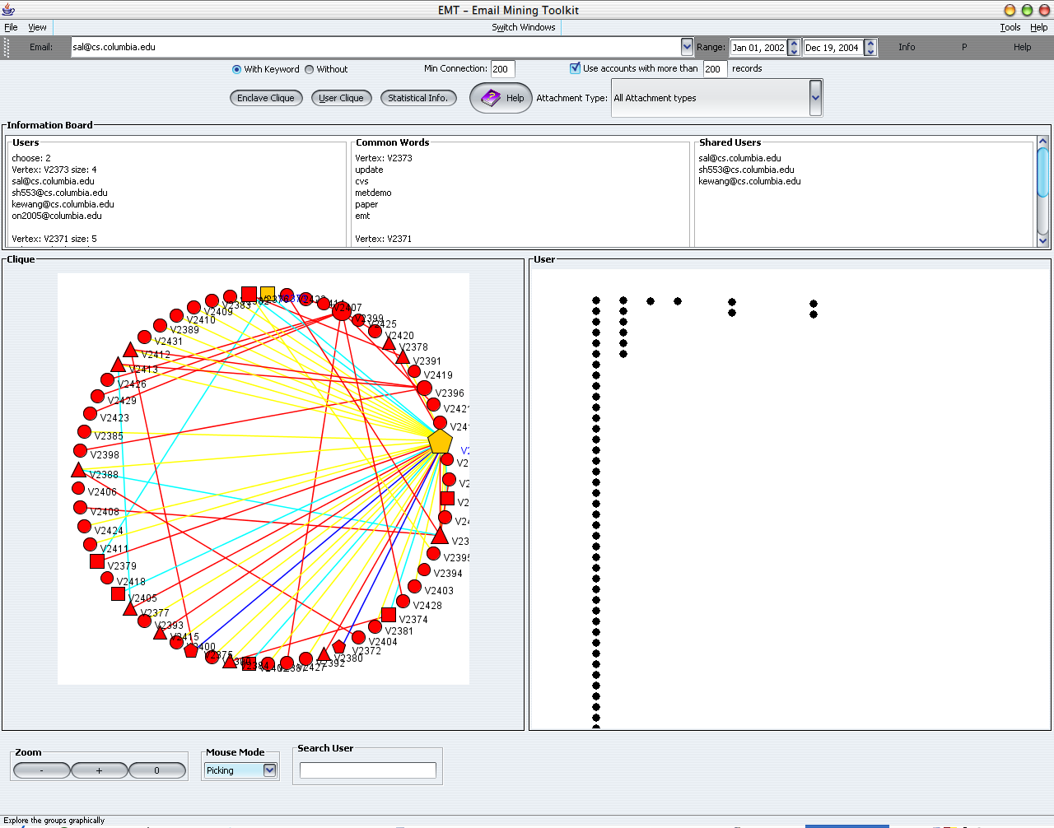
Clique panel
User panel
Information Board
Configuration
Buttons to calculate the Enclave Clique and the User Clique
Figure 8 - Visual cliques

2.5 Account Behavior
One can detect accounts that generate anomalous amounts of email in any given day period. For performance reasons, only per diem (as opposed to per-minute and per-hour) detection is enabled. The thresholds are set under the ToolsAlert Options menu. You can set separate thresholds for yellow and red alerts. For each type of alert, enter the number of standard deviations by which the account must exceed its average in order to generate an alert. To run the tests in the User Behavior window, click the Compute Statistics button. Alerts will appear in the Alerts window.

2.6 Similar Users
The Similar Users window is designed to find a group of email accounts that have similar usage behaviors with a selected account. It can also be used to view the usage histograms of different metrics of an email account. The interface has three main parts: the upper part contains all choices for the operation; the middle part is a plot that shows the histogram of the selected metric for the selected account; and the lower part shows a list of similar users for the selected account and the corresponding histograms.
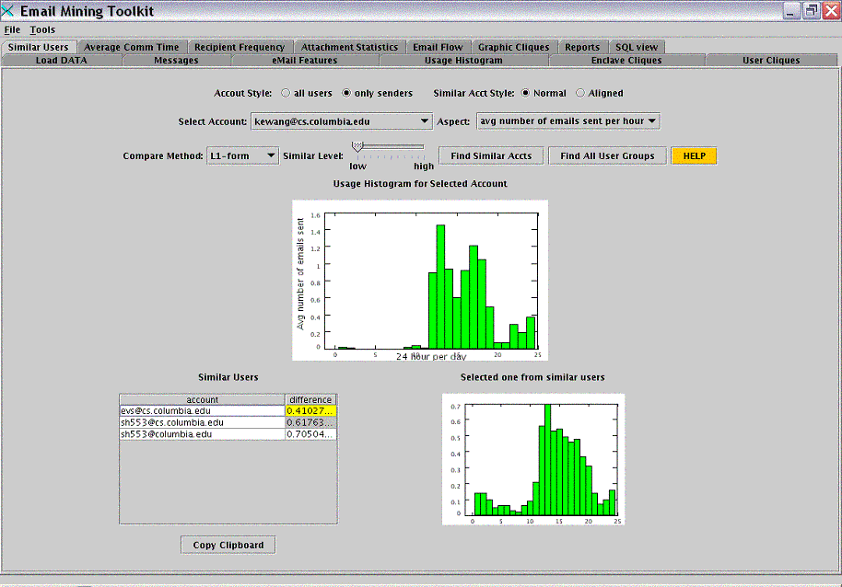
Histogram of selected account
Select account and compare method
Similar Users for selected account
Histogram for highlighted similar user (highlighted)
Similar accounts to selected one or find all similar accts groups
Figure 9 – Similar Users
The top section of the screen displays the following components:
- Two radio buttons after the label Account Style allow the user to choose between considering “all users” or only those accounts for which we have all of their sent emails in the database that are called “senders.” We will explain their difference in the following paragraph.
- Two radio buttons after the label Similar Acct Style allow use of a different kind of histogram when finding similar user groups. For example, if “normal” is selected, we use the normal histogram as computed for the 24 hours per day for comparison. If “aligned” is selected, we first align the histograms and then make comparisons based on those aligned histograms. Please refer to [3] for the description of the definition of aligned histogram.
- A drop-down list with the label Select Account enables the user to choose an email account as the base for finding similar accounts.
- A drop-down list with the label Aspect offers four aspects of analysis. These aspects are: the average number of emails sent out per hour; the average size of emails sent out per hour (in KB); the average number of attachments of emails sent out per hour; and the average number of recipients of emails sent out per hour.
- A drop-down list with the label Compare Method allows you to choose a comparison method in order to find similar accounts. There are four comparison methods: L1-form, L2-form, Quadratic, and KS-test. Please refer the Technical Manual [3] for the description of these methods.
- A slider with the label Similar Level lets the user set the similarity level of the retrieved accounts to the base account. In total, there are 11 levels from “low” to “high.”
- A Find Similar Accts button starts the process of finding similar accounts using the above choices.
- A Find All User Groups button starts the process of finding groups for all of the users, automatically separating users into different groups based on their histograms of behaviors. The comparison also is based on all the above choices.
The choice of radio buttons, all users and only senders, affects the accounts in the Select Account drop-down list. If the only senders button is chosen, only those accounts for which the database has all of their sent emails will be included. If the button is chosen, then the accounts list will contain all of the accounts that appear as senders for given email in the database. The accounts other than “senders” are comprised of the emails received by the senders. Thus, the histogram for the accounts other than “senders” may not be able to represent their behaviors fully since the database contains only parts of those emails. Also, if the only sender button is chosen, then the candidate similar accounts are also only those “sender.” This is the same for the all users button (v2.1).

The selection of radio buttons normal and aligned does not affect the histogram drawn in the plot. It only affects the computation of the similarity between different accounts. Imagine if a user in California sends email at 8 a.m. Pacific Time when it is already 11 a.m. for the recipient in New York. Thus, it is more reasonable to align their histograms to some common start point. This alignment applies to a given situation, and we enable the user to decide which histogram he or she wants to use.
The middle part of this window is a plot that graphs the histogram of a selected account. The histogram is shown as a bar graph. The x-axis represents the 24 hours in one day, and the y-axis represents the daily average value of the selected aspect of emails sent by that account. The emails are divided into different hour slots according to their send time. All of the histograms in the Similar Users window and in the Usage Histogram window have the same style.
This histogram plots changes in email behavior according to the aspect and account selections. Click on a different aspect or account from the drop-down list to display the corresponding histogram. You can look through the accounts' histograms of different characteristics without doing any comparison. The Find Similar Accts button should be clicked only when the user wishes to find account that is similar to the selected account on a given aspect. If you wish to see all of the behavior patterns, as well as which users belong to a specified pattern, then click the Find All User Groups button. The results of all of the groups are displayed in the table below.
The lower part of the Similar Users window shows the results of a search for similar users with regard to the same given aspect. It includes a table and a plot. If the Find Similar Accts button is clicked, then the table contains all of the accounts found to be similar to the selected one as well as their corresponding distance to it. The table is sorted by distance, from smallest to largest. The smaller the distance is, the more similar the account is. Click on any entry of this table to display the corresponding histogram in the plot next to the table.
Similarly, if the Find All User Groups button is clicked, then the table will contain all of the groups of accounts similar to other accounts inside that group. Groups separated by “Group n” are highlighted in yellow by row; n signifies the group number. The accounts within that group are listed below that row. Also, the accounts are sorted by distance. The first account in one group is the one that the user used as the base account for comparisons. So, the first account in a group always will have the distance zero. Click on a row to display the corresponding histogram on the right side.

2.7 Usage Histogram
The Usage Histogram window compares an email account's behavior over different periods.

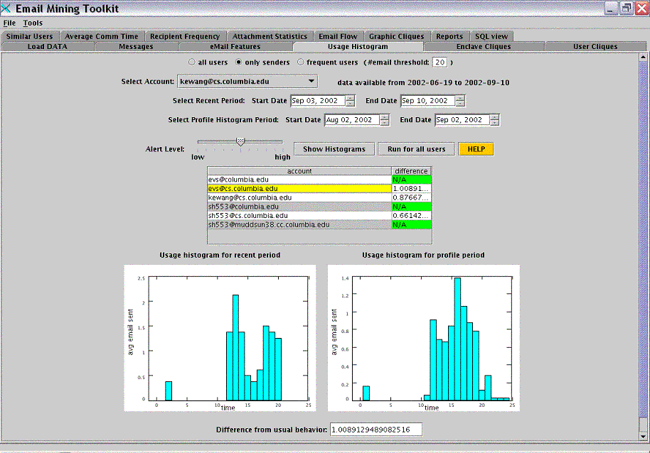
Data available for selected account
Select periods for comparison
Results for all accounts under the same period
Histograms for the highlighted account
Results and analysis
Figure 10 – Usage Histogram

The Usage Histogram window contains the following parts:
- Radio buttons, all users, only senders, and frequent users, enable you to specify the type of accounts that you wish to analyze. If you select frequent users, specify the threshold for number of emails that appear in the database.
- A drop-down list labeled Select Account lists all of the email accounts in the database in alphabetical order. Click the email account you wish to analyze.
- A label showing the available data for the selected account and the start and end dates for the data.
- Four input fields labeled Select Recent Period and Select Profile Histogram Period that allow you to set the respective start and end dates for the recent period and the profile period.
- A slider labeled Alert Level that can set the alert level at one of the 11 levels.
- A Show Histograms button that displays the histograms for recent and profile periods and begins the comparison once the account, the periods, and the alert level are chosen.
- A Run for all users button that starts the process of comparing all email accounts with the selected periods above.
- A table displaying the result of the comparison of all users that appears after the Run for all users button is clicked. The table has two columns, one for the email account and one for its corresponding “difference.”
- Two plots show the usage histograms. The left plot is for the recent period, and the right plot is for the profile period. When the Show Histograms button is clicked, the plots will show the recent and the profile histograms for the selected user from the above drop-down list. When the Run for all users button is clicked, the table is computed for all users in the database. You may click on an individual row in the database to see the recent and profile histograms for that user.
- Finally, the results of the comparison are displayed with the proper alert level.
First, select the email account you wish to view. Once an email account is selected, then the label next to the drop-down list will show the period for which the database has data for this particular account, in the “from minimum-date to maximum-date” format. This information can guide you in setting the recent and the profile periods. Only a period within the minimum and maximum dates is valid.
There are two periods that may be selected. The first one is called the recent period, and the second is called the profile period. The profile period is the period that you believe portrays normal behavior, and the recent period is the one that you wish to compare against the normal profile period. Set up the dates either by entering a date in the “MM, DD, YYYY” format or by clicking the up and down arrows to increase or decrease dates.
There are two restrictions on the system to guard against inaccuracy. First, the start date must be smaller (i.e., earlier) than the end date. Second, restriction the start date cannot be earlier than the minimum date, and the end date cannot be later than the maximum date. These limitations ensure that the histogram of the profile period is valid and can represent the real behavior of the email account. If these two restrictions are not observed, there are exceptions with proper information. By default, the recent period is set to the most recent one-week period according to the minimum-date and maximum-date. The profile period is set to the one month before the most recent period. Both the default recent period and the profile period must meet the two limitations; otherwise, they will change to meet them, which may cause a period to be shorter than a week or a month.
Below the period selection, there is a slider that can be used to select the alert level. Altogether, there are eleven alert levels from lowest (level 0) to highest (level 10). The higher alert level, the more sensitive the system is to the abnormal behavior.
After choosing the email account, recent and profile periods, and alert level, click the Show Histograms button to start the comparison. There are two plots showing the respective usage histograms for the recent and the profile periods. The usage histogram displays results as a bar graph, in which each bar represents the average number of emails sent in one hour for the specified period, totaling 24 bars for the 24 hours per day. The result of the comparison is shown at the bottom as the distance between the two histograms. The distance method used here is the Mahalanobis distance function, which is described in the Technical Manual [3]. According to the distance and the alert level that user chooses, the system judges whether the recent behavior is normal, abnormal, or might be abnormal. These judgments are indicated by different colors: red for abnormal behavior alert, yellow for might be abnormal alert, and blue for normal behavior. If the behavior is abnormal or might be abnormal, the alert is sent to the whole system's alert log, and an alert dialog appears simultaneously.
One may also compare all accounts by clicking the Run for All users button. It uses the same recent and profile periods set during period selection, and the same alert level. Then it goes through all of the accounts and shows its results in the table. The table initially is not visible and is only displayed when Run for all users is clicked. In the table, all accounts are displayed with their corresponding differences between their behaviors during the recent and profile periods. If the account does not have valid data for the recent or profile period, “N/A” will be shown in the “difference” column in green. If the resulting difference is judged as “abnormal” according to the alert level, then the “difference” column will be shown in red; if is “might be abnormal,” then the column will appear in pink. Thus, it is easy for users to see which accounts do not behave normally in that period of time. In order to view the histogram of one account, simply click on the row of this table. The recent and profile histograms will appear below the table, just as they did when you clicked Show Histogram button.

2.8 Recipient Frequency
The Recipient Frequency window models the email flows from an individual email account. It analyzes the frequency at which the selected user communicates email message to each recipient.
The Recipient Frequency window consists of a thin menu bar above the main window. The top part includes six buttons: Profile, Chi Square, CS + cliques, Hellinger Distance, Run, and Test. Also, the number of records in the database (each email equals one record) for the selected user is displayed in blue in the same area. The number of records indicates the size of the dataset for the selected user, since the number of email records varies widely from one user to the next.

2.8.1 Profile
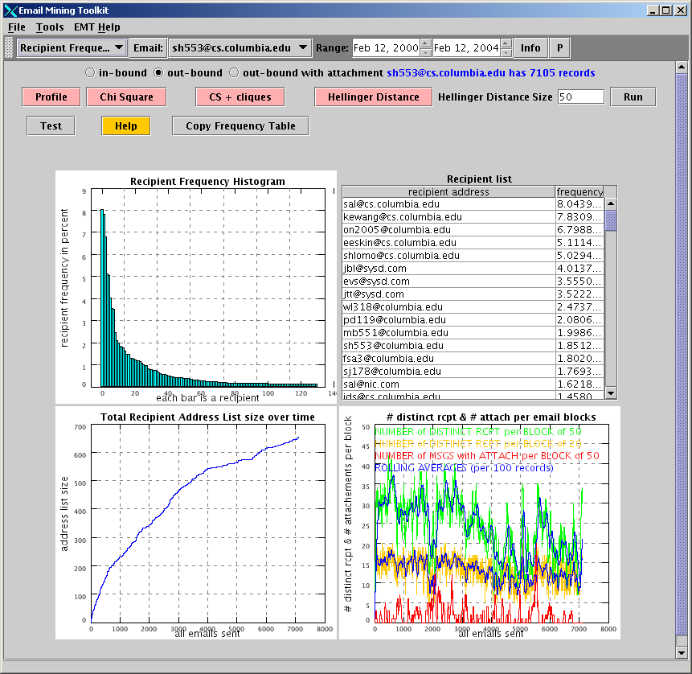
Email address of each recipient along with the corresponding frequency
Number of distinct recipients and number of emails with attachments
Frequency of each recipient
Total recipient address list size over time
Different analysis
Figure 11 - Main Recipient Frequency Window.
Three radio buttons will appear in the upper side of the window: in-bound, out-bound with attachment, and out-bound, which is selected by default. They enable the user to choose only emails sent by the user (out-bound), only the ones received by the user (in-bound), or only the ones sent with an attachment (out-bound with attachment).
The chart in the upper left side, called the Recipient Frequency Histogram, plots a bar graph indicating the frequency of each recipient to whom the selected user has ever sent an email. The table in the upper right side, called the Recipient List, displays the email address of each recipient along with the corresponding frequency of received emails from the selected user. This table is sorted is descending order, and each of its rows corresponds to a bar on the Recipient Frequency Histogram.
The chart on the lower left side is the Total Recipient Address List Size over Time chart. By “address list,” we mean all recipients who have received an email from the selected user between the two selected dates. Here, the chart plots the address list size, i.e. the number of recipients in the address list, over time. It starts at zero at the beginning of the dataset and grows as the selected user sends more emails to new recipients not already listed.
The chart in the lower right side is called the # of distinct rcpt & # of attach per email blocks chart. It displays three variability metrics and the rolling average of the first two metrics. See the Technical Manual [3] for more explanation.
Click the Hellinger Distance button, at the top of the screen, to replace the default Total Recipient Address List Size over Time chart with a Hellinger distance plot. The text-field Hellinger distance size defaults at 100, but it may be changed to another value; doing so will redraw the Hellinger distance plot with the new parameter.
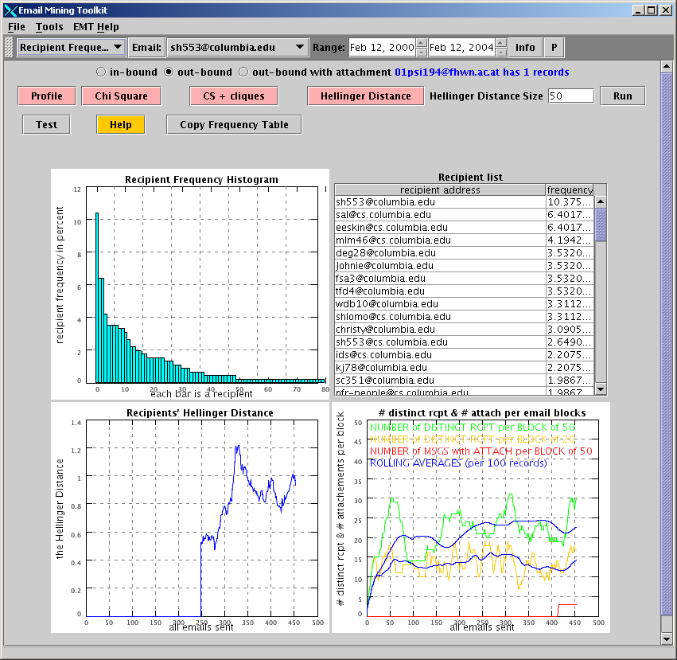
Hellinger Distance
Hellinger Distance training window size
Figure 12 – Hellinger Test

2.8.2 Chi Square
The Chi Square window is accessed by clicking the Chi Square button either from the Profile window or from the CS + cliques window.
The Chi Square window compares the selected user's profile between two time frames. On the upper side, the Recipient Frequency histogram and the Recipient List table are displayed, corresponding to the so-called “Training Range.” This screen is similar to the top part of the Profile window, but it only shows a range of records instead of the entire history.
The bottom half of the screen shows the Recipient Frequency histogram and the Recipient List table for the “Testing Range.” You may change both ranges by entering values into the corresponding text fields (the ranges may overlap or be non-adjacent) and then clicking the Run button.
The Diff Threshold field is set at five (5) by default and can be changed by entering another value and then clicking Run. It displays any cell in the diff (difference) column with an absolute value greater then the threshold in red. Also, it signals the largest deviation in recipient frequency between the training range and the testing range.
At the bottom of the window, a Chi Square statistic is calculated in order to evaluate the similarities between the frequency table of the “Training Range” and the frequency table of the “Testing Range.” In addition, the degrees of freedom and the p-value of the Chi-square test, as well as the Kolmogorov-Smirnov distance, are displayed at the bottom of the window. For more details, please see the Technical Manual [3].
In summary, you may use the Chi Square window to change the user, change the ranges, change the threshold, or move to another panel.
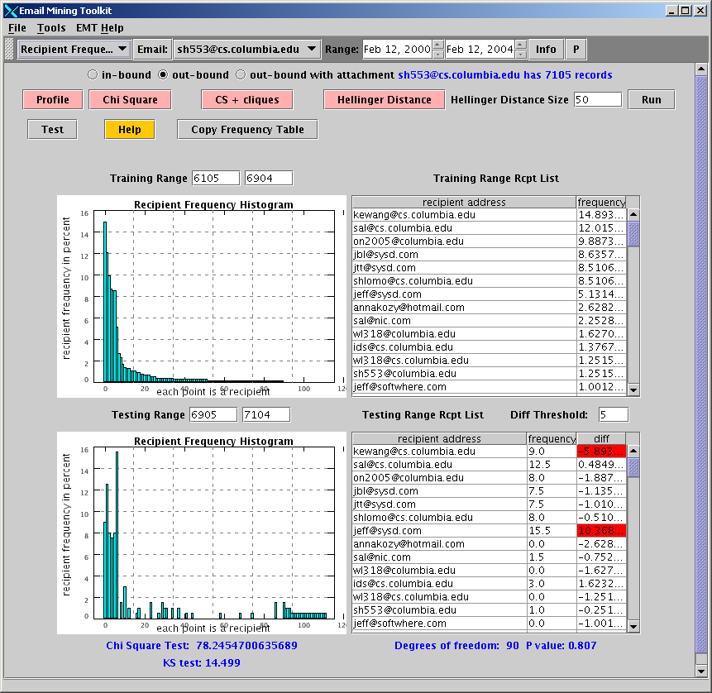
Training and testing range
Run
Significant difference
Calculated results
Figure 13 - chi Test

2.8.3 Chi Square + Cliques
The Chi Square + Cliques window is accessed via the CS + cliques button. This window is very similar to the Chi Square window, but it incorporates user cliques in the recipient list.
The Chi Square + Cliques window applies the clique functionality of EMT to the recipient frequency metrics. Cliques are defined in more detail in the Technical Manual. Basically, cliques are groupings of users with large pair-wise email flows, thus representing tightly connected small groups of email users.
The Chi Square + Cliques window displays all cliques in the “Recipient List” table in green (but only if the selected user belongs to an observed clique). Double-clicking on any green cell that corresponds to a given clique (each clique is named clique[i], i=1,2,,,) displays a window listing the members of that clique. Also, you may change the overall clique threshold (as defined under the main Cliques window) by modifying the Clique Threshold field and clicking Run. Doing this recalculates the entire database clique list with the new threshold and displays the corresponding metrics.
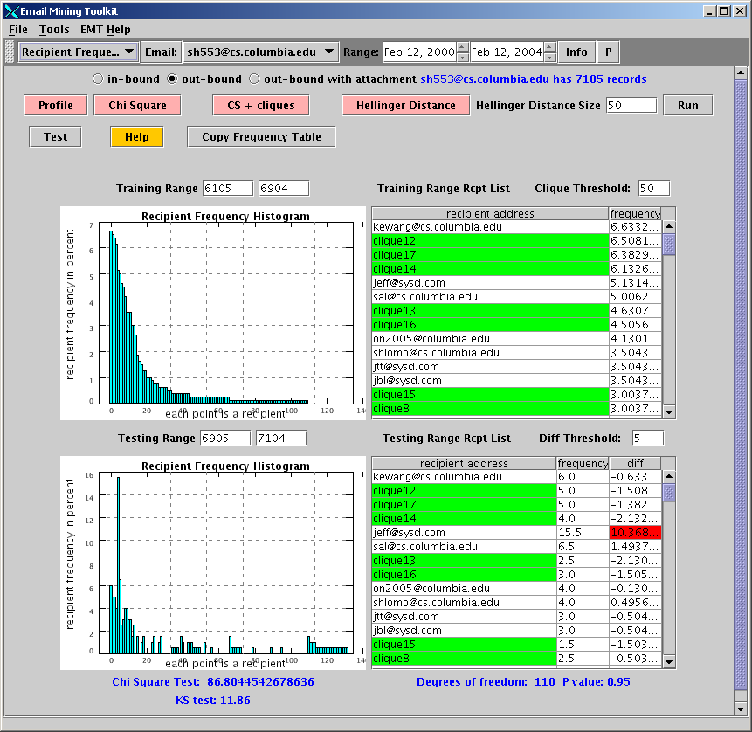
Grouping users by clique
Clique threshold
Figure 14 - Clique chi Test

2.8.4 Virus Simulation
Clicking on the Test button in the Recipient Frequency window starts the virus simulation routine. This program is used to test the detection efficiency of the various metrics described in Section 2.8. It simulates the intrusion of a virus in a user’s account, runs a detection algorithm, and specifies the emails believed to be corrupt.
To run a simulation, select a specific user from the combo box (otherwise, EMT uses the current selected user). Alter clicking on the Test button, a pop-up Configuration window (shown below) appears, in which the parameters of the simulation are selected; then, clicking on the Set button launches the algorithm and displays the results.
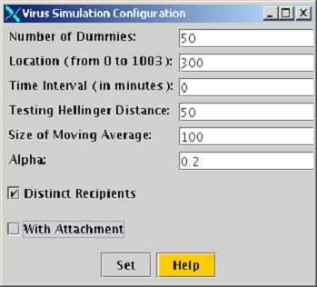
Figure 15 - Virus Test Setting

The simulation parameters that the user can choose:
- Number of Dummies: number of corrupted emails sent by the virus.
- Location: location of the virus attack in the database; this is equivalent to the time of the infection in the past (parameterized by record number).
- Time Interval: virus propagation rate; for example, “Time Interval = 60” means one corrupted email sent every 60 minutes.
- Testing Hellinger Distance: length used for the Hellinger distance calculation.
- Size of Moving Average: length of the moving averages used as thresholds.
- Distinct Recipients: If selected, the virus only sends itself to distinct recipients; if not, a given recipient could receive more then one corrupted email.
- With Attachment: if selected, each corrupted email contains an attachment file.
After running the simulation algorithm, the program displays two windows. The first one contains a total of six charts; the three plots on the left side show how some of the metrics of this section have been modified by the simulated virus infection (the original file is represented by the metrics in yellow, while the corrupted ones are in red); the three plots on the right side repeat the metrics of the corrupted file as seen on the left side (in blue this time), with the addition of the dynamic threshold curves used by the algorithm to detect suspicious emails (in red). Whenever a metric crosses its threshold, an alert is triggered; the maximum level of alert is when the three metrics provide an alert at the same time.
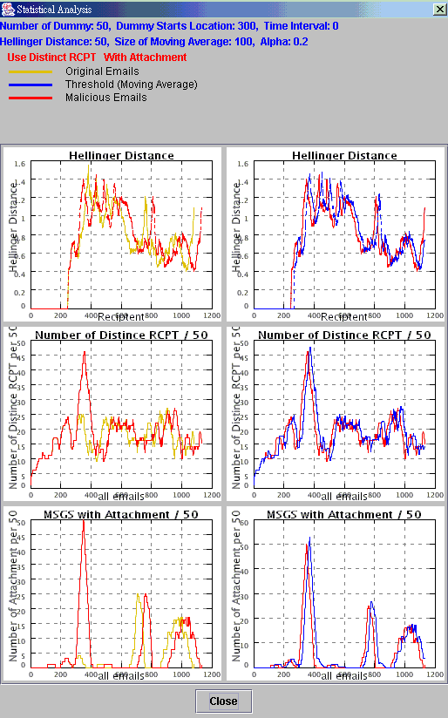
Figure 16 - Results Virus Simulation
The first window contains the six charts as described in the previous page; the three detection metrics used are the Hellinger distance, the number of distinct recipients per block of 50, and the number of messages with attachment per block of 50
.
The second window shows the final results of the detection algorithm; each email is labeled as either normal (in blue), or suspicious (in red); the usual classification between false, true, positive, negative is performed; the specific parameters related to the simulation that was just run are also displayed (like infection propagation rate, …); the plot at the center of the window shows how infection and alerts are located over time.
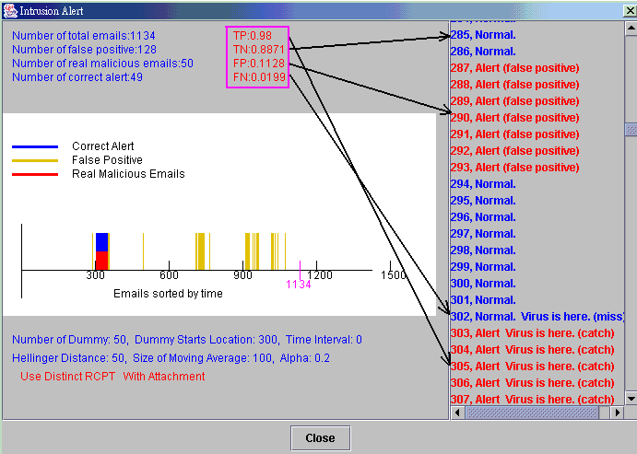
Figure 17 - Results of Virus Detection
The following classification is used:
True Positive (TP): corrupted emails correctly identified as corrupted.
True Negative (TN): normal emails correctly identified as normal.
False Positive (FP): normal emails incorrectly identified as corrupted.
False Negative (FP): corrupted emails incorrectly identified as normal.

2.9 Email Configuration
N-Gram Setting
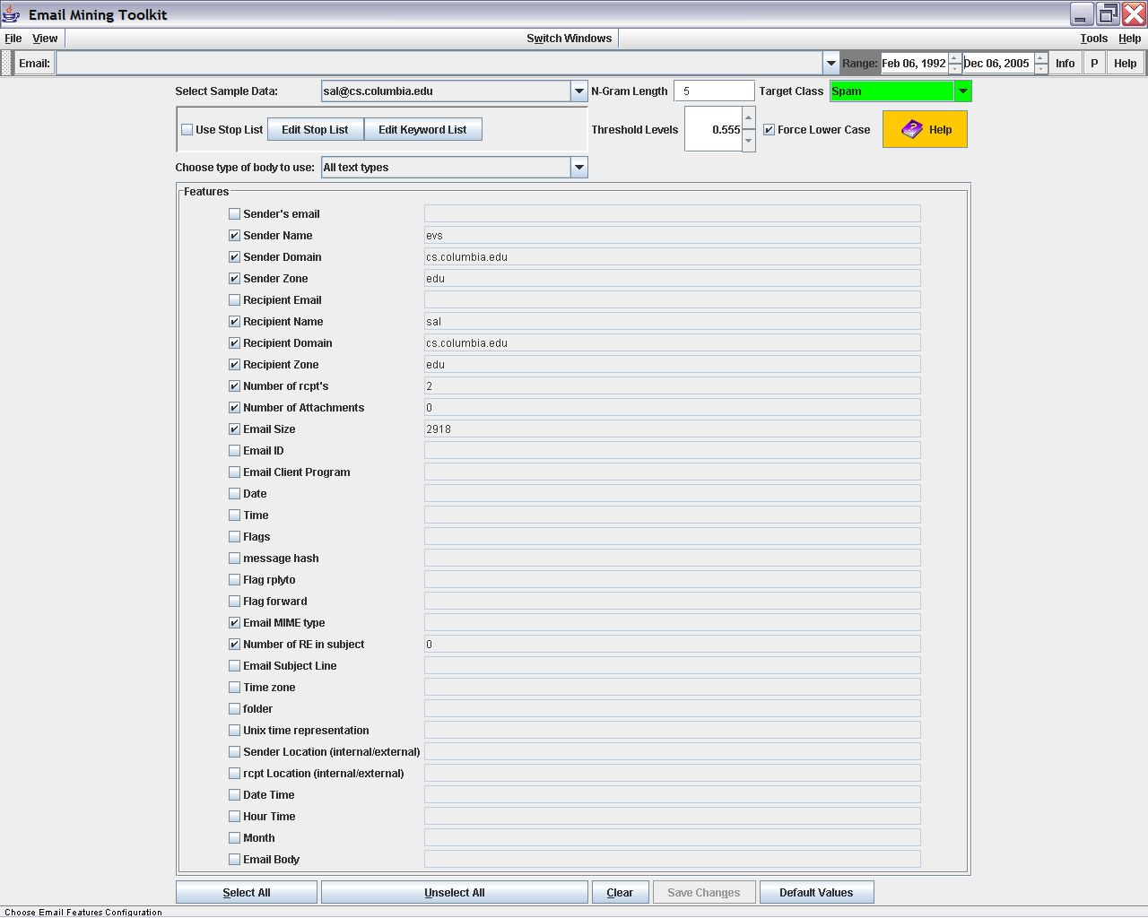
Global Stop list
Global Key list
Target Label
Naïve Bayes Settings
Save Changes
Figure 18 - EMT Configuration Window
The Email configuration window sets different parameters in EMT. The top portion deals with global setting for different window components. For example, setting the length of the N-gram size when computing ngram distances. In addition here is where a stop list can be specified and a keyword list defined. In addition the bottom portion allows setting the Naïve bayes model features which are used in the machine modeling components. Example Emails to select a few emails and display their relevant features in the window. If a certain feature is not selected, then its information will not be shown.
The available features are listed on a separate line on the window.
The Choose All button and the Un-Choose All button at the bottom of the screen can be used to quickly select or unselect all features, respectively. Remember to save any changes by clicking on “save changes”.

Supervised Learning

2.10.1 Training Area
NOTE: As of version 2.2 Training and Testing windows have been folded into the Message view.
The Training Area window enables you to build machine-learning models from different sets of emails.
Use the drop-down box labeled Learning Method at the top right of the screen to select the preferred machine learning method. Four learners are available: the Naïve Bayes with ngram, Ngram, Text Classifier, and Naïve Bayes with Text Classifier.
The Naïve Bayes learner models the joint probabilities of different features. The selection of features relates directly to the type and accuracy required of the chosen form of learning.
The Ngram modeler is a content-based learner. It computes k length grams based on the content of given emails during training. The threshold for k length grams is between zero and 10, which indicates the number of characters used. The default is set at five. Testing locates similar emails with a chosen degree of similarity.
The Text Classifier is a learner that classifies text according to keyword content. It is a general Naïve Bayes text classifying method as described in Tom Mitchell’s book, Machine Learning.
The Name of Model text field enables you to choose a model name. As soon as a name is created, then the text field is saved to disk. The use of model names allows you to create several different models and then to test each one over data in order to find the most accurate model.
The Check Model Info button displays file information relevant to a model if the information exists on the disk.
The Choose Features button opens the Choose Features window. The Choose Features window is similar to the Email Features window. The text field labeled Features being used connects to an SQL statement that tells the system how to select features for learning and evaluating models.
The Condition for Training Cases text field is a SQL statement that states the conditions for choosing emails from which to develop a model. The default setting chooses all of the classes from the system that are pre-labeled “S” for Spam and “N” for not interesting. To begin this process, at least some of the emails must be labeled. This can be done manually in the Message window or with a set of SQL statements. The following line shows the statement that was used to create the training cases, which is an SQL statement combining the previous two lines.
The View Training button displays the current training examples. Click on a row to display additional information about a specific email. Click on a column header to sort the selected column.
The Build Models from Training button and/or window takes the conditions specified for creating test cases and runs them through the specified learner, thus building the model. Then it saves the new model(s) to disk. At completion, a pop-up window appears to say that the model has been saved to disk.
Once training is finished, a pop-up window displays the cross validation results of the training (v2.1)

2.10.2 Testing Area
(v2.1)
The Testing Area window allows the model created in the Training Area window to be loaded and tested against a dataset. The model may be evaluated over partial data or used to reclassify the entire database of emails.
Specify the name of the file in the Name of Model File text field. Click Load to enter the model into memory. It is important to choose the correct learning-method model type from the Learning Method drop-down list before loading the model.
The Condition for test cases text field is an SQL statement where you can select conditions to create an example dataset against which the model will be tested. The default, “UID< 1200,” uses the first 1,200 data entries from the database. The UID may be customized to allow evaluation over any subset of the data.
The Threshold for Class option sets a threshold that changes the current classification to a projected classification if a score is higher than the selected threshold.
Click the View Testing Examples button to display the test example in a table at the bottom of the screen. Click Model on Test to compare the loaded model against the test examples and to show a label and score for each email. Click Update DB to test the current model against the entire database. As examples are evaluated, the display at the bottom of the screen shows the system’s progress.
The Stats on Result button shows information about the classification of the example in the table (v2.1).

2.10.3 Email Features
Click Email Features to return to the Email Feature window. See the explanation under section 1.9 for more information.

2.11 Report and Forensic Window
The report and forensic window has two main uses. The first is to organize and display different types of alerts from any part of EMT. The second is to create a forensic discovery of the email store using specific features to EMT to guide the search.
Alerts can be generated by any of the other windows. Each alert consists of a severity level and brief explanation. Click on an alert to bring up a detailed explanation.
Start by click on the “refresh email info” and choosing which emails to examine. The list can be restricted by a minimum amount of emails exchanged in either incoming, outgoing, or both. Choose an email which might look interesting, and if the “display profile” is click , a profile of the entire usage is show on the bottom left. On the bottom right (if the “get VIP” is chosen) the list of the user’s most important contacts are shown. If the “calculate VIP diff” is also chosen, a calculation is done based on the user’s general profile, and the specific profile of any chosen user in the VIP list. Double clicking on the main user list allows a report to be created. Clicking on the distance button, will also allow a report to be generated.
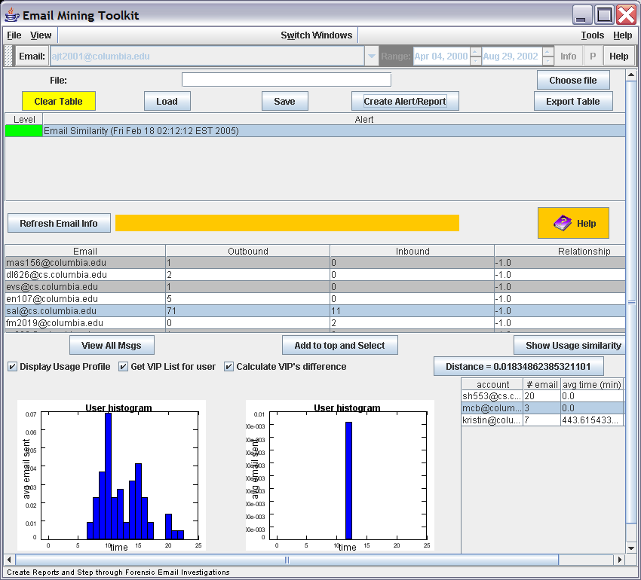
Sample Alert
Starting point
User and profile and VIP list
Distance for VIP and regular
VIP user and history
Figure 19 - Forensic and Reports

2.12 Email Flow
The Email Flow window displays the series of emails sent between clique member and details the relationships of email recipients and senders (e.g. who sent the email; who received it; who was cc’d the email, etc.)

The top of the Email Flow window enables you to configure the tabular and graphic displays. It includes the following components:

- Email List textbox, to the right of the User box, lists all of the emails By Subject, By Content (By Content includes mailref) or By Attachment topics associated with emails sent or received by the selected user.
- Display Size consists of three radio buttons, small, medium, and large, that change the scale of the graphic. This is useful when there are too many dots and lines to display clearly in a small screen. Click on the appropriate button to select a proper scale for the graph.
- Threshold consists of two text fields. The N-Gram Subject threshold determines the degree of relative emails that are grouped by subject. The Length of Content threshold determines the number of characters compared when grouping content.
- Group Type consists of three radio buttons, By Subject, By Content and By Attachment, that enable you to organize emails by subject, by content or by attachment, respectively.
- Update Email List refreshes the email list when the account or group type is changed.
- Run calculates the email flow based on your configurations and displays the results.

Select an email account, Click Update Email List. Select a subject of email, and then click Run. All of the related emails will be shown in the User & Email Table, and all of the email accounts and their relationships will be shown in the Email Flow graph.

User & Email Table
All of the emails for the selected user are displayed in this table. The emails are sorted by time. Each email has an index number, from 0 to N-1. Each column represents a user (i.e. email account). In the cells of this table, “sender” means that such user (in the particular column) is the sender of the email (represented by the row), “rcpt” means that the user is the recipient of the email, and “s & r” means that the user is both the sender and recipient of the email (i.e. he copies the email to himself).

To display details about a particular email, click on the corresponding row. The Detail window displays.

The playback button allows an emails movement to be stepped through.

Email Flow
This section discusses elements in the Email Flow graph.

Definition
Each dot represents a user (i.e. email account). Each user appears once in this graph. A line connecting two users indicates that the users have corresponded via email. Yellow lines represent a unidirectional connection (i.e. User A → User B only). Blue lines represent a bi-directional connection (User A ↔ User B).
The concentric circles indicate the time scale represented on this graph. The original sender, the first user, appears in the center of the circle. The outermost circles display users who appear later in the email flow.

To find the user of a dot:
Click on a dot. The user represented by this dot will be shown at the upper-right corner of this graph.

To display emails between two accounts:
Click on two dots, and then click on the rectangle labeled Click here for email exchange Info. All of the emails from A to B and from B to A will be shown.
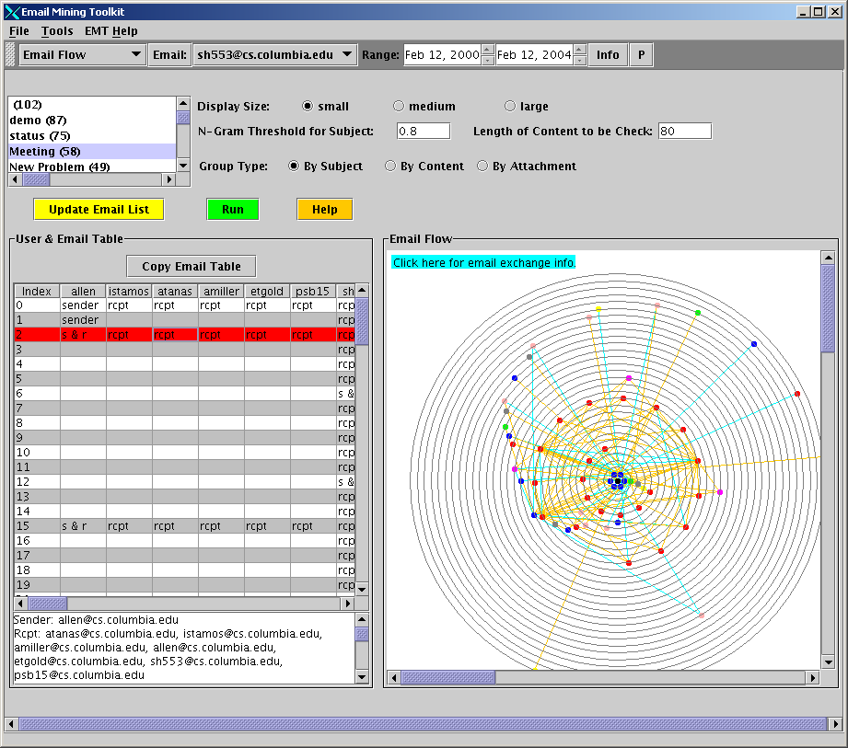
List of subjects
Email Flow Graph
Click here for email exchange Info.
User & Email Table
Threshold
Figure 20 - Email Flow

2.13 Average Communication Time
The Average Communication Time window compares the average times of how quickly a user responds to different people, thus computing who is the most important respondent. EMT considers both the response time and the amount of emails exchanged between accounts determine the importance of different email users to the selected user.
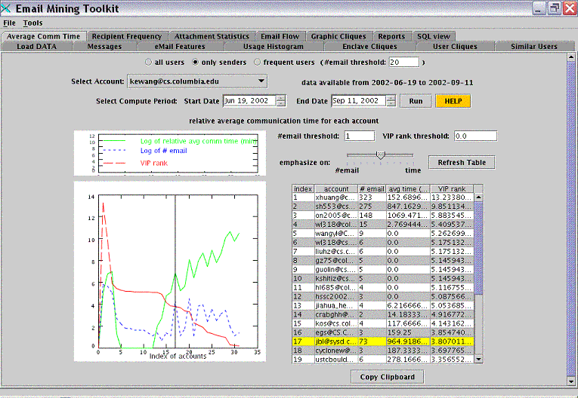
Data available for selected account
Details about each account
Meaning of the curves
Conditions for the view of plot and table
Plot showing the curves
Figure 21 - VIP communication
Position of selected account

The Average Communication Time interface contains the following components:
- Radio buttons, all users, only senders, and frequent users, enable you to specify the type of accounts that you wish to analyze. If you select frequent users, specify the threshold for number of emails that appear in the database.
- Select Account drop-down list displays all of the email accounts in the database in alphabetical order. Click the email account that you wish to analyze.
- Data available label shows the database archive for the selected account and the start and end dates for the data. This information is updated automatically to show the data for selected account.
- Select Compute Period features two text fields, Start Date and End Date, allow you to set the start and end dates of the period you want to analyze.
- Run button computes the relative average communication time, amount of emails exchanged, and VIP rank of different accounts to the selected one. The detailed results are displayed in the table below and corresponding data curves are displayed in the large plot.
- HELP button provides contextual help for this window
- A small plot in the middle of the window explains the kinds of curves that are drawn in the plot below.
- A large plot under 6 is used to draw out three curves: number of emails, average communication time and VIP rank. The X-axis is in the order of the index of accounts as shown in the table.
- Next to 6 there are two text fields and a slider. As the labels indicate the text fields are used to specify the threshold for number of emails and the VIP rank. The slider is used to decide between number of emails and average communication time, which is more important in computing the VIP rank.
- Refresh Table button refreshes the view in the table and the large plot according to the conditions specified in 9.
- Under 9 is a table giving an index number for each account. There are five columns: index, account, number of emails, communication time, and VIP rank. Each column can be sorted increasingly or decreasingly by clicking on the column header. Select an account by clicking on the corresponding row. A vertical black line appears on the Account plot indicating the position of the selected account in the graph.

Using the Average Communication Time Window
First, specify the type of accounts you want to check. There are three radio buttons on the top, which are all users, only senders and frequent users. Only senders means only those accounts that we have collected the emails from their sent box. Frequent users are those accounts that have relatively a lot emails in the database. The threshold for frequent users can be specified in the text field following it. The email accounts in the drop down list will change with the choice of radio buttons.

Then, select the email account you wish to view. Once an email account is selected, then the label next to the drop-down list will show the period for which the database has data for this particular account, in the “from minimum-date to maximum-date” format. This information can guide you in setting the period that will be analyzed. Only a period within the minimum and maximum dates is valid. Specify the dates either by entering a date in the “MM, DD, YYYY” format or by clicking the up and down arrows to increase or decrease dates.
There are two restrictions on the system to guard against inaccuracy. First, the start date must be smaller (i.e., earlier) than the end date. Second, restriction the start date cannot be earlier than the minimum date, and the end date cannot be later than the maximum date. If these two restrictions are not observed, there are exceptions with proper information. By default, the start date is set to the minimum-date and the end date is set to the maximum-date.
Below the period selection, there are two text fields and a slider that can be used to set the threshold to control what part of result is shown in the table and plot. The slider is used to decide between number of emails and average communication time, which is more important in computing the VIP rank. More nearer to the end of time means that the average communication time accounts more when compute VIP rank. For more information about the formula used to compute the VIP rank, please refer to the Technical Manual [3].
After you have chosen the email account and set the period and the thresholds, click Run to start the computation. There is a plot and a table showing the results, both graphically and numerically. You can configure different settings and then click Refresh Table to generate a different view of the same results.
The plot displays three curves: number of emails, average communication time and VIP rank. The X-axis is in the order of the index of accounts as shown in the table. The explanation for each curve is on the top of the plot. The X-axis is in the order of the index of accounts as shown in the table. You can see one account’s position in the plot by clicking its row in the table. A vertical black line will be drawn on top of the curves to highlight the place.

2.13 Virus Scanning
This tab displays the virus scanning. Users can select the detecting models and analyze the emails. The top of the window enables you to select the type of emails (i.e. inbound/outbound and with/without attachment) and the models, such as Clique, Hellinger Distance and MEF. Virus Scanning tab includes the following components:
      - Email Type allows the user to select the type of emails to be analyzed.
      - Method Using decides the model(s) used.
      - Get Email displays the emails of the selected account in the result table.
      - Click on Detect button to start the detection.
      - Click on Generate Report button to send the detection report to Reports tab.
      - Click on Update MEF Model button to update the model using current malicious email attachments.
      - Result Table displays the emails and analyzed results.

Select an email account, proper date range and the type of emails (in/outbound), and click on Get Email. The email records will be displayed in the result Table. Select a record or multiple records and click on the right button of the mouse to set the proper labels (i.e. normal, malicious and unknown) of the emails. Check the methods to be used. Click on Detect to start the detection. Emails that are labeled as “normal” and “malicious” will be the training data, and emails that are labeled as “unknown” will be the testing data.

Result table:
This table displays the email features such as sender, recipient, subject, time, attachment, folder and reference number. There are also four label columns. Label column allows user to mark the data as normal, malicious or unknown. Click on right button of your mouse to select the type of labels. Clique, Hellinger and MEF columns represent the detecting result of the modes.

Update MEF Model:
Click on this button, EMT will add the attachments of emails that are labeled as “malicious” to MEF model. Once an attachment is added, it cannot be removed, unless the model file (under ./MEFModel/ folder) is deleted manually. However, since one model files may contain multiple malicious attachments, please be careful when doing this.
If there is a missing malicious attachment, please select the record in the result table and label it to “malicious”. Then, click on Update MEF Model to update it.

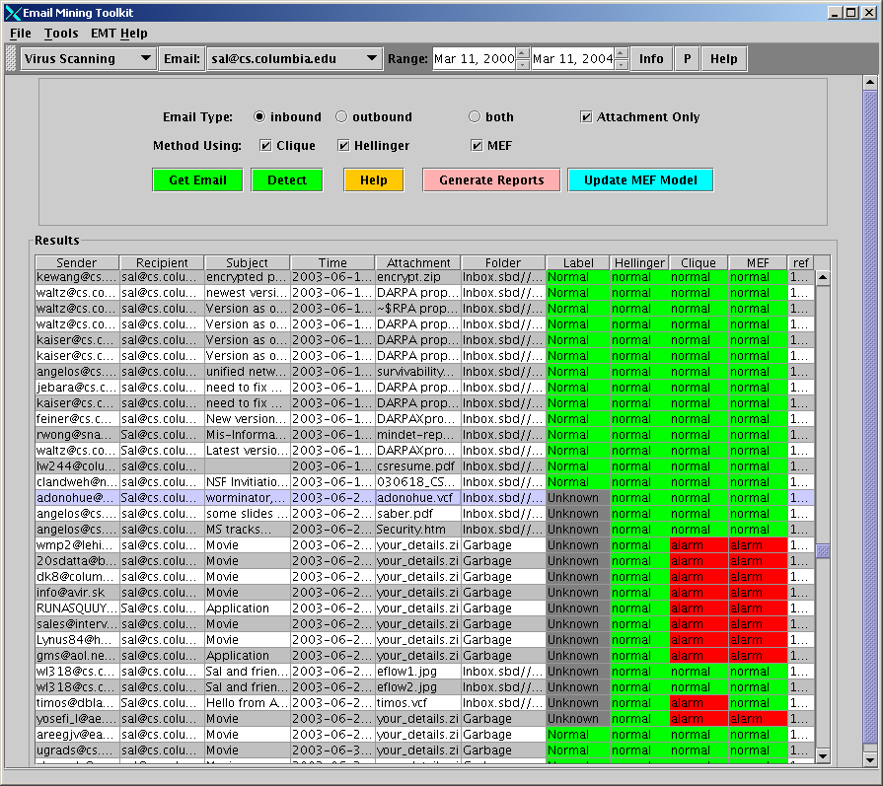
Select the method.
Email records
Alarms
Figure 22 - Virus Analyses

2.14 Attachment Analyzer
This tab displays the Attachment Analyzer. Users can select emails and build models from the attachments. The attachment files are classified by the file extensions. Users can also test new attachments by using pre-built models.

Attachment Analyzer tab includes the following components:
- Email Type allows the user to select the type of emails to be analyzed.
- Users can enter the Truncate Ratio that EMT will only read the first x% bytes of an attachment, where x is the value in the box.
- Users can select 1-gram or 2-gram to analyze. To test new email attachments, the testing gram size must be the same to the training (pre-built model) gram size.
- Select a proper user and the date, and click on Refresh Table button to display the emails in the Email Table.
- Click on Load Model to load a model to the memory.
- Select some emails and right click the mouse button to set them to “Mark”. Click on Save Model. These selected emails will be built to a model and saved. Users can also select to save a new model or append these emails to an old model.
- Click on Merge Models to merge multiple models. Hold the Ctrl or Shift key to select more than one files in the File Chooser.
- Click on Display Model to display the byte distribution of current (loaded) model.
- Click on Test Unknown to test marked email attachments.

Select an email account, proper date range and the type of emails (in/outbound), and click on Refresh Table. The email records will be displayed in the Email Table. Select a record or multiple records and click on the right button of the mouse to set the proper labels (i.e. NA or Mark) of the emails. Click on Test Unknown to test the email attachments, which are set to “Mark”. The result will be shown in a popup window.

Email table:
This table displays the email features such as sender, recipient, subject, time, attachment, folder and reference number. Note that this table only displays emails that have attachment.
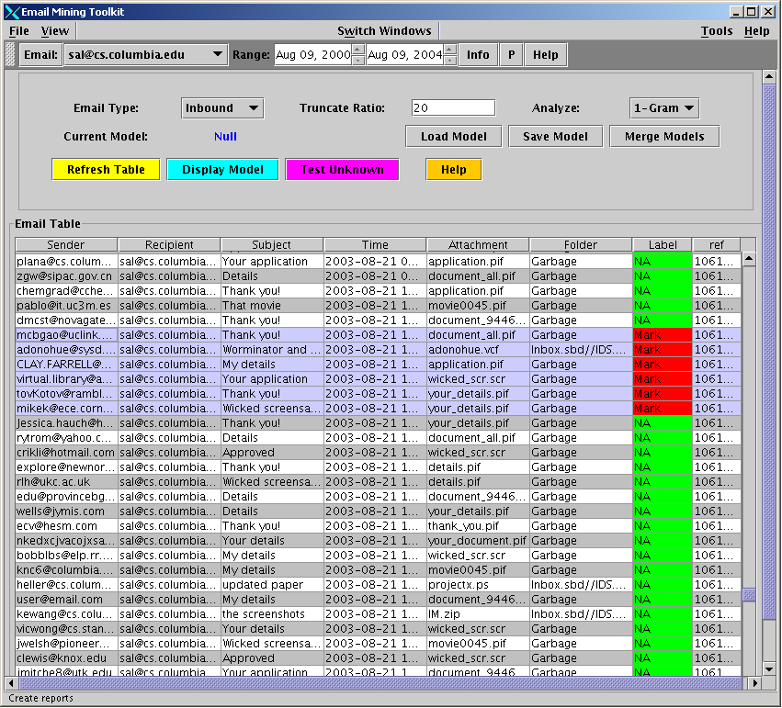
Email Table
Mark
Control Buttons
Figure 23 - Result of Virus Tests

2.15 Search Window
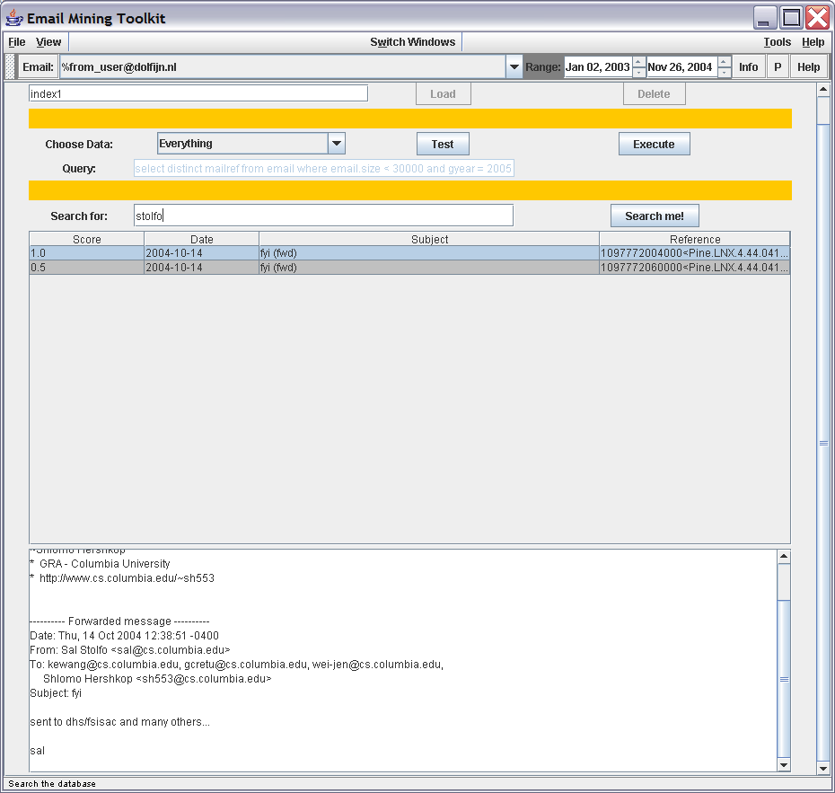
Results
Data Selection
Index name
The search window allows email to be searched once an index has been created. The top level of the window allows an index name to be specified. This allows multiple indices over on email data store. The next section allows a selection criteria to be placed over the data to be analyzed. For example, in very large email sets, one might be interested to only search all emails from a particular user, or associated with a specific domain (for example all emails to and from cs.columbia.edu). Clicking on “Test” allows the user to preview how many records will be indexed. “Execute” will create the particular index, and pop up a progress bar showing the work being performed. NOTE: for efficiency, please disable anti-virus programs before processing emails with malicious attachments, or at least disable file quarantine option in the anti-virus program.
The last section displays the results of keyword searches, and previews a particular message selection.

2.16 Social networks
The social networks module allows the user to generate social networks in the following ways:

2.16.1. Using database with file creation
- Include name of file with a ‘txt’ extension in the field “Filename” (see Figure 24).
- Select the appropriate options (same options as top panel of “Experiments” section).
- Choose any “where” SQL statement necessary for your query in the field ‘SQL where condition’. There is a default SQL statement that will select sender and recipient from the email database.
- Push ‘Execute SQL/Create file’ bottom.
- In the “social networks” section, select text file (‘txt’ extension) to convert to Pajek format (’net’ extension) or bipartite format (‘bp’ extension). If using database information, it is the filename introduced in 1.
The text file has two columns separated by a tab. Each row indicates a relationship between two sets to generate the social networks. For instance, the file may look like:
56287 ABT
69572 ABT
33785 ADCT
- Push ‘Txt2Pajek’ bottom to convert to Pajek or ‘Txt2Bipartite’ to convert to bipartite graph (this format is necessary for transformation to unimodal graph). This step is necessary also to capture the labels of the vertices.
- Select Pajek or bipartite file.
- Select graph format (according to previous selections):
  - Pajek: more generic and adequate for most of the cases
  - Bipartite
  - Bipartite2unimodal: reads a bipartite graph and converts into a unimodal graph.
  - Select the box of “Max weak component” if you want to work with the largest weak component.
Weak component is a subgraph where every vertex v can reach the rest of the vertices in this component regardless of the edge’s direction. A strong component takes into account the edge’s direction. In an undirected graph, a strong and a weak component are equivalent.
- Get graph and statistics: graph will be loaded and statistics of network saved in the file ‘metdemo/datasets/socNetIndic.txt’. The statistics calculated for each vertex are:
- Average distance (avgDistance): For each vertex v in the graph G(V,E), calculates the average shortest path length (average distance) from v to all other vertices in G, ignoring edge weights.
- Cluster coefficient (clusterCoeff)
- Degree: number of vertices that a vertex v is connected to.
- Rank score of degree distribution (DegreeRankScore)
- Rank score based on betweenness centrality (BetweennessRankScore)
- Rank score of “hubs-and-authorities” importance (HITSrank):

Additionally, the “small world“ index is calculated for the social network.
- Choose type of network:
a) Random mixed: this is an experimental module that does not need input file. This option creates a random mixed-mode graph with random edge weights. It applies the voltage clustering algorithm by Wu and Huberman [6] to this graph, using half of the 'seed' vertices from the random graph generation as voltage sources, and half of them as voltage sinks.
The following options require that the bottom “Get graph and statistics” was already selected:
b) Simple network
c) Cluster network:
c.1) Edge-betweenness clusterer: generate clusters using edge-betweenness. Visualize the graph using the Fruchtermain-Rheingold layout, and provide a slider so that the user can adjust the clustering granularity.
c.2) Voltage clusterer: This algorithm discovers communities and is based on voltage drops across networks using the Wu and Huberman [6] algorithm. It provides a slider so that the user can adjust the number of clusters to be generated. It also has an option to group the clusters (see Figure 25). It is necessary to have run first Edge-betweenness clusterer in order to run voltage clusterer properly.
This module uses the libraries of the Jung project http://jung.sourceforge.net. These libraries can generate very large graphs. However, large graphs (larger than 4,000 vertices) may require increasing the amount of memory assigned to run EMT.
The bottom “Get Statistics” generates the statistics mentioned in the previous step for the largest weak component of the new cluster network and save them in the file ‘metdemo/datasets/socNetIndicMod.txt’.
Note that to store the appropriate identifier of each company (permno) in the bipartite graph, the bp file must be created from the text file in the same session. Step 6 must be performed in order to correspond the appropriate permnos to the graph nodes and their social network statistics. This is because the bipartite files contain only numerical representations of the graph nodes. By starting the process from step 6, the permnos of each company are stored internally and allow for the proper permno to be printed out when performing step 9 to generate the statistics of the graph. Note that pajek files and their graph statistics can be generated immediately without having to create the pajek file from the text file.
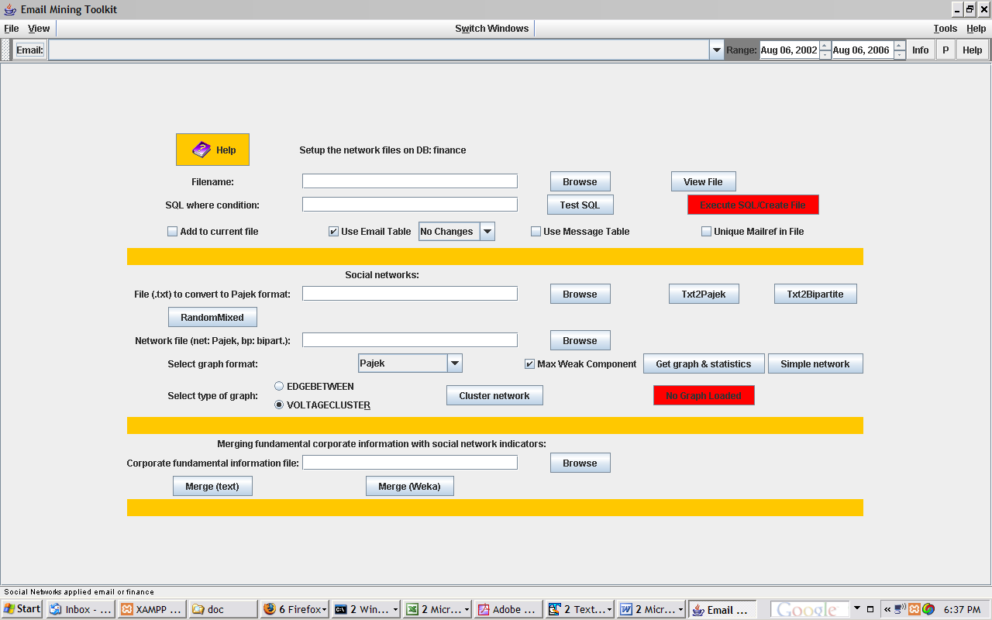
Figure 24 - Email social network window. In the top panel, network file can be generated with sender and recipient email accounts. In the intermediate panel, text files can be converted to Pajek format, and several types of social networks and clusters can be generated with email or external files. The bottom “No graph loaded” becomes green and indicates the type of graph when a graph is loaded. In the bottom panel, social network information can be merged with corporate fundamental information.

2.16.2. Using database without file creation
This option generates a temporary file using the information in the database. Starts in step 2 above.

2.16.3. Using external datasets
Start in step 5 using a text file. This step captures the labels of the vertices of the graph.
The file directorsAnalysts.txt, and its shorter version named directorsAnalystsSmaller.txt, provide the information about directors and analysts by company using its ticker. Analysts, directors, and companies (permnos) are recognized by the letters A, D, and P in front of their respective identifiers. These files are included in the directory datasets for demonstration purpose.
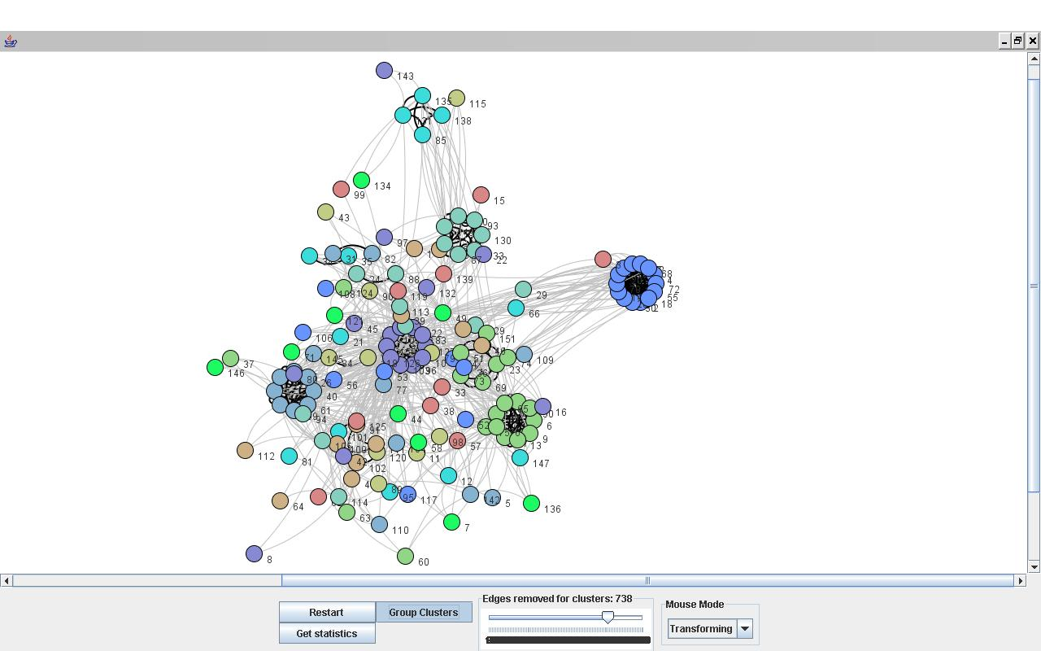
Figure 25 - Clusters of users created according to the quality of connection between networks. The labels of the nodes are the permnos or identifiers of each company.

2.17 Social Hierarchy Detection
This window determines the Social Hierarchy in an organization using a combination of Average Communication and Clique analysis. EMT considers a number of statistics when computing the overall Social Score. In the formula for the Social Score of any given user, EMT takes into account a weighted amount of each of the following statistics: number of emails to/from the user, average communication time between the user and other users, number of Cliques the user is in, how many people are in each of these Cliques and the “importance” of the users in each of the Cliques (using number of emails and average communication time as a metric for importance. Each of these contributing “scores” can then be weighted with respect to each other by the user.

To compute a ranked list of accounts using the current dataset, perform the following steps:
1. Select a Start Date and End Date within which to perform the analysis. The default values are drawn from the date range of the dataset, but calculations can be significantly reduced by selecting a smaller date-range within the dataset.

2. Select a Min # of Messages. This will effect the clique calculations. Only cliques within which users exchanged this number of emails will be returned when the cliques of the dataset are calculated.

3. Select the Type of Attachment in order to further constrain the Clique calculation. When a type of attachment is selected, only emails with the selected type of attachment will be considered when the Cliques are calculated. The default is set to All Types.

4. Press Run to run the analysis. A progress window will track the progress of the calculation. The time to perform this calculation will depend on the size of the dataset and the selected parameters. When the analysis is complete, the table below will be populated with the results (a list of accounts, ranked by Social Score). *Note: In certain circumstances, this calculation is very lengthy.*

5. After the analysis has been performed and the table has been populated, a user can specify the thresholds for the number of emails, number of cliques and the Social Score. Only users with values for these fields above the input thresholds will remain in the table.

6. The weight values can then be selected to weight each of the noted values with respect to one another when computing the TimeScore and Social Score values.

7. Press Refresh after inputting the desired parameters to quickly re-compute, re-rank and refresh the table of accounts.

A more detailed description of the formulas and algorithms used for this analysis can be found in the Tech Manual.

3 System Walk Through
This section of the User Manual walks a new user through a first use of EMT.

3.1 Importing Data
Your first task is to enter email data into the database. Open the Load Data window by clicking on the Load Data in the switch windows selection menu. Select the email data file that you wish to import using the Browse button. Click Import to load the data into the database. Upon completion, information about the imported file can be accesed by choosing database infor tab in the window and clicking on Refresh. For issues or problems please see FAQ (section 4).

3.2 Viewing Data
Click the Message window to reveal a view of the data. To show a different data view, choose a pattern (for example other date period). Click on more info to preview how many records will be fetched. If a reasonable amount is present click on Refresh.
If no data appears, check that the period between the dates at the top of the window reflects the data in the database. Once data appears, you may double-click on any record to bring up more information.
Multiple records can be chosen either through shift click, mouse drag or ctrl+click.
To sort a specific column in ascending order, click on the column name. example click on the subject column. To reverse sort, click on the column while holding down the “shift” key.

3.3 Viewing Attachment Information
When a new dataset is inserted into the database, its statistical information must be updated. First, open the Attachment Statistics window and then click Refresh Attachment List. Now click on Compute Statistics and Alerts to update the statistical information. This process may take a few minutes, during which the button becomes inactive.
When the button becomes active again, choose an attachment from the drop-down list in order to see information about it from the database. The “Null” symbol represents emails with no attachments. You must update the alert function thresholds in order to generate the appropriate alerts to the Alert Table window. This may be done through the top menu by clicking Tools→Alert Options.

3.4 Learning
By default, all new data are classified as unknown. This means that the class column in the database is set at “?.” In this example, in order for EMT to perform machine learning, some of the data has to be labeled “spam” while other data are labeled “not interesting.” This may be done by one of three ways: via a manual setting, via the Message window, and via SQL changes to the database.
Bring up a specific folder in the window. Label all the examples, either through choosing a group of messages, right click then label. Or manual labeling each one.
Before running a learning algorithm, go to the email configuration window, and make sure the current features are the ones you want.
Side note: Certain features are inappropriate for Naïve Bayes learning. For example, a feature such as mailref is not conducive to learning which email is “interesting,” since the mailref has no connection to that aspect.
Click on build model, specify a model name, choose learning type (see help button). Then click on train. A roc curve showing how the model evaluated over the training window, will appear at the end of the training.
To evaluate a model, load up another view, choose eval mode, specify the model name, and see how it labels the examples.

3.4.1 Common Learning Errors
Each algorithm requires a minimal number of labeled messages as examples. If you have labeled too few messages, then you will see a pop-up window indicating that there is an insufficient amount of labeled data.

3.5 “Interesting” Users
To locate “Interesting” users, open the Similar Users window. Select either senders or all users. Select a user from the drop-down list and click Find Similar Accts. You may be able to locate more users by adjusting the slider to a lower level. Click on the user account name to bring up a usage graph for each of the found users. In addition, you can click Find All User Groups to find all groups of similar users. These options enable you to get a general idea about the users’ email usage behavior.

3.6 Screen Capture / Printing
This version of EMT does not have screen capture capabilities. To create a snapshot of what is seen on the screen, use the screen capture functionality available in Windows. Click the Alt-Print Screen buttons, and Windows will capture the current active window. In addition, you may click Print Screen to capture the entire screen.
There is also cut-and-paste functionality available in some of the table displays. Use the Windows keyboard shortcuts to copy (Ctrl-c) and paste (Ctrl-v) to copy selected data from a table to another application. You can also copy the entire test table to the clipboard as text by clicking the Copy to Clipboard button in the Testing Area window.
Individual graphs can be saved by right clicking on them and choosing a file location to save to.

FAQ
  - Problem Starting EMT
      - Check that the correct jar files are being pointed to. The following jar files are needed by emt:
        - lib/mmmysql2.jar
        - lib/chapman.jar
        - lib/mail.jar
        - lib/activation.jar
        - lib/derby.jar
        - lib/jcommon-0.9.6.jar
        - lib/jfreechart-0.9.21.jar
        - lib/lucene-1.4.3.jar
        - emt.jar
      - Check that you have the correct batch file specified by manually seeing the contents of the batch file
      - Check that the EMT 3.6.3 logo is showing.
      - Check that permissions are set correctly (non windows)
        - Linux requires +x on emtclient.bat file
      - Check java version (1.4+).
      - Check disk space.
  - Problem with importing data
      - Small note: many technical issue were fixed in 3.0+ including:
        - Missed message in parser
        - Missed attachments in parser
        - Date problems in the data
      - Manually check to see the mail file is readable
      - Manaually check that the file is either mbox or outlook express.
      - double check path and spelling of file
      - Check that readdbx.exe is installed and aviable for outlook files. This is bundled with EMT.
      - confirm that mail.jar and activation.jar are specified in batch file
  - Problem with data
      - Try to run data cleaning and date cleaning tools in sql window.

References

(See http://www.cs.columbia.edu/ids/publications)
[1] Bhattacharyya, Manasi, Shlomo Hershkop, Eleazar Eskin, and Salvatore J. Stolfo. “MET: An Experimental System for Malicious Email Tracking.” In Proceedings of the 2002 New Security Paradigms Workshop (NSPW-2002). Virginia Beach, VA: September 2002.

[2] Schultz, Matthew G., Eleazar Eskin, and Salvatore J. Stolfo. “Malicious Email Filter - A UNIX Mail Filter that Detects Malicious Windows Executables.” In Proceedings of USENIX Annual Technical Conference - FREENIX Track. Boston, MA: June 2001.

[3] Hershkop, Shlomo, Ke Wang, Weijen Lee, Olivier Nimeskern, Germán Creamer, and Ryan Rowe. EMT Technical Manual. Technical report, Columbia University. June 2006.
[4] Stolfo, Salvatore J. Shlomo Hershkop, Ke Wang, Olivier Nimerkern and Chia-Wei Hu. "A Behavior-based Approach to Securing Email Systems". "Mathematical Methods, Models and Architectures for Computer Networks Security", Proceedings published by Springer Verlag, Sept. 2003.
[5] Stolfo, Salvatore J., Chia-Wei Hu, Wei-Jen Li, Shlomo Hershkop, Ke Wang, and Olivier Nimeskern. "Combining Behavior Models to Secure Email Systems". CU Tech Report April 2003.
[6] Wu, Fang and Bernardo A. Huberman, Discovering Communities in Linear Time: a Physics Approach, Euro. Phys. J. B, 38: 331-338 (2003).

Appendix A: Capabilities
Capabilities Added and Changes Made for version EMT v2.2
The following capabilities are enabled in EMT v2.2:
- Classifiers may be trained to distinguish by file type per se through manual, external processing of input archives and labeling of data by specialized SQL commands. The SQL interface is accessible from the EMT GUI.
- Email accounts may be clustered according to similarity. In the Similar Users window, when you click on an account, the cluster around that account is computed.
- Classifier outputs may be sorted according to class label in the Message Tab.

The following changes have been made to EMT v2.2:
- Repair of various bugs in the system.
- Addition of capabilities to build, store, retrieve and evaluate models from the GUI.
- Generation of accuracy reports when building a model.
- Addition of more viewing options for data seen in the Message window.
- Creation of simulations to test statistical models for attachments.
- Increase of flow models.
- Ability to cluster emails by subject.

Capabilities Added and Changes Made to EMT v2.2
The following changes have been made and provided in EMT V2.2
- Machine learning Models have been added, TF-IDF, Pgram, SVM, and Keyword Detector.
- The message window has been expanded. The training and testing have been collapsed into functionality under the Message window.
- Grouping by content/subject added.
- Graphical Clique navigation and Email Flow pattern visualization.
- Help buttons in the various windows explaining functionality.
- Integration of functionality for keyword detection.
- Tuning optimization on the technical side to make models run faster.

The following changes have been made to EMT v3.0
- Replace the parser with java version. No requirement to install perl.
- Bug fixes in parser logic and ability
- Collect full email attachment (limited now to 600K bytes to keep things manageable) replace old 2K byte limit.
- Optimize load up routines
- General optimization and speedup
- Any version of java after 1.4 is now allowed
- Ability of creating and manipulating databases
- ROC curves for model evaluation
- Message window refresh speedups.
- Models are stored as zipped saving space.

The following changes have been made to EMT v3.5

- Bug fixes with linux, mysql and general sql commands.
- Integration into java based derby database
- New machine learning models which are trained per example, so that can be updated, instead of learn once through batching
- Updated code to work with Java 1.5
- Addition of file analyzers and virus modeling
- Integration of outlook, outlook express modelers in the parser and import window
- Keyword analysis in the Message window over selected messages
- Revised schema to work better with date type manipulations

The following changes have been made to EMT v3.6
- Bug fixes
- Addition of forensic window as part of report window
- Scores from machine learning models smoothed out.
- Link analysis modeler and engine
- Limited NGram modeler added
- Experimental window added
- Faster startup by caching date view
- Component integration
- Ability to “playback” email flow
- File analysis window
- Added folder tree to the message window
- Added choice of sender, recipient, or none usage view to the message window when selecting a message
The following changes have been made to EMT v3.6.3
- Date manipulation fixes in the graphical email layout
- Search indexing
- Forensic capabilities
The following changes have been made to EMT v3.6.6
- Social network window added
- Improvements on handling single file email collections (like enron)
- Fix of unix time to millisecond precision for organizing the emails
- Usage profile include overall account activity

